0851-化妆镜外壳蜡模3D打印生产记录
Makeup mirror shell wax mold
🖨️ 红蜡精密铸造
🖥️ 打印机: HP
📦 材料: 红蜡高精度3D打印
在TikTok上，有人因化妆镜外壳蜡模的问题找上我们。生活就是这样，遇到困难时，我们总能一起找到解决办法。
On TikTok, someone reached out to us about an issue with the wax mold of a makeup mirror shell. That's life; when we encounter difficulties, we can always find a solution together.
________________________________________________________________________________
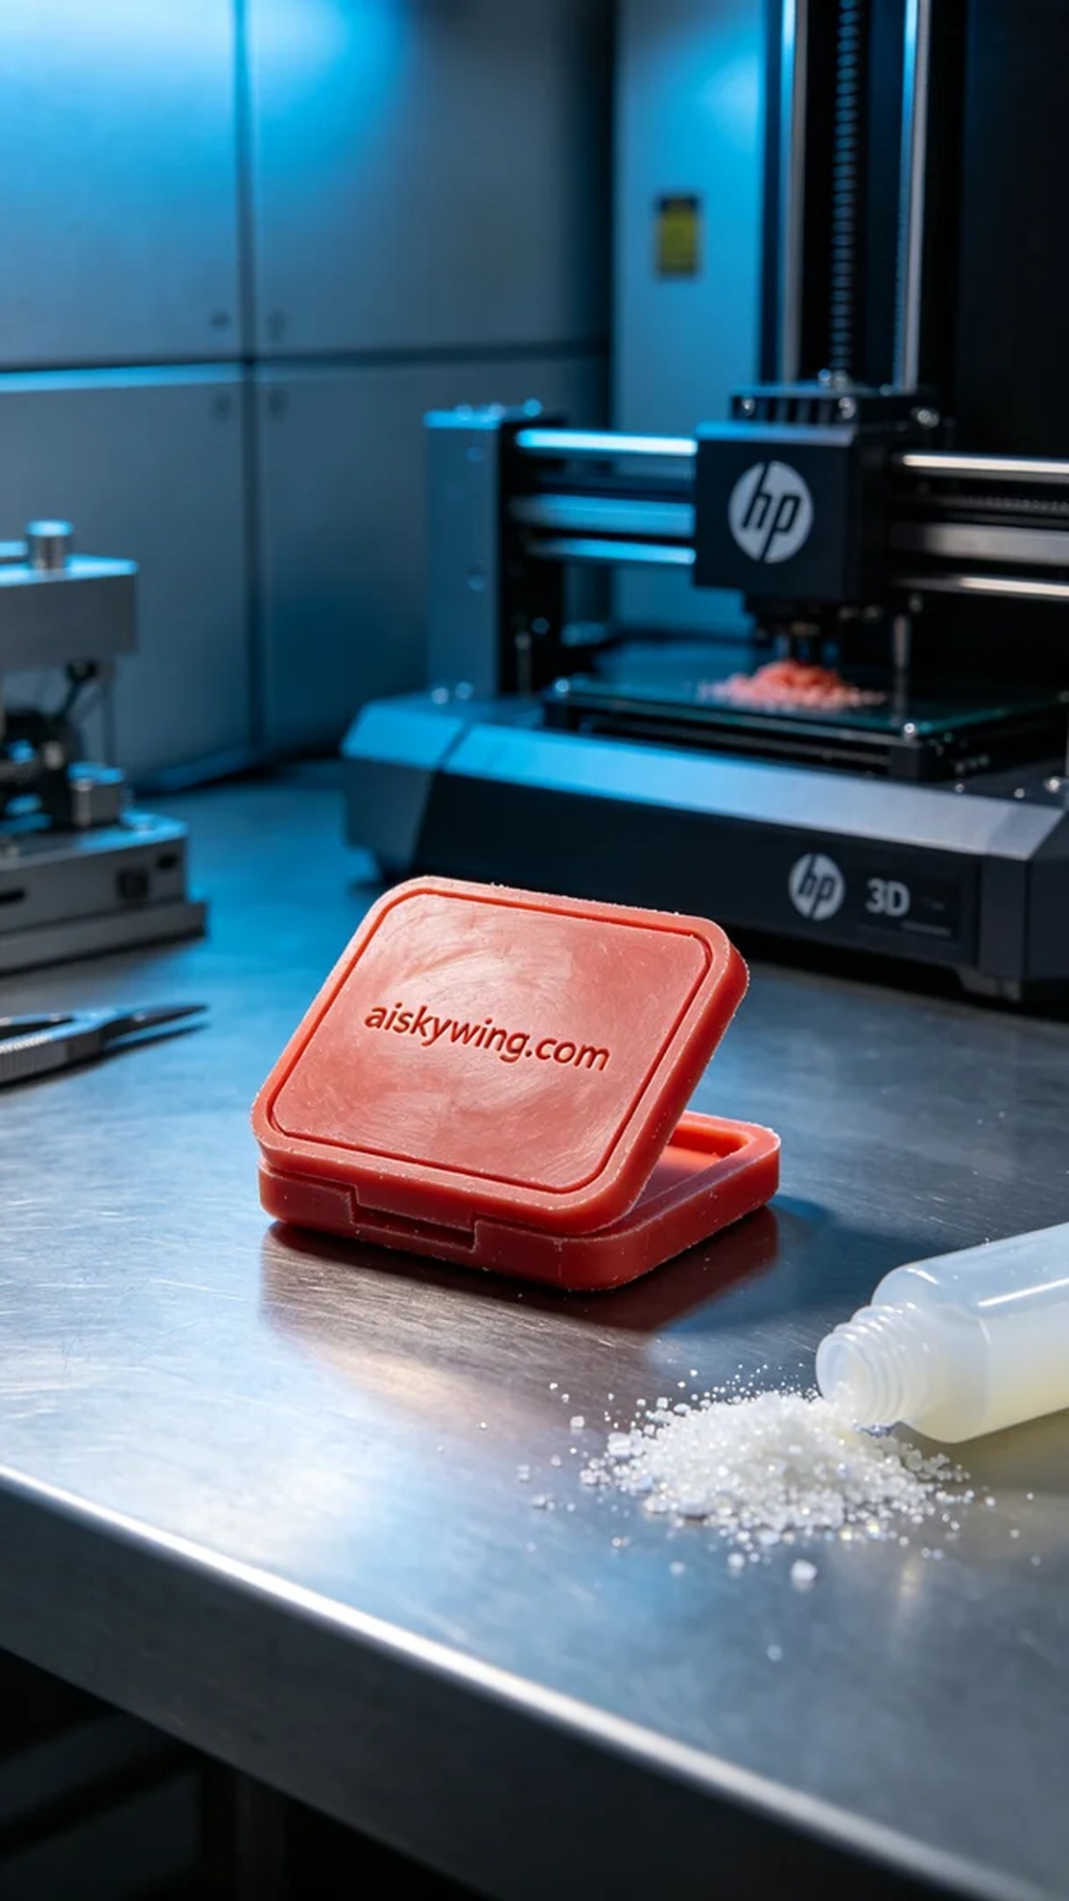
For the production of this makeup mirror shell wax model, we used high-precision red wax 3D printing material. This material exhibits excellent detail carving capabilities, showcasing micro-level craftsmanship, while the waxy luster gives the finished product a delicate appearance. In the preparation phase, we thoroughly checked the HP brand 3D printer to ensure it was functioning correctly, and optimized the printing parameters: layer thickness at 0.1mm, temperature set at 60 degrees Celsius, power at 80%, and printing speed controlled at 50mm per second, with the entire printing process expected to take four hours.
As the printing process began, the HP printer operated like a skilled craftsman, gradually transforming the liquid red wax into a solid wax model. Each layer's deposition was closely monitored to ensure there were no bubbles or material defects. As the printing approached completion, my anticipation grew, eager to see the final form of this piece.
Once printing was complete, we proceeded to the post-processing phase. First, the wax model was carefully removed from the print bed, followed by a wash with clean water to eliminate any residual resin. Next, we used fine sandpaper for sanding to ensure a smooth surface, followed by a curing process that typically required 30 minutes under UV light. Finally, I meticulously inspected every detail to ensure nothing was overlooked, making sure that every "aiskywing.com" inscription was clearly visible and flawless.
After a series of meticulous steps, the makeup mirror shell wax model was finally completed. The diligence and persistence at each stage not only made the final product aesthetically pleasing but also highly precise and satisfying.
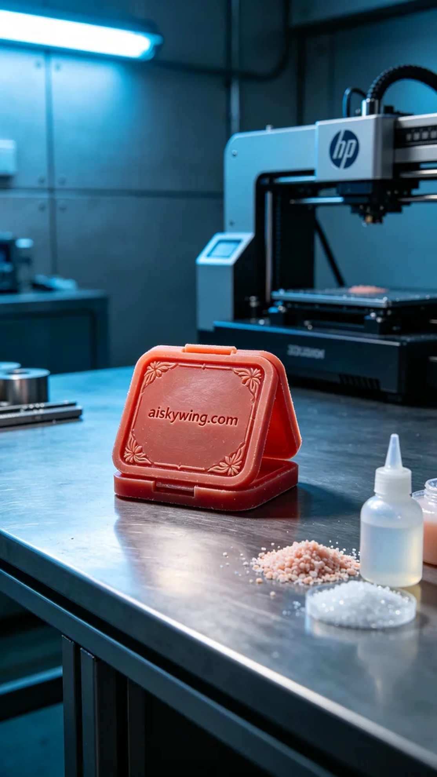
为了制作这个化妆镜外壳蜡模，使用的是红蜡高精度3D打印材料。这种材料具有极佳的细节雕刻能力，能展现出微米级的工艺细节，蜡质光泽让成品看起来极为精致。在准备阶段，我们仔细检查了HP品牌的3D打印机，确保设备正常运行，并对打印参数进行了优化设置：层厚0.1毫米，温度设定在60摄氏度，功率为80%，打印速度控制在50毫米每秒，预计整个打印过程需时四个小时。
打印过程开始后，HP打印机如同一位熟练的工匠，缓缓地将液态红蜡转变为坚固的蜡模。每一层的沉积都经过我的严格监控，确保没有气泡或材料缺陷。随着打印逐渐接近尾声，我的心情也愈加期待，期待看到这件作品的最终形态。
打印完成后，我们进入后处理环节。首先将蜡模从打印床上小心取下，随后用清水清洗以去除残留的树脂。接下来，我们使用细砂纸进行打磨，以确保表面光滑，再进行固化处理，通常需要在UV灯下固化30分钟。最后，我仔细检查了每个细节，确保没有遗漏，确保每个“aiskywing.com”的字样都清晰可见，完美无瑕。
经过一系列精细的步骤，这个化妆镜外壳蜡模终于完成了。每个阶段的认真与坚持，让最终的成品不仅美观，更具备高精度，令人满意。
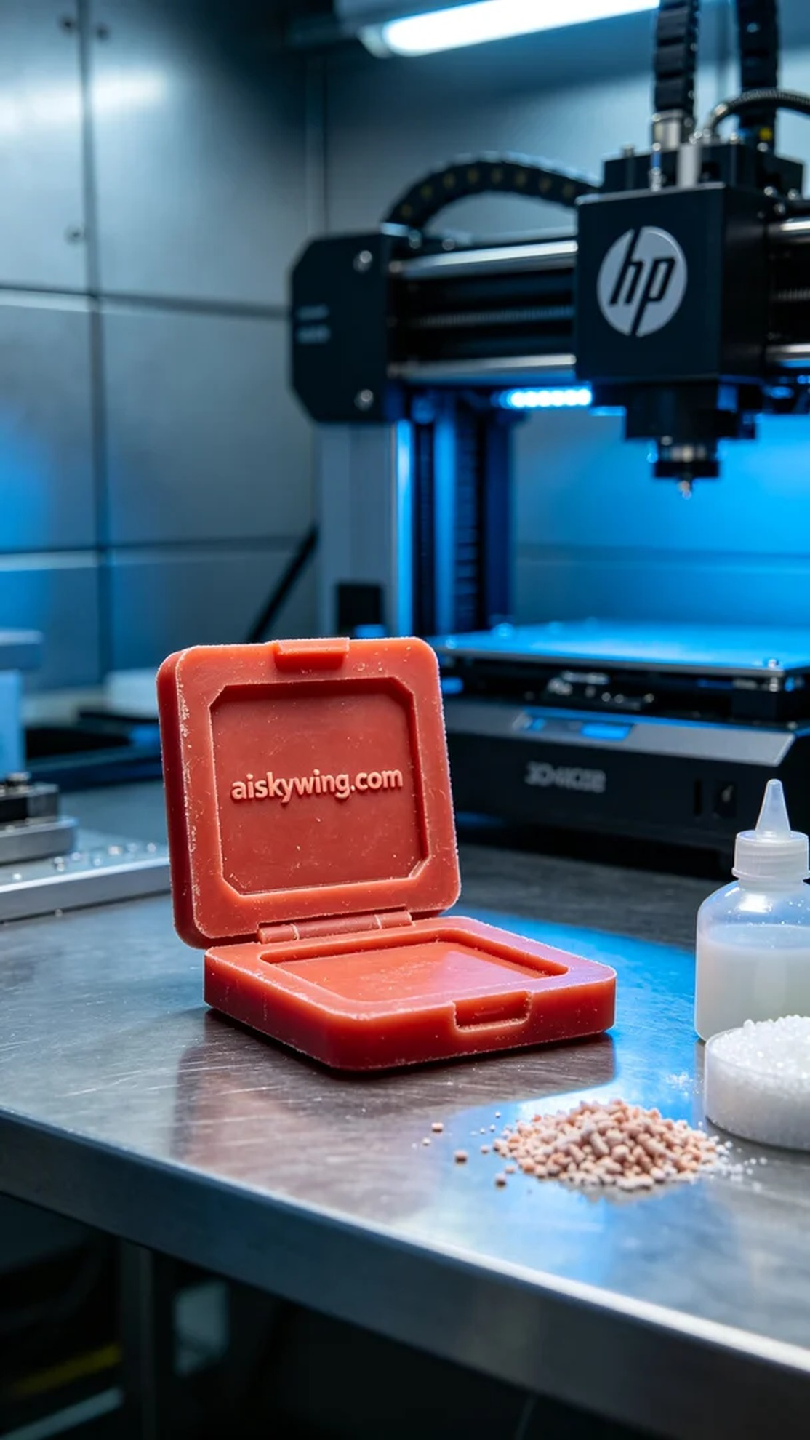
Aiskywing Industrial 3D Printing
Makeup mirror shell wax mold


