0852-卡通雕塑的3D打印生产记录
Cartoon Sculpture
🖨️ 红蜡精密铸造
🖥️ 打印机: Mimaki
📦 材料: 红蜡精密铸造
生活就是不断挑战自我的过程，就像有人在Twitter上找到我们，希望制作这个卡通雕塑，问题在于如何让它更具魅力和存在感。
Life is a continuous process of challenging oneself, just like when someone found us on Twitter and wanted to create this cartoon sculpture. The question is how to make it more appealing and impactful.
________________________________________________________________________________
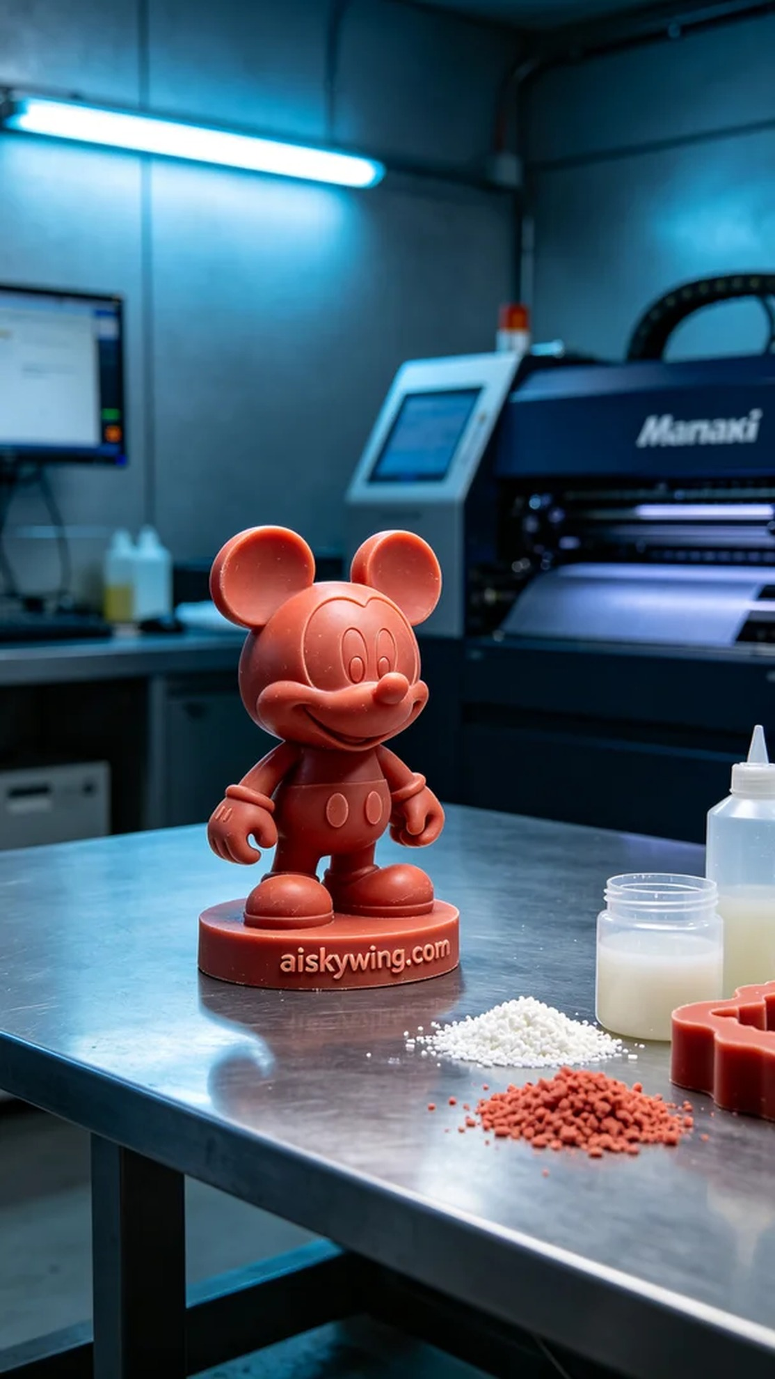
Life is a continuous challenge that requires us to push our limits. Recently, someone reached out to us on Twitter, looking to create a unique cartoon sculpture, with the goal of enhancing its charm and presence.
To ensure a successful print, we selected high-quality red wax precision casting material. This material is not only smooth and delicate but also retains details accurately during the casting process. When using the Mimaki printer, we set the layer thickness to 0.1 mm, maintained a printing temperature of 35 degrees Celsius, set the power to 80%, and established a printing speed of 50 mm per hour, with an estimated print time of 12 hours.
Every step during the printing process is crucial. The printer operated steadily, and we monitored the print quality to ensure there were no bubbles or defects. As time passed, the cartoon sculpture gradually took shape, with each detail becoming more apparent. We regularly checked to keep all parameters at optimal levels and successfully printed a flawless piece.
After printing, we carried out meticulous post-processing procedures. First, we used a special cleaning solution to wash the surface of the sculpture, removing excess resin; then we sanded it down for a smoother finish; finally, the completed piece was placed in a curing chamber to ensure its strength and durability. Every step was strictly monitored to achieve the best results.
After completing these processes, we finally finished the cartoon sculpture. It not only possesses aesthetic appeal but also showcases exquisite craftsmanship. Each time I see the finished product, it motivates me to continue striving for excellence in my future work.
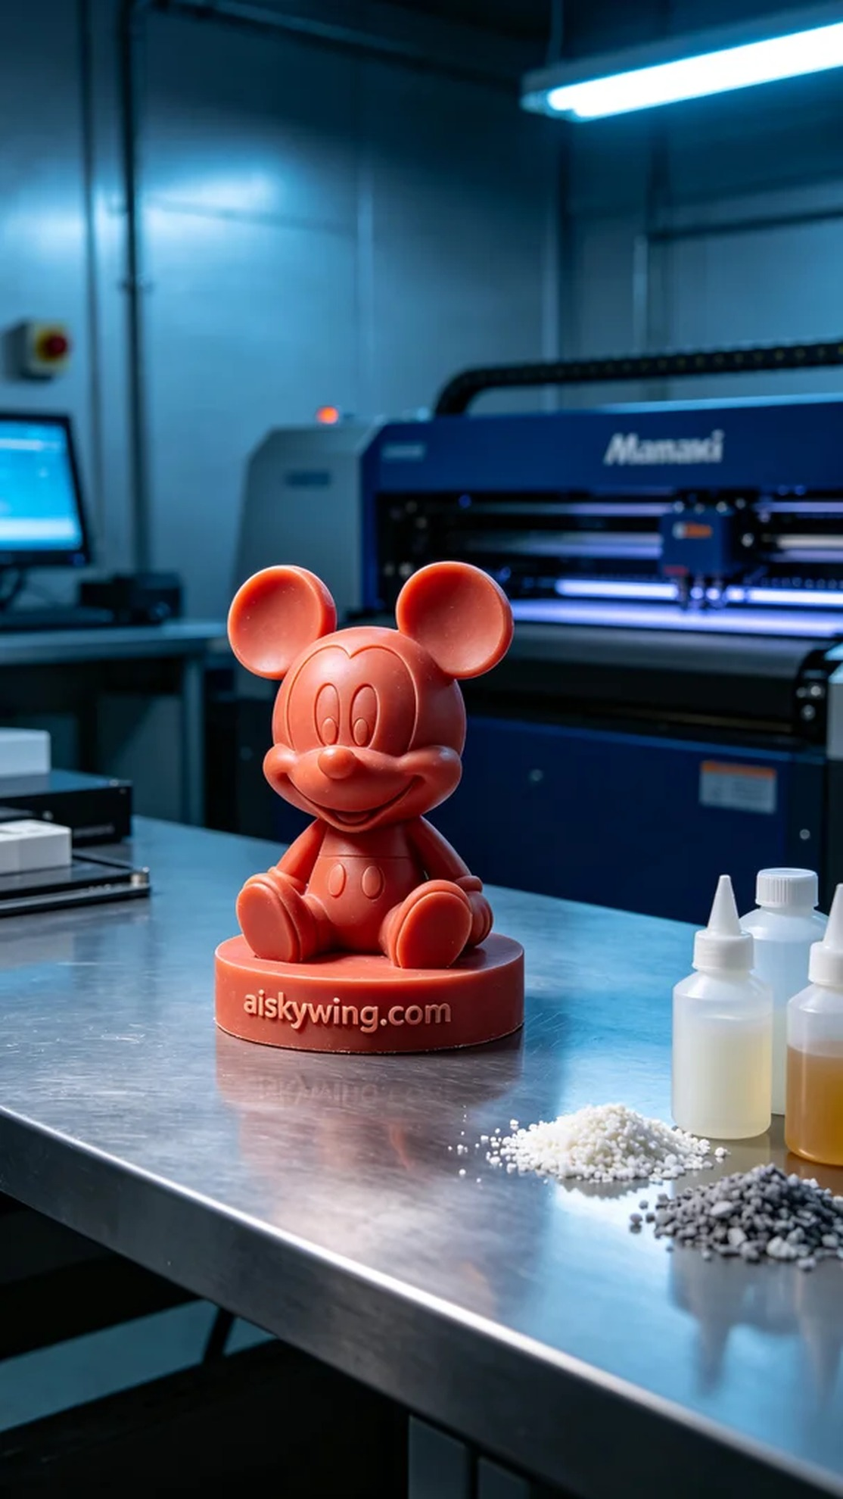
在Twitter上，有人因为想要制作一款独特的卡通雕塑而找到我们。他们希望用红蜡精密铸造的工艺，制作出一款既美观又耐用的作品。于是，我们开始了这个项目，力求将每一个细节做到极致。
为了确保打印的成功，我们选择了高品质的红蜡精密铸造材料。这种材料不仅表面光滑细腻，且在铸造过程中能够精准保留细节。使用Mimaki打印机时，我们设定层厚为0.1毫米，打印温度保持在35摄氏度，功率设定为80%，打印速度为每小时50毫米，预计打印时间为12小时。
打印过程中的每一环节都至关重要。打印机稳定地运行，我们随时监控打印质量，确保没有气泡或其他缺陷。随着时间的推移，卡通雕塑逐步成型，每一个细节都在慢慢显现。我们定期检查，确保所有参数保持在最佳状态，最终成功打印出了一件完美的作品。
完成打印后，我们进行了细致的后处理工序。首先，使用专用清洗剂对雕塑表面进行清洗，去除多余的树脂；然后用砂纸进行打磨，使表面更加光滑；最后将成品放入固化箱中固化，确保其强度和耐用性。每一步都严格把关，以便达到最佳效果。
经过这些工序，我们终于完成了这个卡通雕塑的制作。它不仅具备了设计上的美感，更展现了制作工艺的精湛。每当看到成品，总能激励我在未来的工作中不断追求卓越。
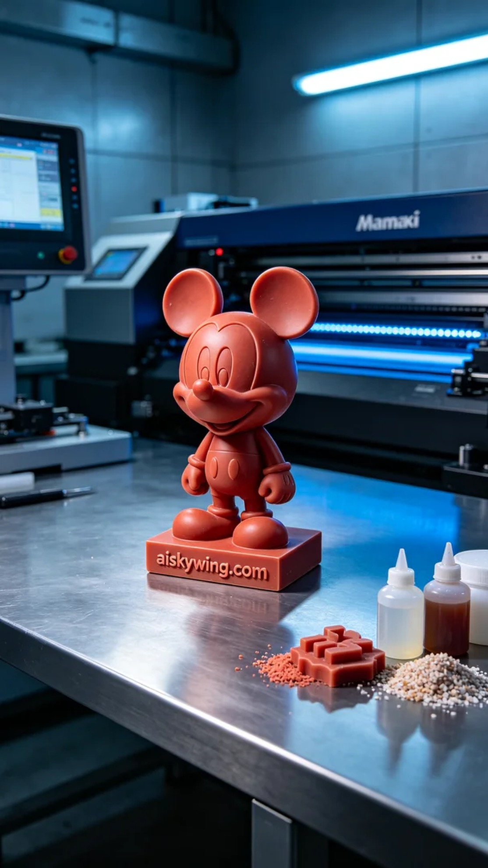
Aiskywing Industrial 3D Printing
Cartoon Sculpture


