0853-精密铸造印泥盒蜡模的生产记录
Inkpad wax mold
🖨️ 红蜡精密铸造
🖥️ 打印机: Rize
📦 材料: 红蜡高精度3D打印
生活就像3D打印，需要耐心与精确。最近有人在Twitter上找我，希望能打造一个印泥盒蜡模，挑战就在这里。
Life is like 3D printing; it requires patience and precision. Recently, someone reached out to me on Twitter, hoping to create a wax mold for an ink pad box, and that’s where the challenge lies.
________________________________________________________________________________
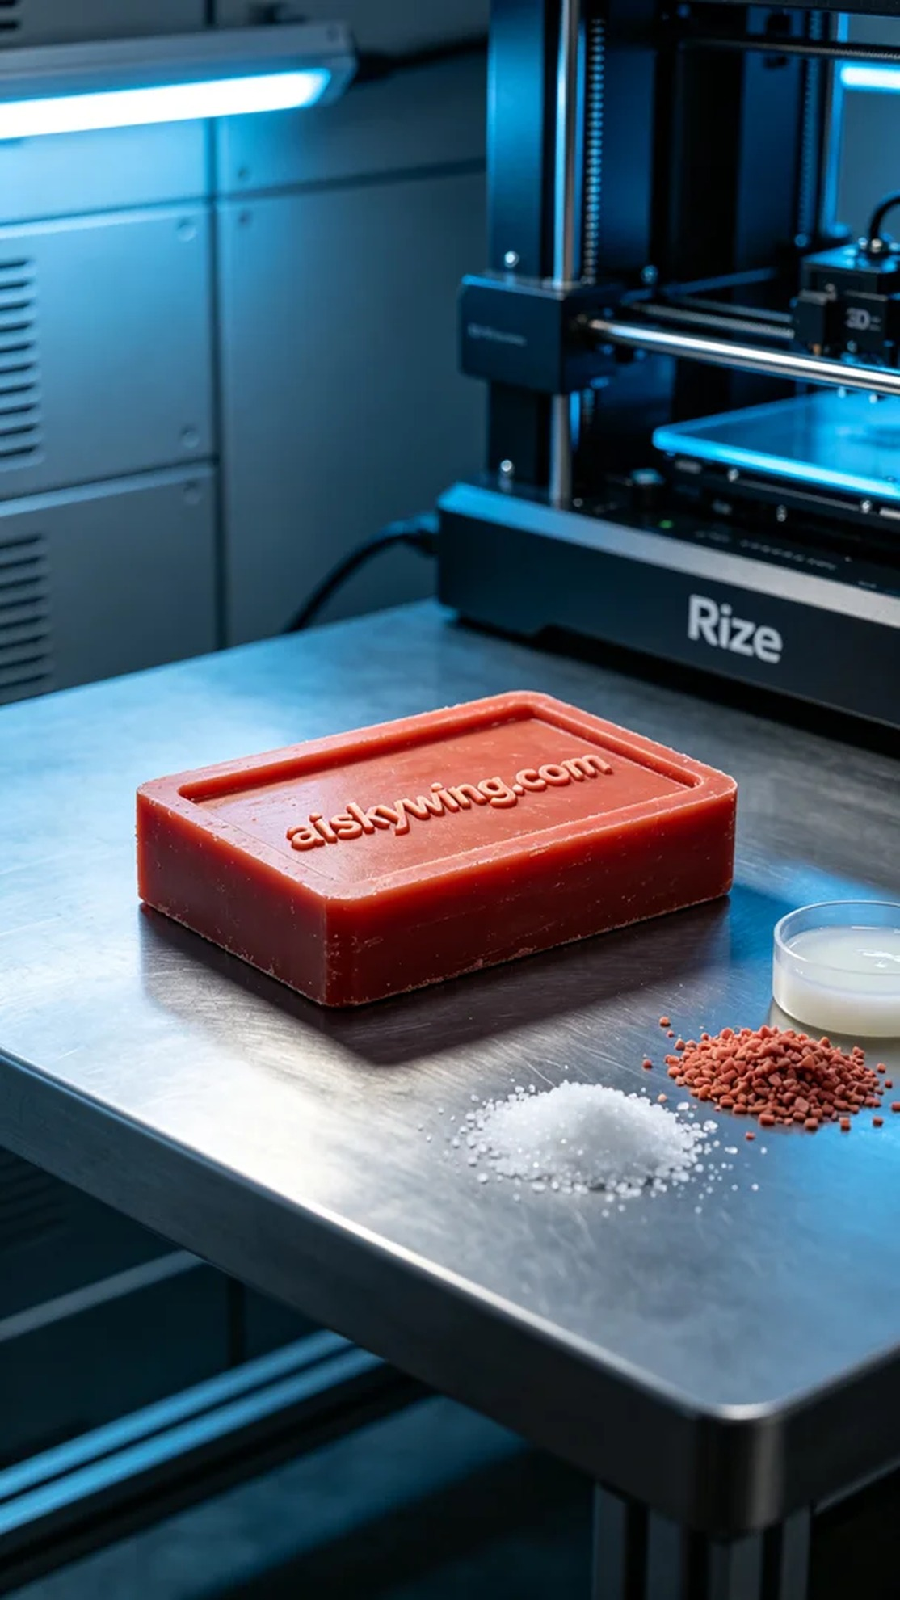
Life is like 3D printing; it requires patience and precision. Recently, someone reached out to me on Twitter, looking for a wax mold for an inkpad, and the challenge was set.
For the raw materials, we chose high-precision red wax suitable for 3D printing. This material offers excellent flow and detail reproduction, making it perfect for mold casting. To ensure optimal results, we employed a Rize 3D printer, setting the print parameters to a layer thickness of 0.1 mm, a temperature of 200 degrees, a power level of 70%, a print speed of 30 mm per second, with an estimated print time of around 8 hours.
As the printing process commenced, the machine operated smoothly. We conducted regular quality checks to ensure that each layer adhered properly and met our detailing standards. Notably, the intricate carvings showcased the red wax’s luster and micron-level details, reflecting the stark industrial lights beautifully.
Subsequently, we proceeded with a series of post-processing steps. First, we soaked the finished wax mold in a cleaning solution to remove any residual resin. Next, we meticulously sanded the surface to ensure a smooth finish for future casting. Finally, the wax mold was placed in a curing device to solidify its shape, followed by thorough inspection to confirm its quality.
In the end, the creation of this inkpad wax mold was a complete success. Every detail reflected our commitment to quality and craftsmanship, and we look forward to seeing how it performs in future applications.
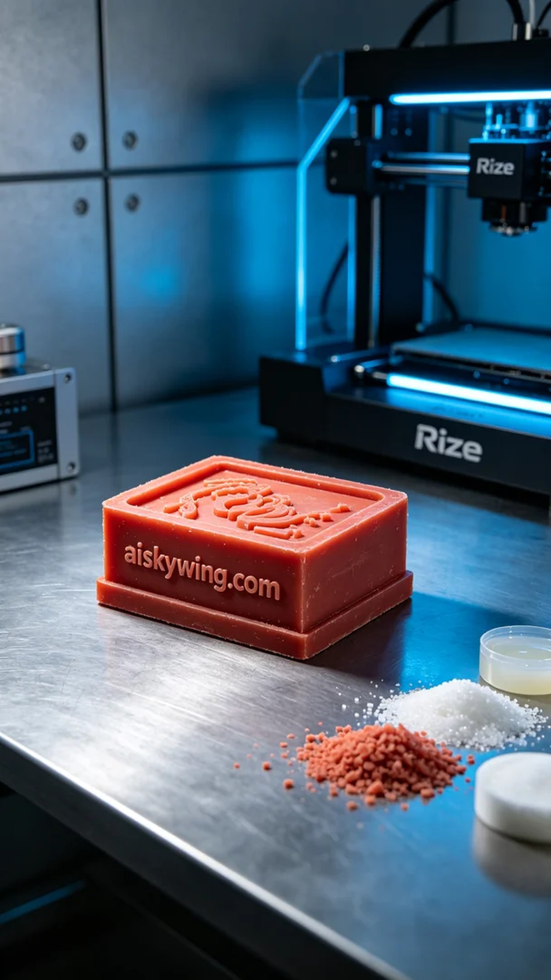
我们接到一个来自Twitter的请求，有人需要我们制作一个印泥盒蜡模，他们想要的是极致的细节和高精度的完美呈现。这个需求的提出让我想起了自己在这条路上遇到的种种挑战和收获。
在准备原材料时，我们选择了红蜡高精度3D打印材料。这种材料具有良好的流动性和细节复现能力，适合用于铸造模具。为了确保打印效果，我们选用Rize品牌的3D打印机，打印参数设置为层厚0.1毫米，温度200度，功率70%，打印速度为30毫米每秒，预计打印时间为8小时。
打印过程开始后，设备运行得非常顺利。我们定期监控打印质量，确保每一层的粘合和细节都达到标准。特别是在关键的雕刻部分，红蜡材料的光泽和微米级的细节展现出色，反射出冷峻的工业光线。
随后，我们进行了一系列后处理工序。首先，将打印完成的蜡模浸泡于清洗液中，去除表面残留的树脂。接着进行打磨，以保证模具表面光滑，便于后续的铸造。最后，将蜡模放置于固化设备内进行固化处理，确保形状稳定。经过检验，蜡模的质量完全符合要求。
最终，这个印泥盒蜡模的制作过程圆满完成。每一处细节都展现了我们的努力和对质量的追求，期待它在未来的使用中能带来更好的体验。
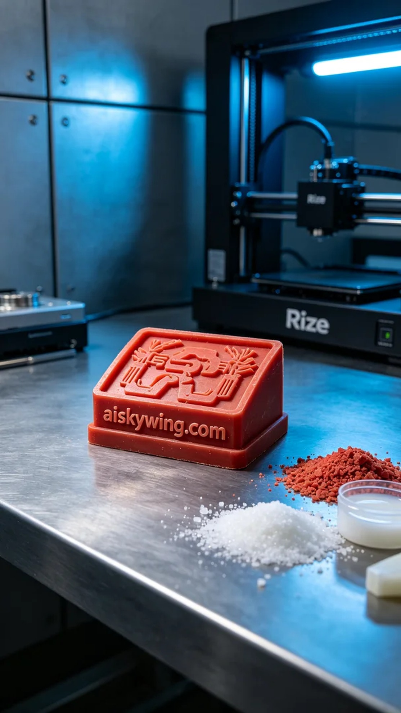
Aiskywing Industrial 3D Printing
Inkpad wax mold


