0857-印章蜡模的3D打印生产记录
Seal Wax Mold
🖨️ 红蜡精密铸造
🖥️ 打印机: Carbon
📦 材料: 红蜡精密铸造
生活再难，也别停下脚步。就像接下这个印章蜡模置于画面正中央的单子，有人希望通过我们解决他们的需求。
No matter how difficult life gets, don't stop moving forward. Just like taking this wax seal mold and placing it right in the center of the picture, some people hope to have their needs met through us.
________________________________________________________________________________
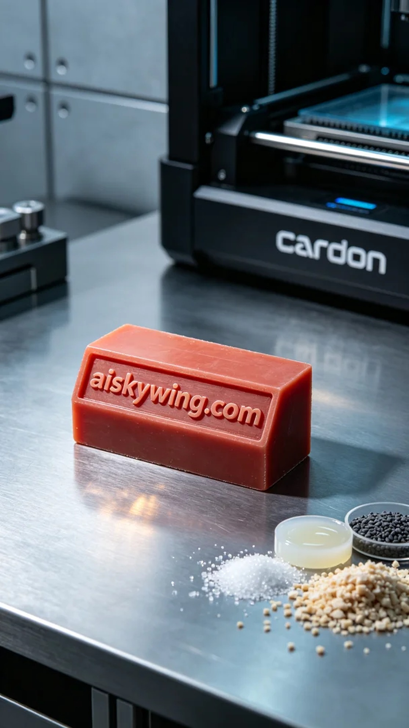
On Facebook, someone reached out to us in search of a high-quality seal wax mold. They wanted to accurately showcase the engraving “aiskywing.com” for their upcoming wax seal applications. This was a project worth taking on.
We chose red wax precision casting as our material, known for its excellent flow at high temperatures and the smooth finish it provides. To meet the design needs, we set the Carbon printer to a layer thickness of 0.1mm, maintaining a printing temperature of 25°C, power at 50W, and a printing speed of 30mm/s, estimating the entire process to take about 8 hours.
As the printing process commenced, the Carbon printer operated smoothly. We closely monitored the print quality, ensuring that each layer aligned precisely. At each stage, we observed the excellent flow characteristics of the red wax material, clearly showcasing the intricacy of the engraving. The printer’s monitoring system continually provided feedback, ensuring there were no issues.
After printing, we carried out multiple post-processing steps. First, we placed the seal wax mold in a cleaning solution to thoroughly remove any uncured resin. Once cleaned, we carefully sanded the surface to enhance its smoothness, ensuring the mold would achieve perfect results during use. Next, we performed curing on the mold to optimize its hardness. The final step was inspection, confirming that every detail met our high standards.
After a series of efforts, we successfully delivered the seal wax mold. Every challenge is an opportunity for growth, and the final result is truly rewarding.
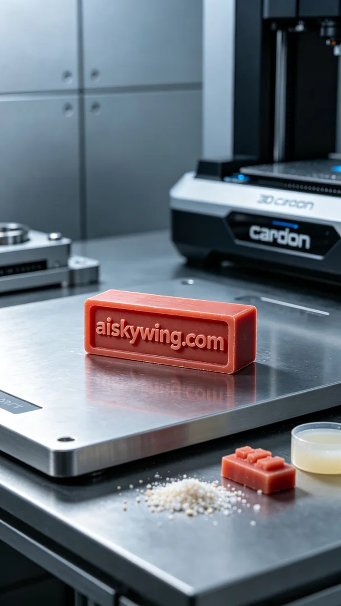
在Facebook上，有人因寻找一款高质量印章蜡模而联系我们。他们希望能够精确展现出“aiskywing.com”字样，以便于后续的蜡封应用。这是一个值得挑战的项目。
我们的原材料选择了红蜡精密铸造，这种材料能在高温下保持良好的流动性，并确保成品的细腻光滑。为了满足设计需求，我们在Carbon打印机上设定了层厚0.1毫米，打印温度保持在25摄氏度，功率为50W，打印速度为30毫米/秒，整个打印过程预计耗时大约8小时。
打印过程开始后，Carbon打印机顺利运行。我们时刻关注打印质量，确保每一层都能精准对齐。在打印的每个阶段，我们都观察到红蜡材料的流动性非常好，能够清晰地展现出雕刻的细节。设备的监控系统也在不断反馈数据，确保没有任何问题发生。
完成打印后，我们进行了多道后处理工序。首先，将印章蜡模放入清洗液中，彻底去除未固化的树脂。清洗完毕后，我们小心地进行打磨，使表面更加平滑，确保蜡模在使用时的完美效果。接着，我们对蜡模进行了固化处理，以让其达到最佳硬度。最后一步是检验，确保每个细节都达到预期标准。
经过一系列的努力，最终成功交付了这款印章蜡模。每一次挑战，都是成长的机会，最终成绩让人振奋。
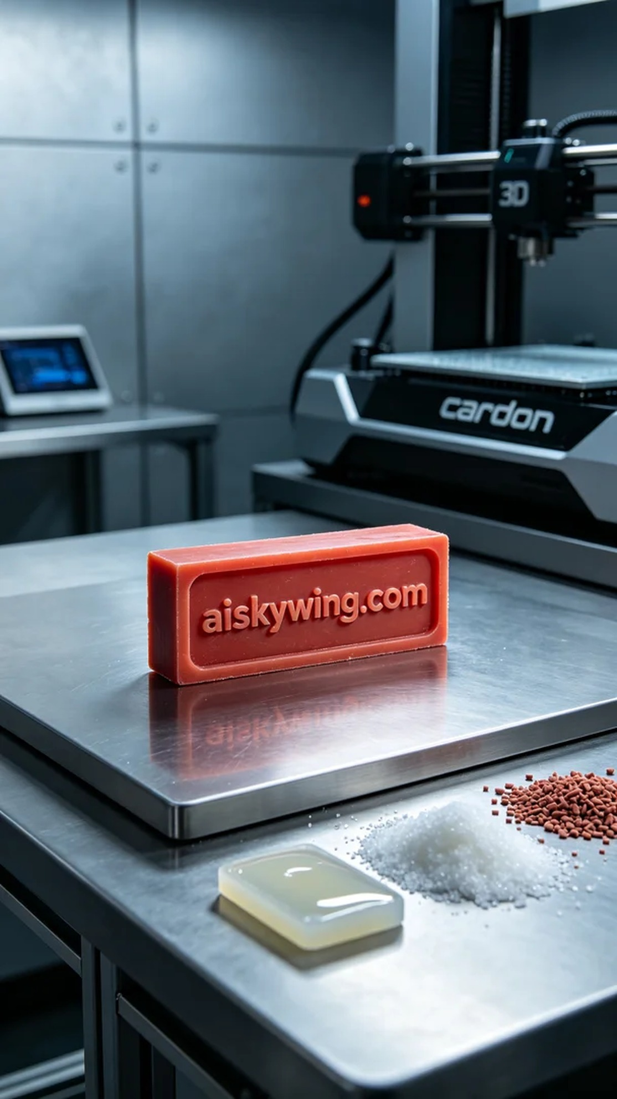
Aiskywing Industrial 3D Printing
Seal Wax Mold


