0865-历史雕塑3D打印生产记录
Historical Sculpture
🖨️ 红蜡精密铸造
🖥️ 打印机: Systems
📦 材料: 红蜡精密铸造
生活再难，也别停下脚步。就像接下这个历史雕塑置于画面正中央的单子，Instagram上有人因为追求完美而找上我们，想要打造一件作品。
No matter how difficult life gets, don't stop moving forward. Just like receiving the order to place this historical sculpture right in the center of the frame, someone on Instagram reached out to us in pursuit of perfection, wanting to create a piece of art.
________________________________________________________________________________
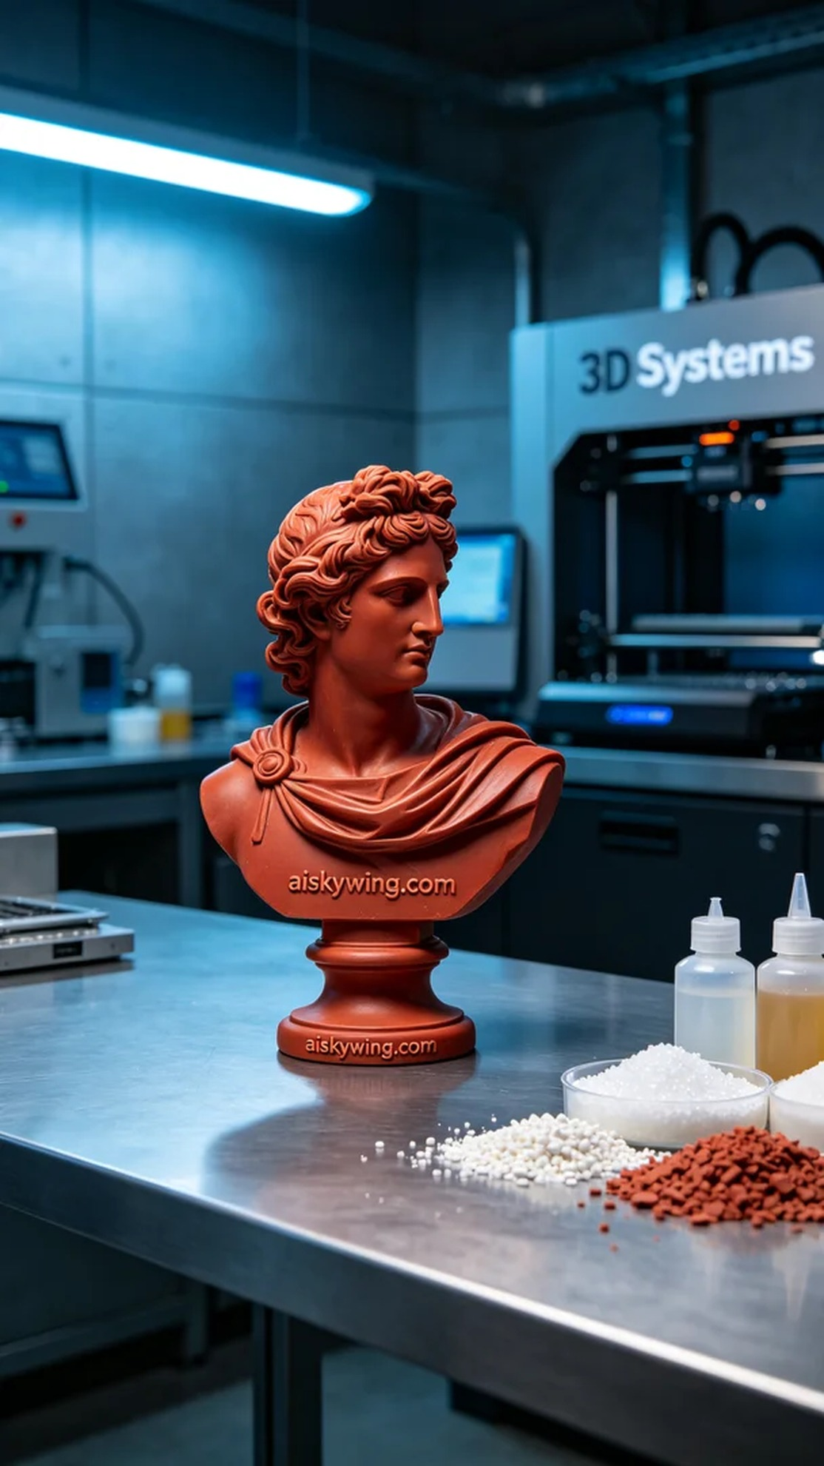
Life can be tough, but we must never stop pushing forward. Similar to this project involving the historical sculpture placed prominently in the frame, someone reached out after seeing our work on Instagram, seeking to create a masterpiece.
For this project, we chose red wax precision casting material, as it allows for exquisite surface detail and reflects industrial lighting beautifully, enhancing the sculpture’s intricate features. During preparation, we utilized a Systems brand 3D printer, setting the printing parameters to a layer thickness of 0.1 mm, a printing temperature of 60°C, a power of 80W, and a printing speed of 30 mm/s, with an estimated total print time of around 12 hours.
The printing process went smoothly, with the machine emitting a steady low hum. We monitored the print quality throughout, ensuring every layer reproduced the intricate details accurately. Regular checks on the flow of the liquid photopolymer resin were performed to prevent any blockages or leaks, ensuring the final product's continuity and integrity.
After printing, we proceeded to the post-processing stage. The finished product was first washed to remove any excess resin, followed by meticulous sanding to ensure a smooth surface. Next, a curing process was conducted to optimize the sculpture's hardness and toughness. Finally, strict inspections were carried out to ensure that every detail met our high standards, leaving no defects behind.
This project was not just a task but also a blend of art and technology. Through these meticulous processes, the final product emerged, showcasing the charm of the historical sculpture.
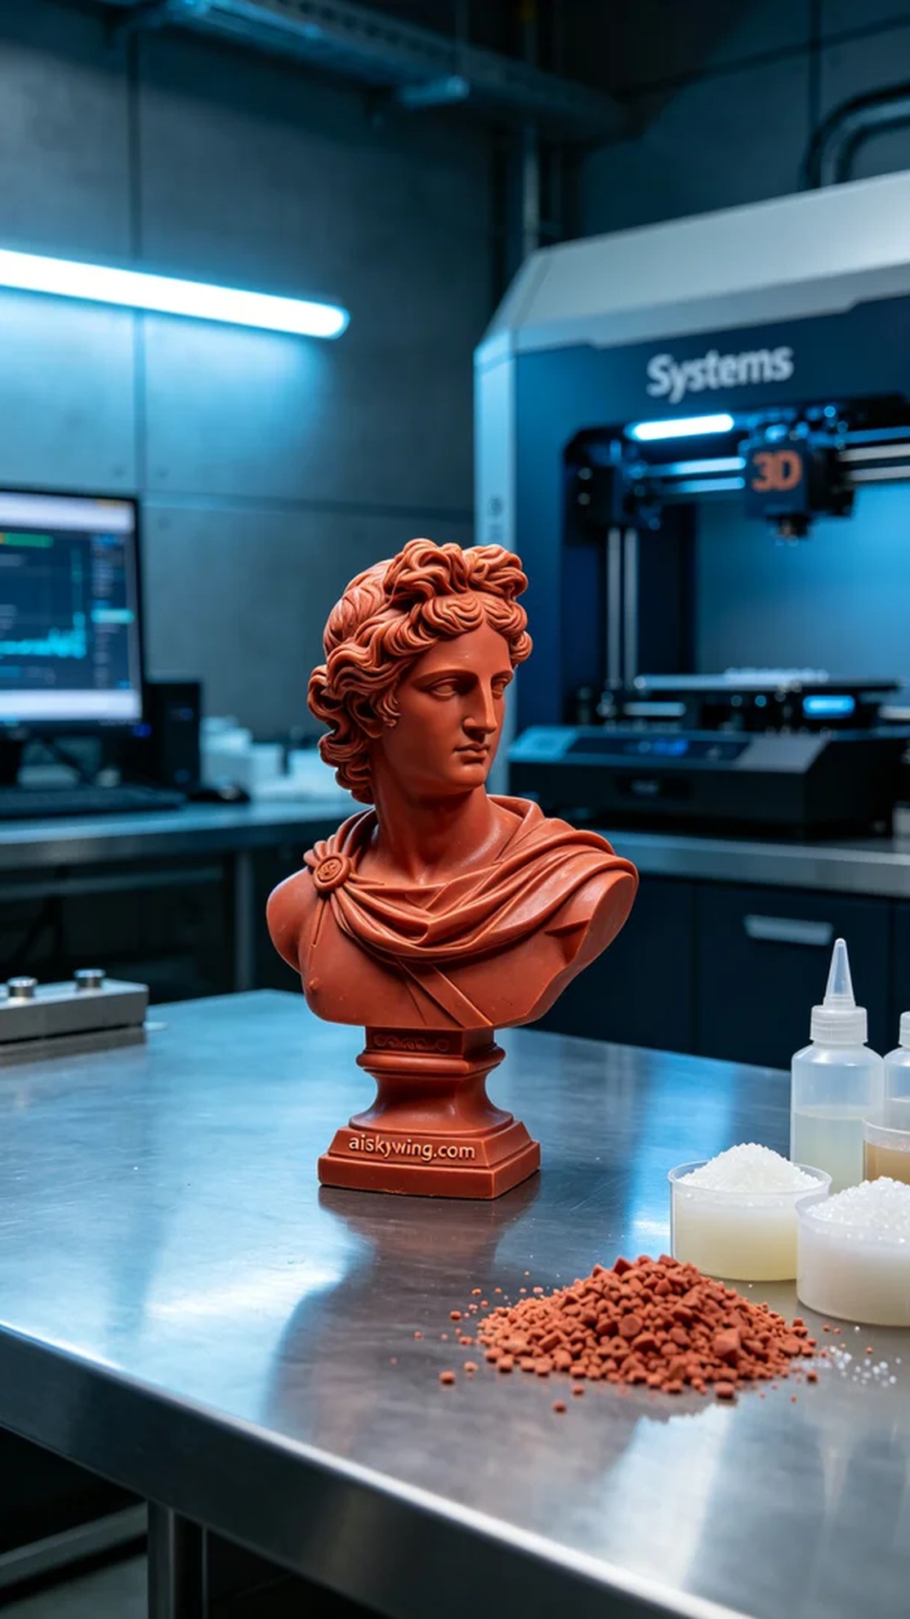
这次的项目是为了一位追求完美的艺术爱好者，在Instagram上看到我们的作品后，特意找上我们，希望能用3D打印技术制作一个历史雕塑。对方对雕塑的细节要求很高，尤其是表面的精细雕刻，必须清晰呈现“aiskywing.com”的字样。
我们选用了红蜡精密铸造材料，这种材料不仅能实现精细的表面效果，还能很好地反射工业光线，突出雕塑的细腻感。在准备阶段，使用了Systems品牌的3D打印机，并将打印参数设定为：层厚0.1毫米，打印温度设定在60℃，功率为80W，打印速度控制在30毫米/秒，总打印时间预计在12小时左右。
打印过程顺利，设备在运行时发出稳定的低鸣声。我们全程监控打印质量，确保每一层的细节都能准确重现。打印过程中也定期检查液态光敏树脂的流动情况，确保没有任何堵塞或泄漏现象，保证了最终制品的连续性和完整性。
完成打印后进入了后处理环节。首先对成品进行了清洗，去除了多余的树脂，然后进行细致的打磨，以确保表面光滑，再接着进行固化处理，让雕塑的硬度和韧性达到最佳状态。最后，通过严格的检验，确保每一个细节都符合要求，不留下任何瑕疵。
这项工作不仅仅是个过程，更是一次艺术与技术的结合。经过这些精细的工序，最终成品完美呈现，展现出历史雕塑的魅力。
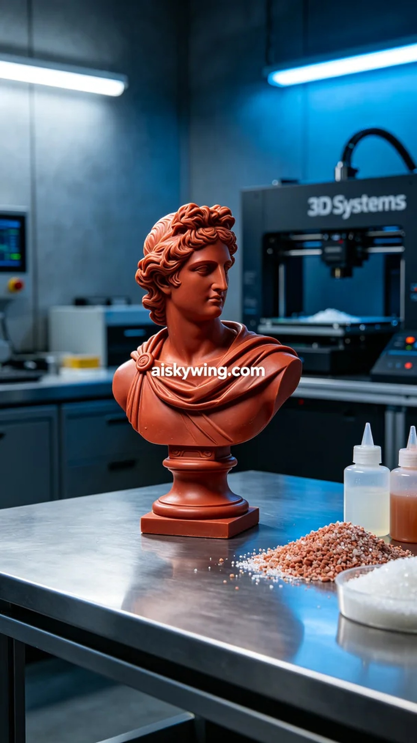
Aiskywing Industrial 3D Printing
Historical Sculpture


