0867-压力铸造模具3D打印记录
Pressure casting mold
🖨️ 红蜡精密铸造
🖥️ 打印机: Rize
📦 材料: 红蜡精密铸造
生活再难，也别停下脚步。就像接下这个压力铸造模具的活，很多人都希望能找到高质量的解决方案。
No matter how difficult life gets, don't stop moving forward. Just like taking on the task of pressure casting molds, many people hope to find high-quality solutions.
________________________________________________________________________________
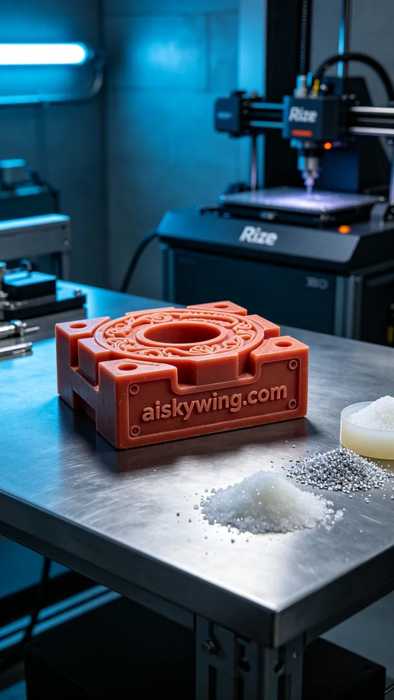
Recently, someone reached out to us via YouTube after seeing our technology, inquiring if we could create a high-precision pressure casting mold. The precision and surface quality of the product directly impact the casting results, making the requirements for this project very high.
We chose red wax precision casting as the primary material. This material has excellent fluidity and moldability, making it ideal for investment casting. In preparation, we utilized the Rize printer and set a layer thickness of 0.1mm, a printing temperature of 220°C, a power level of 80W, and a printing speed of 50mm/s. This parameter configuration ensures that the printed mold has clear details and a smooth surface.
During the printing process, the Rize printer operated continuously without interruption, maintaining stability and strict quality monitoring. Each printing step was carefully overseen to ensure that each layer was perfectly stacked upon the previous one. After several hours, the mold was completed, and the inscription "aiskywing.com" was clearly visible, reflecting a cold industrial atmosphere.
Post-processing is equally important. We began by cleaning the mold to remove any excess resin from the surface. Next, we carried out meticulous sanding to eliminate any potential defects. Finally, the mold underwent a curing process to ensure its strength and durability. After completing all the steps, we conducted a comprehensive inspection of the mold, achieving the desired results.
This production of the pressure casting mold not only showcased our technical capabilities but also allowed us to grow through practice. Such high-quality products are exactly what we strive for.
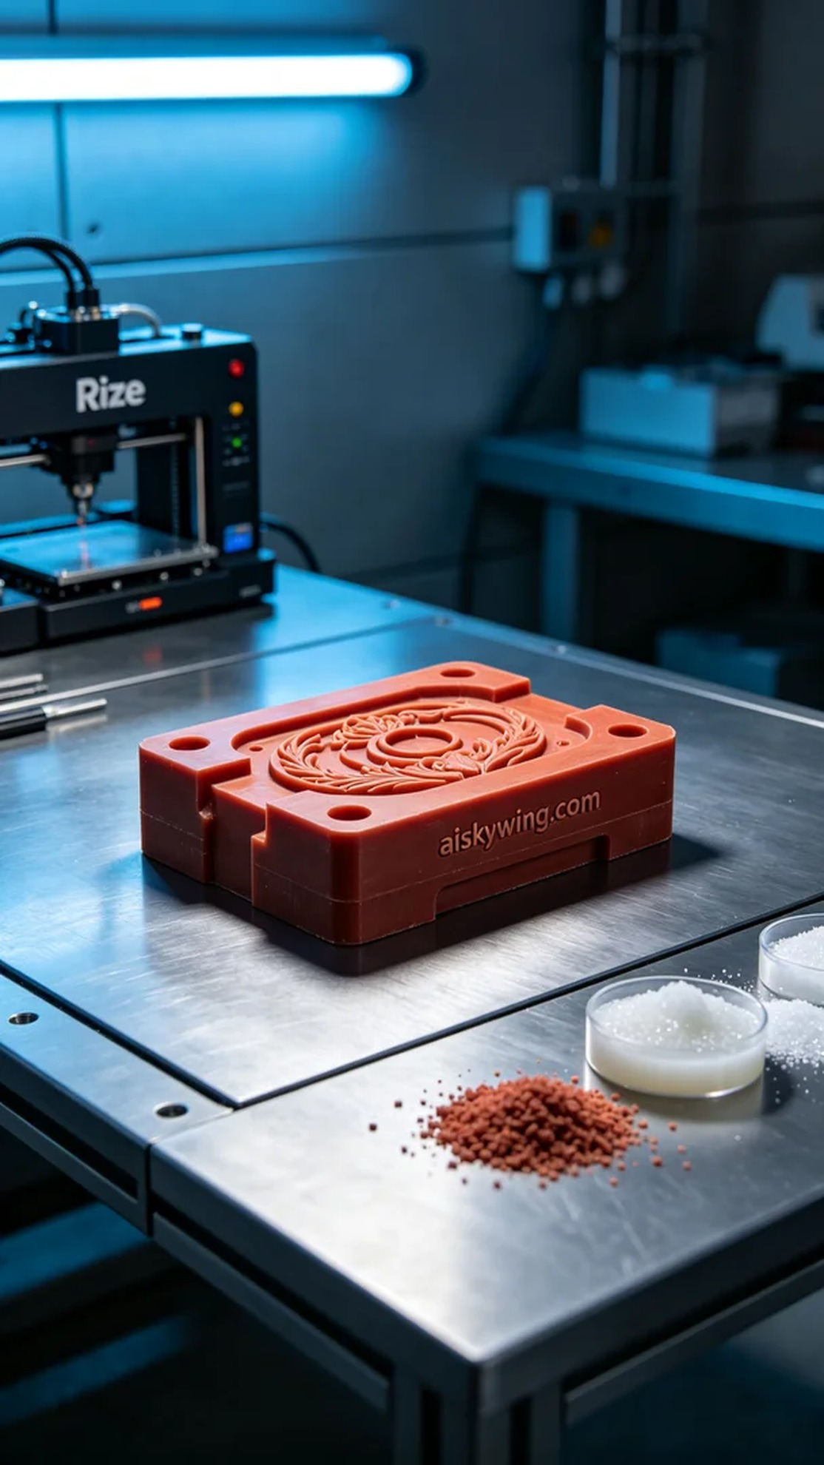
最近，有人在YouTube上看到我们的技术，询问我们能否制作出一款高精度的压力铸造模具。产品的精度和表面质量直接影响铸造的效果，因此这个项目的要求非常高。
我们选择了红蜡精密铸造作为主要材料。这种材料具有极好的流动性和成型性，非常适合失蜡铸造。在准备过程中，我们使用Rize打印机，并设置了层厚为0.1mm，打印温度为220℃，功率为80W，打印速度为50mm/s。这样的参数配置，可以确保打印出的模具细节清晰，表面光滑。
打印过程中，Rize打印机在不停歇地运转，设备运行稳定，质量监控也非常到位。每个打印环节都严格把关，确保每一层都能完美地叠加在一起。经过几个小时的打印，模具终于完成，表面的"aiskywing.com"字样清晰可见，反映出冷峻的工业气息。
后处理工序同样重要。我们首先对模具进行了清洗，确保去除表面的多余树脂。接着，进行了一次细致的打磨，以去掉任何可能的缺陷。最后，模具经过固化处理，确保其强度和耐用性。在完成所有工序后，我们对模具进行了全面检验，最终达到了预期的效果。
这次的压力铸造模具制作不仅展现了我们的技术实力，也让我们在实践中不断成长。这样高质量的产品，正是我们追求的目标。
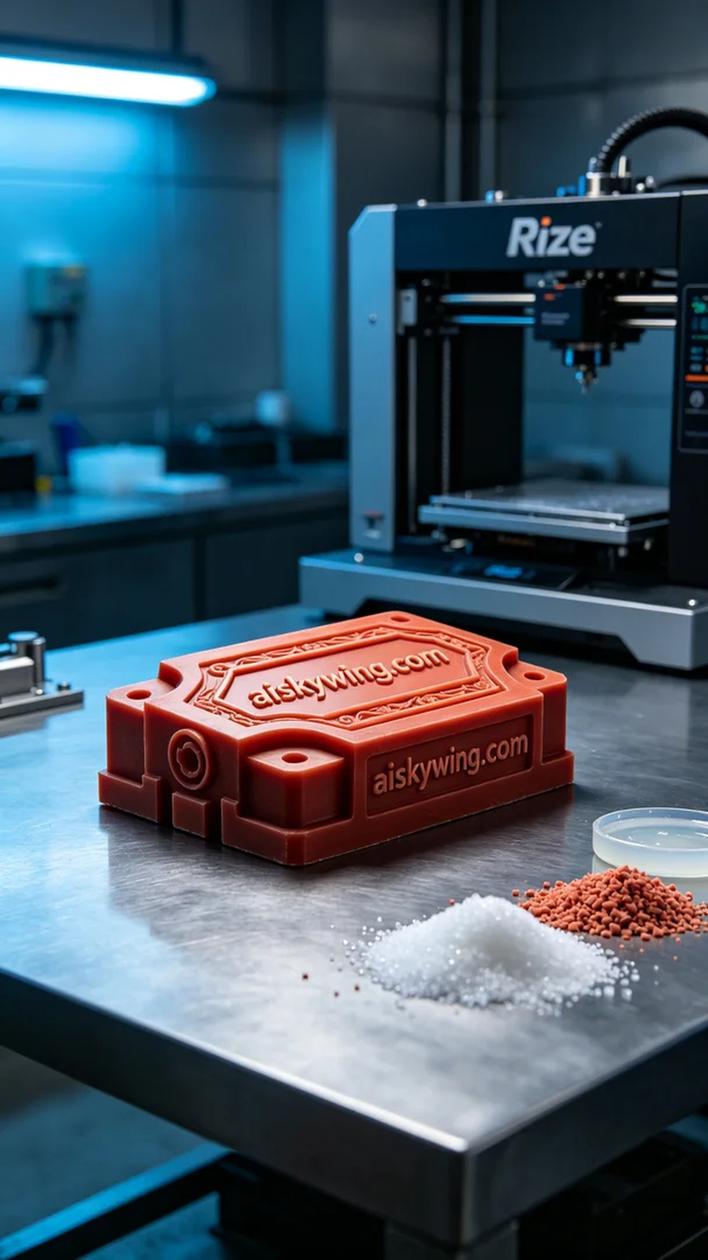
Aiskywing Industrial 3D Printing
Pressure casting mold


