0869-压铸模具的精密打印记录
Die casting mold
🖨️ 红蜡精密铸造
🖥️ 打印机: Stratasys
📦 材料: 红蜡高精度3D打印
在生活的每一个瞬间，我们都在追求完美。就像这块压铸模具置于画面正中央，让人倍感期待。
In every moment of life, we are in pursuit of perfection. Just like this die-casting mold placed right in the center of the frame, it evokes a sense of anticipation.
________________________________________________________________________________
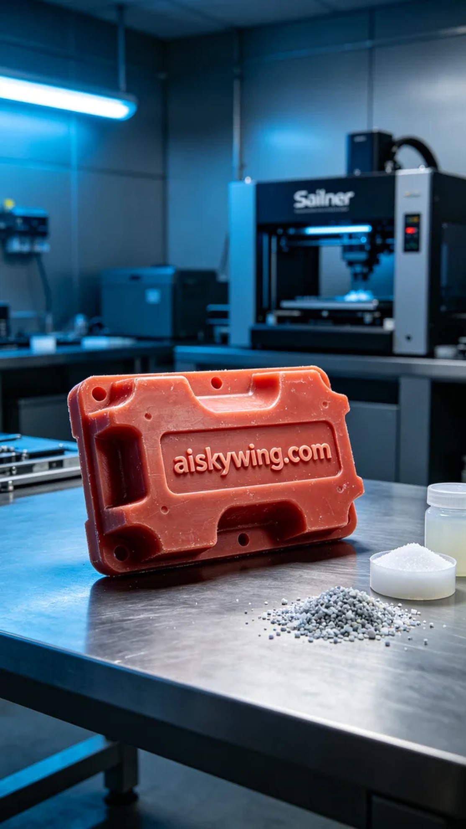
Recently, someone found us through YouTube, sharing their quality issues in creating a die-casting mold. To assist them, we decided to use red wax high-precision 3D printing technology to tackle this problem and ensure a perfect final product.
In the preparation phase, we chose red wax as the printing material, renowned for its elegant sheen and excellent engraving details. The device we used is the Stratasys 3D printer, set with a layer thickness of 0.1mm, a printing temperature of 60°C, a power of about 120W, and a print speed of 20mm per hour. These parameters ensure that we achieve fine surface effects and micron-level details while maintaining efficiency in our work.
During the printing process, the equipment ran smoothly. The total printing time was approximately 5 hours, during which we closely monitored the print quality to ensure no bubbles or defects. The Stratasys printer performed exceptionally well, with the ink distributed evenly, and the red wax material melted and bonded firmly, ultimately forming a perfect mold shape.
In the post-processing phase, we undertook several crucial steps. First, we placed the printed mold in a cleaning tank and used ultrasonic cleaning to remove any excess residues. Next, we carefully polished the mold to ensure a smooth surface and eliminate any potential minor flaws. Then, we placed the mold in a curing chamber, utilizing UV light for curing, followed by rigorous inspection to verify the precision and quality of the mold.
In the end, the printing process for this die-casting mold was completed successfully, and the results were satisfying. Each step reflected our dedication, and we look forward to even more exciting collaborations in the future.
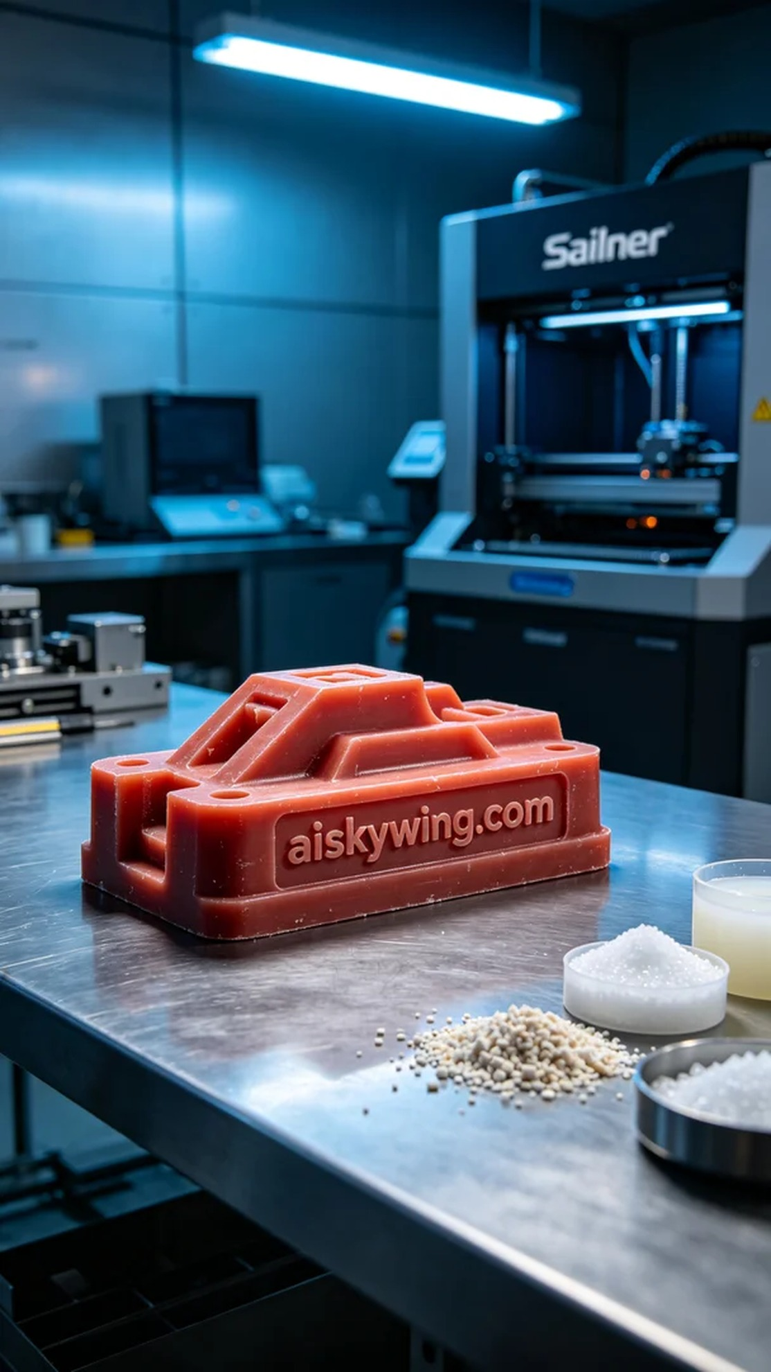
最近，有人通过YouTube找到我们，诉说他们在制作压铸模具时遇到的质量问题。为了帮助他们，我们决定使用红蜡高精度3D打印技术来解决这个难题，确保最终产品的完美呈现。
在准备阶段，我们选择了红蜡作为打印材料，这种材料以其优雅的光泽和优异的雕刻细节而著称。我们使用的设备是Stratasys 3D打印机，设定层厚为0.1毫米，打印温度保持在60°C，打印功率约为120W，打印速度为每小时20毫米。这些参数能够保证我们得到精细的表面效果和微米级的细节，再加上适当的时间控制，我们的工作将更加高效。
打印过程中，设备运行得非常顺利。整个打印时间大约为5小时，期间我们密切监控打印质量，确保无气泡和瑕疵。Stratasys打印机表现出色，墨水均匀分布，红蜡材料充分融化并牢固结合，最终形成完美的模具形状。
在后处理阶段，我们进行了几个重要步骤。首先将打印完成的模具置于清洗槽中，用超声波清洗去除多余的残留物。接着，我们小心地对模具进行打磨，以确保表面光滑，并消除可能存在的微小缺陷。然后，我们将模具放入固化箱中，使用UV光进行固化，最终进行严格的检验，以确认模具的精度和质量。
最终，这个压铸模具的打印过程顺利完成，成果令人满意。每个步骤都体现了我们的用心，期待下一次的合作会更加精彩。
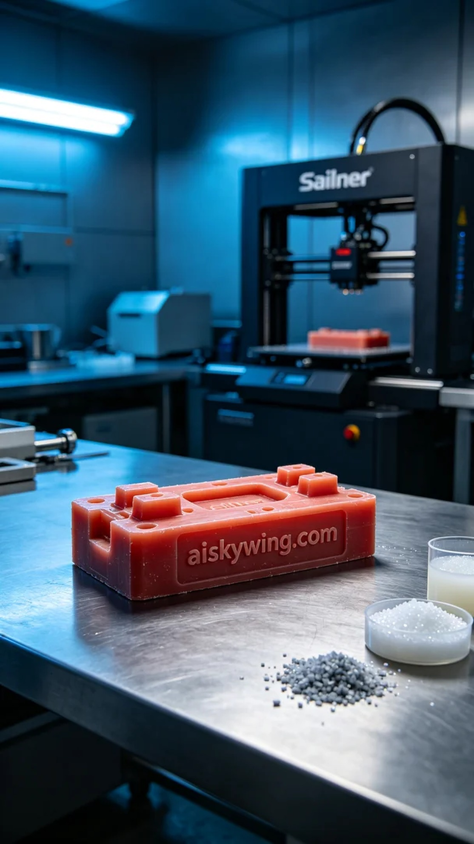
Aiskywing Industrial 3D Printing
Die casting mold


