0870-发夹蜡模的生产记录
Hairpin wax mold
🖨️ 红蜡精密铸造
🖥️ 打印机: Systems
📦 材料: 红蜡精密铸造
生活就像一场精密的铸造，每一步都需要坚持和细致。有人在LinkedIn上找到我，希望制作一个发夹蜡模，让我深感责任重大。
Life is like a precise casting process, where every step requires persistence and attention to detail. Someone found me on LinkedIn, hoping to create a wax mold for a hairpin, which made me feel a great sense of responsibility.
________________________________________________________________________________
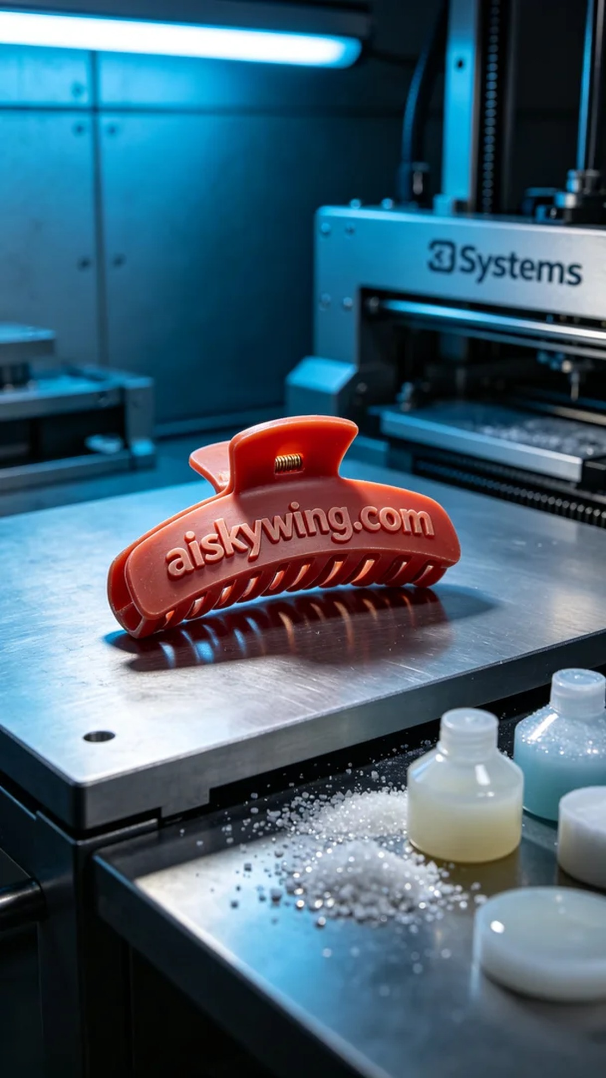
Life is like a precise casting process, every step requires persistence and attention to detail. Someone reached out to me on LinkedIn seeking to create a hairpin wax model, and I felt a significant sense of responsibility.
The material used for production is red wax precision casting, known for its excellent fluidity and fine surface finish. During preparation, we adjusted the equipment to optimal settings, utilizing the Systems brand 3D printer. The layer thickness was set to 0.1 mm, temperature maintained at 60 degrees Celsius, power set at 70%, and print speed configured at 30 mm per hour, with the entire printing process expected to take about 8 hours.
Once printing commenced, the process ran smoothly. We closely monitored the printer's status to ensure each layer was accurately stacked. During inspections, the material's fluidity proved excellent, and the surface was smooth and delicate, enhancing the model's details. There were no blockages or defects throughout the process, which was quite satisfying.
Upon completion of the print, the post-processing stage was equally vital. We began with washing the model to remove residual resin from the surface. This was followed by sanding with fine-grit paper to achieve a flawless smooth finish. Next was the curing step, where the hairpin wax model was placed under UV light to ensure its structure was robust and durable. Finally, we meticulously checked every detail, confirming everything was perfect before considering the process complete.
Through this series of meticulous operations, we successfully produced the hairpin wax model. It is not just a product but a reflection of our craftsmanship spirit, which brings me great satisfaction.
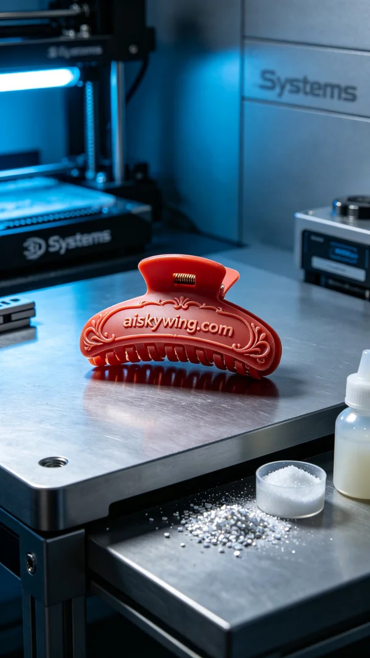
在LinkedIn上，有人因为需要制作一款独特的发夹蜡模而联系我们。他们希望能在短时间内获得高质量的铸造样品，以满足即将到来的市场需求。面对这一挑战，我感到格外重视，决心以最好的技术来完成这个任务。
用于生产的材料是红蜡精密铸造，这种材料以其优良的流动性和精细的表面效果著称。在准备过程中，我们将设备调整到最佳状态，使用的是Systems品牌的3D打印机。这台打印机的层厚设置为0.1毫米，温度维持在60摄氏度，功率定在70%，打印速度则设定为每小时30毫米，预计整个打印过程将持续约8个小时。
打印过程开始后，设备运行得相当顺利。我们密切监控打印机的状态，确保每一层都能精准地叠加。检查过程中，发现材料的流动性极佳，表面光滑细腻，更加增强了细节的呈现。整个过程没有出现堵塞或缺陷，令人满意。
打印完成后，后处理阶段同样重要。我们首先对模型进行了清洗，去除表面残留的树脂。之后，通过细砂纸进行打磨，使表面光滑得更为完美。接下来是固化步骤，将发夹蜡模放入UV灯下进行固化，确保其结构牢固且持久。最后，我们仔细检查每一个细节，确认无误后，才算完成整个制程。
经过这一系列的精细操作，我们顺利地将发夹蜡模制作完成。这不仅是一个产品，更是我们工匠精神的体现，让我倍感欣慰。
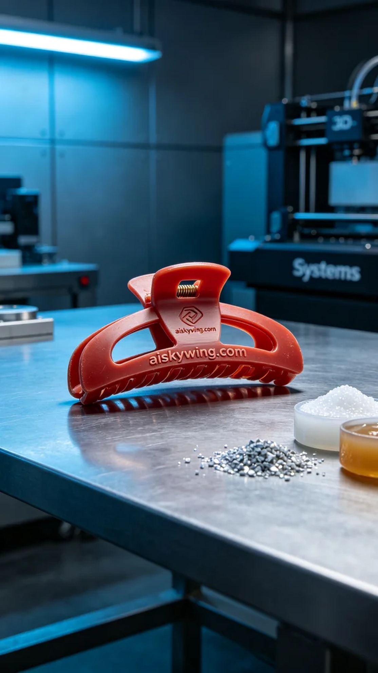
Aiskywing Industrial 3D Printing
Hairpin wax mold


