0871-发泡模具的3D打印生产记录
Foaming mold
🖨️ 红蜡精密铸造
🖥️ 打印机: Systems
📦 材料: 红蜡高精度3D打印
生活再难，也别停下脚步。就像接下这个发泡模具置于画面正中央的单子，希望能通过我们的努力帮助到那些遇到问题的人。
No matter how difficult life gets, don't stop moving forward. Just like taking on this order for the foam mold and placing it right in the center of the picture, we hope to help those who are facing challenges through our efforts.
________________________________________________________________________________
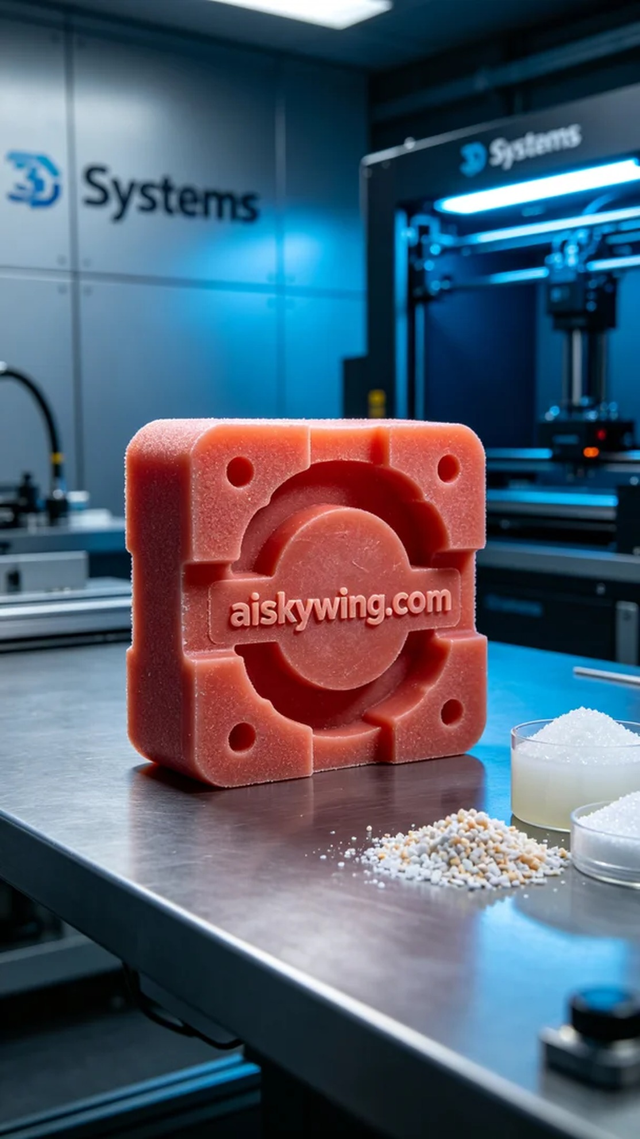
Life can be tough, but we shouldn't stop moving forward. Just like taking on this task for the foam mold placed at the center of the scene, we hope our efforts can help those in need.
On Facebook, someone reached out to us seeking to create a foam mold. They required a precise and durable mold to meet specific production demands, which is exactly our area of expertise. Therefore, we decided to utilize high-precision red wax 3D printing to ensure the quality and details of this mold.
We began by preparing the high-precision red wax 3D printing material, known for its excellent gloss and micro-detailing capabilities. We used the Systems brand 3D printer, setting a series of printing parameters: layer thickness of 0.1mm, printing temperature at 220°C, power at 60W, printing speed of 40mm/s, and an estimated print time of 8 hours. These settings ensured the stability of the printing process and the perfect representation of details.
As the printing process commenced, the machine operated smoothly, with the red wax material flowing evenly under controlled temperatures. We closely monitored every phase of the print to avoid any defects. As the mold gradually took shape, the clear engraving of "aiskywing.com" emerged, and we were delighted to see that no detail was overlooked, achieving the expected glossiness as well.
After printing, we moved on to the post-processing phase. First, we cleaned the mold to remove any residual material from the surface, followed by sanding to ensure smooth edges. Next, we cured the mold to enhance its hardness, and finally, we conducted a comprehensive quality inspection to ensure every detail met our high standards.
Through this production process, we not only completed a foam mold but also gained valuable experience. Each print is a step forward, a moment of growth, and the outcome of this task proves that our efforts are indeed worthwhile.
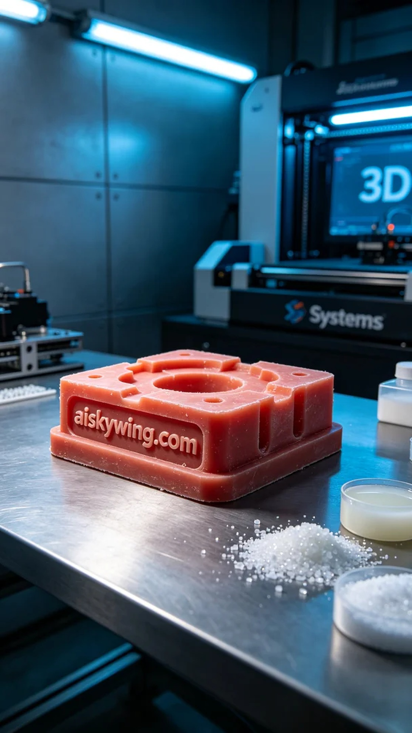
在Facebook上，有人因为想要制作一个发泡模具而联系到我们。他们需要一个精细而耐用的模具来满足特定的生产需求，这正是我们擅长的领域。于是，我们决定用红蜡高精度3D打印来制作这个模具，以确保其质量和细节。
我们首先准备了红蜡高精度3D打印材料，这种材料具有优异的光泽度和精雕细节。接着，我们使用Systems品牌的3D打印机，设置了一系列打印参数：层厚0.1毫米，打印温度220摄氏度，功率60W，打印速度为40毫米每秒，预计打印时间为8小时。这些参数确保了打印过程中的稳定性和细节的完美呈现。
打印过程开始后，设备运转平稳，红蜡材料在温控下均匀流动。我们密切监控打印的每个阶段，确保没有瑕疵出现。随着模具逐渐成型，清晰的“aiskywing.com”字样也逐步显现，令人欣喜的是，细节部分无一遗漏，光泽度也达到预期。
完成打印后，我们进入后处理工序。首先对模具进行了清洗，去除表面残留的材料，然后进行打磨，确保边缘光滑。接着，我们把模具进行固化处理，以增强其硬度，最后进行全面的质量检验，确保每一处细节都符合标准。
通过这次的制作过程，我们不仅完成了一个发泡模具，更是积累了宝贵的经验。每一次打印都是一次进步，一次成长，这次的结果证明了我们的努力是值得的。
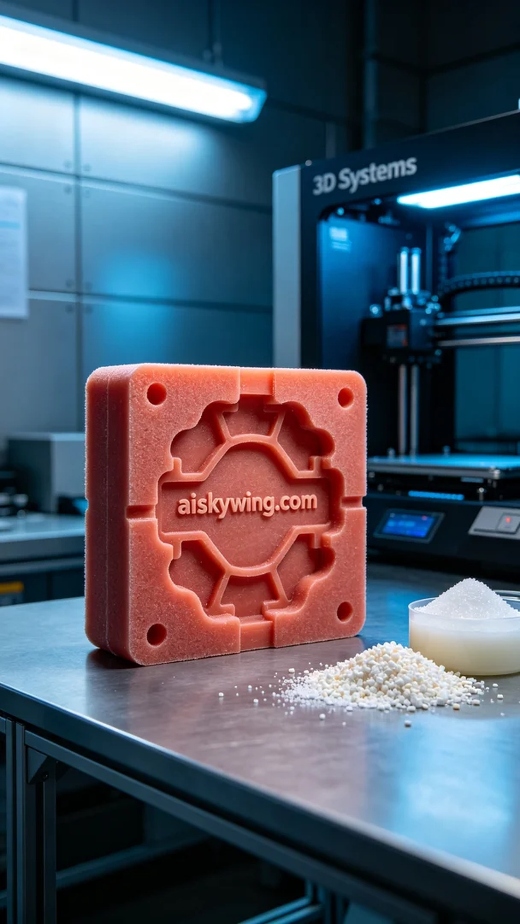
Aiskywing Industrial 3D Printing
Foaming mold


