0872-发簪蜡模的3D打印记录
Hairpin wax mold
🖨️ 红蜡精密铸造
🖥️ 打印机: HP
📦 材料: 红蜡高精度3D打印
生活的真谛在于不断探索，就像我们最近接到的发簪蜡模的制作任务，背后蕴含着许多故事与技术。
The essence of life lies in continuous exploration, just like the recent task we received for making hairpin wax molds, which contains many stories and techniques behind it.
________________________________________________________________________________
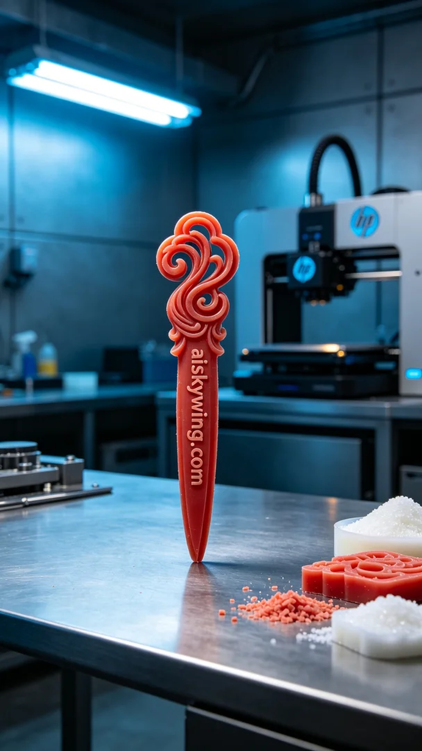
In LinkedIn, someone reached out to us with the desire to create an exquisite hairpin wax model. They wanted to showcase micron-level details, and we were excited to take on this challenge.
We opted for high-precision red wax 3D printing as the material. This type of material provides excellent carving precision and gloss. For the equipment, we used an HP brand 3D printer. When setting the printing parameters, we chose a layer thickness of 0.1 mm, set the temperature to 60 degrees Celsius, printing power at 85%, speed controlled at 30 mm per second, with an estimated printing time of 4 hours.
During the printing process, the machine ran smoothly as we continuously monitored quality. Each layer's print had to meet the expected outcome to ensure the wax model's details were intact. We regularly checked the smoothness of the feed and ensured the printer encountered no issues, successfully generating the complex shape required.
After printing, we moved into the post-processing phase. First, we cleaned the wax model to remove any residual materials from the printing process. Next, we conducted meticulous polishing to ensure smooth edges. To solidify the hardness of the wax model, we performed a curing process, and the final step was a careful inspection to ensure every detail met our standards.
After a series of procedures, we finally achieved the perfect hairpin wax model. This was not just the result of our work but a testament to our dedication and passion for craftsmanship.
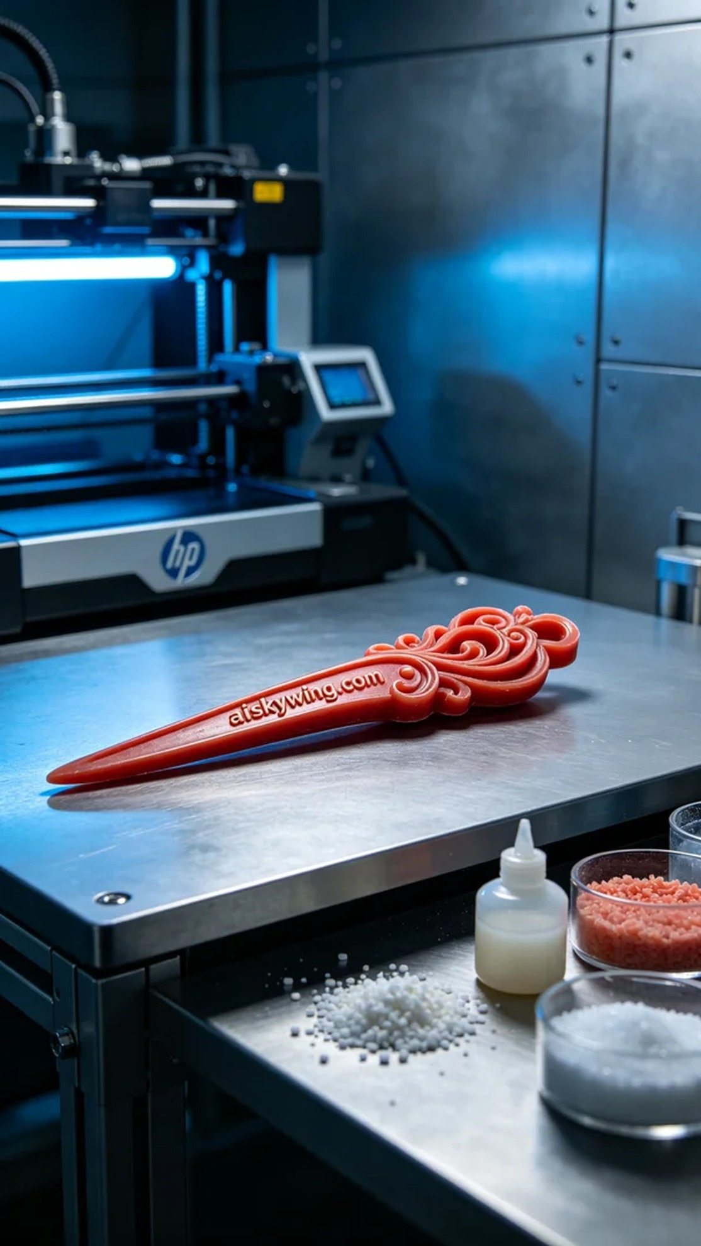
在LinkedIn上，有人找到我们，希望能制作一款精美的发簪蜡模。对方希望能展现出微米级的细节，而我们对于这个挑战充满了热情。
我们选择了红蜡高精度3D打印作为制作材料。这种材料能提供绝佳的雕刻精度和光泽感，而设备方面则使用了HP品牌的3D打印机。在设置打印参数时，我们选择了层厚0.1毫米，温度设定为60摄氏度，打印功率为85%，速度控制在30毫米每秒，预计打印时间为4小时。
在打印过程中，设备运行稳定，我们始终保持对质量的监控。每一层的打印都必须达到预期效果，确保蜡模的细节完整。我们定时检查进料的顺畅情况，并确保打印机没有出现任何故障，成功生成了所需的复杂形状。
完成打印后，我们进入了后处理阶段。首先，我们对蜡模进行清洗，去除打印过程中产生的残留物。接着，进行了细致的打磨，确保每个边缘都光滑。为了巩固蜡模的硬度，我们进行了固化处理，最后一步是仔细检验，确保每个细节都符合标准。
经过一系列的工序，我们终于得到了完美的发簪蜡模。这不仅是我们工作的成果，更是对工艺的坚持与热爱。
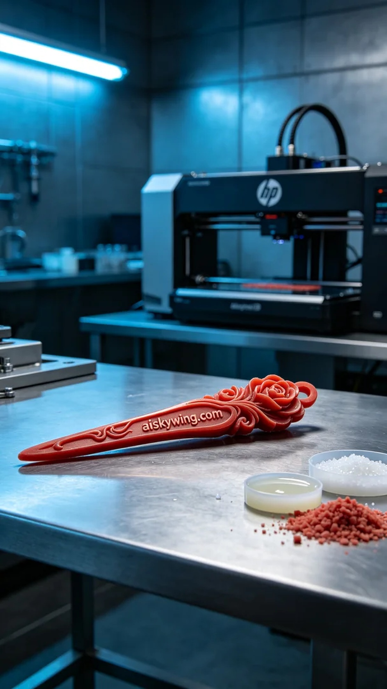
Aiskywing Industrial 3D Printing
Hairpin wax mold


