0875-口红管蜡模3D打印生产记录
Lipstick tube wax mold
🖨️ 红蜡精密铸造
🖥️ 打印机: Voxeljet
📦 材料: 红蜡精密铸造
生活再难，也别停下脚步。就像有人在Instagram上找我们处理这个口红管蜡模，面对困难我们始终不退缩。
No matter how tough life gets, don't stop moving forward. Just like when someone reached out to us on Instagram to handle this lipstick tube wax mold, we never back down in the face of challenges.
________________________________________________________________________________
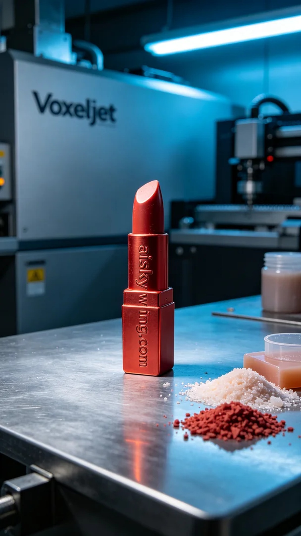
Life can be tough, but that shouldn't make us stop. Just like when someone reached out to us on Instagram for assistance with creating a lipstick tube wax model, we never back down from a challenge.
When someone approached us with the need for a beautifully crafted lipstick tube wax model, we quickly began production preparations, understanding the project's unique requirements. To achieve their vision, we decided to utilize the precision casting of red wax to ensure that every detail is perfectly delivered.
For the material, we selected high-quality red wax precision casting, known for its excellent fluidity and ability to capture fine details, making it ideal for complex model production. We prepared the Voxeljet 3D printer, setting the printing parameters to a layer thickness of 0.1 mm, a print head temperature of 60 degrees Celsius, a power setting of 80 watts, and a print speed of 50 mm per hour, with the entire process estimated to take around 5 hours.
During printing, the equipment ran smoothly, and we conducted periodic quality monitoring to ensure each layer met our standards. The gentle hum of the machine echoed in the workshop, and each time we saw the lipstick tube wax model gradually taking shape, our anticipation grew.
Post-processing steps are equally important. After printing, we carefully removed the wax model and cleaned it to ensure the surface was free from impurities. Then we meticulously sanded it to remove any potential burrs before curing the wax model to guarantee its strength and stability. After thorough inspection, we found that every detail was flawless, meeting our quality standards.
In the end, this lipstick tube wax model was successfully completed through the team's efforts, showcasing high-quality craftsmanship and design. No matter how many challenges lie ahead, such achievements always fill us with satisfaction and pride.
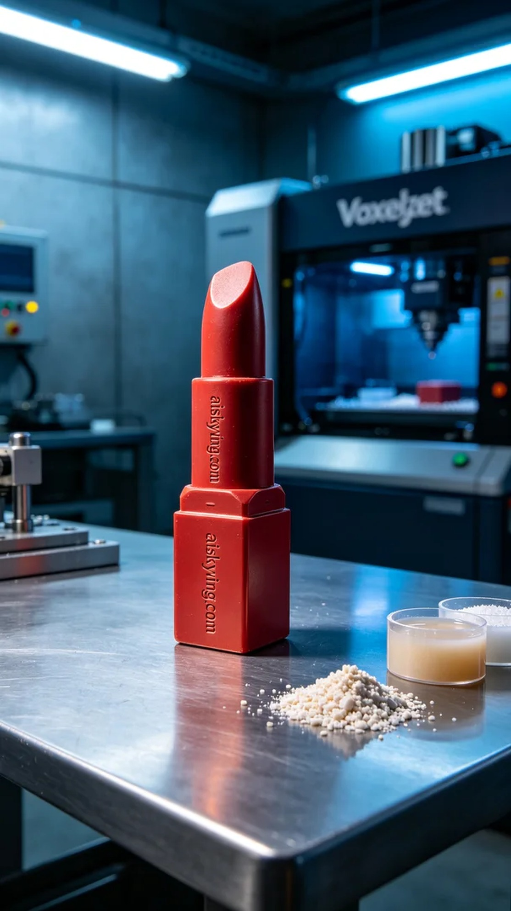
有人在Instagram上向我们求助，希望制作出一款精美的口红管蜡模，因其需要高精度和细腻的表面效果。为了实现他们的想法，我们迅速开始了生产准备。了解到这个项目的特殊性后，我们决定使用红蜡精密铸造工艺，以确保每一个细节都得到完美呈现。
在材料选择上，我们选用了高质量的红蜡精密铸造材料，其特性是良好的流动性和高细节还原能力，适合用于复杂的模型制作。在设备上，我们准备了Voxeljet 3D打印机，打印参数设定为层厚0.1毫米，喷头温度保持在60摄氏度，功率设定为80瓦，打印速度为每小时50毫米，整个打印过程预计耗时约5小时。
打印过程中，设备运行得十分稳定，我们定期对质量进行监控，确保每层的打印都符合标准。由于使用的是红蜡材料，打印时机器发出的轻微嗡嗡声在车间内回响，每当看到逐渐成型的口红管蜡模，心中总是充满期待。
后处理的工序同样重要。在打印完成后，我们小心地将蜡模取出，并进行清洗，确保表面无任何杂质。接着，我们进行了细致的打磨工作，去掉任何可能的毛刺，最后将蜡模进行固化，以保证其强度和稳定性。经过检验，所有的细节都完美无瑕，符合了我们的品质标准。
最终，这款口红管蜡模在团队的努力下顺利完成，展现出了高质量的工艺与设计。无论未来有多少挑战，这样的成果总会让我们感到满足与自豪。
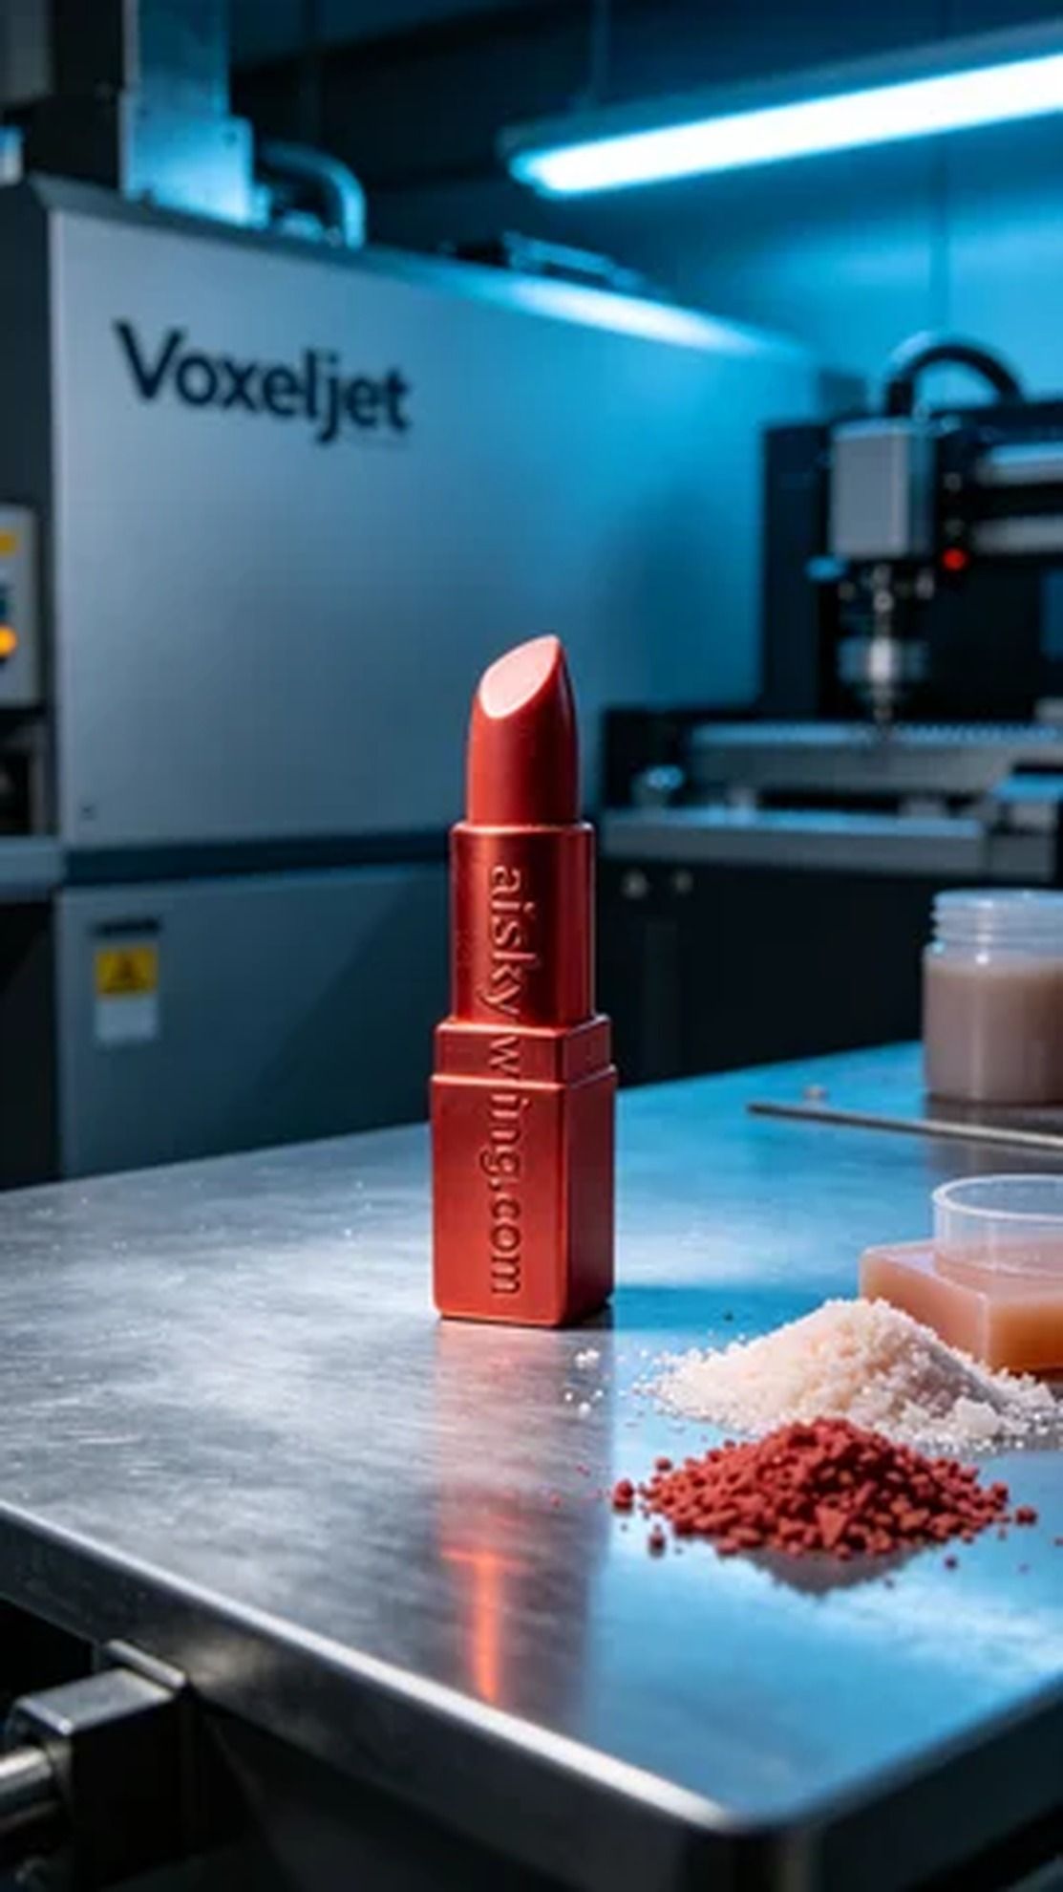
Aiskywing Industrial 3D Printing
Lipstick tube wax mold


