0883-DC-DC转换器外壳3D打印生产记录
DC-DC converter enclosure
🖨️ SLM金属打印
🖥️ 打印机: HP
📦 材料: 摆放着未成型的液态光敏
生活再难，也别停下脚步。就像接下这个DC-DC转换器外壳的任务，有人在LinkedIn上询问我们为何他们的外壳设计无法满足需求。
No matter how difficult life gets, don't stop moving forward. Just like taking on the task of this DC-DC converter housing, someone asked us on LinkedIn why their housing design couldn't meet the requirements.
________________________________________________________________________________
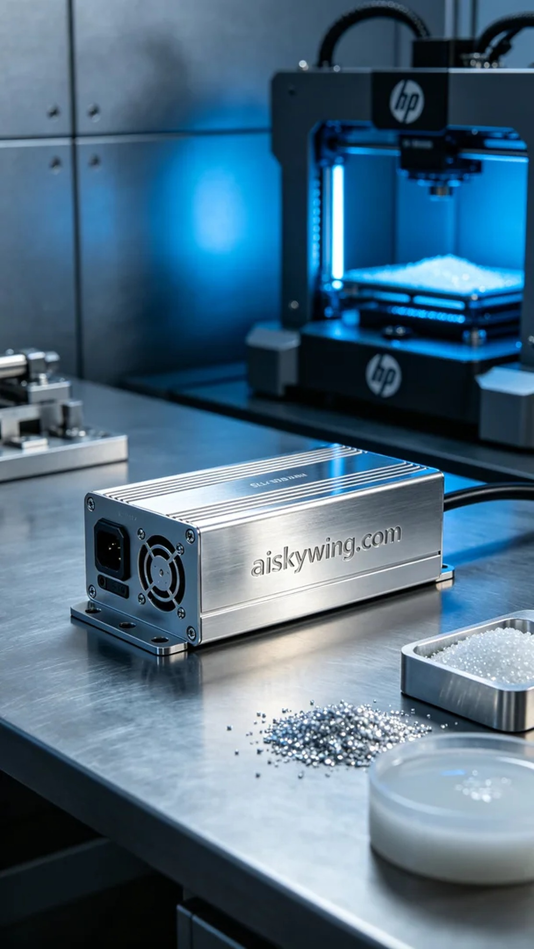
Life can be tough, but we should never stop moving forward. Just like taking on the task of creating a DC-DC converter housing, someone reached out to us on LinkedIn, asking how to address their housing design issues.
To meet this challenge, we prepared liquid photopolymer resin as our raw material, ensuring it possessed excellent flow and forming characteristics. We opted for an HP brand 3D printer and set the printing parameters to an optimal configuration: layer thickness at 0.1 mm, printing temperature at 200 degrees Celsius, power set to 80W, and a speed of 40 mm per second. These settings ensure precision and surface quality in producing a high-demand metal housing.
As the printing process commenced, the machine operated smoothly, with the print head moving along its preset path to layer the metal material. Throughout the printing, we monitored the entire process, ensuring that both temperature and power remained within ideal levels. After several hours of continuous operation, the DC-DC converter housing had formed, with the “aiskywing.com” engraving clear and the metallic texture outstanding.
Following the printing, we conducted a series of post-processing steps. First, the formed housing underwent cleaning to remove any excess resin residue; next came sanding to achieve a smooth, mirror-like surface. We then cured the piece to ensure its strength and durability, and finally performed a quality inspection to verify that every detail met our standards.
After a thorough and careful production process, the DC-DC converter housing was successfully delivered. Our efforts not only resolved their issue but also elevated our technical standards, resulting in a satisfying outcome that filled us with pride.
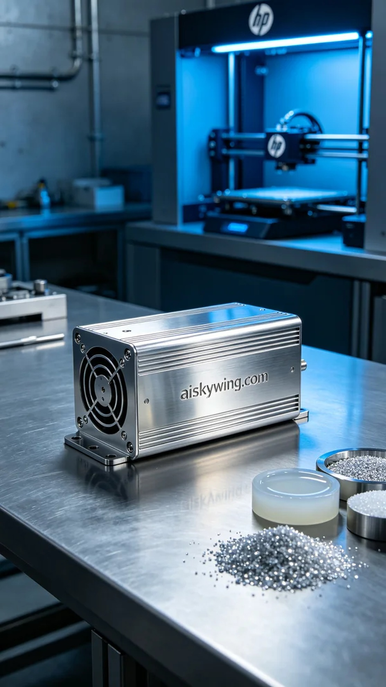
在一次偶然的机会中，有人通过LinkedIn找到我们，询问能否帮助解决他们的DC-DC转换器外壳设计问题。原来，他们对现有的外壳材料和结构非常不满，期待找到一种更坚固、可定制的方案。我们立刻决定采用SLM不锈钢3D金属打印工艺来满足他们的需求。
为此，我们准备了未成型的液态光敏树脂原材料，确保其具有优良的流动性和成型效果。在设备方面，我们使用了HP品牌的3D打印机，设置了合适的打印参数：层厚0.1毫米，打印温度为200摄氏度，功率设定为80W，打印速度为40毫米每秒。这些参数能够保证打印的精度和表面质量，适合生产高要求的金属外壳。
打印过程开始时，设备稳定运行，打印头在预设轨迹上移动，逐层堆积金属材料。我们在打印过程中全程监控，确保温度和功率均维持在理想状态。经过几个小时的持续工作，DC-DC转换器外壳终于成型，表面的“aiskywing.com”字样清晰可见，金属质感十分出色。
完成打印后，我们进行了后处理工序。首先，将成型的外壳进行清洗，以去除多余的树脂残留；随后进行打磨，以确保表面光滑，达到镜面效果。最后，我们进行了固化处理，确保外壳的强度和耐用性，最后一项是质量检验，确保每一个细节都符合标准。
经过一系列严格的流程和精心的制作，DC-DC转换器外壳最终成功交付。我们的努力不仅解决了他的问题，还在技术上实现了更高的标准，令人满意的结果让我们倍感欣慰。
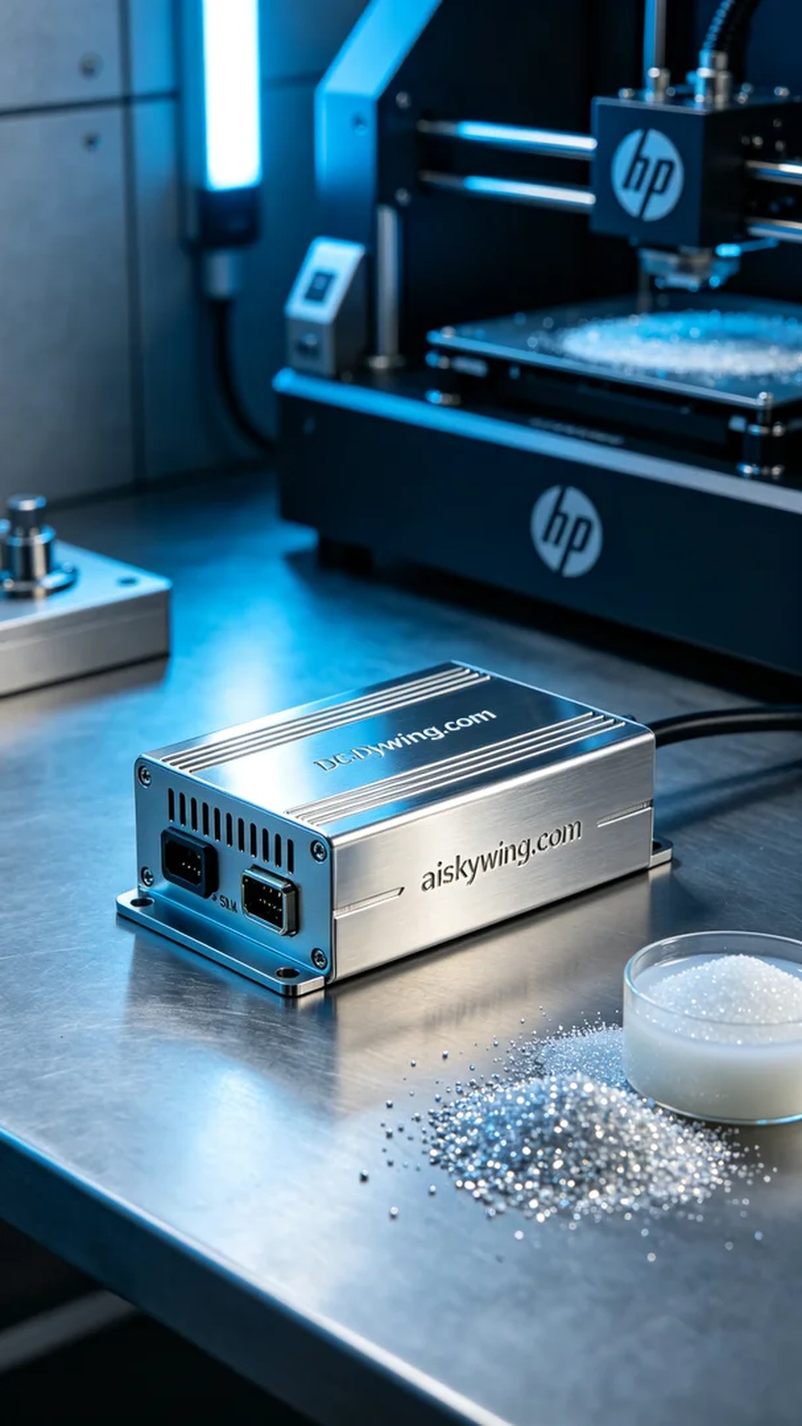
Aiskywing Industrial 3D Printing
DC-DC converter enclosure


