0884-仪表盘装饰条3D打印生产记录
Dashboard trim strip
🖨️ SLM金属打印
🖥️ 打印机: Stratasys
📦 材料: 摆放着未成型的液态光敏
在LinkedIn上，有人因为对汽车内饰个性化的需求找上了我们。于是，我们开始了这个仪表盘装饰条的制作之旅。
On LinkedIn, someone reached out to us due to their need for personalized automotive interior. Thus, we began our journey of creating this dashboard trim.
________________________________________________________________________________
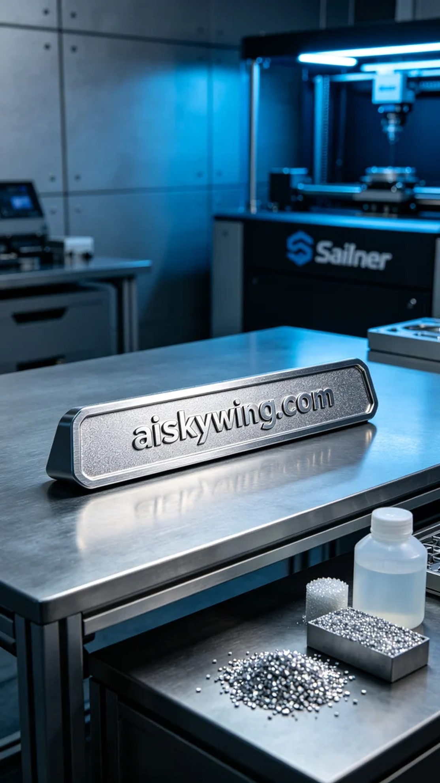
In LinkedIn, someone approached us due to their need for personalized automotive interior accessories. Thus, we embarked on the journey of creating this dashboard decorative strip.
The project involves a dashboard decorative strip where the client wishes to enhance the uniqueness of their car interior through our technology. To meet this demand, we decided to adopt the SLM metal printing process, utilizing high-strength and lightweight titanium alloy materials to ensure that the product is both aesthetically pleasing and highly durable.
For materials, we chose unformed liquid photopolymer resin as the base, known for its excellent flowability and shaping capability in 3D printing. During the preparation phase, we set up the Stratasys printer with parameters defined at a layer thickness of 0.1mm, a temperature set at 50°C, laser power configured to 200W, and a printing speed of 30mm/s. This ensured clarity of detail while maintaining structural integrity.
During the printing process, we closely monitored the machine's operation. The Stratasys printer performed excellently while printing the dashboard decorative strip, as the precise movement of the robotic arm and stable laser output ensured perfect adhesion of each layer. With a real-time feedback system, we made necessary adjustments to parameters to maintain the quality of the print in optimal condition. After several hours of continuous operation, the printing was finally completed.
Post-processing procedures are equally important. We began by cleaning the printed piece to remove any residual liquid photopolymer resin on the surface, followed by sanding to eliminate minor imperfections and ensure smoothness. Subsequently, we cured it to enhance the strength and durability of the material. Finally, we conducted stringent inspections to ensure every detail met quality standards, resulting in a high-quality dashboard decorative strip.
Through a meticulous series of procedures, we successfully completed the production of this dashboard decorative strip. It embodies not only our technological prowess but also our unwavering commitment to quality.
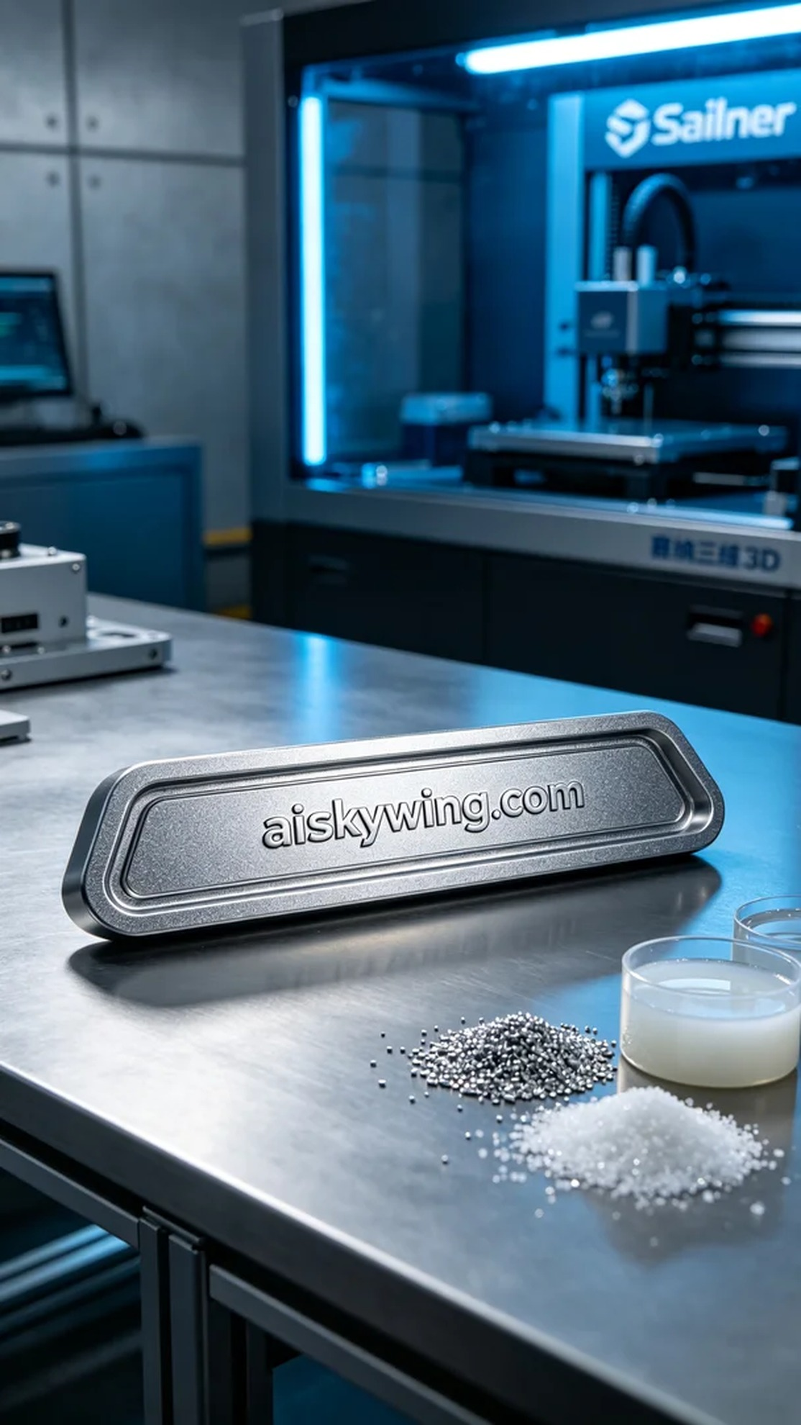
这次的项目涉及到一款仪表盘装饰条，客户希望通过我们的技术来提升其汽车内饰的独特性。为了满足这一需求，我们决定采用SLM金属打印工艺，利用高强度、轻量化的钛合金材料，以确保产品在美观的同时，兼具耐用性和实用性。
在材料方面，我们选择了未成型的液态光敏树脂作为基础，这种材料在3D打印中具有良好的流动性和塑形能力。准备工作中，我们将Stratasys打印机进行设定，打印参数定为层厚0.1mm，温度控制在50°C，激光功率设置为200W，打印速度为30mm/s。这样一来，能够保证细节的清晰度和结构的坚固性。
打印过程中，我们严格监控设备运行情况。Stratasys打印机在打印仪表盘装饰条时，机械臂的精确运动及激光的稳定输出确保了每一层的完美结合。通过实时反馈系统，我们也随时调整参数，以确保打印质量在最佳状态下进行。经过几个小时的持续作业，打印终于完成。
后处理工序同样重要。首先对打印件进行清洗，去除表面残留的液态光敏树脂，随后进行打磨，以消除细微瑕疵，确保表面光滑。接着，将其进行固化处理，加强材料的强度和耐用性。最后，进行严格的检验，确保每一个细节都符合质量标准，最终呈现出一款高品质的仪表盘装饰条。
经过一系列细致入微的工序，我们成功完成了这款仪表盘装饰条的制作。它不仅是技术的体现，更是我们对品质的坚守与追求。
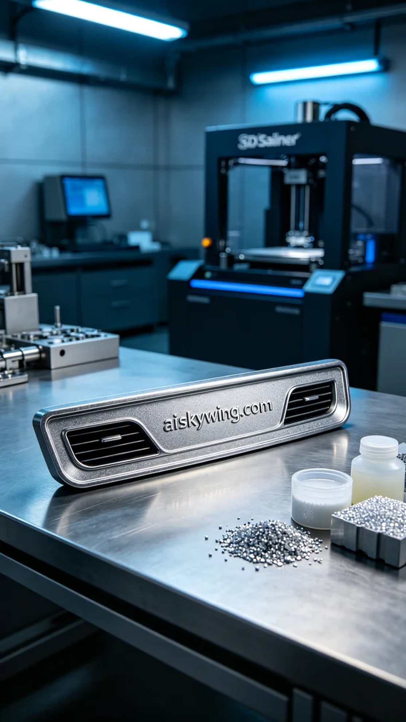
Aiskywing Industrial 3D Printing
Dashboard trim strip


