0885-低压线束支架的3D打印记录
Low Voltage Wiring Harness Bracket
🖨️ SLM金属打印
🖥️ 打印机: Systems
📦 材料: SLM铝合金
在Instagram上，有人因低压线束支架的问题找到我们，今天就让我们一起看看这个产品的制作过程。
On Instagram, someone reached out to us regarding an issue with the low-pressure wire harness bracket. Today, let's take a look at the production process of this product together.
________________________________________________________________________________
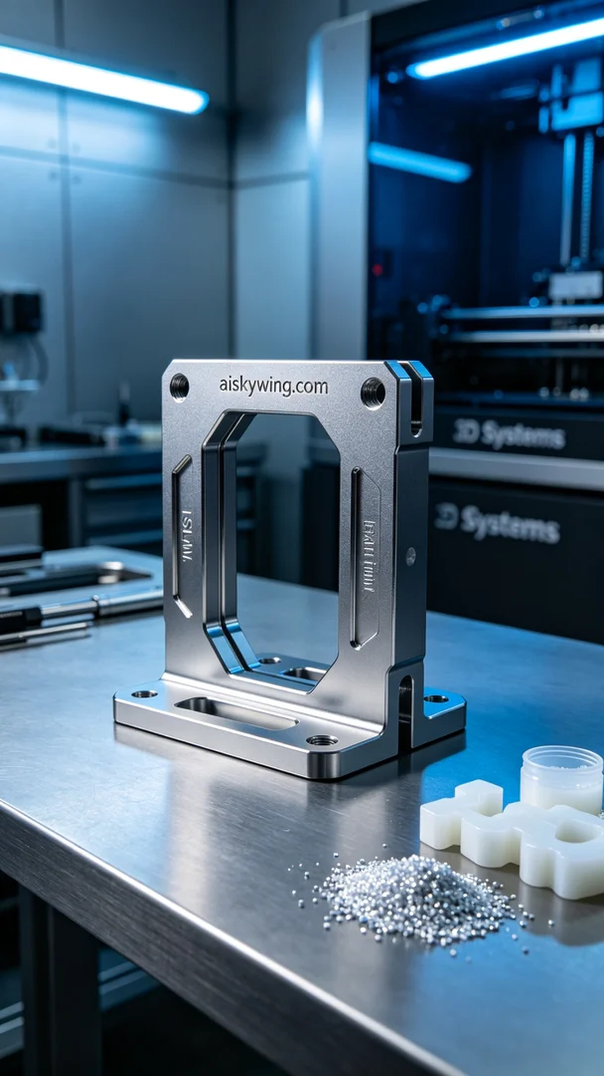
Recently, someone reached out to us on Instagram seeking a robust and precise low-voltage wire harness bracket. They were facing challenges with existing products that failed to meet their industrial requirements, so they hoped to leverage 3D printing technology for a more competitive solution.
To address this, we opted for SLM aluminum alloy as our raw material. SLM aluminum alloy boasts excellent strength and toughness, making it ideal for load-bearing components. Before printing, we prepared the Systems brand 3D printer, setting the parameters to a layer thickness of 0.1mm, a printing temperature of 200 degrees Celsius, a laser power of 200 watts, and a printing speed of 50mm per second, with an estimated total printing time of around 8 hours.
During the printing process, the Systems printer operated steadily. We closely monitored the temperature and layer adhesion quality to ensure each layer perfectly stacked. Timely checks were performed on the nozzle and laser operation to prevent any quality issues. As the printing progressed, the low-voltage wire harness bracket gradually took shape, showcasing the metallic sheen of the aluminum alloy.
Upon completion of the printing, we moved on to the post-processing stage. First, we cleaned the finished part to remove uncured resin from the surface, followed by sanding to ensure a smooth finish. Next, it was placed in a curing device for hardening, and finally, quality inspections were conducted to ensure it met the desired strength and dimensional requirements.
Through these efforts, we successfully produced the required low-voltage wire harness bracket, meeting high demands for both strength and precision. This once again demonstrates the tremendous potential of 3D printing technology in industrial applications.
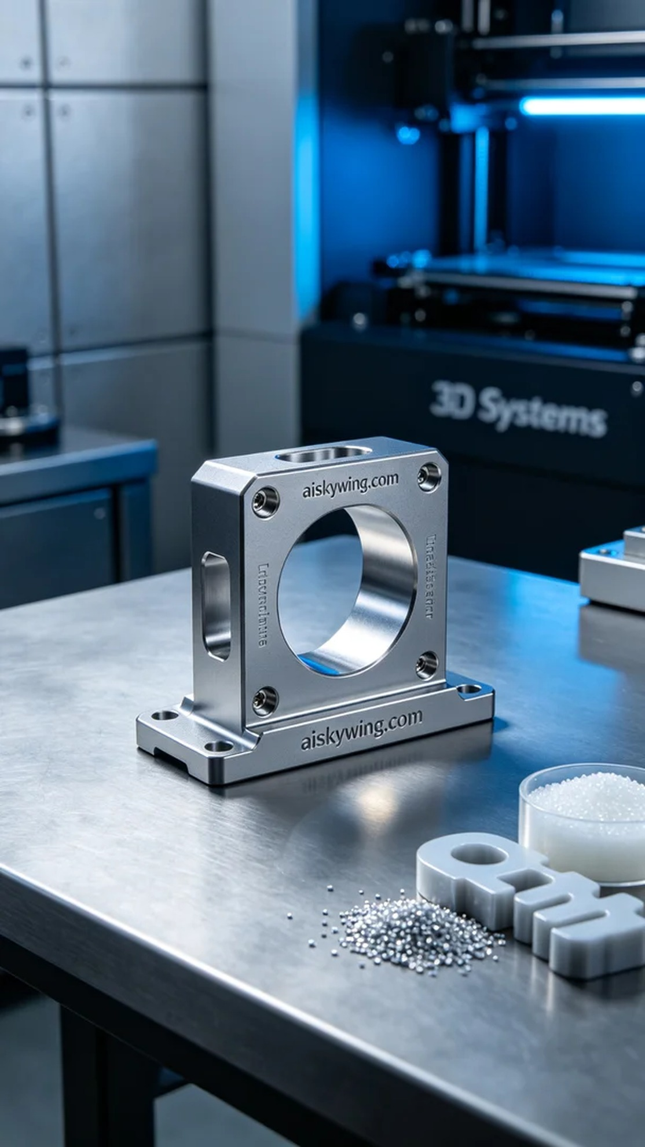
最近，有人因为需要一个强度高、精度好的低压线束支架而找到了我们。他们面临的问题是现有的产品无法满足其在工业环境中的使用要求，因此希望能通过3D打印技术来获得更具竞争力的解决方案。
为了解决这个问题，我们选择了SLM铝合金作为原材料。SLM铝合金具备优良的强度和韧性，特别适合用于制作承重部件。在打印之前，我们准备了Systems品牌的3D打印机，并设置了参数：层厚0.1毫米，打印温度为200摄氏度，激光功率设置为200瓦，打印速度为50毫米每秒，整个打印过程预计耗时约8小时。
在打印过程中，Systems打印机稳定地运转着。我们严格监控温度和层间结合质量，确保每一层都能完美叠加。适时检查喷嘴和激光是否正常工作，以防止出现任何质量问题。随着打印进程的推进，低压线束支架逐渐成型，显现出铝合金的金属光泽。
打印完成后，我们进入了后处理环节。首先对成型件进行清洗，去除表面未固化的树脂，然后进行打磨，以确保表面光滑。接着，将其放入固化设备中进行固化处理，最后进行质量检验，确保其符合预期的强度和尺寸要求。
通过这一系列的努力，我们成功制作出了所需的低压线束支架，满足了对强度和精度的高要求。这再次证明了3D打印技术在工业应用中的巨大潜力。
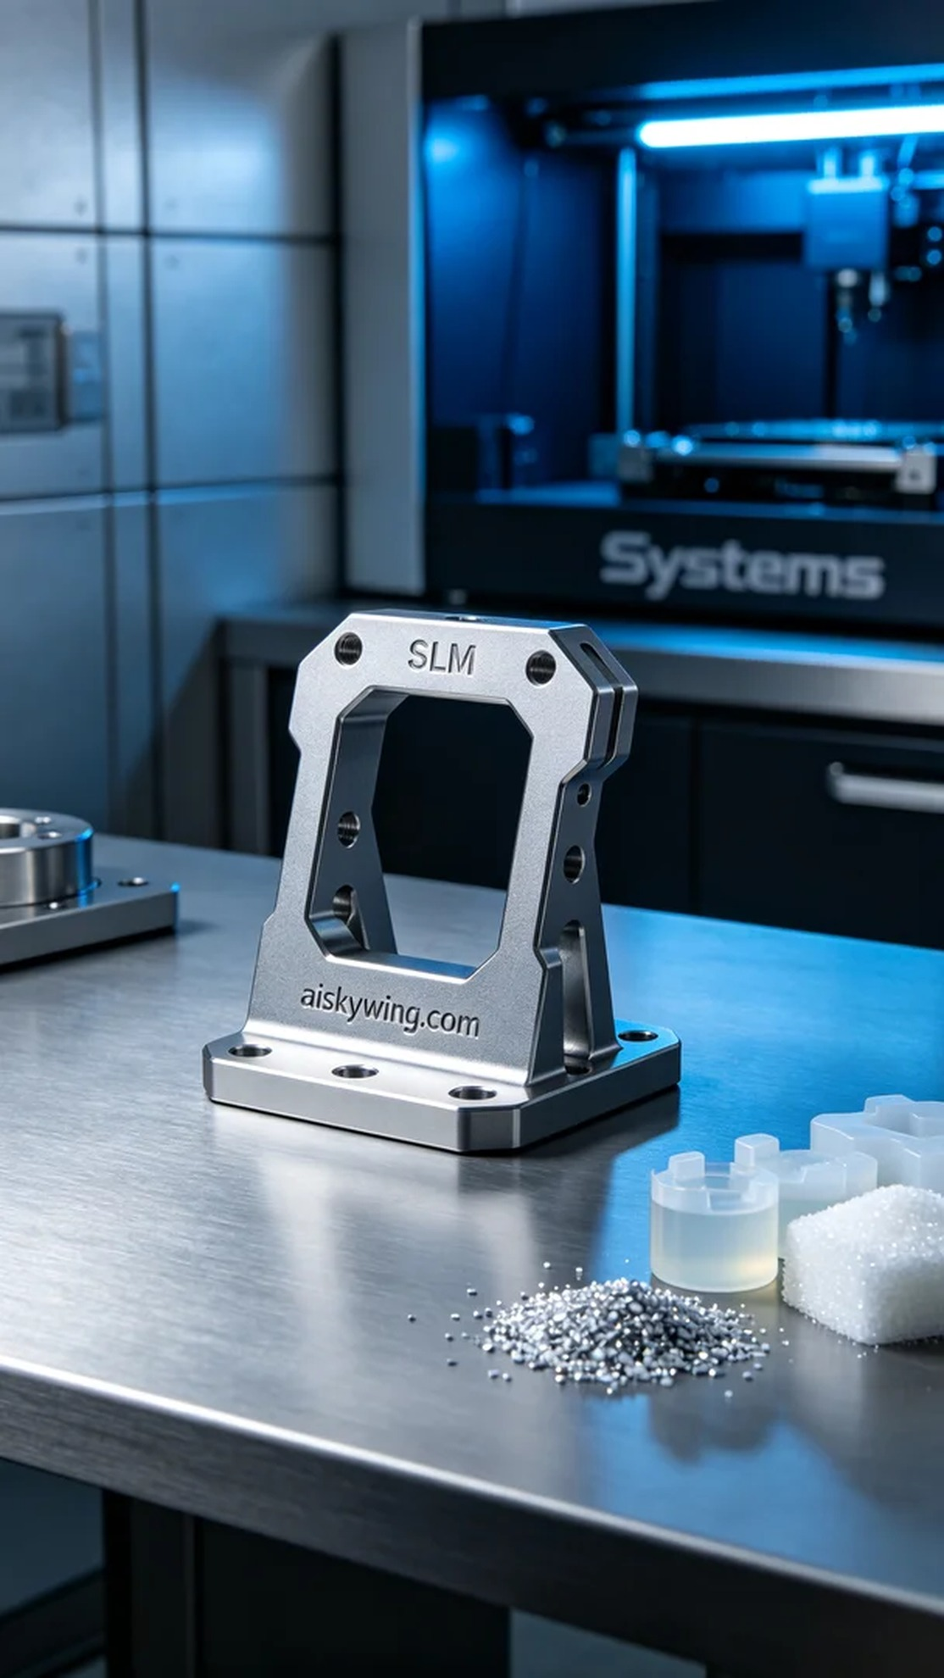
Aiskywing Industrial 3D Printing
Low Voltage Wiring Harness Bracket


