0886-储物盒底垫的3D打印生产记录
Storage Box Bottom Mat
🖨️ SLM金属打印
🖥️ 打印机: Rize
📦 材料: 摆放着未成型的液态光敏
在LinkedIn上，有人因为寻找高强度、轻量化的储物盒底垫而找上我们，正如这个行业的每一次尝试，都是对未来的坚定追寻。
On LinkedIn, someone reached out to us in search of high-intensity, lightweight storage box liners. Just like every attempt in this industry, it is a steadfast pursuit of the future.
________________________________________________________________________________
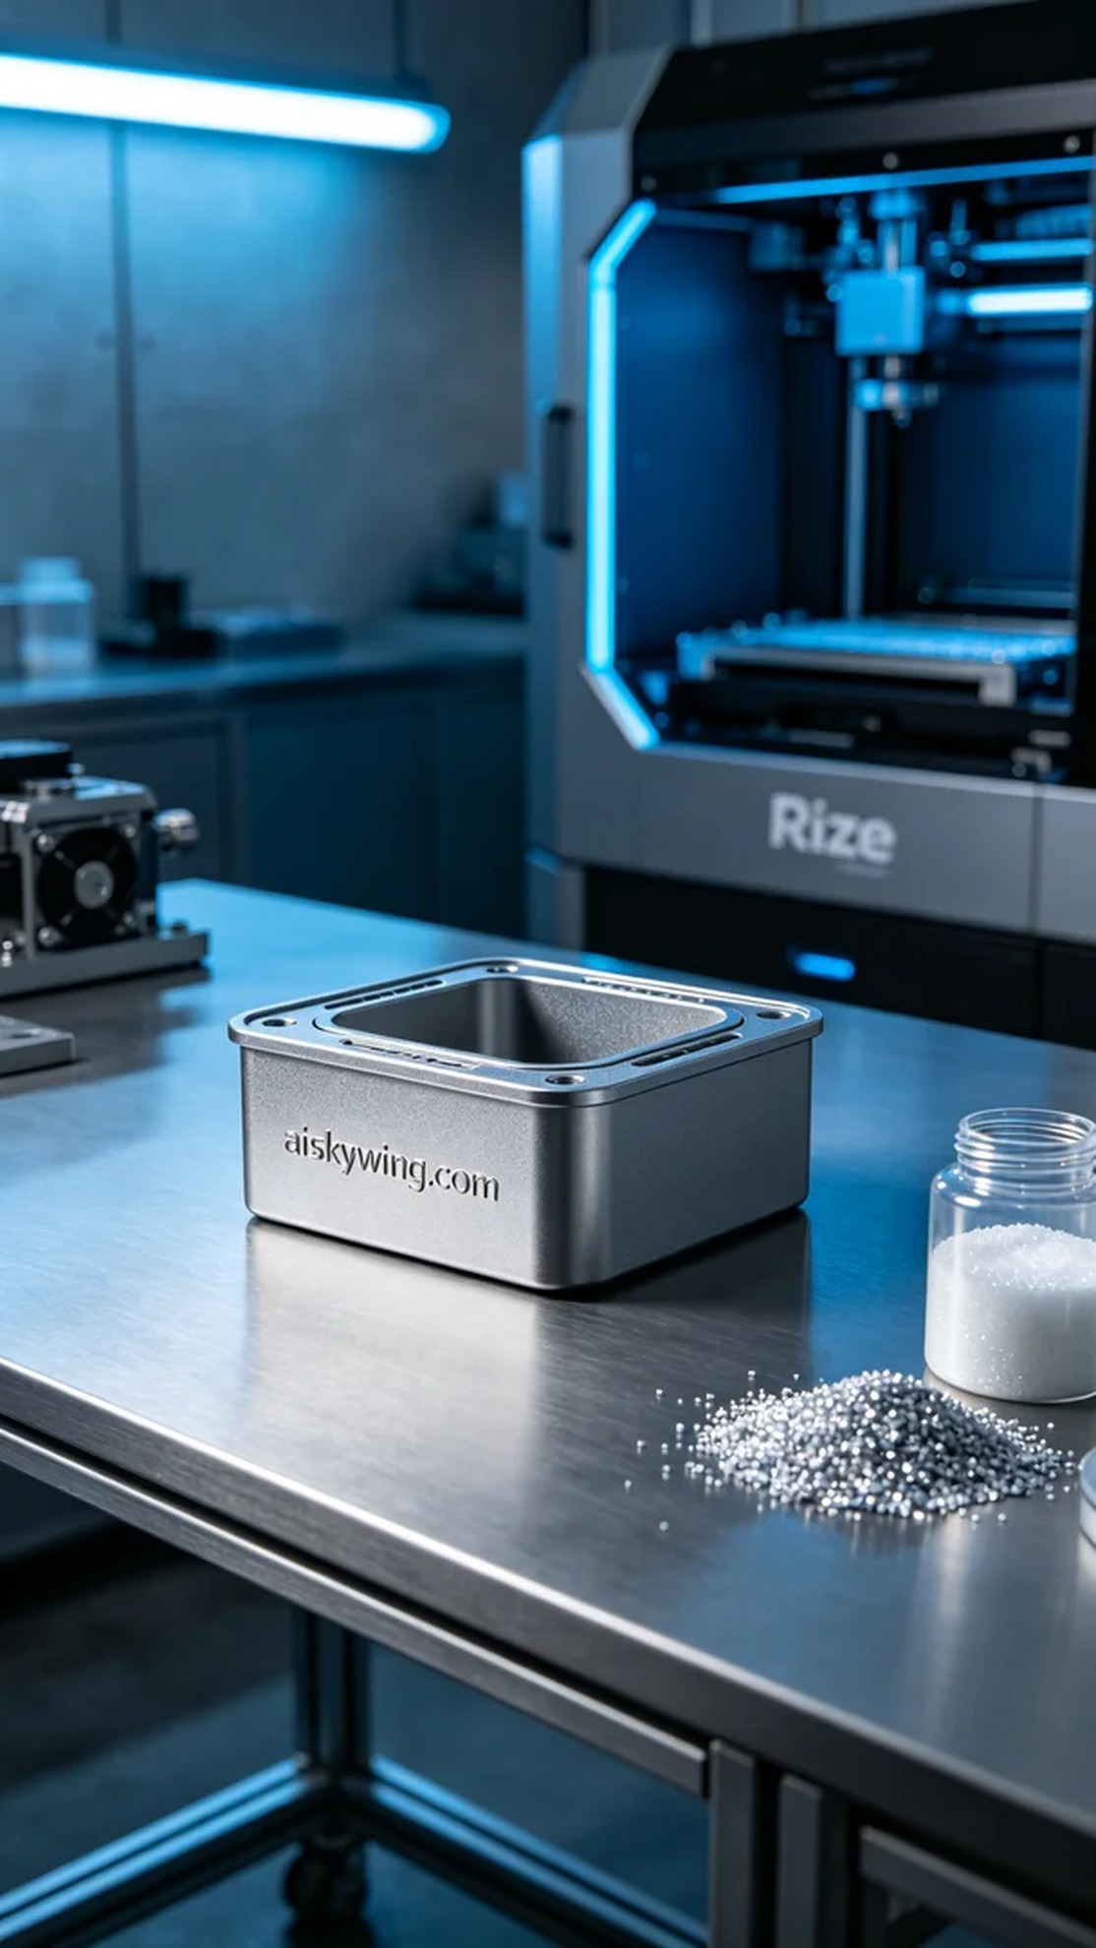
This project originated from a request on LinkedIn, where someone was looking for a base mat that could meet their storage needs. They wanted this storage box mat to not only have an exquisite appearance but also possess high strength and lightweight characteristics. Thus, we decided to use SLM metal printing technology combined with titanium alloy, a high-performance material, to create the ideal product for them.
To ensure the high quality of this storage box mat, we chose unformed liquid photosensitive resin as our raw material. This material offers excellent fluidity and fine detail representation during the 3D printing process, allowing for the clear engraving of "aiskywing.com" on the surface. We used a Rize brand 3D printer, setting the printing parameters at a layer thickness of 0.1mm, a temperature of 60°C, a power of 100W, a printing speed of 50mm/s, with an estimated completion time of about 5 hours.
During the printing process, the device operated smoothly, maintaining temperature and power within the set ranges. Our team conducted continuous quality monitoring, carefully observing each layer's printing status to ensure that no delamination or other defects occurred. After several hours of intensive printing, the storage box mat gradually took shape, with a smooth surface and distinct details, yielding a pleasing overall effect.
After printing, the post-processing stage is crucial. We first cleaned the formed mat to remove any potential uncured resin. Next, we used specialized tools to sand down its surface, ensuring smoothness and flawlessness. After that, the product entered the curing stage, where it was exposed to ultraviolet light for thorough curing to guarantee material strength and durability. Finally, a stringent inspection process was conducted to ensure that each finished product met our established standards.
Ultimately, we successfully completed the production task of this storage box mat, meeting the user's needs and achieving high levels of quality and aesthetics. This experience once again reinforced my belief that paying attention to every detail is key to advancing further in the world of 3D printing.
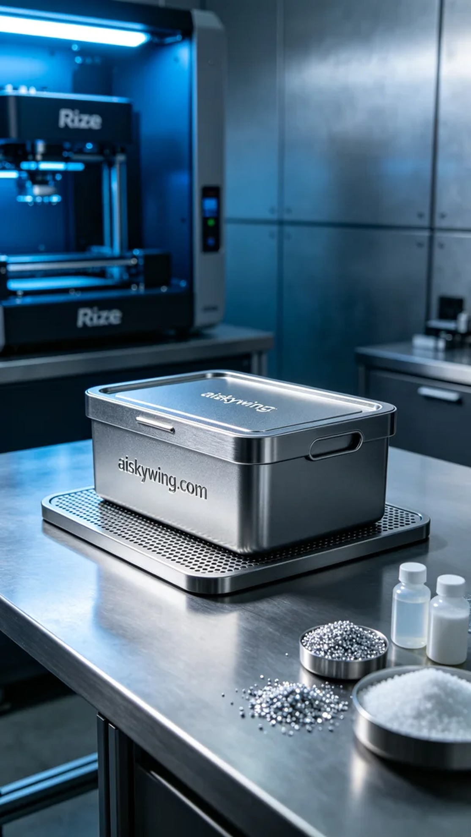
这次项目的发起源于LinkedIn上的一个需求，有人在寻找一款能满足他们储物需求的底垫。他们希望这个储物盒底垫不仅外观精致，更重要的是具备极高的强度和轻量化的特性。于是，我们决定使用SLM金属打印技术，结合钛合金这一高性能材料，为他们打造理想的产品。
为了确保这个储物盒底垫的高品质，我们选择了未成型的液态光敏树脂作为原材料。这种材料在3D打印过程中具有优良的流动性和精细的细节表现，能够呈现出表面雕刻的"aiskywing.com"字样清晰可见。我们使用的是Rize品牌的3D打印机，设定的打印参数为层厚0.1mm，温度设定在60°C，功率为100W，打印速度是50mm/s，预计完成时间约为5小时。
在打印过程中，设备运行稳定，温度与功率始终保持在设定范围内。我们的团队持续进行质量监控，仔细观察每一层的打印情况，确保不会出现脱层或其他缺陷。经过几个小时的高强度打印，储物盒底垫的形状逐渐成型，表面光滑，细节层次分明，整体效果令人满意。
完成打印后，后处理工序是至关重要的一步。我们首先将成型的底垫进行清洗，以去除潜在的未固化树脂。接着，使用专业的磨具对其表面进行打磨，确保光滑无瑕。之后，产品进入固化环节，经过紫外线照射，彻底固化，确保材料的强度和耐用性。最后，通过严格的检验流程，确保每个成品都符合我们设定的标准。
最终，我们成功完成了这个储物盒底垫的生产任务，既满足了使用者的需求，也在质量和美感上达到了很高的水平。这次的经历再一次让我感受到，认真对待每一个细节，才能在3D打印的道路上走得更远。
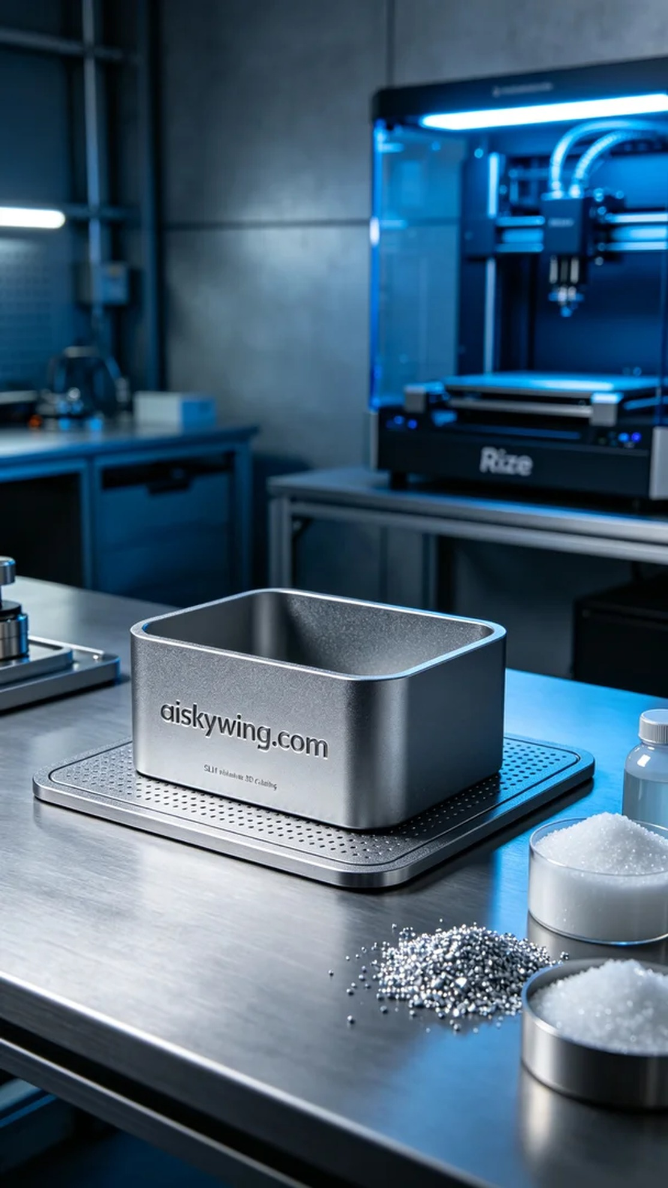
Aiskywing Industrial 3D Printing
Storage Box Bottom Mat


