0891-储物盒隔板3D打印生产记录
Storage box divider
🖨️ SLM金属打印
🖥️ 打印机: Carbon
📦 材料: 摆放着未成型的液态光敏
生活中的每一步都在向前推进，就像有人在LinkedIn上找到我们，想要定制这个储物盒隔板，解决他们的储物问题。
Every step in life moves us forward, just like someone finding us on LinkedIn, wanting to customize this storage box divider to solve their storage problems.
________________________________________________________________________________
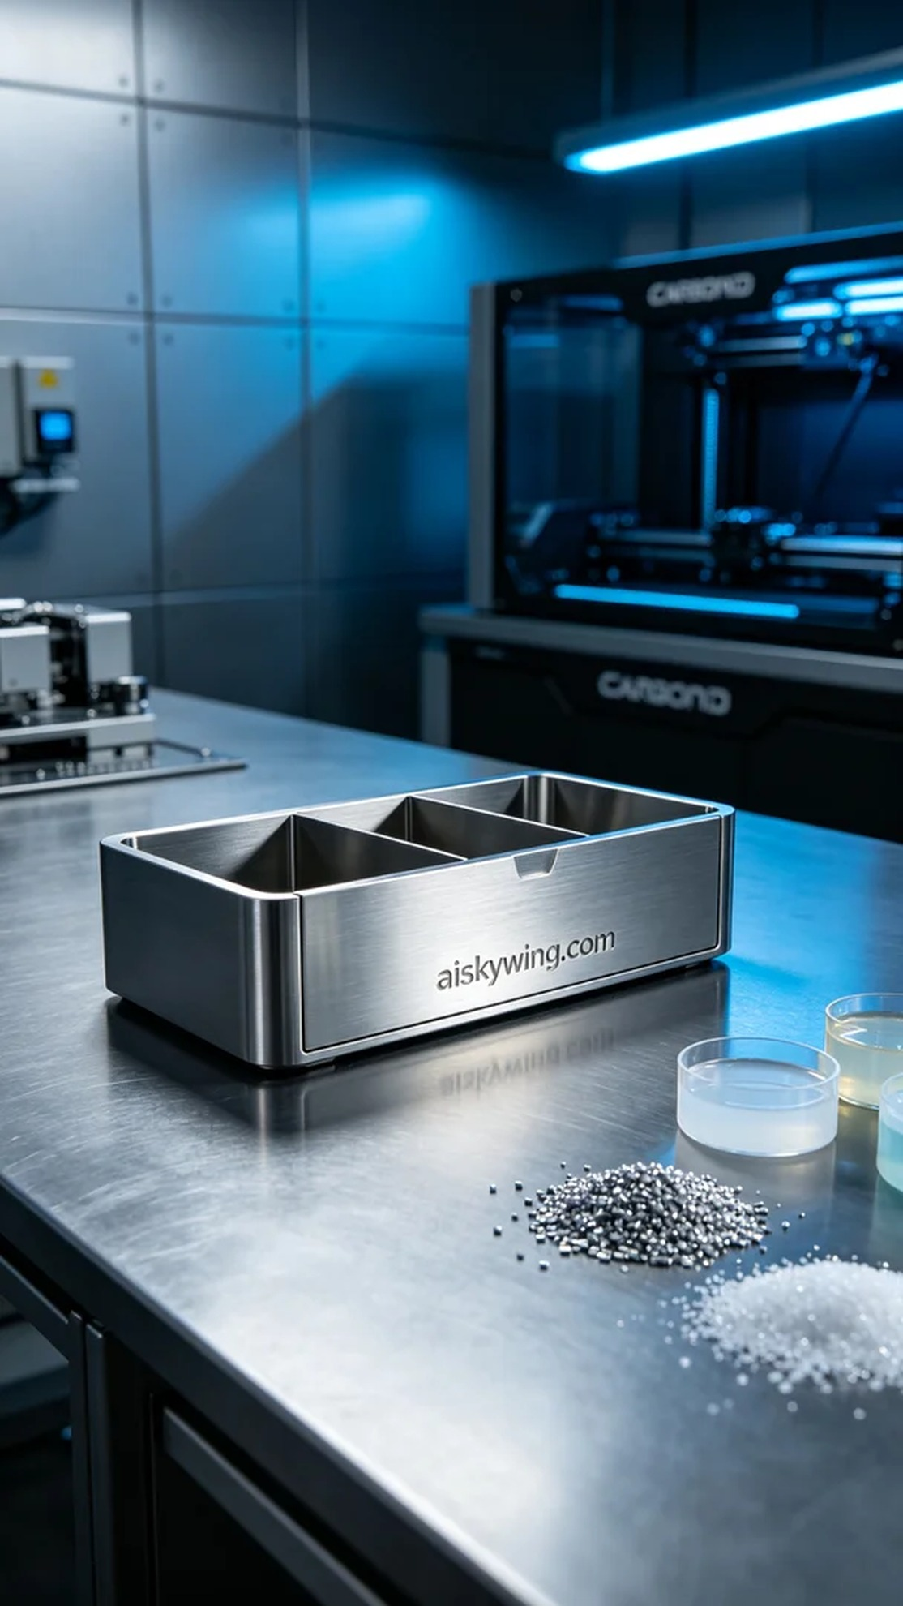
Every step in life pushes us forward, just like someone found us on LinkedIn, seeking a sturdy storage box divider to solve their storage issues.
For this project, we chose unformed liquid photopolymer resin as the raw material due to its excellent fluidity and precision in forming complex structures. The equipment used was a Carbon 3D printer, with printing parameters set to a layer thickness of 0.1mm, a temperature of 25°C, a power of 60W, and a printing speed of 80mm/s, expecting the whole process to take about 4 hours. This setup not only ensures print quality but also improves work efficiency.
During the printing process, the Carbon printer operated smoothly, and we monitored every layer closely to ensure quality standards were met. We paid special attention to the flow of the liquid photopolymer resin, making timely adjustments to ensure optimal printing results, ultimately forming a finely crafted storage box divider.
After printing, we proceeded with post-processing. First, the printed part was placed into a cleaning solution to remove any uncured resin from the surface. Next, we used fine sandpaper to polish the surface, ensuring a smooth finish. We then placed the part in a curing device for UV curing, which took 30 minutes to ensure the material was thoroughly hardened. Finally, we conducted strict inspections to ensure that the dimensions and appearance met the expected standards.
After several days of hard work, the storage box divider was finally completed, with every detail reflecting our dedication. This was not just a successful print, but also the perfect solution to real-world problems.
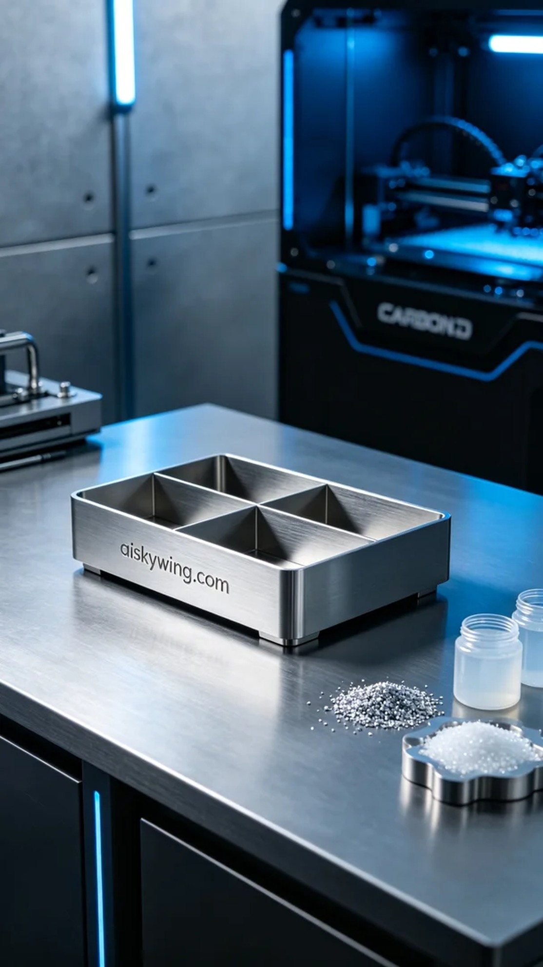
在LinkedIn上，有人向我们求助，想要一款功能强大的储物盒隔板，能够满足他们的日常收纳需求。他们希望这款产品不仅耐用，还要有个性化的外观。接到这个需求后，我们迅速进行设计和准备，确保能按照他们的要求完成。
这次我们选择了未成型的液态光敏树脂作为原材料，因其具有优良的流动性和成型精度，适合复杂结构的打印。使用的设备是Carbon 3D打印机，打印参数设置为层厚0.1mm，温度25°C，功率60W，打印速度80mm/s，整个打印过程预计需要约4小时。这样的设置不仅能保证打印质量，还能提高工作效率。
在打印过程中，Carbon打印机的运行非常稳定，整个过程监控严密，确保每一层的质量都能达到标准。在关键时刻，我们注意到液态光敏树脂的流动情况，及时调整流量，以确保打印效果最优，最终形成了一款精细的储物盒隔板。
完成打印后，我们进行了后处理工序。首先将打印好的部件放入清洗液中，清除表面的未固化树脂。接着，采用细砂纸对其进行打磨，确保表面光滑细腻。然后放入固化设备中进行UV固化，固化时间为30分钟，确保材料充分硬化。最后进行了严格的检验，确保尺寸和外观都达到预期标准。
经过几天的努力，这款储物盒隔板终于完成了，每个细节都体现了我们的用心。这不仅是一次成功的打印，更是为解决实际问题提供了完美的解决方案。
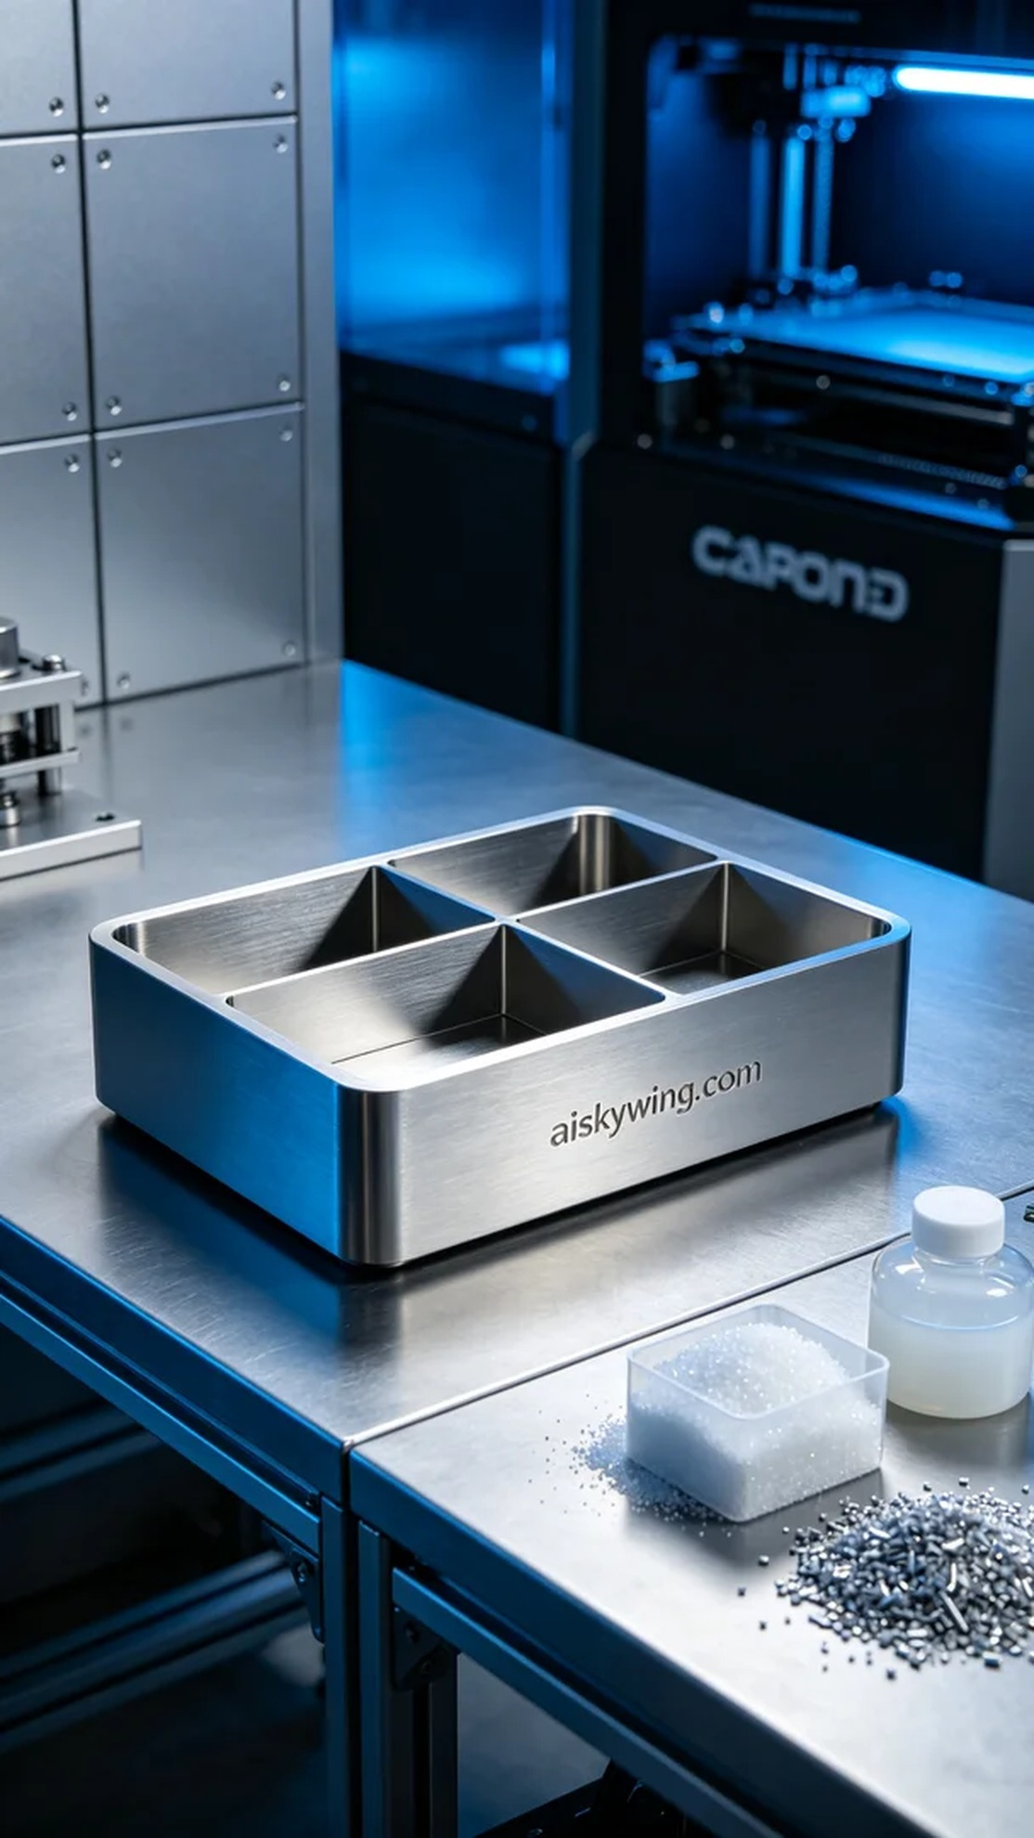
Aiskywing Industrial 3D Printing
Storage box divider


