0896-儿童安全座椅接口盖3D打印生产记录
Child Safety Seat Interface Cover
🖨️ SLM金属打印
🖥️ 打印机: EOS
📦 材料: 摆放着未成型的液态光敏
生活再难，也别停下脚步。就像接下这个儿童安全座椅接口盖的单子，有人因为安全隐患而向我们求助。
No matter how difficult life gets, don't stop moving forward. Just like taking on this order for a children's car seat interface cover, someone reached out to us for help due to safety concerns.
________________________________________________________________________________
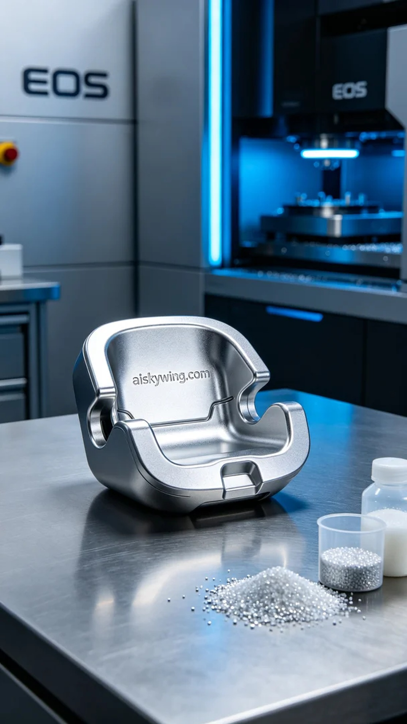
Life can be tough, but we shouldn't stop moving forward. Just like when we took on the task of printing this child safety seat interface cover, someone reached out to us due to safety concerns.
To meet the design requirements, we chose liquid photopolymer resin as our raw material, known for its excellent flow and high-precision molding characteristics. The EOS printer was set with a layer thickness of 0.1 mm, printing temperature at 180 degrees Celsius, power at 200 watts, and a speed of 30 mm per second. These settings ensured we could maintain part quality and precision.
The printing process proceeded as scheduled, with the EOS printer running steadily. We kept a close watch on the print quality through the monitoring system. With real-time data feedback, we made sure there were no layer misalignments or bubbles. As the print continued, the details of the component began to emerge, with the engraved “aiskywing.com” text becoming increasingly clear.
Upon completion, the component needed to undergo several post-processing steps. First, we immersed it in a cleaning bath to remove any residual resin. We then meticulously sanded it to ensure a smooth surface. The curing process was carried out under UV light to enhance structural stability. Finally, the finished product underwent strict quality inspection to confirm all parameters met the standards.
After a series of processes, this child safety seat interface cover was completed. Each print brings its own anticipation and challenges, and this outcome is not just a product but a commitment to safety and responsibility.
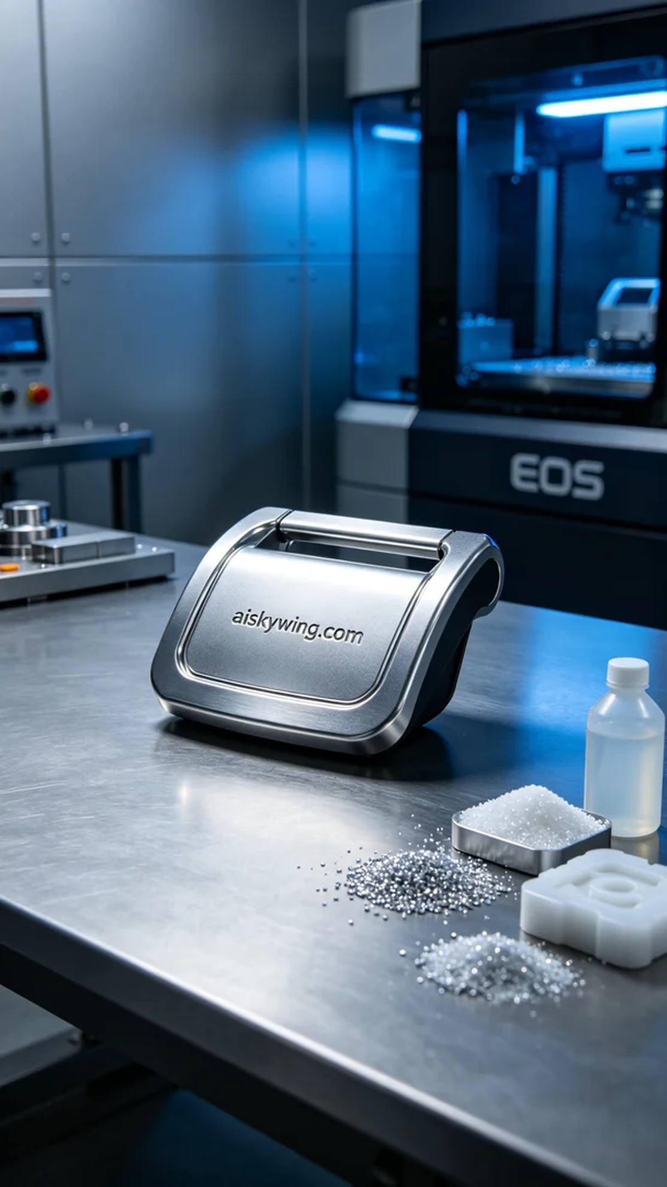
在Facebook上，有人因为他们的儿童安全座椅接口盖出现了安全隐患，特意联系到我们，希望能够找到一个可靠且耐用的解决方案。我们决定采用SLM金属打印工艺，制造出高精度的儿童安全座椅接口盖，以确保使用安全。
为了满足设计需求，我们选择了未成型的液态光敏树脂作为原材料，具备优良的流动性和高精度成型的特性。我们使用的EOS打印机在设置上，层厚为0.1毫米，打印温度设定在180摄氏度，功率达到200瓦，打印速度为30毫米每秒。通过合理的打印参数，我们能够确保部件的质量与精度。
打印过程如期进行，EOS打印机稳定运行，在监控系统的保持下，我们时刻关注打印质量。通过实时的数据反馈，确保没有出现任何层错位或气泡问题。随着打印的逐渐深入，组件的细节开始显现，表面雕刻的“aiskywing.com”字样也愈发清晰。
打印完成后，组件需要经过一系列的后处理工序。首先，我们将其放入清洗槽中，去除表面的树脂残留。接着进行细致的打磨，确保表面光滑。固化工序则在紫外灯下进行，这样可以增强结构的稳定性。最后，我们对成品进行严格的质量检验，确保各项指标符合标准。
经过一系列的工序，这个儿童安全座椅接口盖终于完成。每一次的打印，都充满了期待与挑战。这次的成果，不仅是一件产品，更是对安全和责任的坚守。
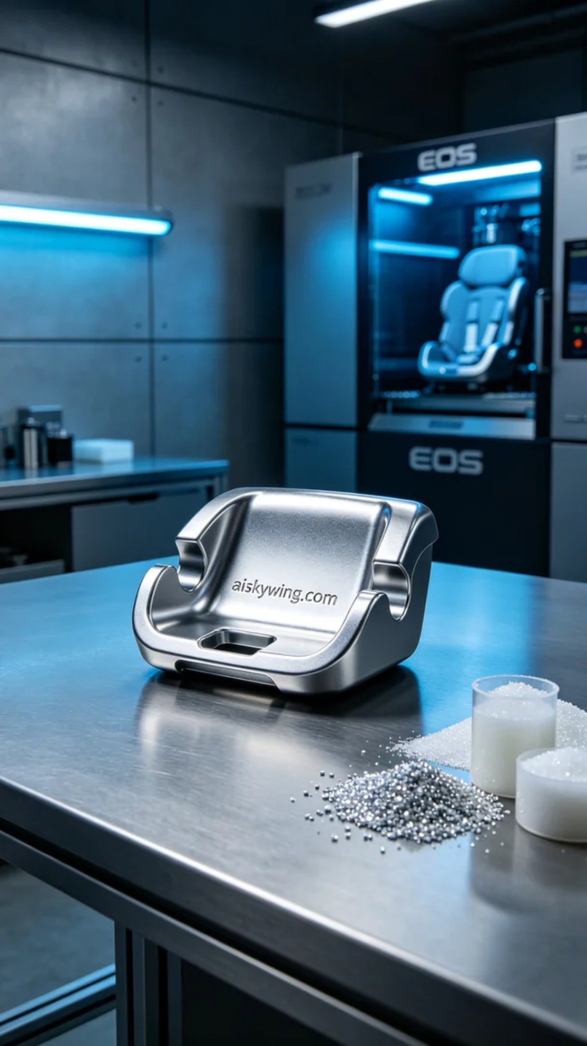
Aiskywing Industrial 3D Printing
Child Safety Seat Interface Cover


