0898-出风口拨片的3D打印生产记录
Air outlet flap
🖨️ SLM金属打印
🖥️ 打印机: Voxeljet
📦 材料: 摆放着未成型的液态光敏
生活再难，也别停下脚步。就像接下这个出风口拨片的单子，面对挑战，我们总能找到解决方案。
No matter how difficult life gets, don't stop moving forward. Just like taking on this order for the air vent flap, when faced with challenges, we can always find solutions.
________________________________________________________________________________
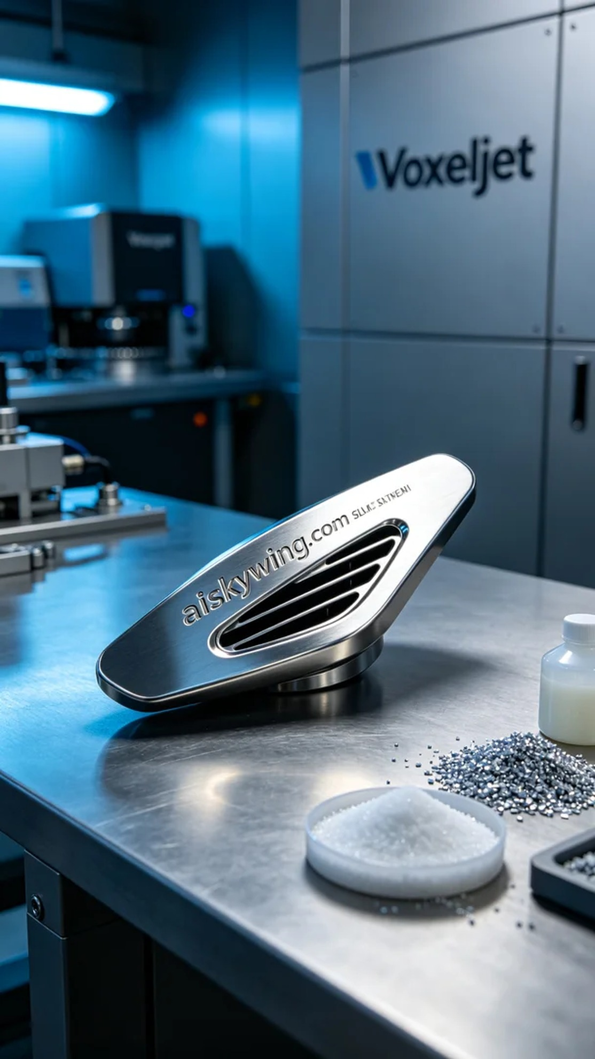
Today, someone reached out to us via WhatsApp to inquire about the production of an air outlet flap. They had high standards for the product's precision and material quality, so we quickly confirmed their needs and decided to use SLM metal printing to meet their expectations.
We prepared the unformed liquid photopolymer resin materials, ensuring they had sufficient fluidity and adhesion for precise fabrication. When using the Voxeljet printer, we set the printing parameters to a layer thickness of 0.1 mm, maintained a temperature of 25°C, set the power to 80%, and printed at a speed of 50 mm/s to ensure perfect material fusion and a high-quality surface finish.
During the printing process, the equipment operated steadily, and after several hours of continuous work, we closely monitored the print quality to ensure every detail met our standards. As the printer hummed and the liquid material gradually formed, the outline of the air outlet flap began to take shape, evoking excitement among the team.
Once printing was complete, we carried out a series of post-processing procedures. First, we cleaned the formed air outlet flap to remove any residual resin from the surface. Next, we used a sander to polish the surface to ensure a smooth finish and perfect appearance. After that, we cured the product to enhance its strength and stability, followed by a comprehensive inspection to confirm that each air outlet flap met the quality standards.
In the end, we successfully completed the 3D printing production of the air outlet flap, meeting their high requirements. This process reminded us once again of the importance of persistence and innovation.
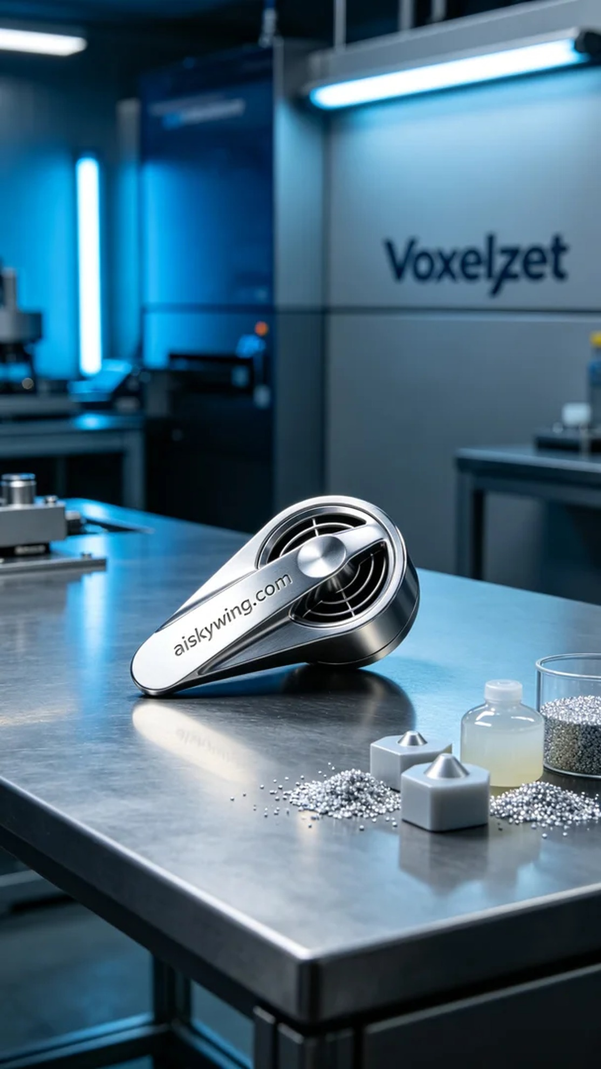
今天，有人通过WhatsApp向我们咨询，想要制作一款出风口拨片，他们对产品的精度和材质要求很高。我们立刻确认了他们的需求，并决定使用SLM金属打印工艺来满足他们的期望。
我们准备了未成型的液态光敏树脂材料，确保其具备足够的流动性和粘附性，以适应精准制造。使用Voxeljet打印机时，我们将打印参数设置为层厚0.1毫米，温度保持在25℃，功率设定为80%，打印速度为50毫米/秒，这样可以确保材料的完美融合和高质量的表面效果。
在打印过程中，设备稳定运行，经过数小时的持续作业，我们对打印质量进行了严密监控，确保每一个细节都能达到我们的标准。随着打印机的轰鸣声和液态材料的逐渐成型，出风口拨片的轮廓逐渐显现，令人兴奋不已。
打印完成后，我们对产品进行了一系列后处理工序。首先，将成型的出风口拨片进行清洗，去除表面的残留树脂；接着，利用打磨机对表面进行打磨，以确保光滑度和外观的完美。之后，我们将产品进行固化处理，以增强其强度和稳定性，最后进行了全面的检验，确保每一件出风口拨片都符合质量标准。
最终，我们成功完成了出风口拨片的3D打印生产，满足了他们的高标准要求。这样的过程，让我们再次体会到坚持与创新的重要性。
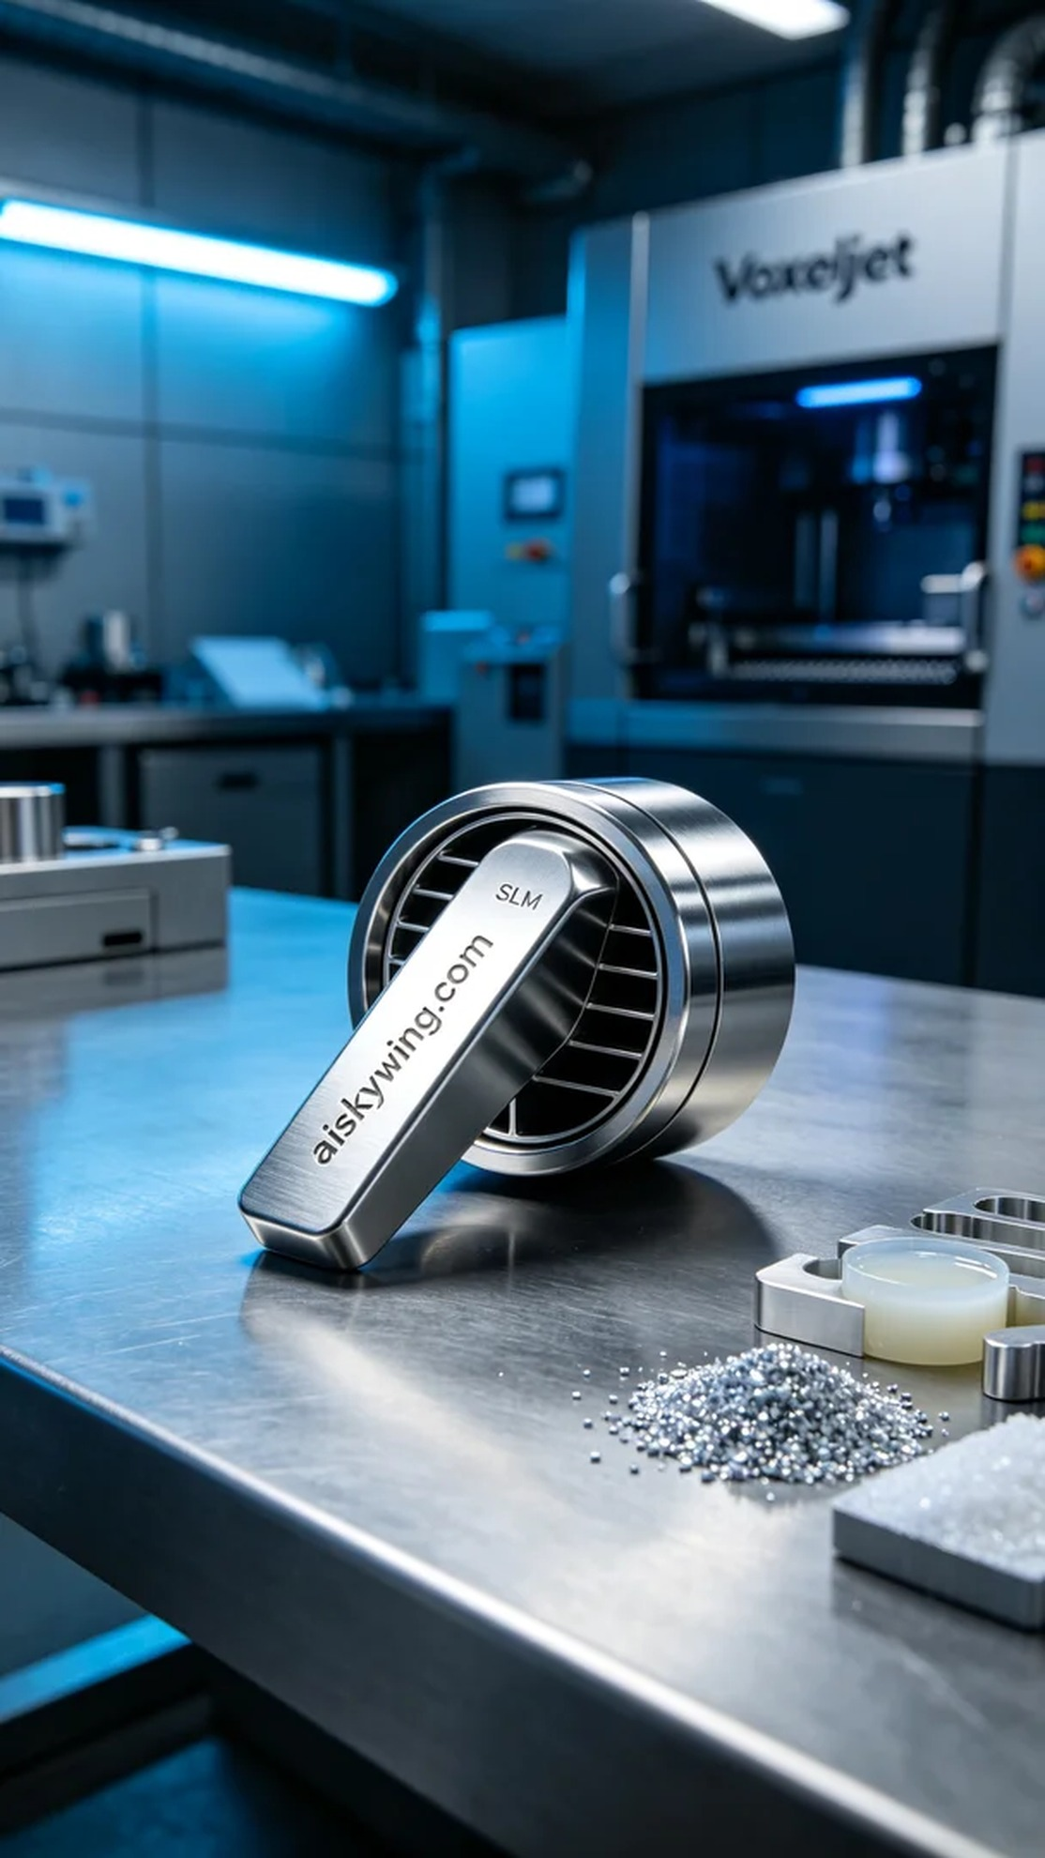
Aiskywing Industrial 3D Printing
Air outlet flap


