0901-3D打印分动器输入轴生产记录
Transfer case input shaft
🖨️ SLM金属打印
🖥️ 打印机: Xjet
📦 材料: 摆放着未成型的液态光敏
有人在WhatsApp上询问，问我能不能帮忙做一个分动器输入轴。我想，生活中总要面对挑战，就像这份工作一样。
Someone asked me on WhatsApp if I could help make a differential input shaft. I thought to myself, we always have to face challenges in life, just like this job.
________________________________________________________________________________
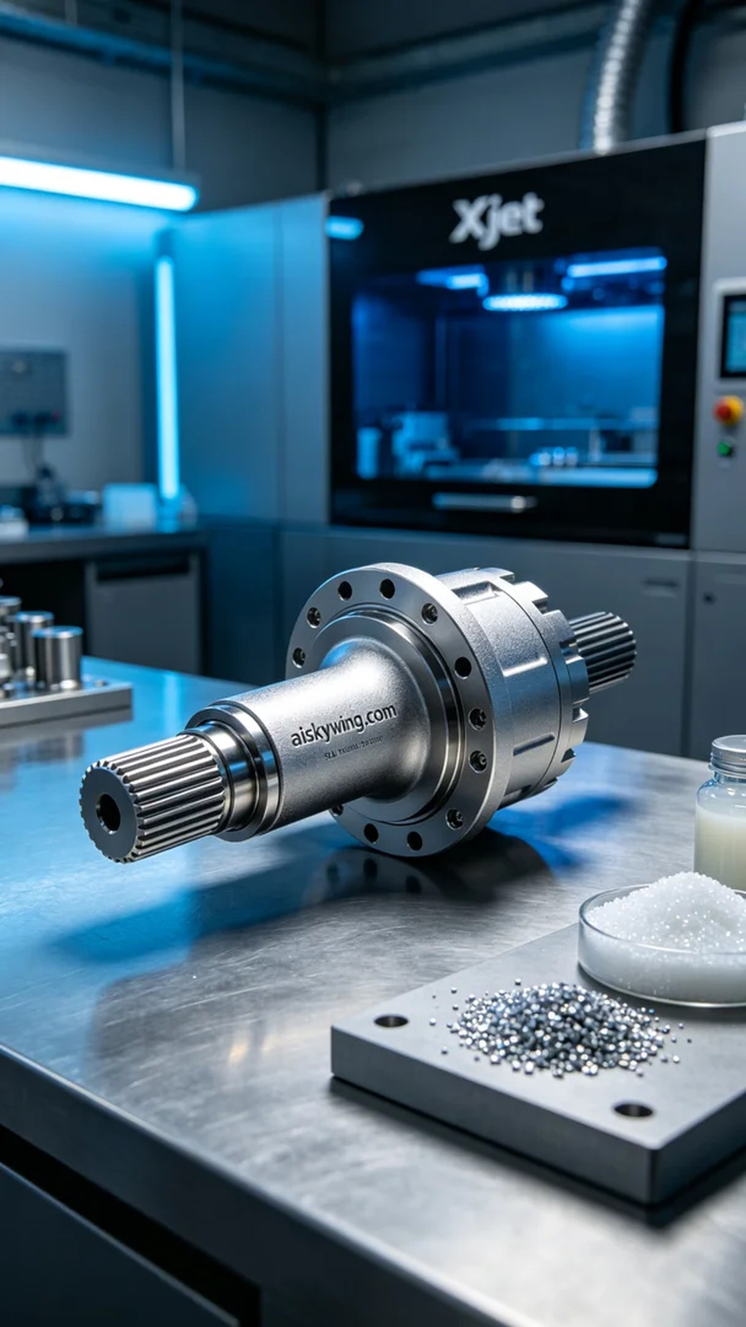
The production of the transfer case input shaft started with a message from someone on WhatsApp asking if I could help create this part. They needed a high-strength yet lightweight component for their industrial equipment. So, I decided to utilize SLM metal printing technology to achieve the best quality.
The raw material used was unformed liquid photopolymer resin, known for its excellent fluidity and high-precision forming characteristics. During the preparation, I carefully checked the Xjet printer to ensure it was in optimal working condition. The printing parameters were set to: layer thickness of 0.1mm, temperature maintained at 25 degrees Celsius, power set at 300W, printing speed of 50mm/s, with an estimated printing time of about 8 hours.
As the printing process began, I monitored the machine's operation throughout to ensure each layer's accuracy met specifications. The stability of the Xjet printer made me feel confident, and even during the long hours of operation, no abnormalities occurred. As the liquid photopolymer resin continually cured, the outline of the transfer case input shaft became increasingly clear, with the details of the final product emerging.
Once the printing was completed, I carried out strict post-processing steps. I first cleaned the surface of the printed part with a cleaning solution to remove any uncured resin, followed by sanding to ensure a smooth surface. After that, I placed it in a curing chamber to enhance its strength. Finally, after a thorough inspection, I confirmed that every detail of the final product met the required standards.
This production experience emphasized the importance of teamwork, and I successfully completed the production of the transfer case input shaft. Every challenge is a chance for growth, and I look forward to the next exciting project ahead.
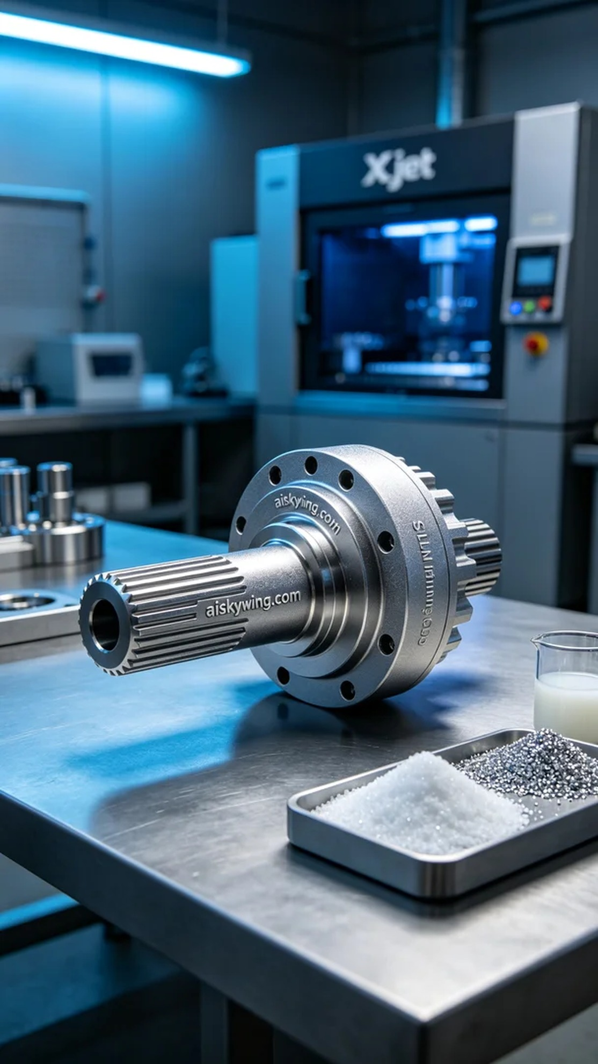
分动器输入轴的制作始于一条来自WhatsApp的消息，有人找我希望能尽快完成这个项目。他们需要一个高强度且轻量化的零件，适用于工业设备。于是，我决定用SLM金属打印技术来实现这个目标，以最好的品质呈现出来。
我们使用的原材料是未成型的液态光敏树脂，具有良好的流动性和高精度成型的特点。在准备过程中，我仔细检查了Xjet打印机的状态，确保设备运行正常。打印参数设置为：层厚0.1mm，温度保持在25摄氏度，功率设定为300W，打印速度为50mm/s，预计打印时间约为8小时。
打印过程开始后，我全程监控设备的运行情况，确保每一层的精度都达标。Xjet打印机的稳定性能让我感到安心，即使在长时间的工作中，也没有出现任何异常。随着液态光敏树脂不断固化，分动器输入轴的轮廓逐渐清晰，成品的细节也在不断显现。
打印完成后，我进行了严格的后处理工序。首先用清洗液将打印件表面的未固化树脂清洗干净，接着用砂纸进行打磨，确保表面光滑。然后，我将其放入固化箱中进行固化处理，以增强其强度。最后，经过仔细检验，确认了成品的每一个细节都符合标准。
这次制作经历让我感受到团队合作的重要性，最终成功完成了分动器输入轴的生产任务。每一次的挑战都是一次成长，我期待着下一个更加精彩的项目。
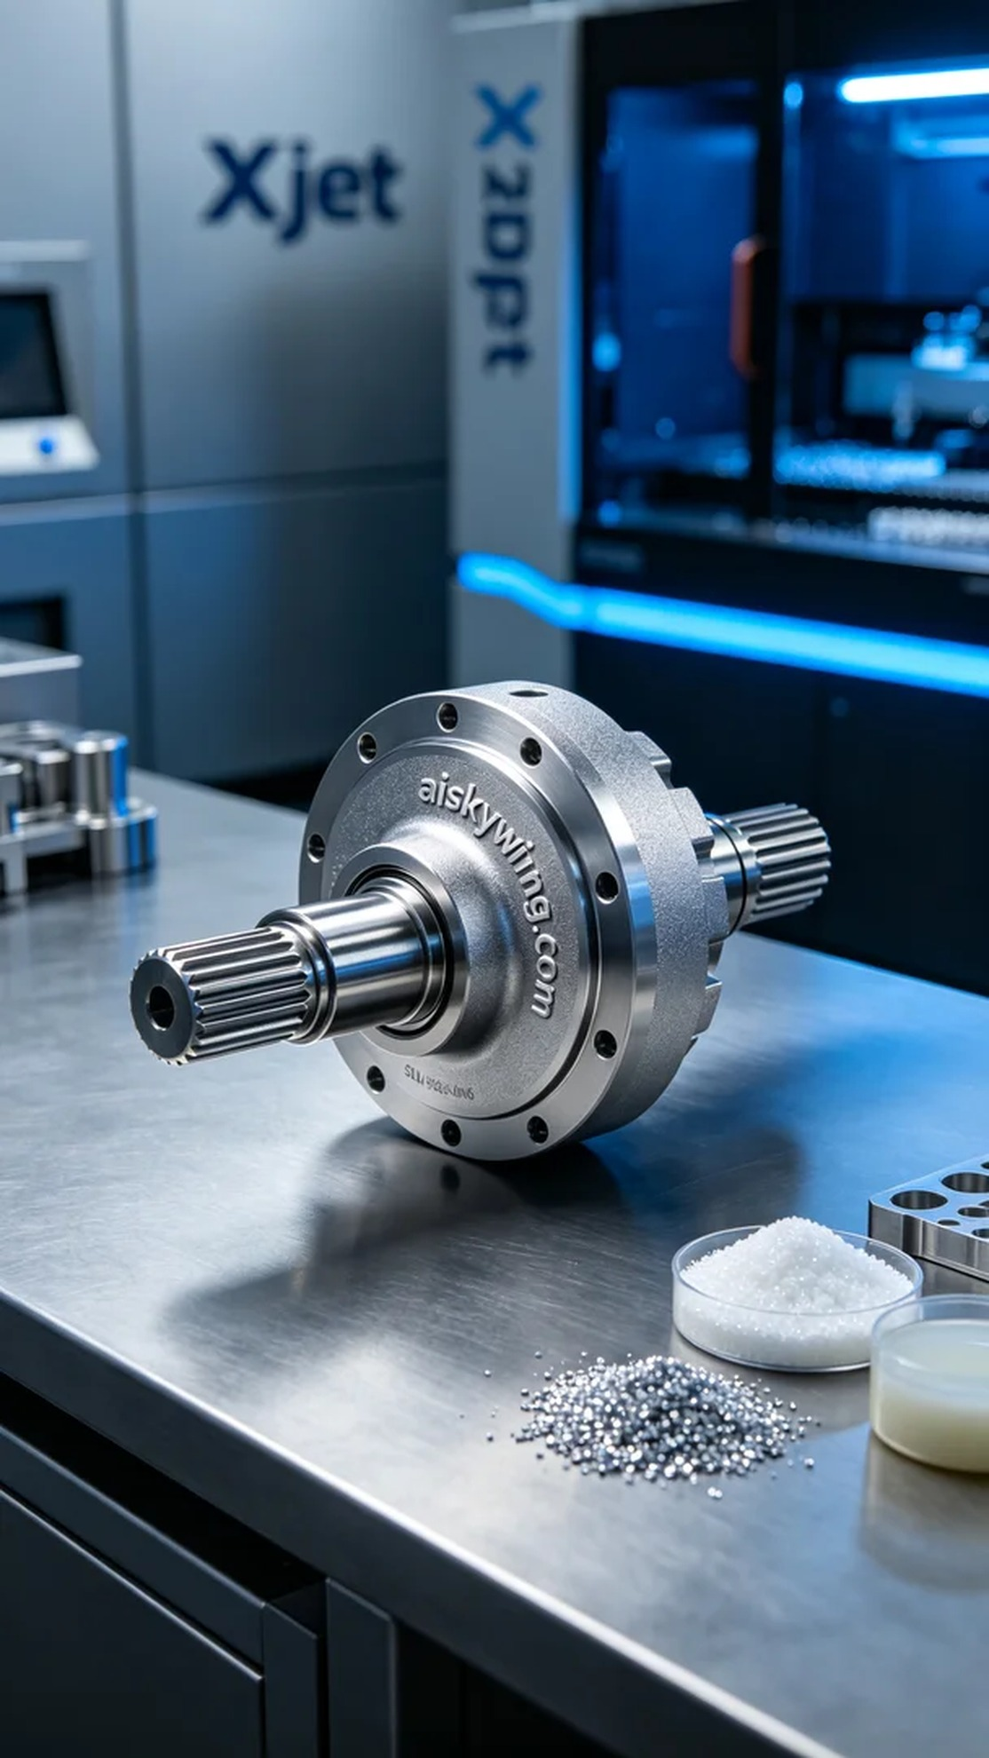
Aiskywing Industrial 3D Printing
Transfer case input shaft


