0903-分动器输出轴的3D打印记录
Transfer case output shaft
🖨️ SLM金属打印
🖥️ 打印机: Stratasys
📦 材料: 摆放着未成型的液态光敏
生活就像3D打印的过程，有些细节需要耐心雕琢。今天，我们接到一个关于分动器输出轴的订单，想让我们帮忙解决之前的一些问题。
Life is like the process of 3D printing, where some details require patient refinement. Today, we received an order regarding the output shaft of the transfer case, and they want us to help solve some previous issues.
________________________________________________________________________________
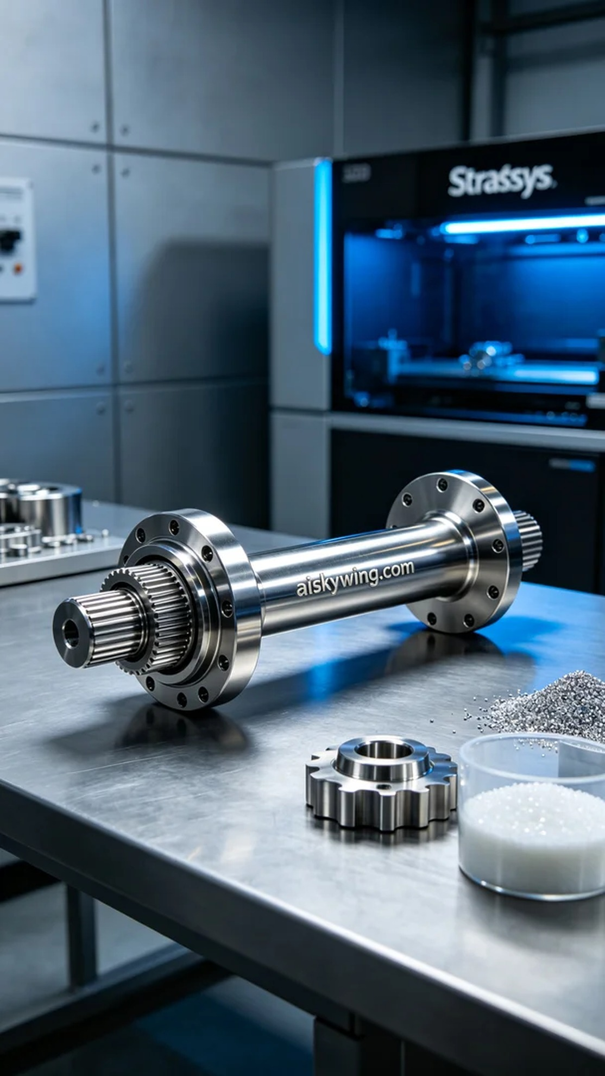
Life is like a 3D printing process; some details need to be meticulously crafted. Today, we received an order for a diversion output shaft, aiming to address some issues they previously encountered.
On Instagram, someone was seeking higher quality mechanical parts and found us. For this diversion output shaft, they wanted to enhance the precision and surface quality, thus improving overall performance. This was quite a challenging project, but we are always eager to take on new tasks.
Regarding materials, we used unformed liquid photopolymer resin, which has excellent fluidity and a detailed surface effect. To ensure print quality, we utilized a Stratasys 3D printer, setting the layer thickness to 50 microns, the print temperature at 200 degrees Celsius, the laser power to 300 watts, and the print speed maintained at 50 mm/s to effectively guarantee the details and strength of the finished product.
During the printing process, the Stratasys printer operated efficiently and steadily, continuously monitoring various parameters to ensure that each layer was deposited precisely. Over time, the diversion output shaft gradually took shape, and the clear surface engraving and reflective effects made us look forward to the final product. Regular checks were performed to ensure no faults would disrupt the printing process.
After printing, we conducted thorough post-processing on the finished product. First, it underwent ultrasonic cleaning in a basin to remove any residual photopolymer resin; then we polished it to enhance smoothness and aesthetics; afterward, we placed the product in a curing machine for UV curing to ensure the material's performance was optimally achieved; finally, we carried out rigorous quality inspections to ensure that each product met the standards.
After a series of processes, this diversion output shaft finally took perfect shape. Each production is a new milestone, and we are immensely proud of the results this time.
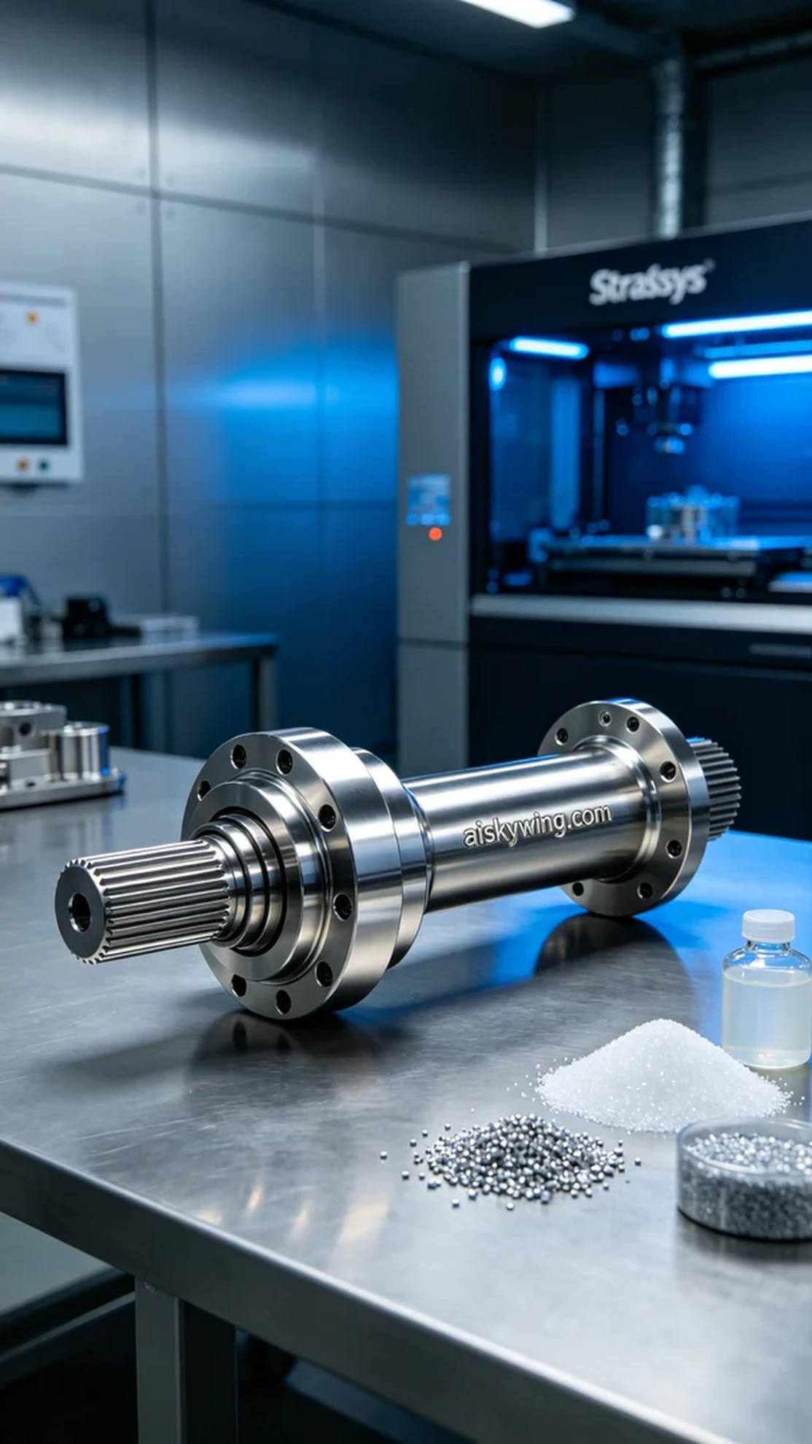
在Instagram上，有人在寻找更高质量的机械零件时找到了我们。对于这次的分动器输出轴，他们希望能提升产品的精度和表面质量，从而增强整体性能。这是一个很有挑战性的项目，但我们一向乐于接受。
原材料方面，我们采用了未成型的液态光敏树脂，具备优良的流动性和细致的表面效果。为了确保打印质量，我们使用了Stratasys的3D打印机，这台机器的层厚设置为50微米，打印温度控制在200摄氏度，激光功率设置为300瓦，打印速度保持在50毫米每秒，这样可以有效保证成品的细节和强度。
在打印过程中，Stratasys打印机高效稳定，始终监控各个参数，确保每一层都能精确沉积。随着时间的推移，分动器输出轴逐渐成型，清晰的表面雕刻与反光效果让人期待。期间，我们对设备进行了定期检查，确保没有任何故障干扰打印过程。
打印完成后，我们对成品进行了详细的后处理。首先在清洗槽中进行超声波清洗，去除残留的光敏树脂；然后进行打磨，以提高光滑度及美观；接着，将成品放入固化机内进行UV固化，确保材料的性能达到最佳状态；最后，我们进行了严格的质量检验，确保每一件产品都能符合标准。
经过一系列流程，这个分动器输出轴终于完美成型了。每一次生产都是一次新的里程碑，而这次的结果也让我们倍感自豪。
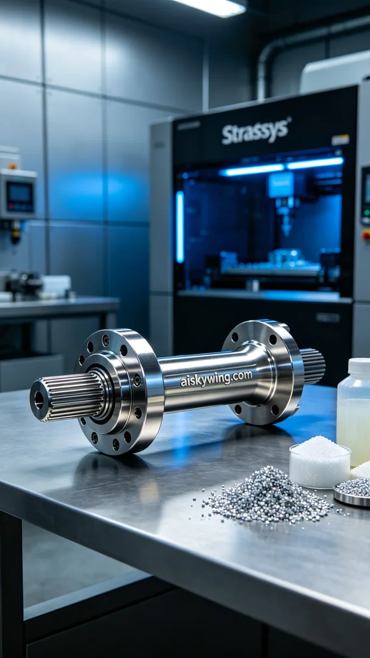
Aiskywing Industrial 3D Printing
Transfer case output shaft


