0904-分动器链条3D打印生产记录
Transfer case chain
🖨️ SLM金属打印
🖥️ 打印机: Carbon
📦 材料: SLM铝合金
生活总会有挑战，但要勇敢面对。就像有位朋友在Instagram上询问我们的分动器链条，我们认真对待每一个需求。
Life will always have challenges, but we must face them bravely. Just like a friend who asked about our differential chain on Instagram, we take every request seriously.
________________________________________________________________________________
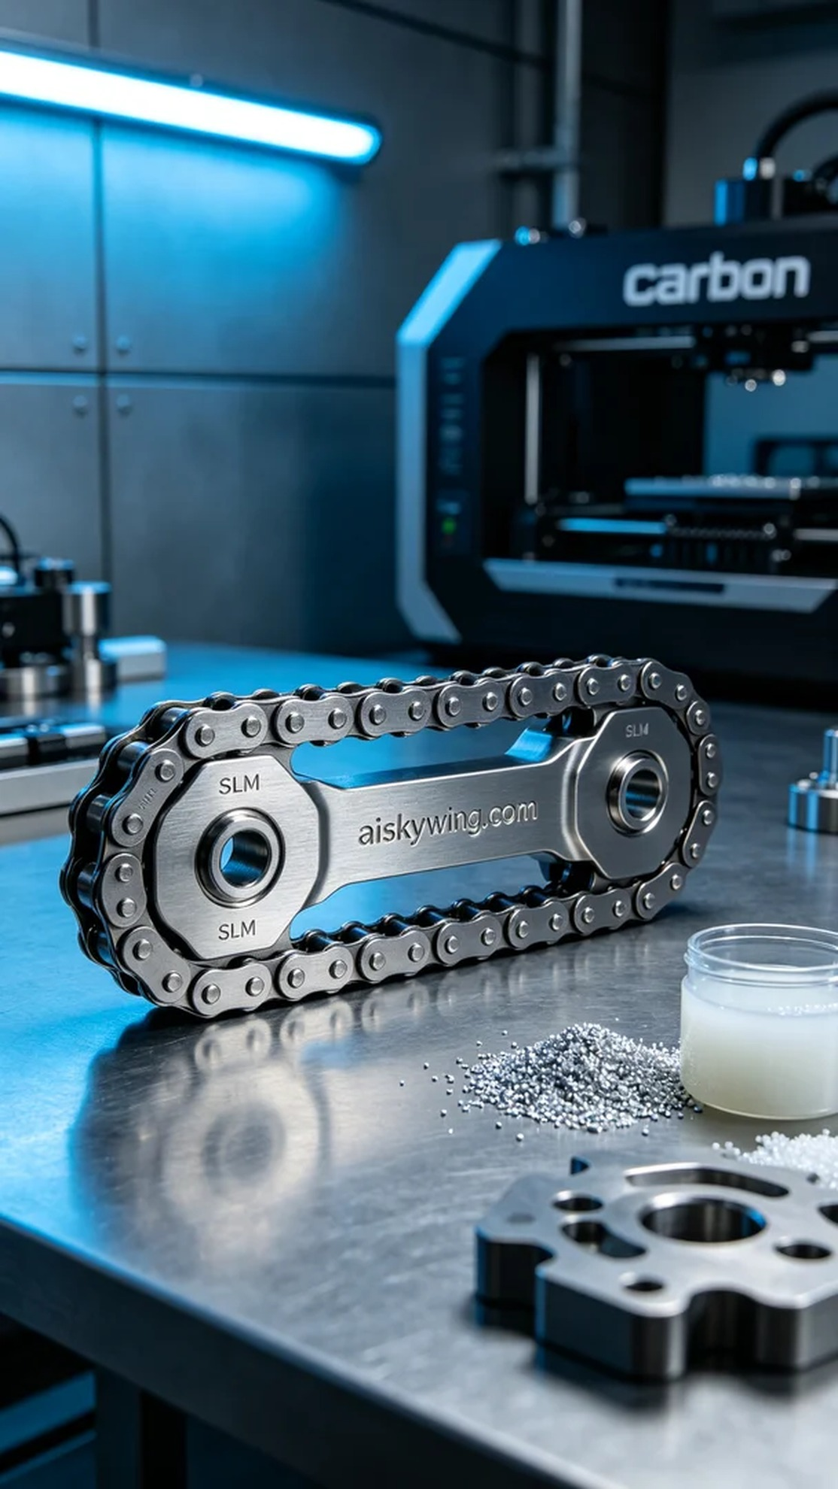
Recently, someone reached out to us via Instagram inquiring about a custom chain for their differential gear. They were looking for a material that offered both strength and lightweight properties, which led them to choose SLM aluminum alloy.
Before starting the print, we thoroughly examined the raw materials. SLM aluminum alloy is known for its excellent strength and toughness, making it ideal for high-precision industrial applications. For the Carbon printer, we set the layer thickness to 0.1 mm, printing temperature at 200°C, power at 80W, and a print speed of 50 mm per hour, with an estimated print time of about 6 hours.
As the printing process commenced, the Carbon printer operated smoothly, with continuous quality monitoring throughout. Each layer of material was deposited uniformly, ensuring the structural integrity of the differential gear chain. We also kept a close eye on the machine's status to prevent any anomalies during the operation.
Once printing was complete, we moved on to the post-processing stage. First, we cleaned the finished product to remove any excess uncured resin. Next, we polished the surface to enhance smoothness. Finally, we placed it in the curing device to ensure its strength and durability. After thorough inspection, all processes were successfully completed.
Everything progressed steadily, and in the end, we delivered a high-quality differential gear chain that showcased the advantages of SLM aluminum alloy and the precision of Carbon printing technology.
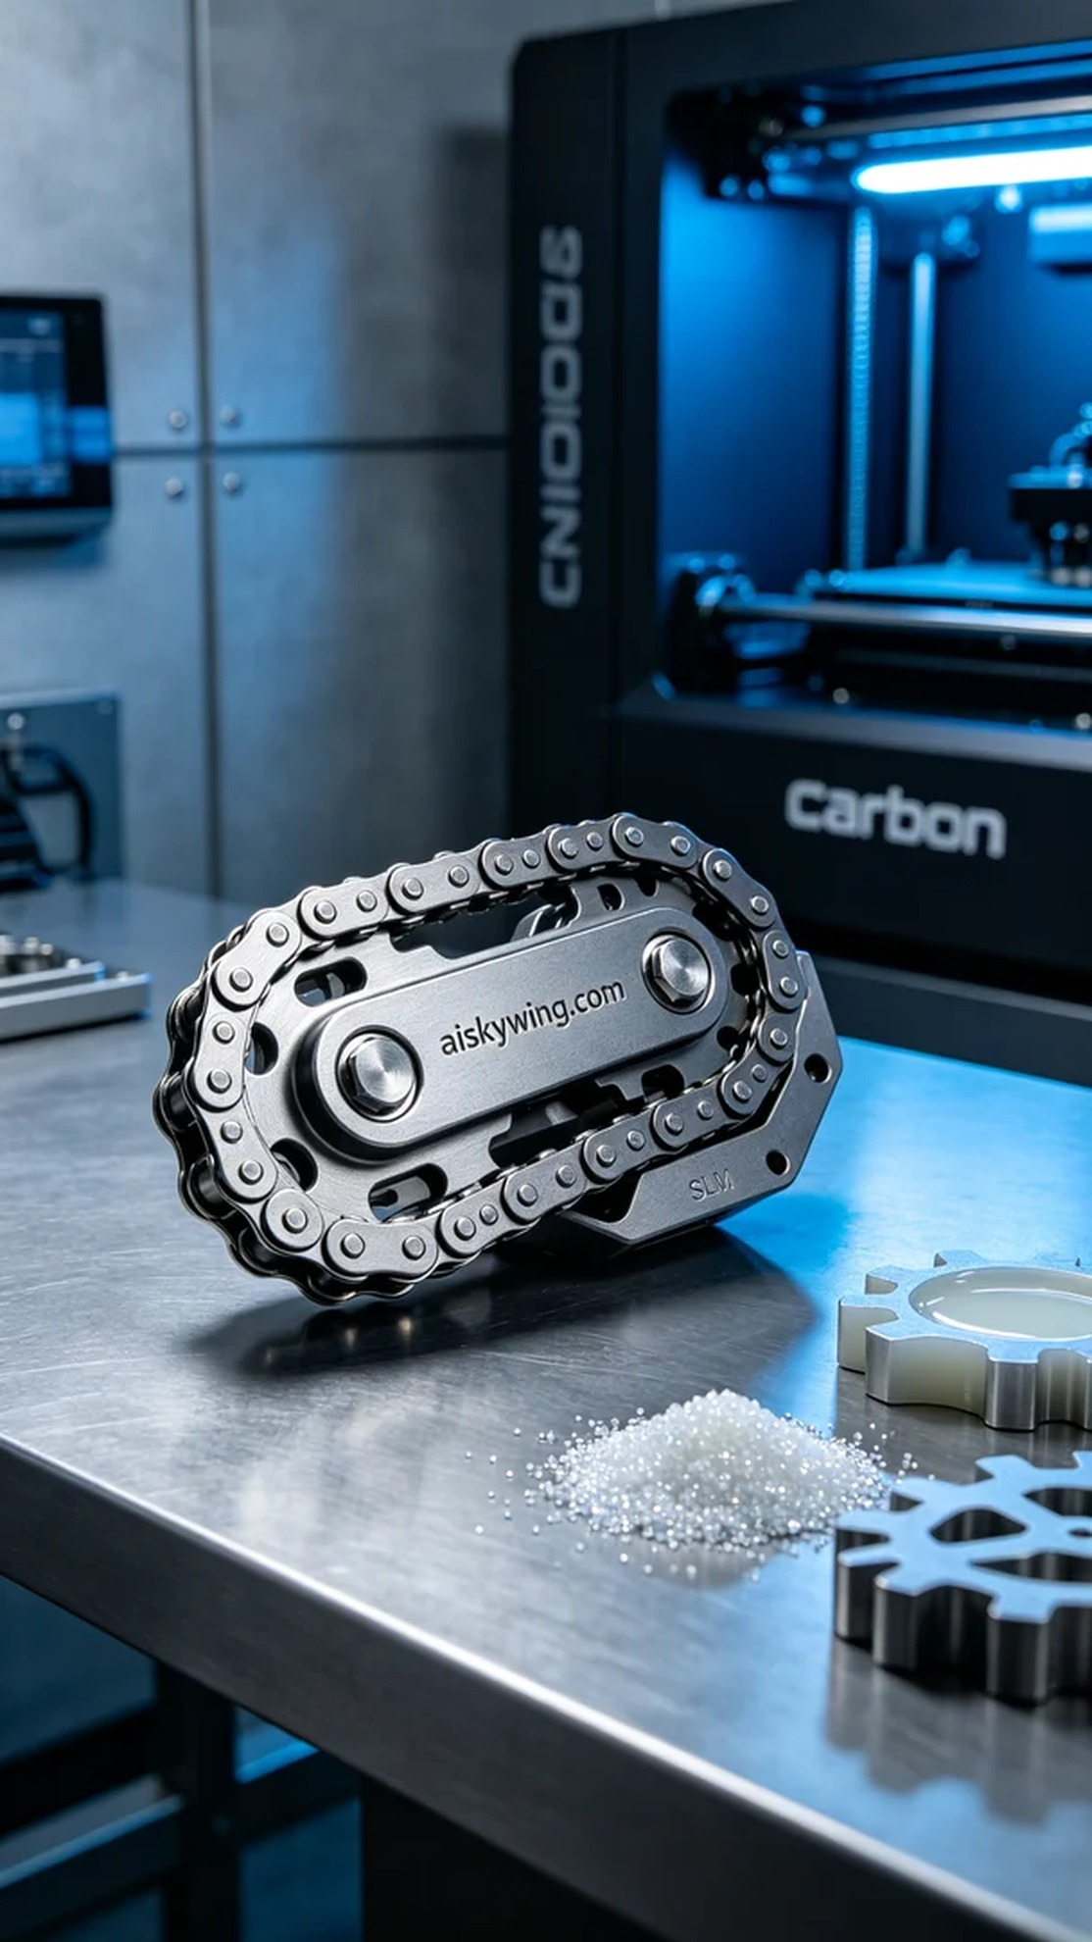
近日，有人通过Instagram联系到我们，希望定制一款分动器链条。由于他们在寻找高强度且轻量化的材料，因此选择了SLM铝合金来满足需求。
在准备这次打印之前，我们对原材料进行了详细的审查。SLM铝合金具有优异的强度和韧性，适合高精度的工业应用。使用Carbon打印机时，我们设定了层厚为0.1毫米，打印温度为200°C，功率设定在80W，打印速度为每小时50毫米，预计打印时间约为6小时。
打印过程开始后，Carbon打印机稳定运行，我们全程监控质量。每层材料的沉积都十分均匀，确保了分动器链条的结构强度。我们也注意到了设备的工作状态，确保没有出现任何异常情况。
在打印完成后，进入了后处理环节。首先对成品进行了清洗，去掉多余的未固化树脂。随后，我们对表面进行了打磨，以提升其光滑度。最后，将其放入固化设备中进行固化，确保产品的强度和耐用性。经过最终的检验后，所有工序都圆满完成。
这一切都在稳步推进，最终，我们成功交付了一款高质量的分动器链条，充分展示了SLM铝合金的优势和Carbon打印技术的精确性。
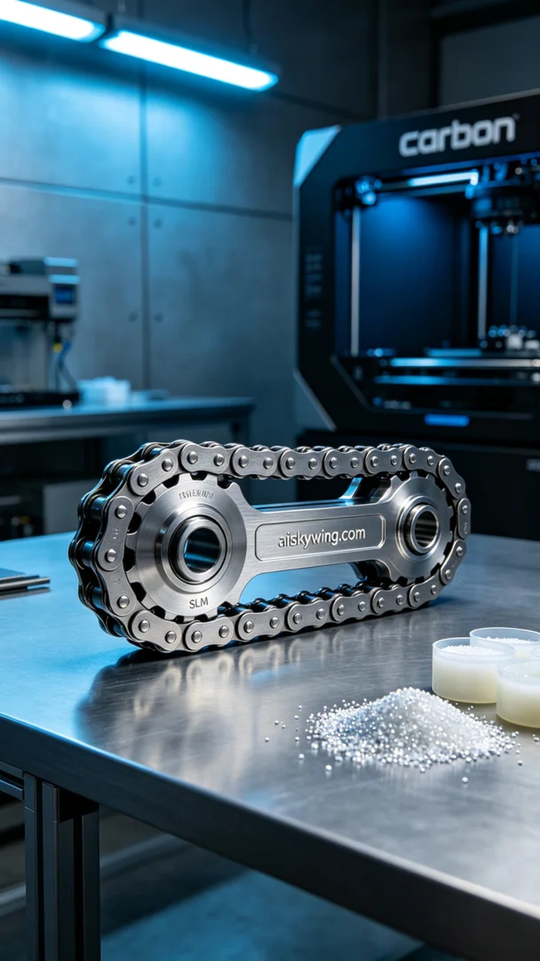
Aiskywing Industrial 3D Printing
Transfer case chain


