0907-制动ESC模块外壳3D打印生产记录
Brake ESC module housing
🖨️ SLM金属打印
🖥️ 打印机: Xjet
📦 材料: SLM铝合金
生活再难，也别停下脚步。就像接下这个制动ESC模块外壳的单子，我知道每一次的挑战都是成长的机会。
No matter how difficult life gets, don't stop moving forward. Just like taking on this order for the ESC module casing, I know that every challenge is an opportunity for growth.
________________________________________________________________________________
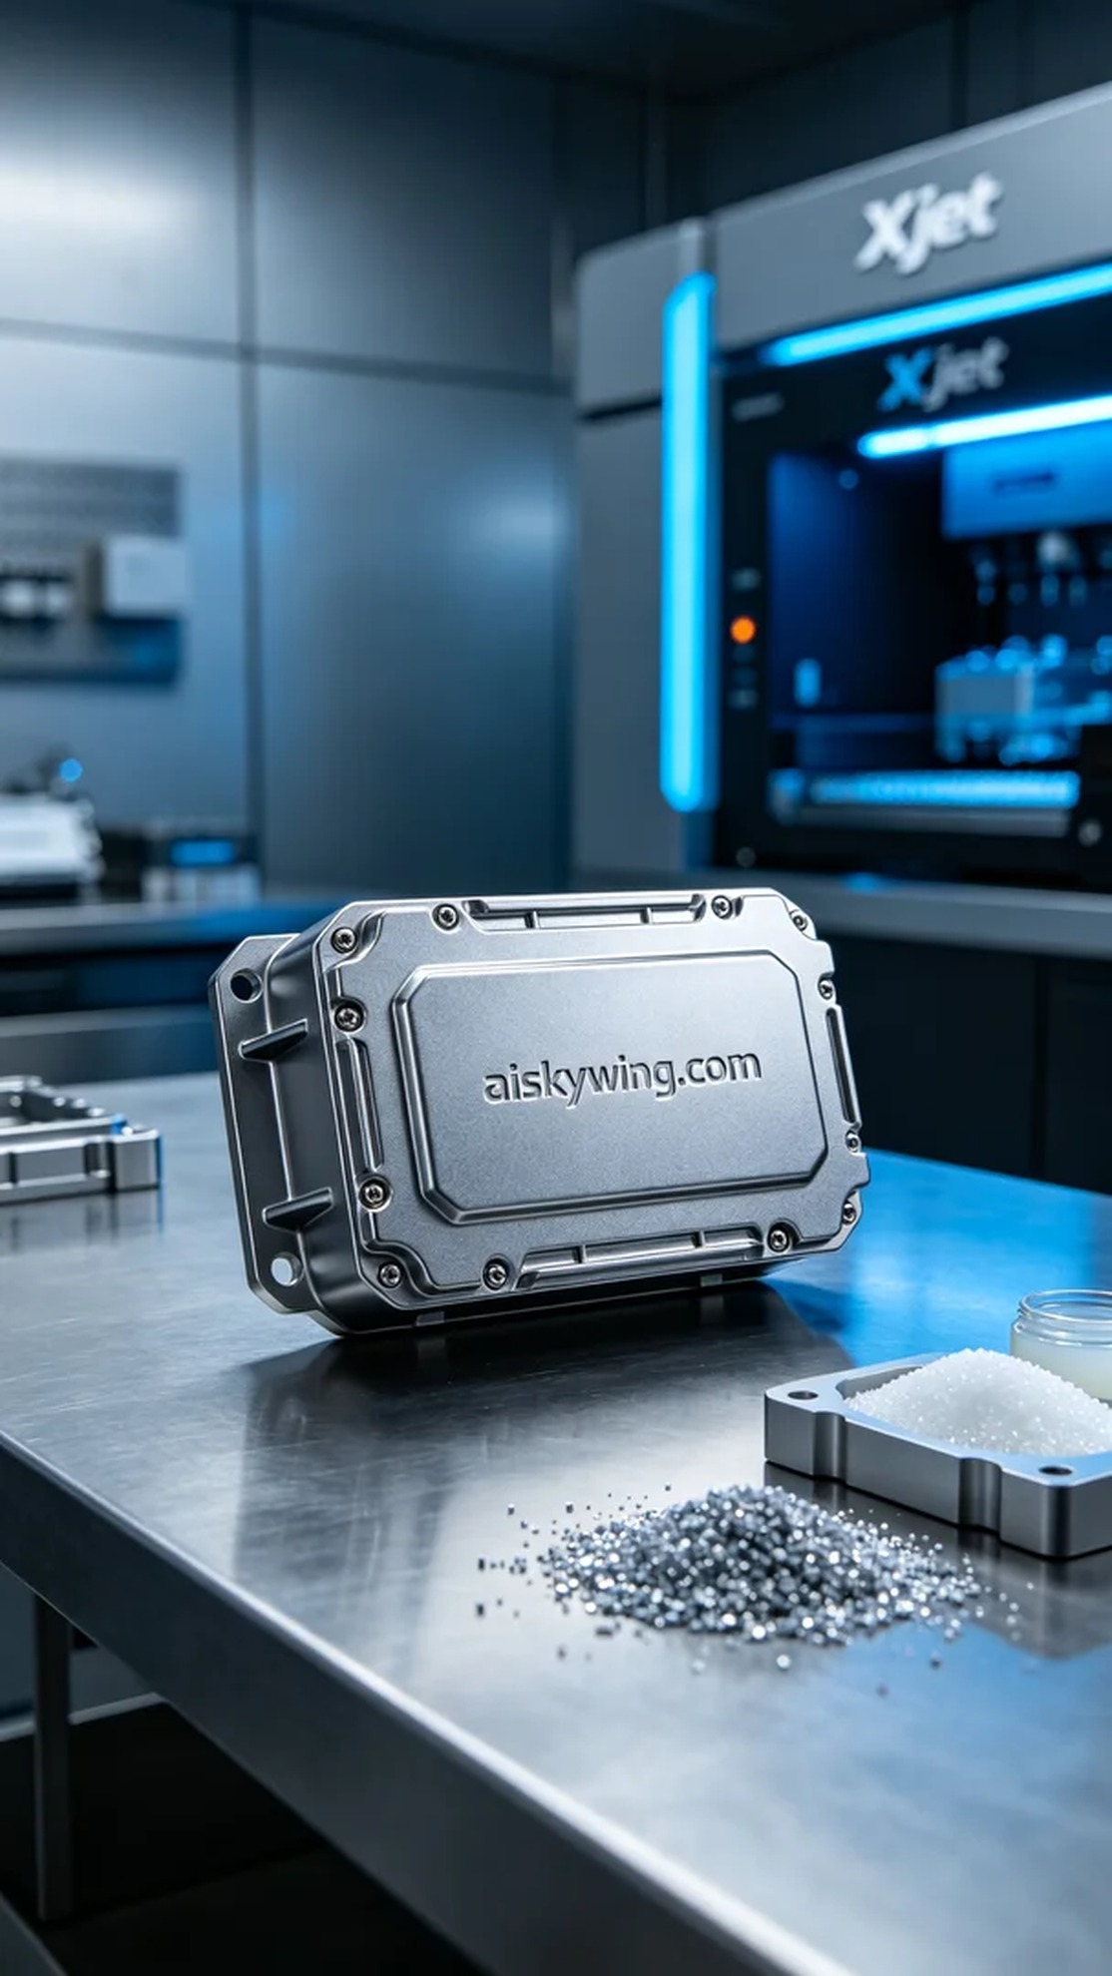
Recently, someone approached us due to a need for a brake ESC module casing. This product not only requires precise design and high-strength materials, but it also needs to withstand complex industrial environments. We decided to use SLM aluminum alloy to meet the high standards expected.
In the preparation phase, we selected the Xjet 3D printer for its outstanding performance in metal printing. The SLM aluminum alloy we used possesses excellent strength and corrosion resistance. For the printing parameters, we set the layer thickness to 0.04 mm, printing temperature at 150 degrees, power at 200 watts, printing speed at 50 mm per second, with an estimated printing time of 6 hours.
During the printing process, the equipment operated stably without any fluctuations. We carefully monitored the real-time display to ensure each layer was deposited evenly. As time went on, the gradually formed casing silhouette looked particularly enchanting under the cold light of the equipment, reflecting a sense of industrial coolness upon completion.
After printing, we proceeded with the post-processing. First, the product was placed in a cleaning tank to remove any residual resin and impurities from the surface. Next, we polished it to ensure a smooth and flawless finish. We then placed it in a curing device for UV curing, followed by a strict inspection, ensuring its dimensions and appearance met the standards.
In the end, this brake ESC module casing, having undergone multiple checks and processing stages, showcases the high-quality mark we strive for. Every detail is meticulously attended to, and we delivered it with full confidence.
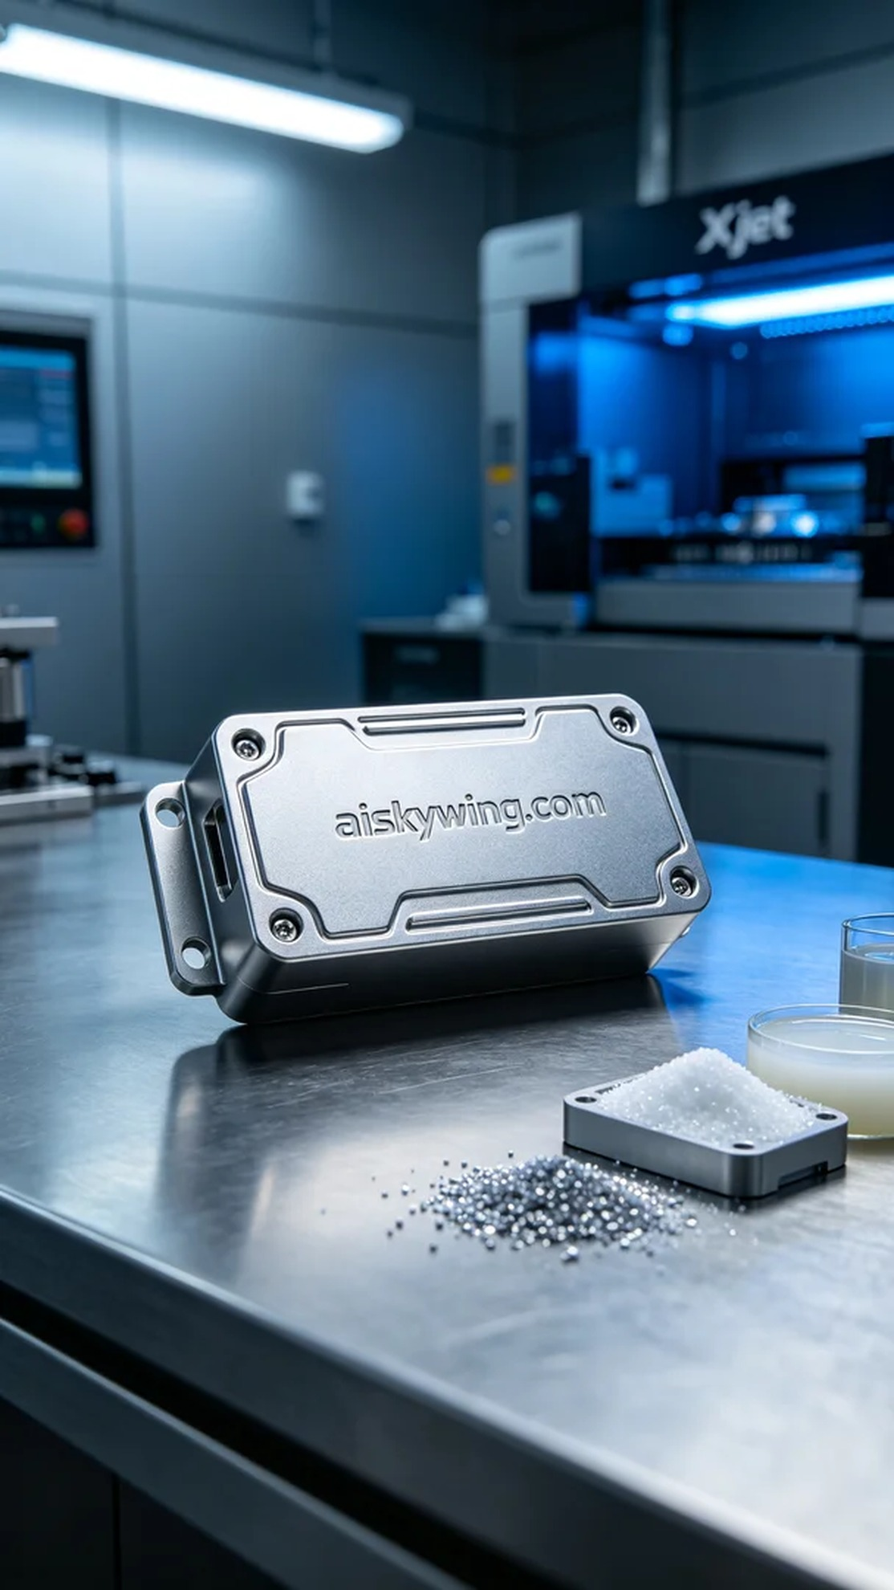
最近，有人因为遇到制动ESC模块外壳的生产需求而找上我们。这个产品不仅需要精准的设计和高强度的材料，还要能适应复杂的工业环境。我们决定使用SLM铝合金来完成这个任务，确保能达到客户的高标准。
在准备阶段，我们选用了Xjet的3D打印机，因为它在金属打印方面的性能表现出色。所用的SLM铝合金材料具有优异的强度和耐腐蚀性。在打印参数设置上，我们选择了层厚0.04毫米，打印温度为150度，功率设置在200瓦，打印速度控制在50毫米每秒，预计打印时间为6小时。
打印过程中，设备稳定运行，整个过程毫无波动。我们对实时监控画面进行了仔细观察，确保每一层都能均匀沉积。随着时间推移，逐步形成的外壳轮廓在设备指示灯的冷光照射下显得格外动人，最终完成时散发出金属的冷峻气息。
打印完成后，我们进行了后处理。首先将产品放入清洗槽中，清除表面残留的树脂和杂质。接着进行了打磨，确保表面光滑无瑕。之后将其放入固化设备中，进行了UV固化处理，最后进行了一次严格的检验，确保尺寸和外观均符合标准。
最后，这个制动ESC模块外壳经过层层把关与处理，呈现出我们追求的高品质标志。每一个细节都不放过，最终交付之前，我们都信心满满。
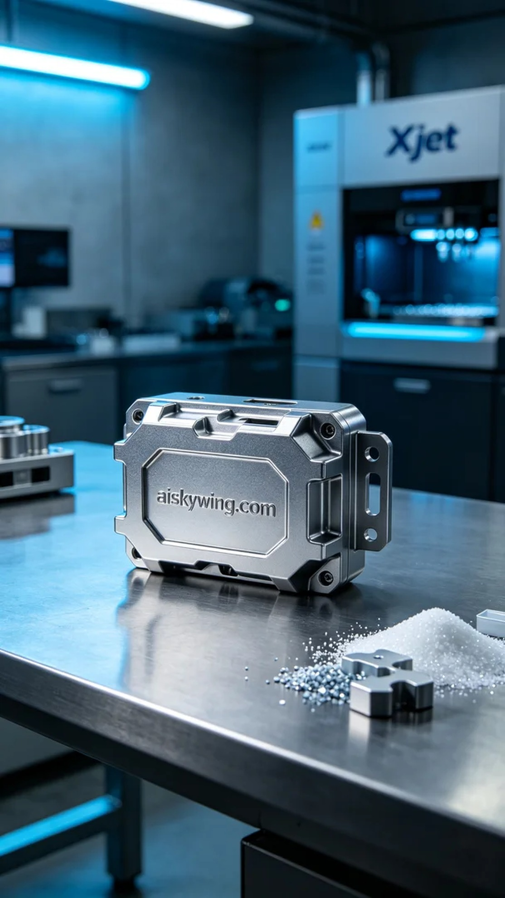
Aiskywing Industrial 3D Printing
Brake ESC module housing


