0934-3D打印制动四回路保护阀壳体生产记录
Brake four-circuit protection valve housing
🖨️ SLM金属打印
🖥️ 打印机: Xjet
📦 材料: 摆放着未成型的液态光敏
生活就像3D打印，层层叠加，最终成就一件完美的作品。就在Twitter上，有人因为制动四回路保护阀壳体的需求找到我们，急需解决他们面临的技术难题。
Life is like 3D printing, layer by layer, ultimately creating a perfect piece. Recently on Twitter, someone reached out to us due to their need for a brake four-circuit protection valve housing and urgently required a solution to the technical challenges they were facing.
________________________________________________________________________________
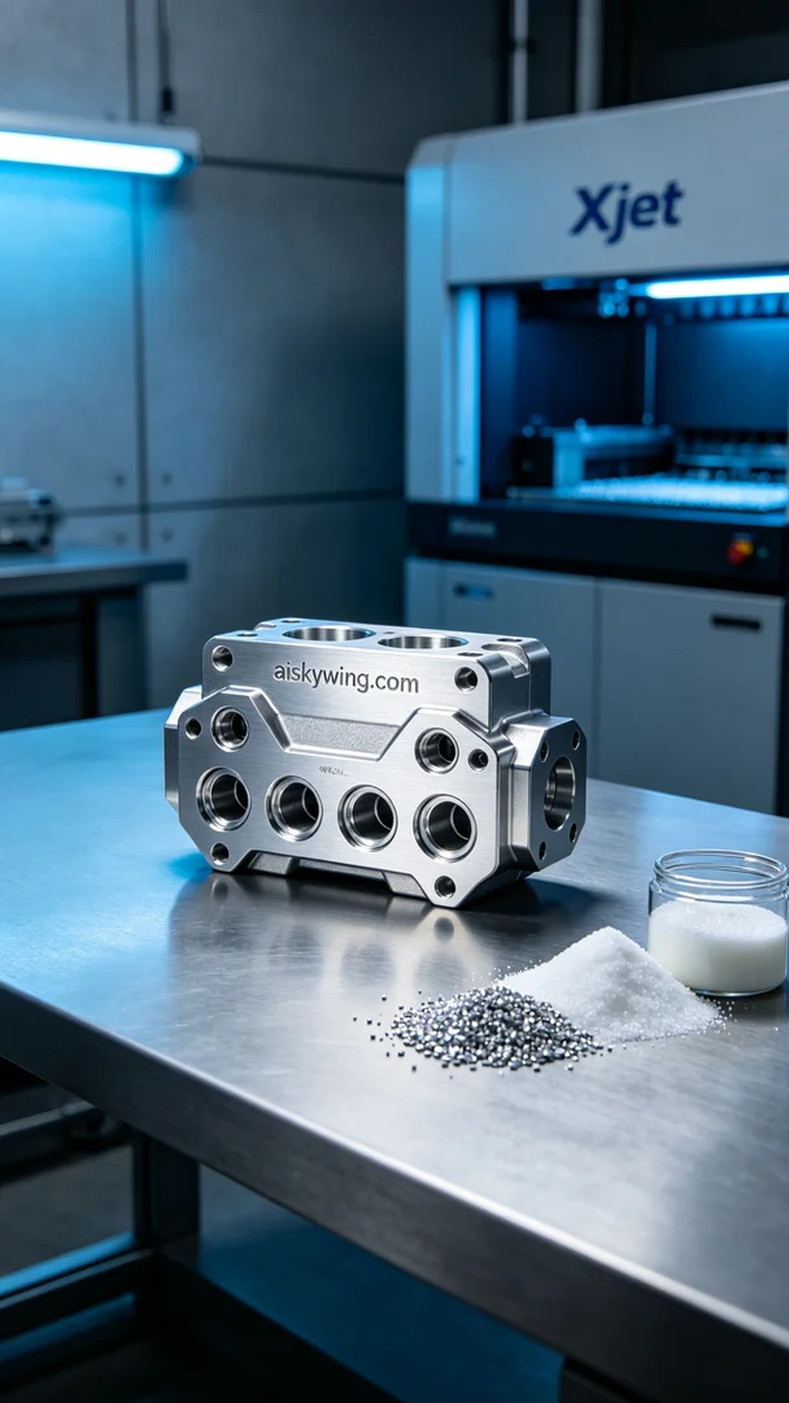
Life is like 3D printing, layer by layer, ultimately achieving a perfect product. On Twitter, someone reached out to us with a need for a high-precision four-circuit brake protection valve housing, emphasizing their strong demand for reliability and performance.
For this production, we used unformed liquid photosensitive resin as the raw material, which has high fluidity, suitable for detailed printing work. We prepared the Xjet 3D printer, setting a layer thickness of 50 microns, maintaining a printing temperature of 120 degrees Celsius, with a power setting of 200 watts and a printing speed of 30 mm per second, estimating a print time of 8 hours to ensure precision and stability throughout the process.
During printing, the Xjet printer operated smoothly, depositing the material layer by layer, with the monitoring system tracking the print quality in real-time. Each layer's adhesion was perfect, maintaining a density of over 99%, ensuring the final product's durability and reliability. This process maintained high standards of quality control, laying a solid foundation for subsequent post-processing.
Post-processing is crucial. We first cleaned the printed part using an ultrasonic cleaner to remove any residual resin on the surface and then meticulously sanded it to achieve a smooth finish. Next, we performed a curing treatment on the printed valve housing to ensure it reached optimal mechanical performance. Finally, we conducted thorough inspections on the finished product to ensure every detail met the design standards.
From this entire process, we successfully created the required four-circuit brake protection valve housing, showcasing the endless possibilities and exquisite craftsmanship of 3D printing. Every step demonstrates our dedication and professionalism, and we look forward to more collaboration opportunities in the future.
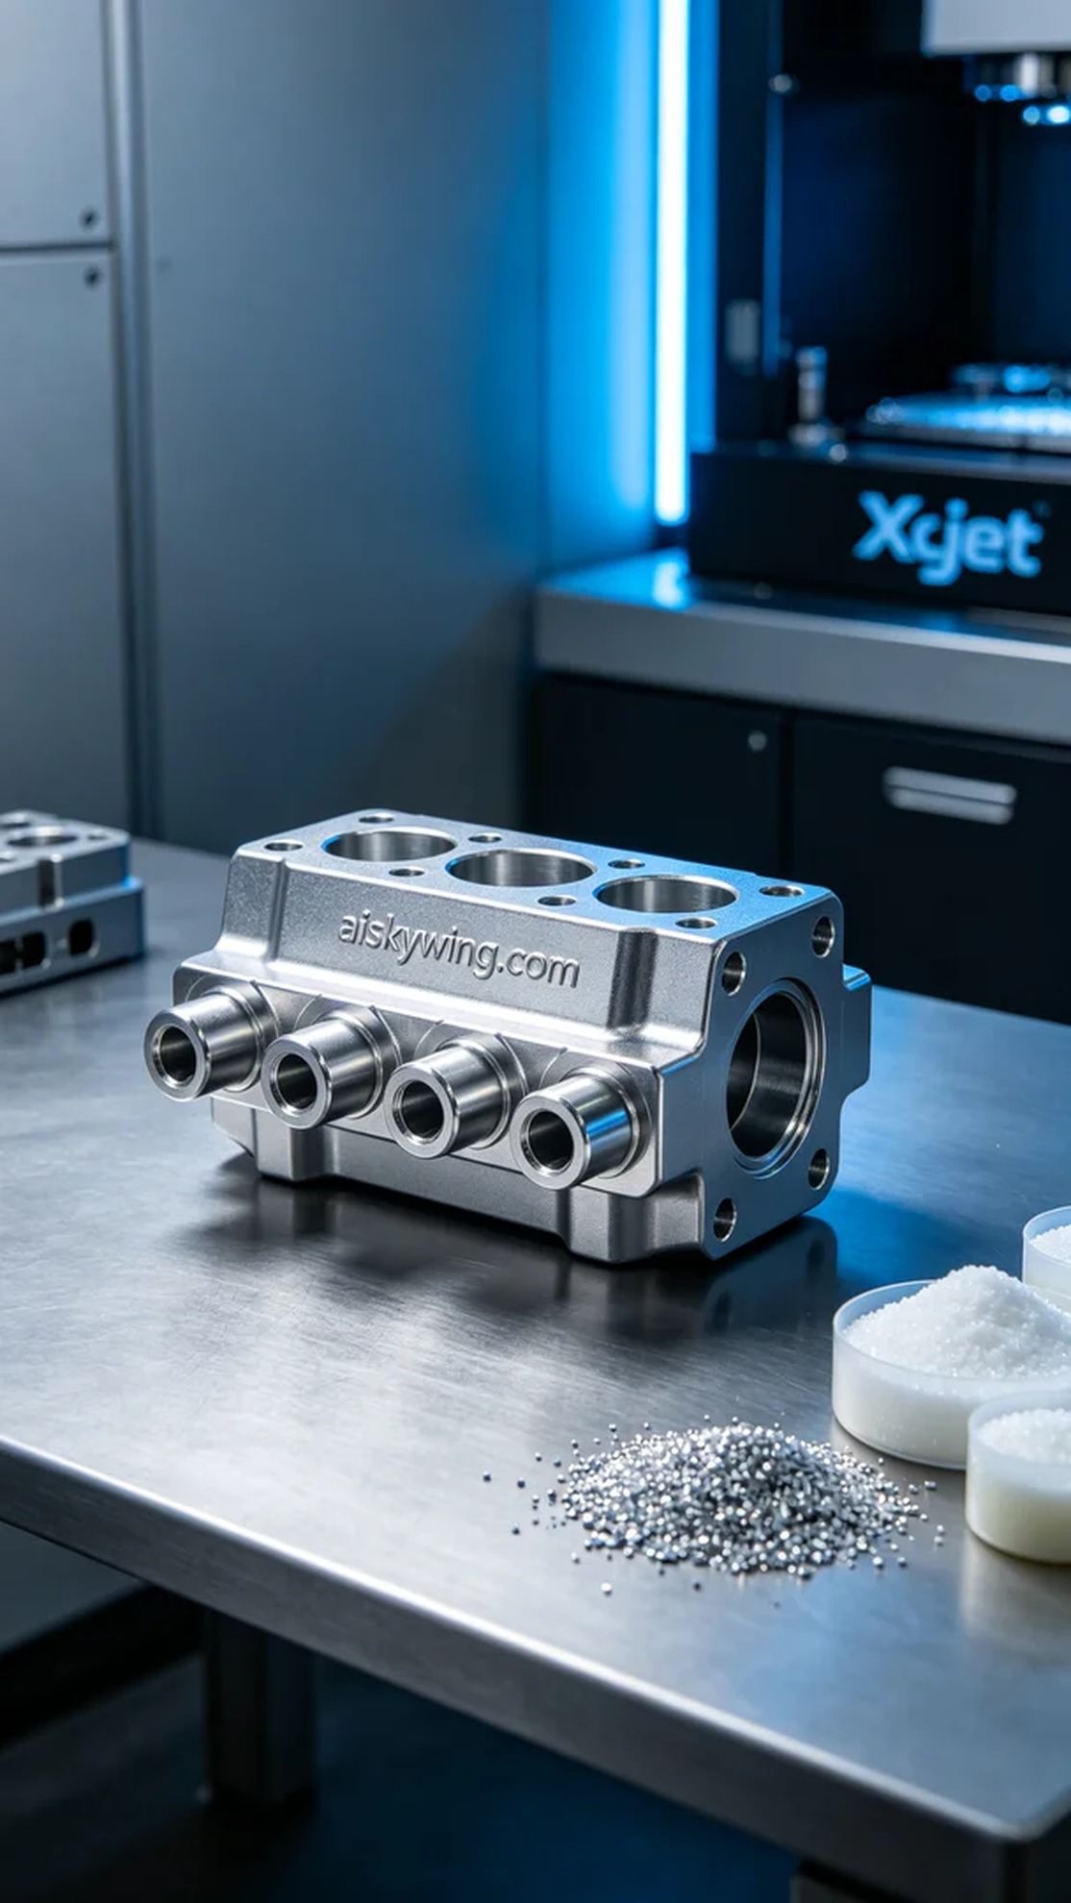
在Twitter上，有人因为需要一个高精度的制动四回路保护阀壳体而找到了我们，强调了他们对产品强烈的可靠性和性能需求。针对这个需求，我们在第一时间进行了一系列准备工作，力求完美呈现。
这次生产使用的是未成型的液态光敏树脂，原材料具有极高的流动性，适合于细致的打印工作。同时，我们准备了Xjet 3D打印机，设置了层厚为50微米，打印温度保持在120摄氏度，功率设置为200瓦，打印速度为30毫米每秒，预计打印时间为8小时，确保整个打印过程的精确性和稳定性。
打印过程中，Xjet打印机运转良好，材料逐层沉积，监控系统实时跟踪打印质量。每一层的结合都表现得十分完美，密度稳定在99%以上，保证了最终产品的坚固性和可靠性。整个过程保持了高标准的质量监控，为后续的后处理打下了良好的基础。
后处理工序至关重要。我们首先对打印件进行了清洗，使用超声波清洗机去除表面残留的树脂，之后进行细致的打磨，以达到光滑的表面效果。接下来，对已打印的阀壳体进行了固化处理，确保其达到最佳的力学性能。最终，我们对成品进行了严格的检验，确保每一个细节都符合设计标准。
从这一流程中，我们成功制作了满足需求的制动四回路保护阀壳体，展现了3D打印的无限可能与精湛工艺。每一步都在传递着我们的用心和专业，期待未来更多的合作机会。
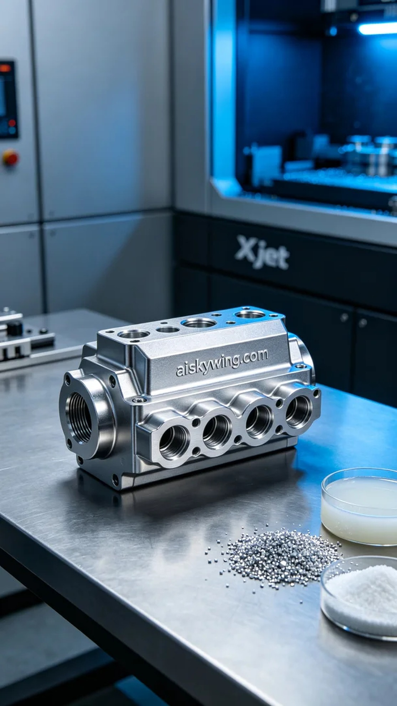
Aiskywing Industrial 3D Printing
Brake four-circuit protection valve housing


