0944-宠物洗脚杯外壳生产记录
Pet foot washing cup shell
🖨️ SLS尼龙烧结
🖥️ 打印机: Carbon
📦 材料: SLS耐高温尼龙
生活就像3D打印的过程，总要经历一些磨难才能成就美好。就像这个宠物洗脚杯外壳，是有人因产品的耐用性与时尚性而找上我们的。
Life is like the process of 3D printing; one must go through some hardships to achieve beauty. Just like this pet foot washing cup shell, someone approached us because of the product's durability and fashionability.
________________________________________________________________________________
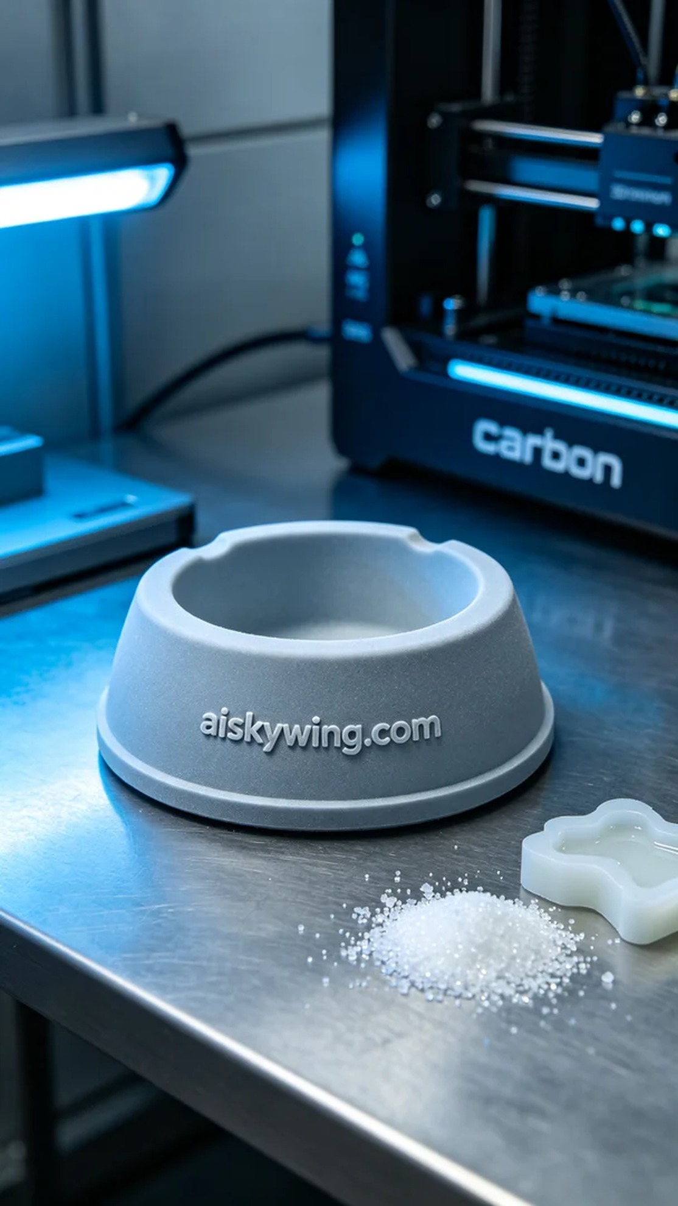
Life is like the process of 3D printing; we must overcome some challenges to achieve beauty. This pet foot washing cup shell is a project initiated by someone seeking durability and style in their product.
We chose SLS high-temperature nylon as the raw material, which can withstand temperatures over 150℃ and offers excellent mechanical properties, making it ideal for a pet foot washing cup. For the equipment, we utilized a Carbon 3D printer, setting the layer thickness to 0.1mm, the printing temperature around 180℃, power at 80%, speed controlled at 30mm/s, with an estimated print time of about 6 hours.
During the printing process, the Carbon printer ran smoothly. We closely monitored the print quality to ensure each layer was deposited evenly, avoiding defects. After every print, we meticulously inspected every detail to ensure the engraving of "aiskywing.com" was clear and that the surface texture matched our design expectations.
Post-processing was equally crucial. After printing, we began with a thorough cleaning to remove excess powder material. Next, we performed sanding to ensure a smooth surface. Then, a curing process was undertaken to enhance the shell's durability and heat resistance. Finally, we conducted a comprehensive inspection of the finished product to ensure it met high-quality standards.
In the end, this pet foot washing cup shell was completed on schedule, combining beauty and strength, successfully meeting the user's requirements. Every detail reflected our craftsmanship, bringing a sense of fulfillment.
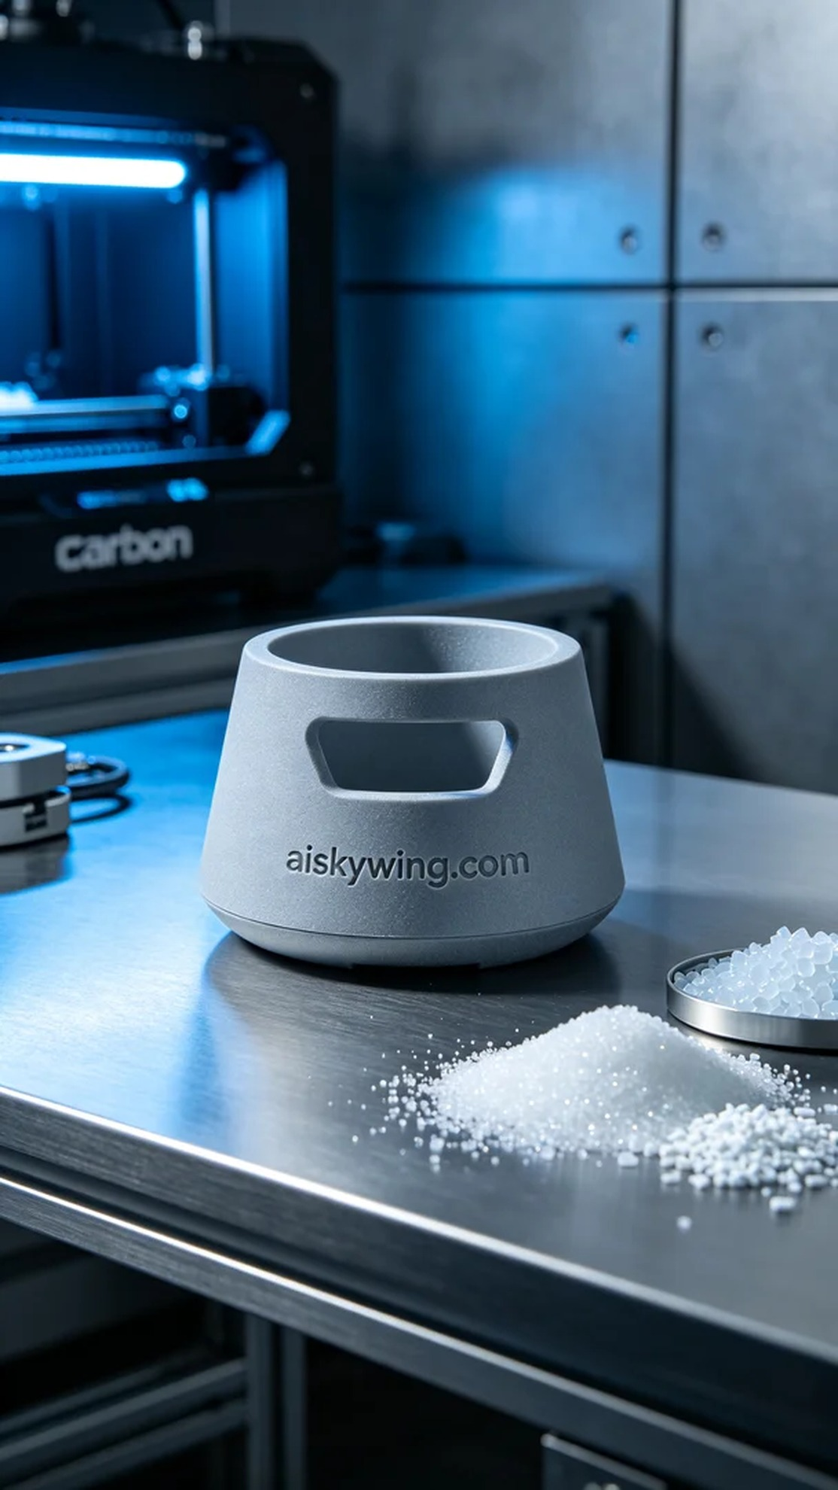
在Facebook上，有人向我们求助，因为他们需要一款既耐用又时尚的宠物洗脚杯外壳，以满足他们的需求。这个项目的挑战在于如何使用适合的材料和工艺，确保外壳的功能性和外观都能达到预期。
我们选择了SLS耐高温尼龙作为原材料，这种材料不仅耐温可达150℃以上，还具备良好的机械性能，适合宠物洗脚杯的使用场景。设备方面，使用了Carbon品牌的3D打印机，打印参数设置为层厚0.1mm，打印温度在180℃左右，功率设定为80%，速度控制在30mm/s，预计打印时间大约为6小时。
打印过程中，Carbon打印机的运行十分稳定。我们实时监控打印质量，确保每一层都能均匀沉积，避免出现缺陷。经过每次打印，我们都仔细检查每一个细节，确保雕刻的“aiskywing.com”字样清晰可见，并且表面磨砂感符合设计要求。
后处理工序同样重要。完成打印后，我们首先进行了清洗，以去除多余的粉末材料。接着进行打磨，确保表面光滑。然后再进行固化处理，增强外壳的耐用性和抗热性能。最后，我们对成品进行了全面检验，确保符合高标准的质量要求。
最终，这个宠物洗脚杯外壳如期完成，既美观又坚固，成功满足了使用者的需求。每一个细节都体现了我们的工匠精神，让人倍感欣慰。
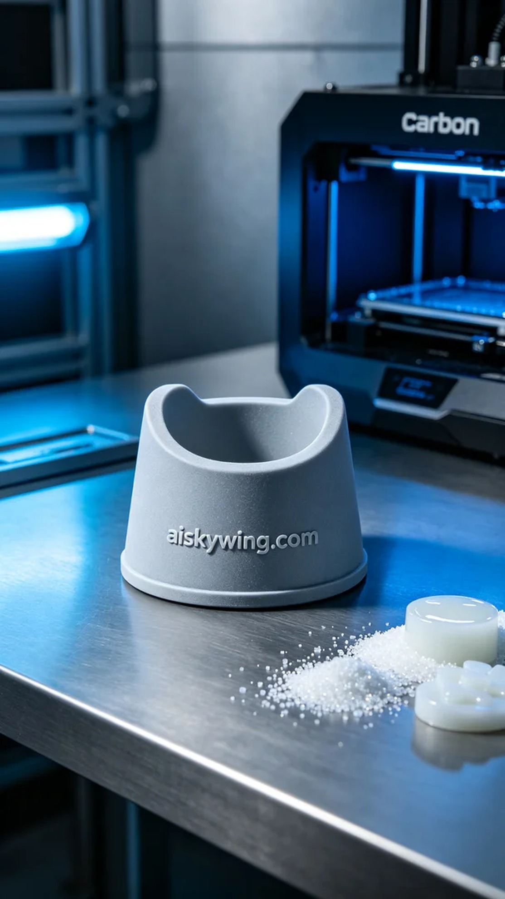
Aiskywing Industrial 3D Printing
Pet foot washing cup shell


