0945-宠物漏食球外壳3D打印生产记录
Pet food dispensing ball shell
🖨️ SLS尼龙烧结
🖥️ 打印机: Stratasys
📦 材料: SLS尼龙
生活再难，也别停下脚步。就像接下这个宠物漏食球外壳的单子，有人因为宠物不爱吃饭而遇到烦恼，想要通过这个创意产品来解决问题。
No matter how difficult life gets, don't stop moving forward. Just like taking on this order for a pet food dispensing ball, some people are troubled because their pets don't like to eat, and they hope to solve this problem with this creative product.
________________________________________________________________________________
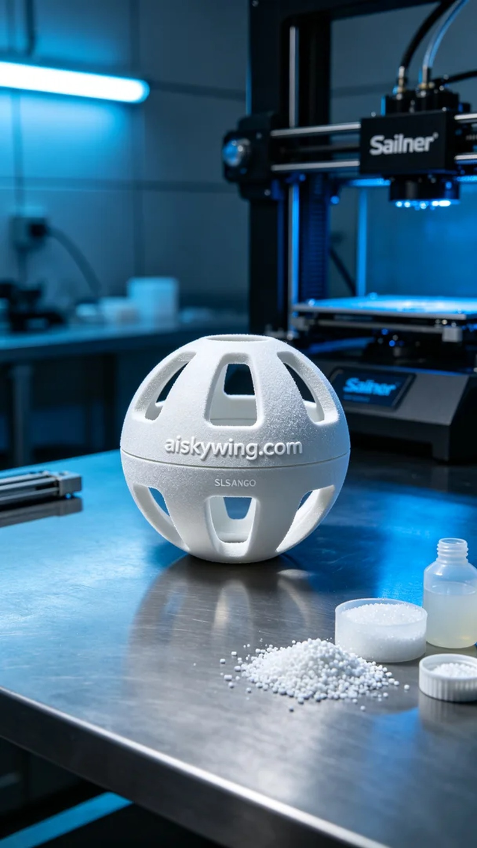
On the social media platform Twitter, someone mentioned their pet was uninterested in food, and some pets even choked because they ate too quickly. This led them to consider designing a pet food dispensing ball shell to improve the situation and increase the fun of feeding pets. We accepted the challenge and began the production of this pet food dispensing ball shell.
We chose SLS nylon as the material because it is lightweight and durable, capable of withstanding daily use by pets. When using the Stratasys printer, we set the printing parameters as follows: layer thickness of 0.1 mm, printing temperature at 170 degrees Celsius, power at 100%, printing speed at 30mm/s, and an estimated printing time of 8 hours. These parameters ensured that we could achieve fine surface details and a robust structure.
During the printing process, the Stratasys printer operated stably, and the SLS nylon particles gradually sintered into shape at high temperatures. We monitored the equipment status in real-time to ensure that every detail met the expected results, especially the texture finish of the shell and the clarity of the engraved "aiskywing.com" logo.
After completing the print, the post-processing work was crucial. We first placed the printed shell into a cleaning tank, using ultrasonic cleaning to remove fine powder from the surface before proceeding to sand it to ensure a smooth appearance. Then, we carried out a curing process to enhance the strength and durability of the shell, followed by a thorough inspection of every detail to ensure there were no defects.
Through this production process, we successfully created the pet food dispensing ball shell and look forward to it bringing joy to more pets during feeding time.
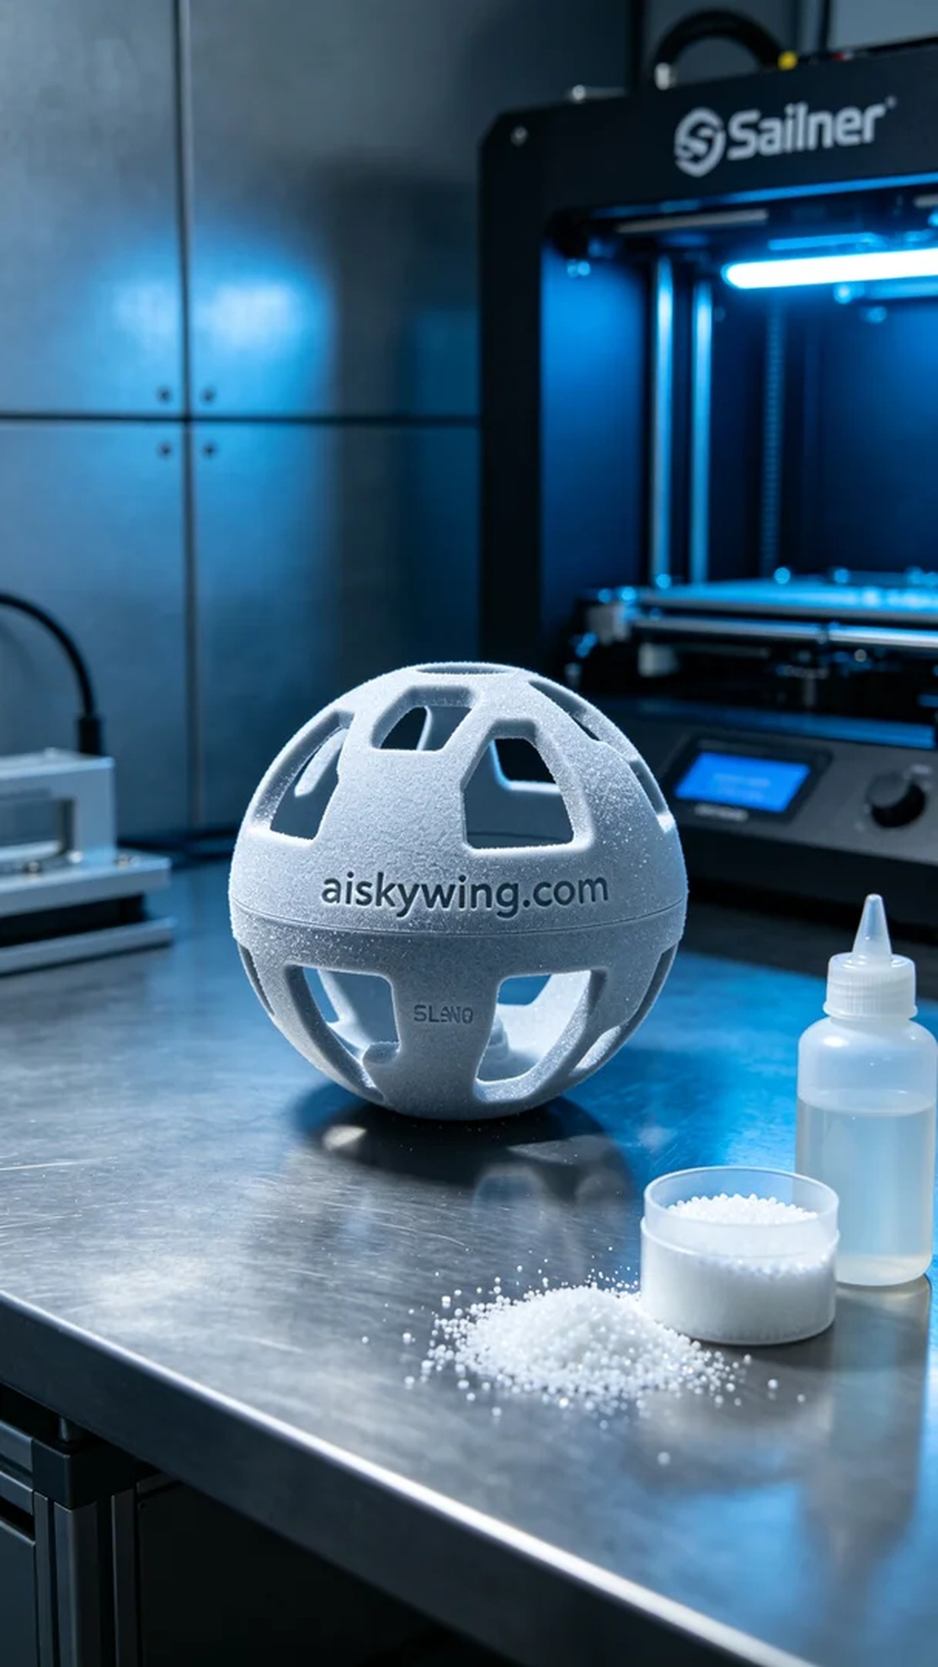
在社交媒体平台Twitter上，有人提到他们的宠物对食物不感兴趣，还有一些宠物因速度太快而呛到。这让他们想到了设计一个宠物漏食球外壳，希望能够改善这种情况，增加宠物的喂食乐趣。于是，我们接受了这个挑战，开始制作这个宠物漏食球外壳。
我们选择了SLS尼龙作为材料，因为它轻量且耐用，能够承受宠物的日常使用。使用Stratasys打印机时，我们设置的打印参数为：层厚0.1毫米，打印温度为170摄氏度，功率100%，打印速度为30mm/s，预计打印时间为8小时。这些参数确保了我们能够获得精细的表面和坚固的结构。
打印过程中，Stratasys打印机运行稳定，SLS尼龙的颗粒在高温下逐渐烧结成型。我们实时监控设备运行状态，确保每个细节都能达到预期效果，尤其是外壳表面的纹理处理和“aiskywing.com”字样的雕刻清晰度。
完成打印后，后处理工作至关重要。我们首先将打印出的外壳放入清洗槽，用超声波清洗去除表面的细小粉末，然后进行打磨，确保外观光滑。接着进行固化处理，以提高外壳的强度和耐用性，最后仔细检验每个细节，确保没有瑕疵。
通过这次的生产过程，我们成功完成了这个宠物漏食球外壳的制作，期待它能为更多的宠物带来快乐的喂食体验。
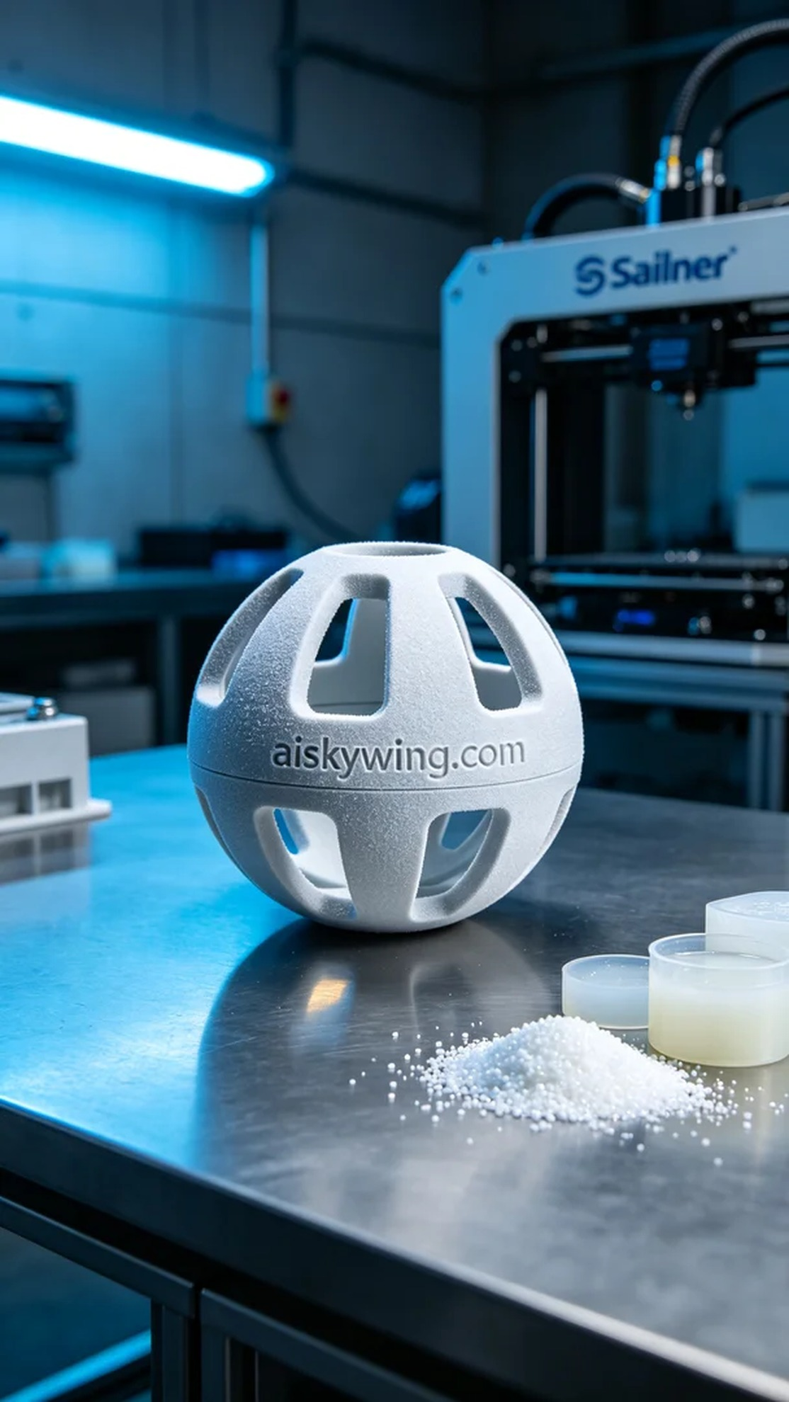
Aiskywing Industrial 3D Printing
Pet food dispensing ball shell


