0947-宠物牙刷手柄3D打印生产记录
Pet toothbrush handle
🖨️ SLS尼龙烧结
🖥️ 打印机: Xjet
📦 材料: SLS耐高温尼龙
生活再难，也别停下脚步。就像接下这个宠物牙刷手柄的单子，有人因为想让宠物更健康而找到我们。
No matter how difficult life gets, don't stop moving forward. Just like when we took on the order for this pet toothbrush handle, someone reached out to us because they wanted to make their pet healthier.
________________________________________________________________________________
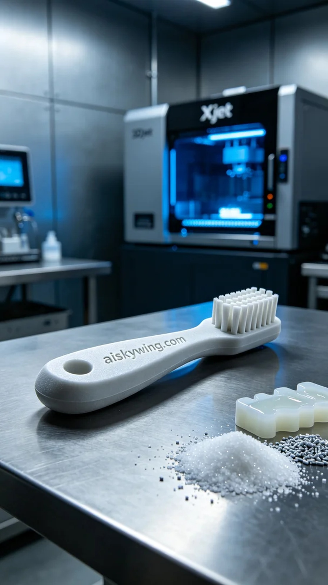
Life can be tough, but we should never stop moving forward. Just like when we took on the task of producing this pet toothbrush handle; someone reached out to us wanting to provide better care for their pet.
The raw material we chose is SLS nylon, known for its high-temperature resistance, capable of withstanding temperatures above 150℃. With a matte finish, this nylon provides a non-slip grip perfect for the toothbrush handle. To ensure quality, we prepared the Xjet 3D printer, setting the layer thickness to 0.1 mm, the printing temperature to 220℃, power to 80%, and printing speed to 50 mm/s, so that every detail would be captured perfectly.
During the printing process, we closely monitored the printer’s performance to ensure material flow and precision. The Xjet printer operated steadily, layering the material with impressive clarity, and the shape of the handle began to reveal itself layer by layer over a few hours.
Once the printing was complete, we proceeded with crucial post-processing steps. First, the handle was placed in a cleaning tank where residual powder was removed using a specialized cleaning solution. Then, we moved on to sanding to enhance the smoothness of the handle. Finally, the toothbrush handle was cured under UV light in a curing machine to ensure its durability and strength, followed by a thorough inspection to ensure all dimensions met the required standards.
In the end, this pet toothbrush handle was completed with meticulous craftsmanship and stringent quality checks, showcasing the strengths of SLS nylon and the exceptional performance of the Xjet printer.
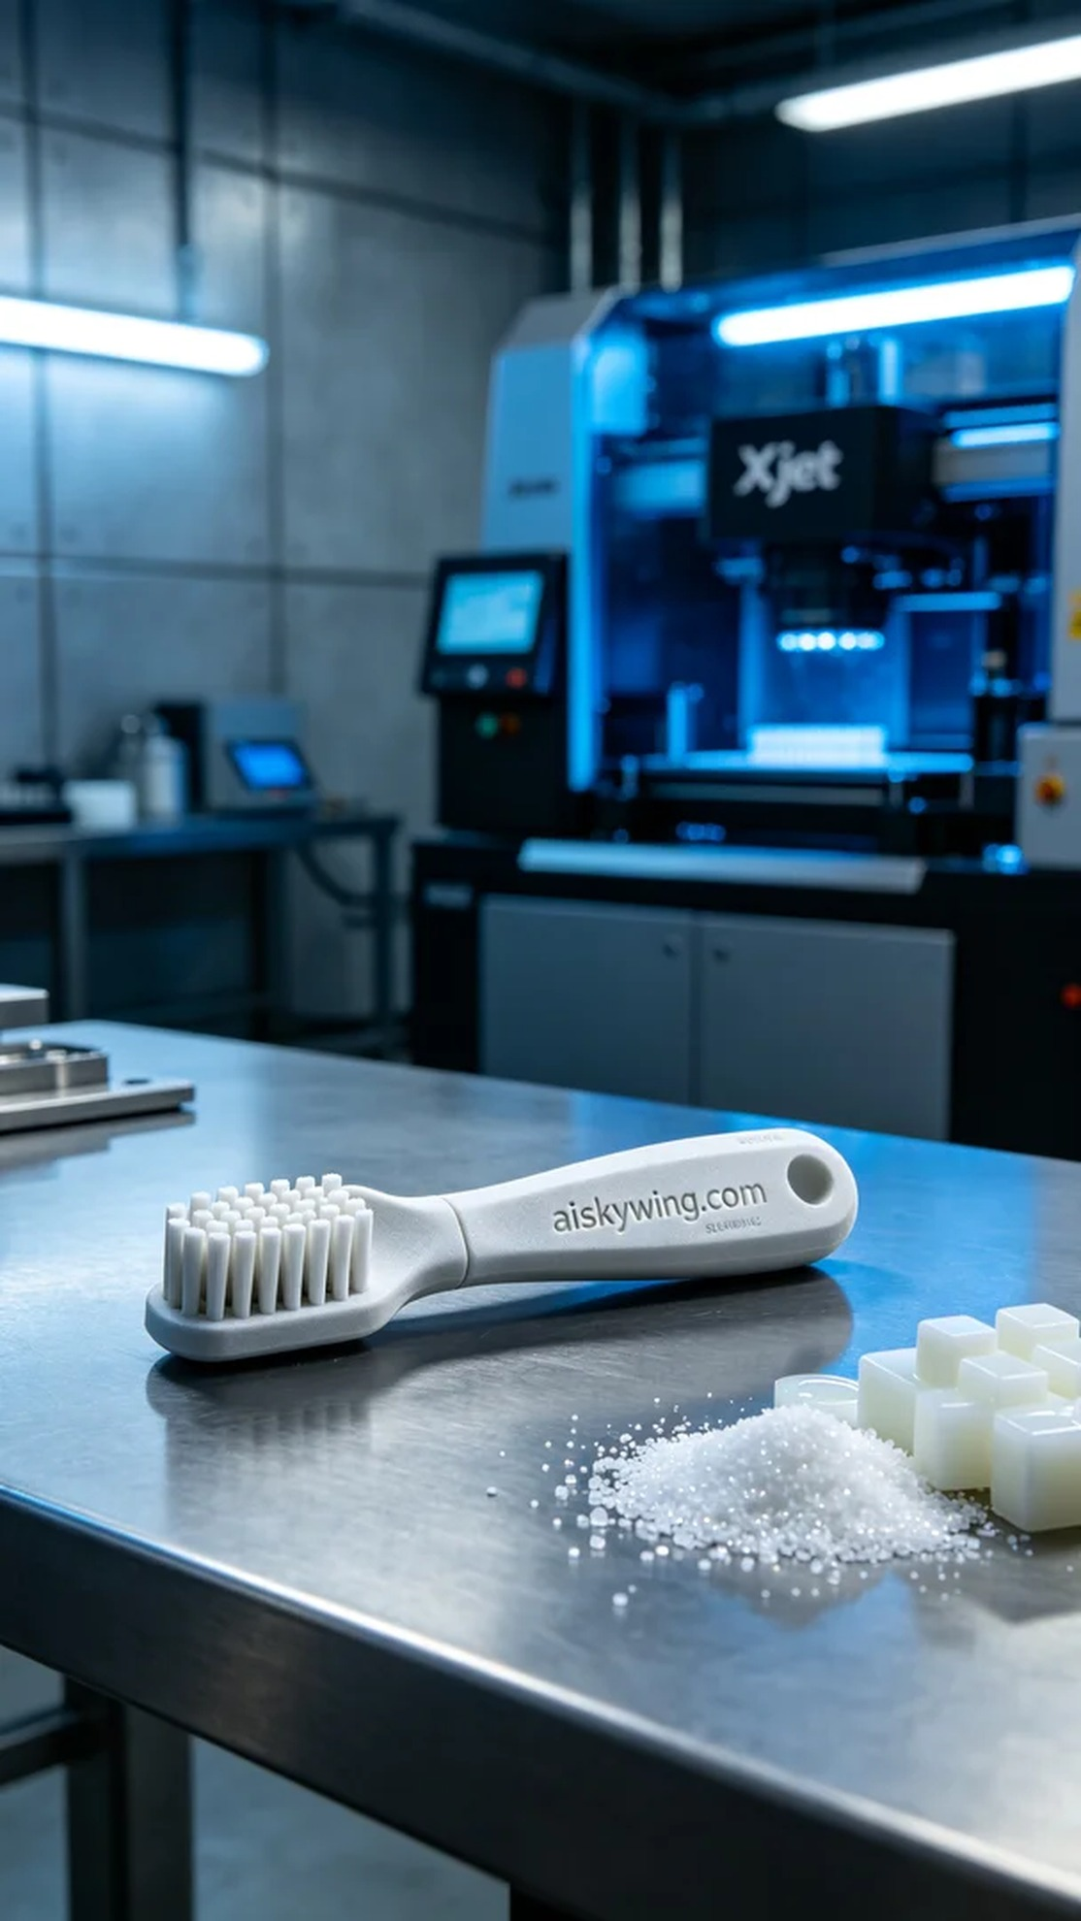
在LinkedIn上，有人因为宠物护理的需求找到我们，希望能生产一款高质量的宠物牙刷手柄。这个产品不仅要适应高温环境，更要方便使用，因此我们选择了SLS耐高温尼龙作为主要材料。
原材料SLS耐高温尼龙具有优异的耐热性，能够承受高达150℃的温度，并且表面磨砂质感使得手柄在使用时不会滑落。为了确保打印质量，我们准备了Xjet品牌的3D打印机，并设置了层厚0.1毫米、打印温度220℃、功率80%和打印速度50毫米每秒等参数，确保每个细节都能完美呈现。
打印过程中，我们严格监控设备的运行状态，确保材料的流动性和打印精度。Xjet打印机在运转时保持稳定，打印效果逐层堆叠，每个细节都清晰可见。经过几个小时的打印，手柄的基本形状逐渐显现，令人期待。
完成打印后，后处理工序不可忽视。我们首先将手柄放入清洗槽，使用清洗液去除残留的粉末，接着进行打磨处理，使得手柄的触感更加光滑。最后，手柄被放入固化机内，经过UV光照射进行固化，确保其强度和耐用性，最后进行检验，确保每个尺寸都符合标准。
最终，这款宠物牙刷手柄在精细的工艺和严格的质检下顺利完成，充分展现了SLS耐高温尼龙的特性和Xjet打印机的卓越性能。
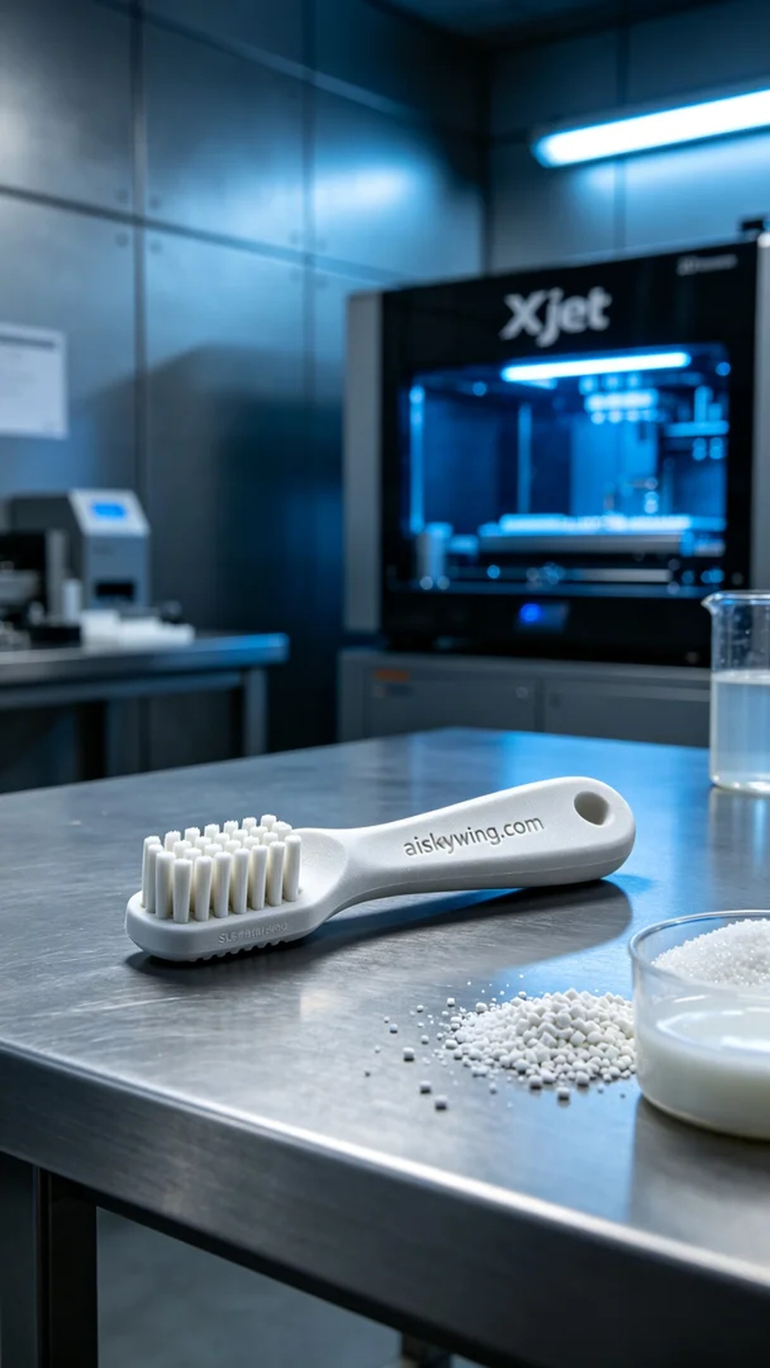
Aiskywing Industrial 3D Printing
Pet toothbrush handle


