0948-宠物牙膏挤出器的3D打印记录
Pet toothpaste dispenser
🖨️ SLS尼龙烧结
🖥️ 打印机: Mimaki
📦 材料: SLS阻燃尼龙
生活中总有一些小问题，像这个宠物牙膏挤出器的需求，促使我们用心去解决。LinkedIn上的朋友们，就是因为这个需求找到了我们。
In life, there are always small problems, like the need for this pet toothpaste dispenser, that prompt us to solve them thoughtfully. Friends on LinkedIn found us because of this demand.
________________________________________________________________________________
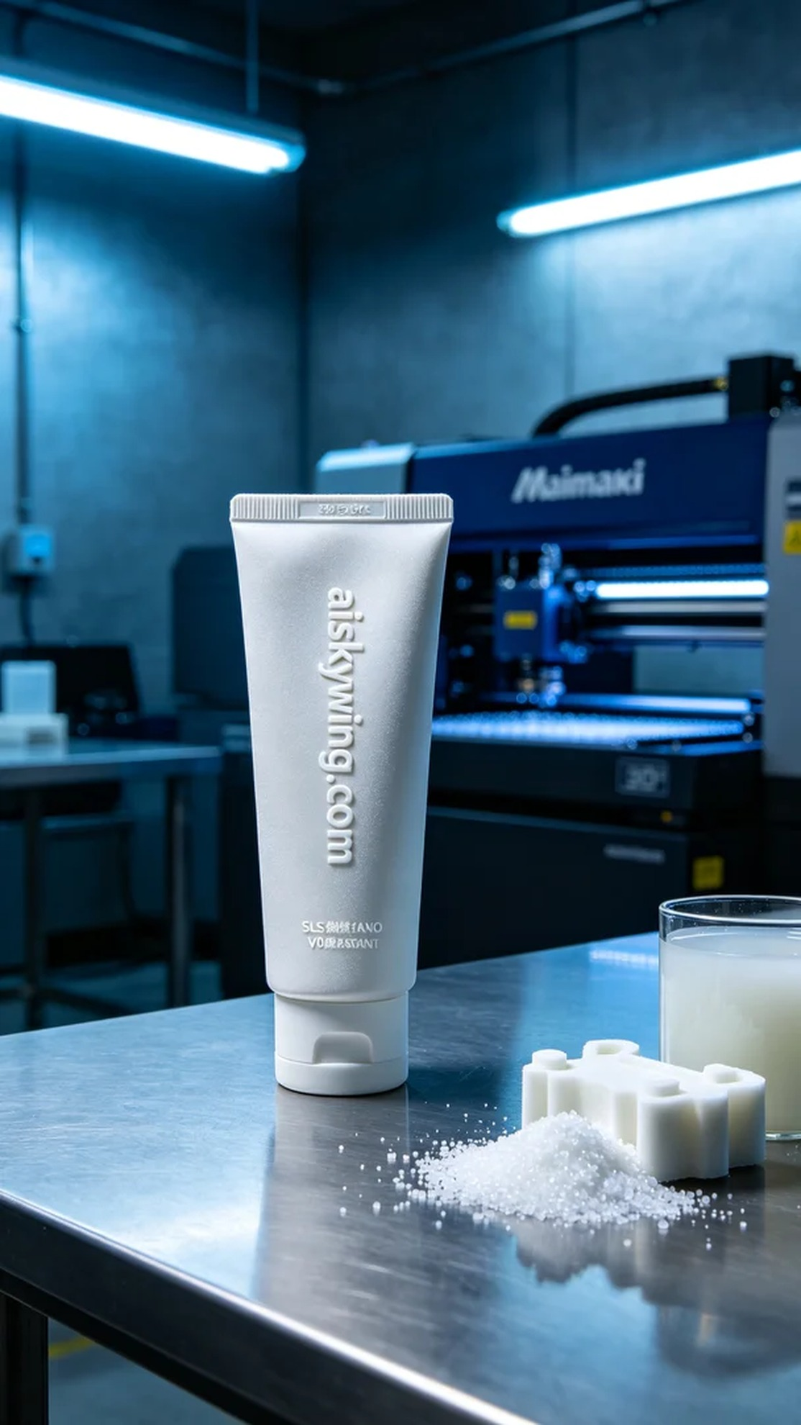
In our daily lives, there are always small issues that prompt us to find solutions. The request for a pet toothpaste dispenser came from a connection on LinkedIn, leading us to address this need with dedication.
We chose SLS flame-retardant nylon for this project, as it offers excellent mechanical strength and a V0 flame-retardant rating, making it ideal for pet products. In terms of equipment preparation, we ensured that our Mimaki printer was in optimal condition and set the appropriate print parameters. The layer thickness was set to 0.1mm, printing temperature maintained at 190℃, laser power set to 40W, printing speed at 30mm/s, with an estimated total print time of 8 hours to ensure every detail was flawlessly executed.
During the printing process, the Mimaki printer operated steadily. We closely monitored print quality to ensure each layer bonded thoroughly to form a robust structure. At critical moments, we paid special attention to material flow and temperature variations, allowing us to adjust parameters promptly and guarantee a flawless final product.
After printing, we carried out a detailed post-processing procedure. First, the final product was cleaned to remove excess powder, followed by meticulous sanding to ensure a smooth, flawless surface. Next, we performed a curing treatment to enhance durability and flame-retardant properties and conducted strict inspections to ensure each item met our standards.
In the end, we successfully completed the production of this batch of pet toothpaste dispensers. Through this 3D printing experience, we not only addressed practical issues but also demonstrated the efficiency and reliability of the Mimaki printer in production.
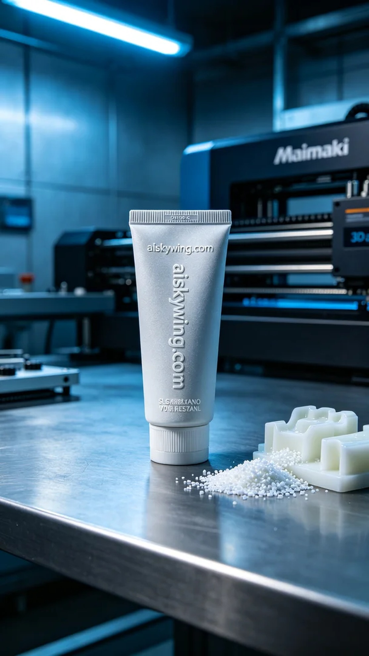
今天，我们接到一个关于宠物牙膏挤出器的订单，有人希望能找到一个合适的解决方案。为了满足这个要求，我们决定使用SLS尼龙烧结工艺，借助Mimaki打印机进行生产。客户希望这个产品能够具备良好的阻燃性和耐用性，以确保宠物的安全。
我们选择了SLS阻燃尼龙作为原材料，这种材料具有优异的机械强度和V0级的阻燃性能，非常适合在宠物日常用品中使用。在设备准备方面，我们确保Mimaki打印机处于最佳状态，同时设置了合适的打印参数。层厚度设定为0.1mm，打印温度保持在190℃，激光功率设置为40W，打印速度为30mm/s，整个打印预计需要8小时，这样可以确保每个细节的完美呈现。
在打印过程中，Mimaki打印机稳定地运行。我们密切监控打印质量，确保每一个层次都能够充分结合，形成坚固的结构。在打印的关键时刻，我们特别注意材料的流动性和温度变化，以便及时调整参数，确保最终的成品无瑕疵。
完成打印后，我们进行了详细的后处理工序。首先，我们对成品进行了清洗，以去除多余的粉末，然后进行了细致的打磨，确保表面光滑无瑕。接着，我们对产品进行了固化处理，以增强其耐用性和阻燃性，最后进行了严格的检验，以确保每一件产品都符合标准。
最终，我们成功地完成了这批宠物牙膏挤出器的制作。通过这次的3D打印经验，我们不仅解决了实际问题，也证明了Mimaki打印机在生产中的高效与可靠。
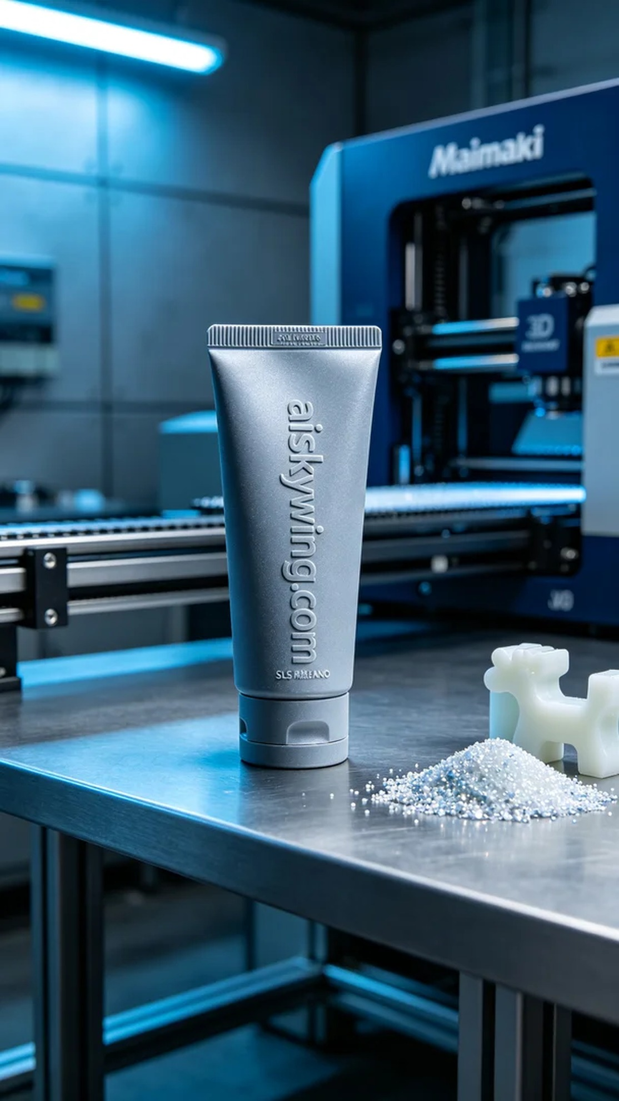
Aiskywing Industrial 3D Printing
Pet toothpaste dispenser


