0951-宠物牵引绳手柄3D打印生产记录
Pet leash handle
🖨️ SLS尼龙烧结
🖥️ 打印机: HP
📦 材料: SLS尼龙
生活就像3D打印，耐心和细致才能成就完美。最近，有人通过Instagram找到我们，希望制作一款宠物牵引绳手柄。
Life is like 3D printing; patience and attention to detail are essential for achieving perfection. Recently, someone reached out to us through Instagram, hoping to create a pet leash handle.
________________________________________________________________________________
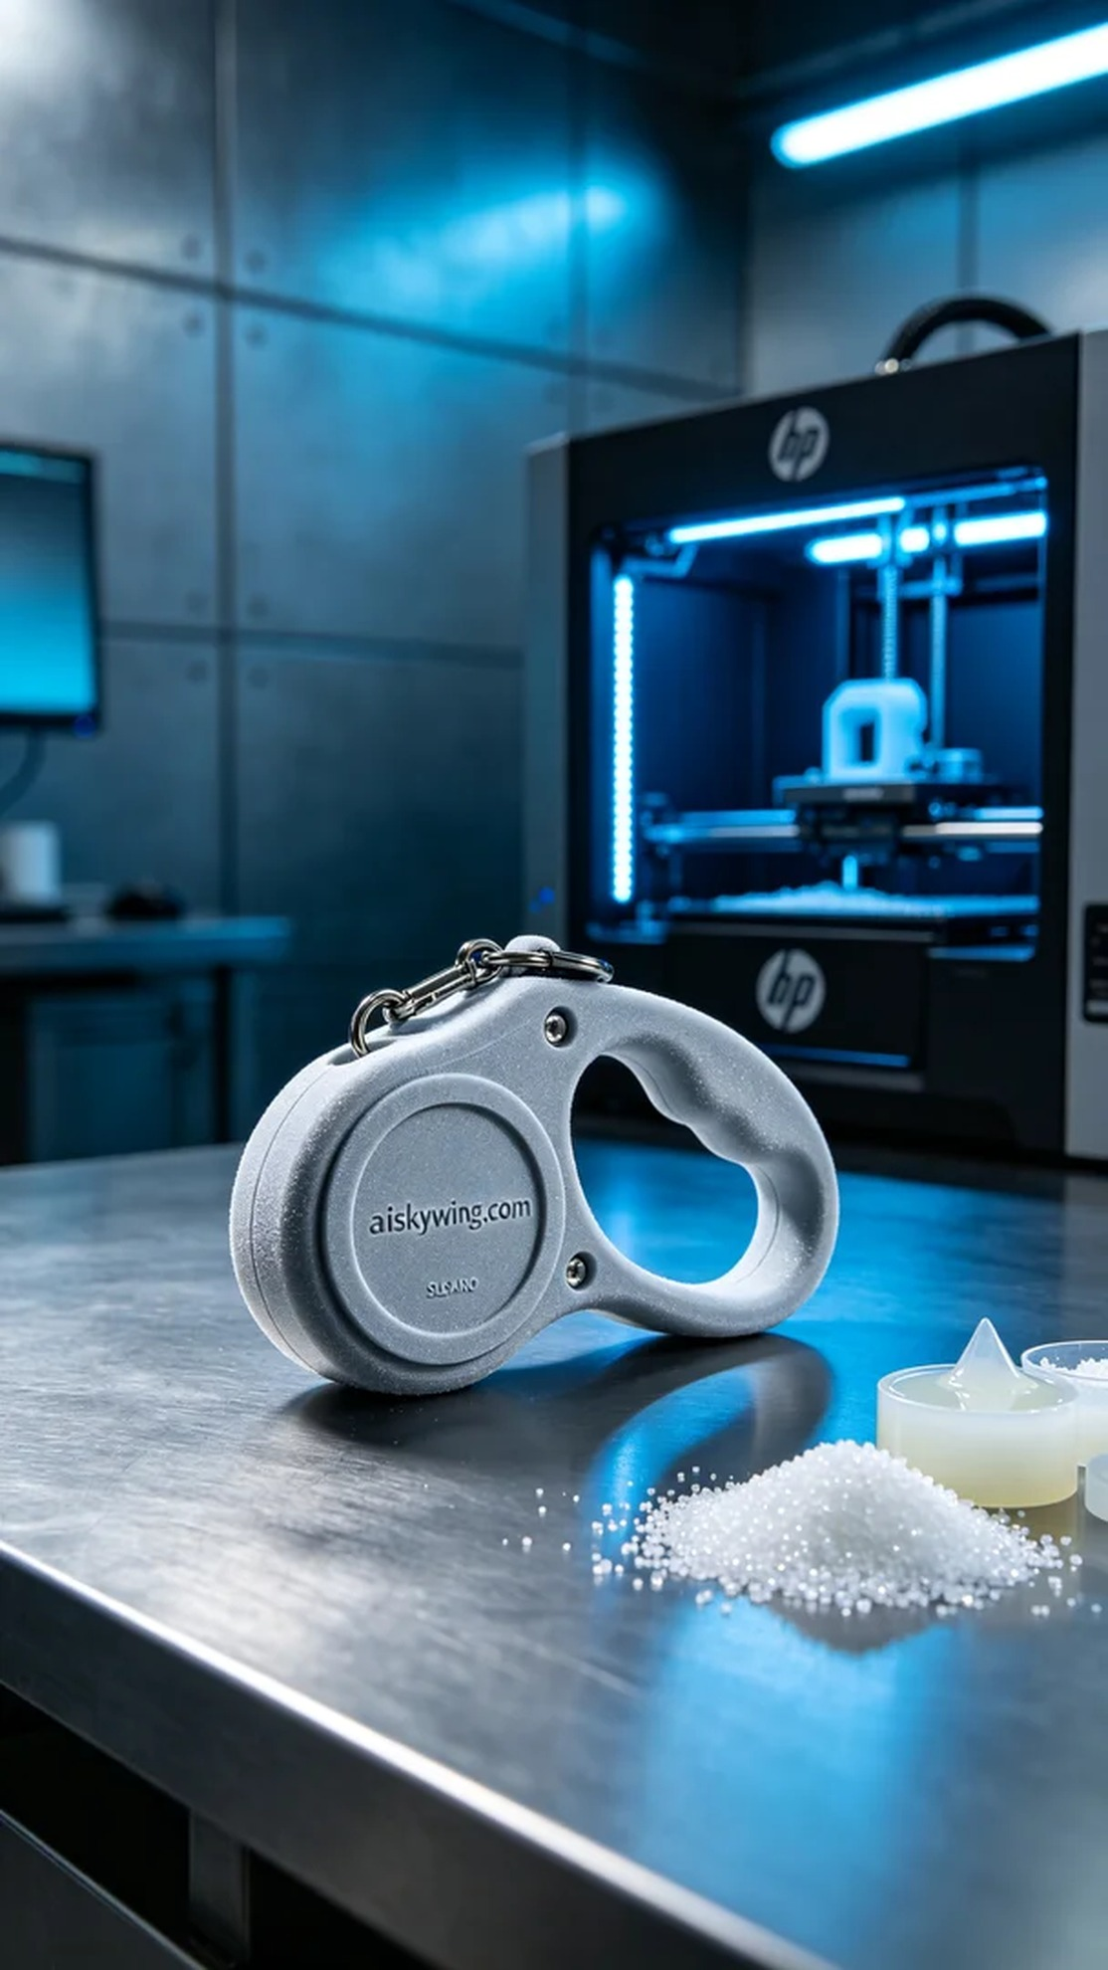
Life is like 3D printing; patience and attention to detail are essential for perfection. Recently, someone reached out to us through Instagram, seeking to create a durable and aesthetically pleasing pet leash handle.
In the preparation phase, we carefully selected SLS nylon as the printing material. It offers excellent mechanical properties and good wear resistance, making it ideal for pet use. The settings for the HP printer were adjusted to a layer thickness of 0.1mm, a printing temperature of 180°C, a power setting of 90%, and a print speed of 40mm/s. With precise design and preparation, we ensured that every detail would be perfectly captured.
The printing process went smoothly, with the HP printer operating in optimal condition. The real-time monitoring system of the device helped us detect subtle changes, ensuring even sintering of the material. As each layer gradually formed, the outline of the pet leash handle became increasingly clear, and the fine surface texture shone brilliantly in the stark industrial lighting.
After printing, we commenced the post-processing steps. First, we cleaned the printed handle to remove excess powder. Next, we sanded it down to ensure all edges were smooth, preventing any harm to pets. Finally, we cured it to optimize the handle's strength and conducted rigorous quality inspections to ensure each product met our high standards.
Ultimately, this pet leash handle emerged with a fresh sheen after our series of meticulous efforts. We look forward to seeing it bring convenience and joy to more pets and their owners.
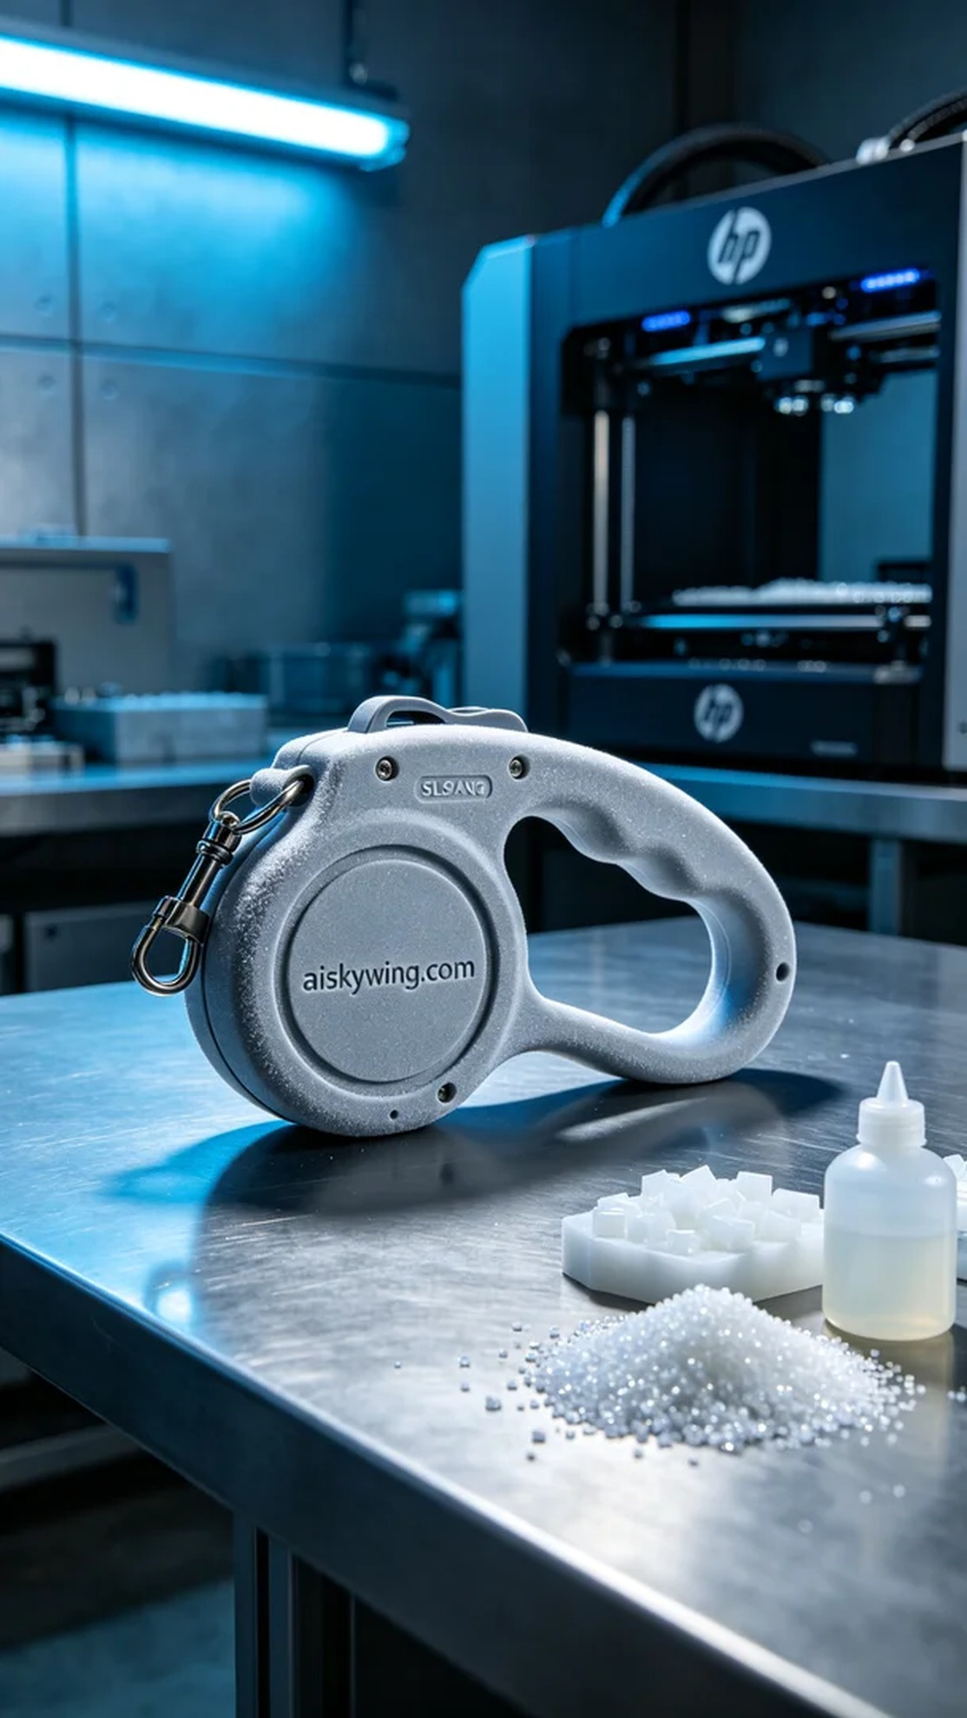
我们最近接到了一个来自Instagram的请求，有人希望我们能为他们制作一款耐用且设计精美的宠物牵引绳手柄。他们在寻找一种能够轻量化且又具备强度的材料，最终SLS尼龙成为了他们的首选。
在准备环节，我们仔细挑选了SLS尼龙作为打印材料。它具有优异的机械性能和良好的耐磨性，适合宠物使用。使用的HP打印机参数设置为：层厚0.1mm，打印温度为180℃，功率设置为90%，打印速度则调整为40mm/s。经过精确的设计和准备，我们确保了每一个细节都能完美呈现。
打印过程顺利进行，HP打印机的运行状态良好。设备的实时监控系统帮助我们检测到细微的变化，确保材料的均匀烧结。随着每一层的逐渐成型，宠物牵引绳手柄的轮廓愈加清晰，细腻的表面细微纹理也在冷峻的工业光线中显得格外迷人。
完成打印后，我们开始了后处理工序。首先，将打印出的手柄进行清洗，以去除多余的粉末。接着，经过打磨处理，确保所有边缘光滑，避免对宠物造成伤害。最后，进行固化，让手柄的强度达到最佳状态，并经过严格的质量检验，确保每一件产品都符合标准。
最终，这款宠物牵引绳手柄在经过我们的一系列精细工作后，焕发出崭新的光彩。我们期待它能为更多的宠物和主人带来便利与快乐。
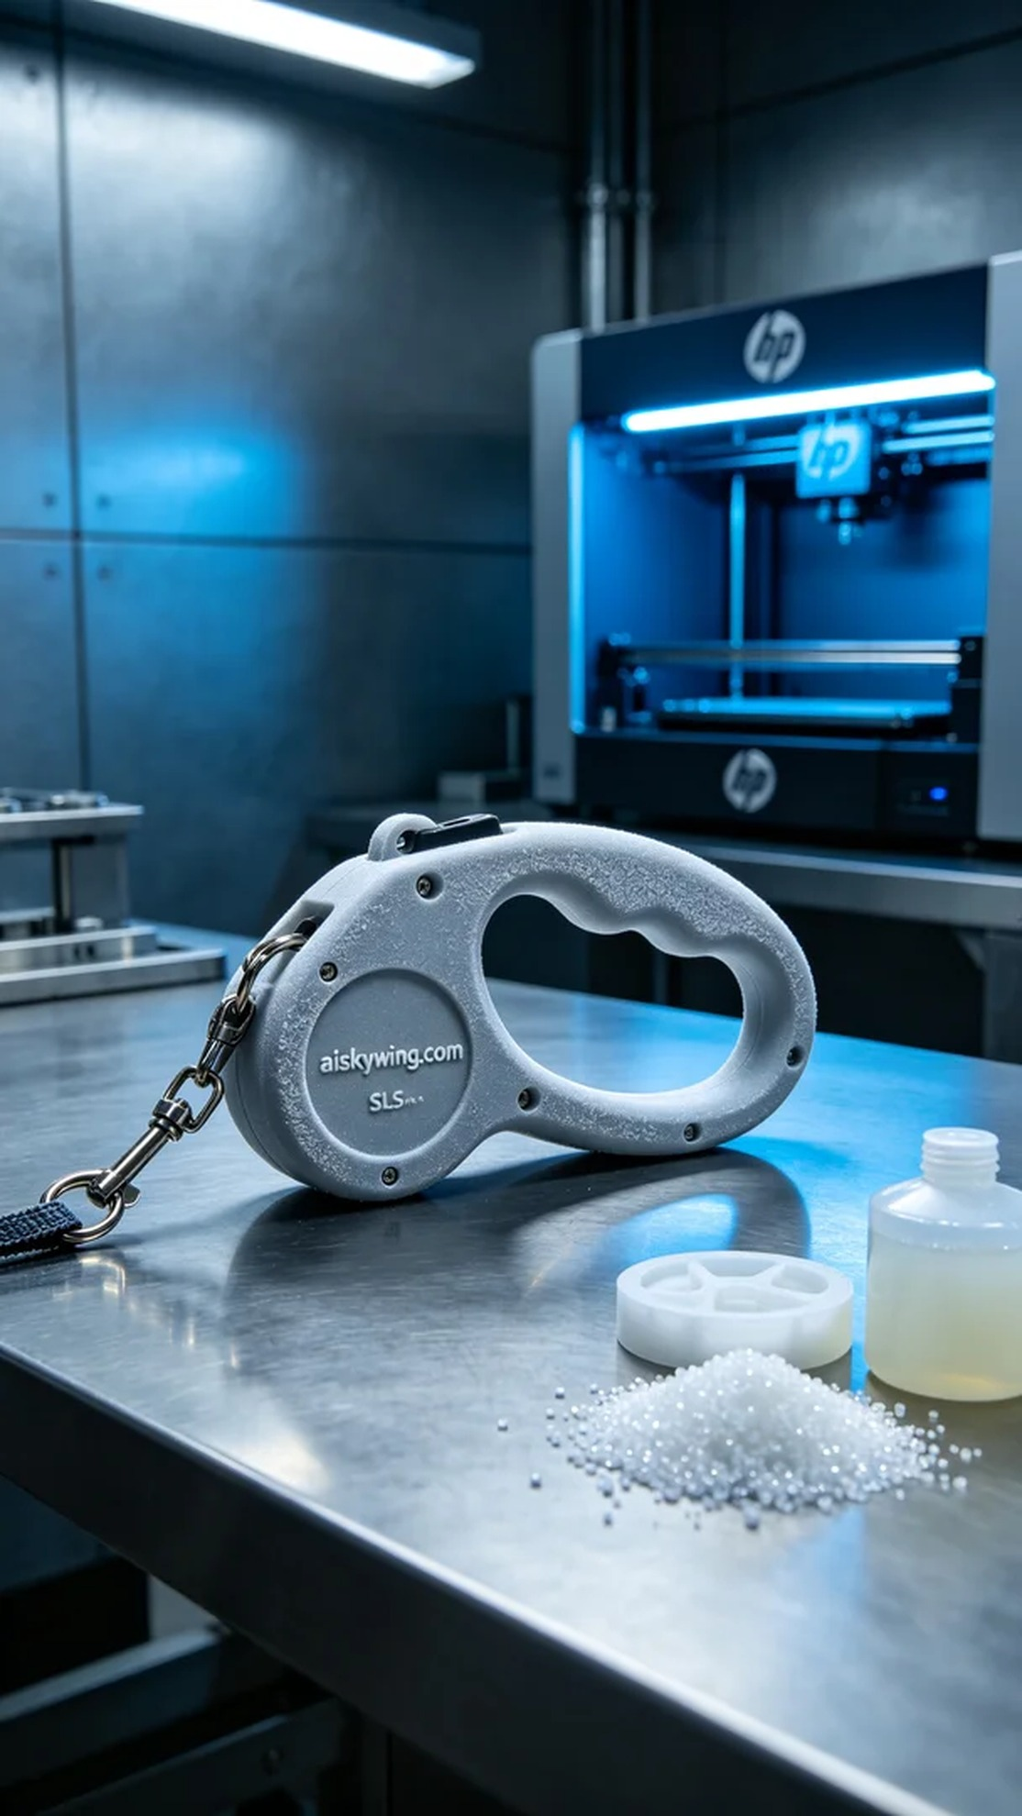
Aiskywing Industrial 3D Printing
Pet leash handle


