0952-宠物猫爬架连接件的3D打印记录
Pet cat climbing frame connector
🖨️ SLS尼龙烧结
🖥️ 打印机: HP
📦 材料: SLS阻燃尼龙
有时候咬牙坚持，不是为了证明什么。就像做这个宠物猫爬架连接件时，有人找到我，想解决他们的猫咪爬架连接问题。
Sometimes, gritting your teeth and persevering is not about proving anything. It's like when I was working on the connector for this cat climbing frame; someone approached me wanting to solve their cat climbing frame connection issue.
________________________________________________________________________________
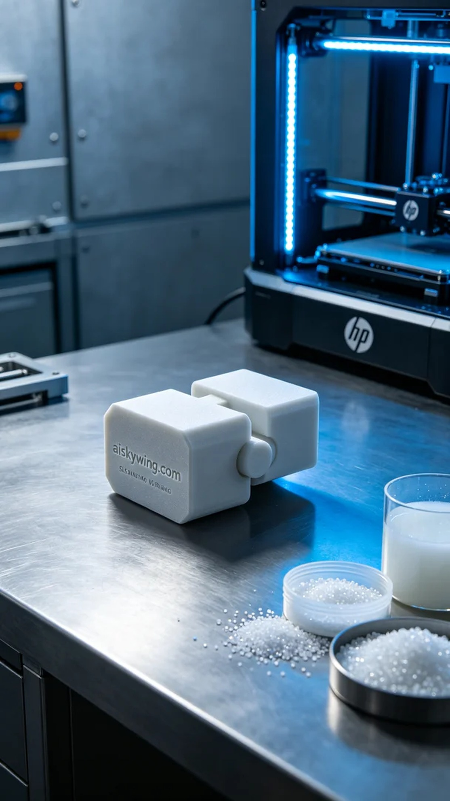
Sometimes holding on and pushing through isn't about proving anything. Like when we worked on the pet cat climbing frame connector, someone approached us to solve their stability issue with their existing climbing frame connections.
For this project, we chose SLS flame-retardant nylon as our material. This material not only offers excellent strength and toughness but also possesses V0 flame-retardant ratings, ensuring safety for pet products. We set the HP printer parameters to a layer thickness of 0.1mm, with a temperature of 210°C, a power output of 25%, and a speed of 15mm/s, estimating the entire print process to take around 8 hours for perfect layer adhesion.
Throughout the printing process, the HP printer ran efficiently and steadily, which was satisfying. We kept a close eye on the temperature and power output, ensuring high-quality prints while regularly checking the progress to prevent any blockages or deviations. Ultimately, the connector turned out perfectly, with a refined surface and clear details.
After printing, we proceeded with the post-processing steps. First, we placed the finished product in a cleaning tank to remove any unformed powder. Next, we sanded the surface using fine sandpaper to ensure there were no sharp edges that could harm the cats. Finally, we cured the connector to ensure its strength was at its best before performing a final quality inspection.
After a series of meticulous steps, the pet cat climbing frame connector was completed on schedule, being both aesthetically pleasing and practical. We are thrilled to provide such a high-quality solution for someone, confident that their cats will enjoy playing on the new climbing frame.
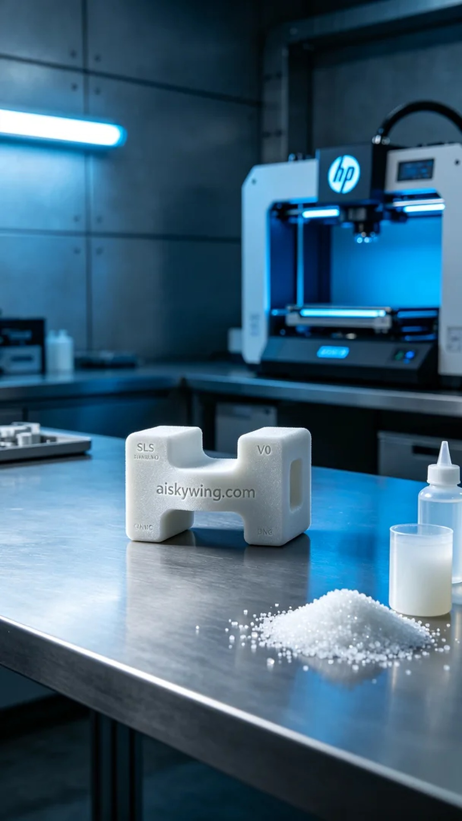
今天，我们接到了一个关于宠物猫爬架连接件的订单。有人向我们咨询如何解决他们在使用现有爬架时的连接不够坚固的问题。这让我们决定使用HP品牌的3D打印机为他们打造出一个更为稳固的连接件。
原材料方面，此次我们选用了SLS阻燃尼龙，这种材料不仅具备良好的强度和韧性，还具有V0级的阻燃性能，适合宠物用品的安全性需求。打印机参数设定为：层厚0.1mm，温度210°C，功率为25%，速度为15mm/s。整个打印过程预计需时约8小时，确保每一层都完美结合。
在打印过程中，HP打印机高效稳定的运行令人满意。我们始终关注设备的温度和功率输出，确保打印质量。同时，定时检查打印进度，确保没有出现任何堵塞或偏差。最终，连接件完美呈现，表面细腻，细节清晰可见。
完成打印后，我们进行了后处理工序。首先，将成品放入清洗槽中，清洗掉未成型的粉末。接着，使用细砂纸对连接件的表面进行打磨，确保没有锐利边缘，避免对猫咪造成伤害。最后，我们对连接件进行了固化处理，确保其强度达到最佳状态，并进行最终的质量检验。
经过一系列严格的步骤，这个宠物猫爬架连接件如期完成，既美观又实用。我们非常高兴能够为有人提供这样高质量的解决方案，相信他们的猫咪会在新爬架上玩得开心。
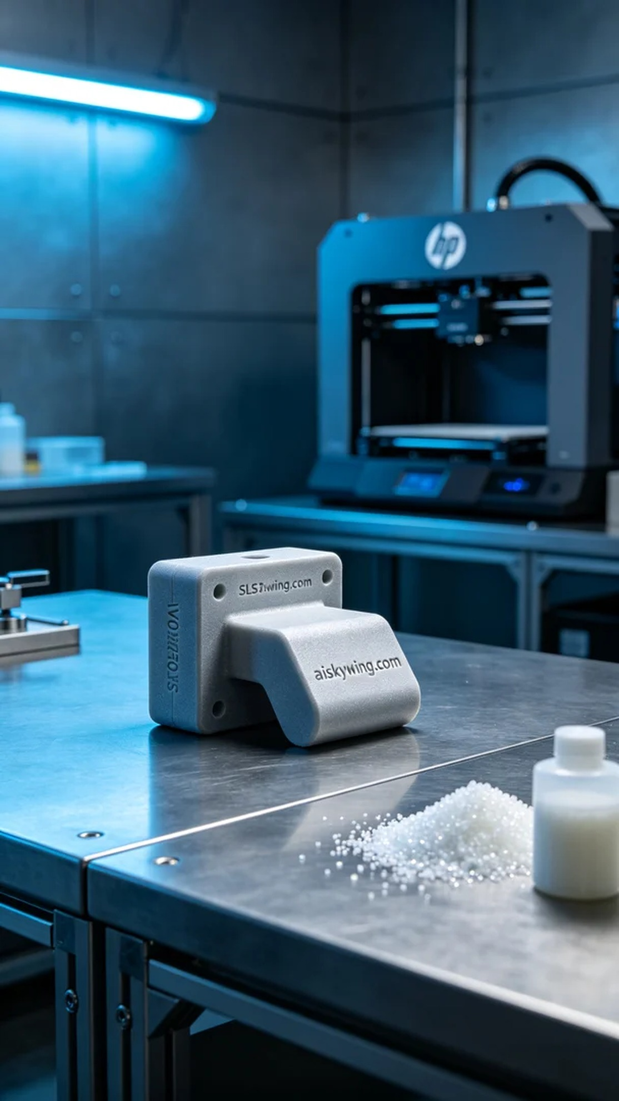
Aiskywing Industrial 3D Printing
Pet cat climbing frame connector


