0953-宠物猫砂盆铲的3D打印记录
Pet cat litter scoop
🖨️ SLS尼龙烧结
🖥️ 打印机: Voxeljet
📦 材料: SLS尼龙PA12
生活再难，也别停下脚步。就像接下这个宠物猫砂盆铲的单子，有人因为缺乏合适的工具而求助于我们，想要解决他们的烦恼。
生活再难，也别停下脚步。就像接下这个宠物猫砂盆铲的单子，有人因为缺乏合适的工具而求助于我们，想要解决他们的烦恼。
________________________________________________________________________________
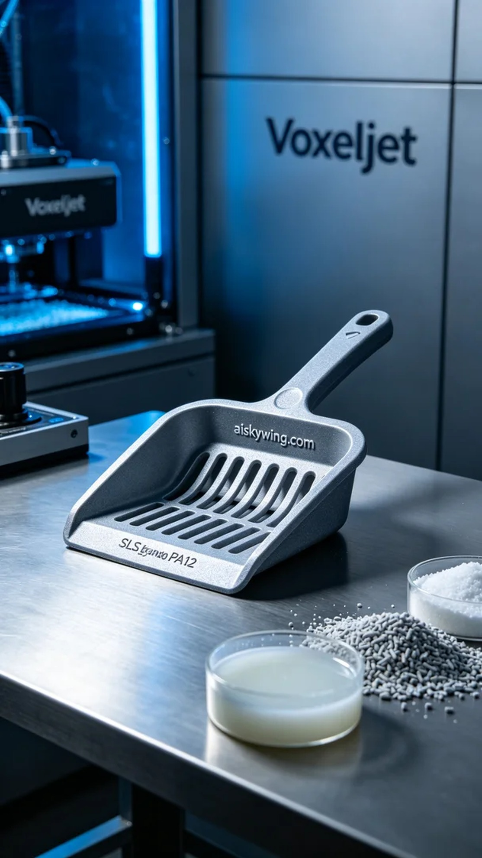
In today's work, someone reached out to us, expressing their concerns about using conventional cat litter scoops, particularly regarding the material and strength. Consequently, we decided to print a new pet cat litter scoop to address their issues.
Before production, we selected SLS nylon PA12 as the primary material. This material offers excellent strength and toughness, while its matte surface texture effectively resists wear and tear. During the preparation, we utilized a Voxeljet 3D printer, setting appropriate parameters: a layer thickness of 0.1 mm, a temperature of 180 degrees Celsius, a laser power of 40 watts, a printing speed of 300 mm per second, and an estimated printing time of 4 hours.
The printing process went smoothly, with the Voxeljet printer performing reliably, effectively translating the design into a physical product. Throughout the process, we closely monitored the machine's operation to ensure no abnormalities arose. After several hours, the scoop was finally formed, and its appearance met our expectations, with the engraving of "aiskywing.com" impressively clear, showcasing exquisite craftsmanship.
Following this, we proceeded with the post-processing procedures. The first step was to wash the finished product with clean water to remove dust and residue from the surface. After cleaning, we sanded the edges of the scoop to ensure a smooth touch. Then, we performed a curing process in an oven to ensure that the material's strength reached optimal levels. Finally, we conducted a thorough inspection of the scoop to ensure no defects were present.
After completing all the procedures, the pet cat litter scoop was successfully delivered to the individual in need. Through this production, we not only resolved their issue but also experienced the charm of 3D printing technology.
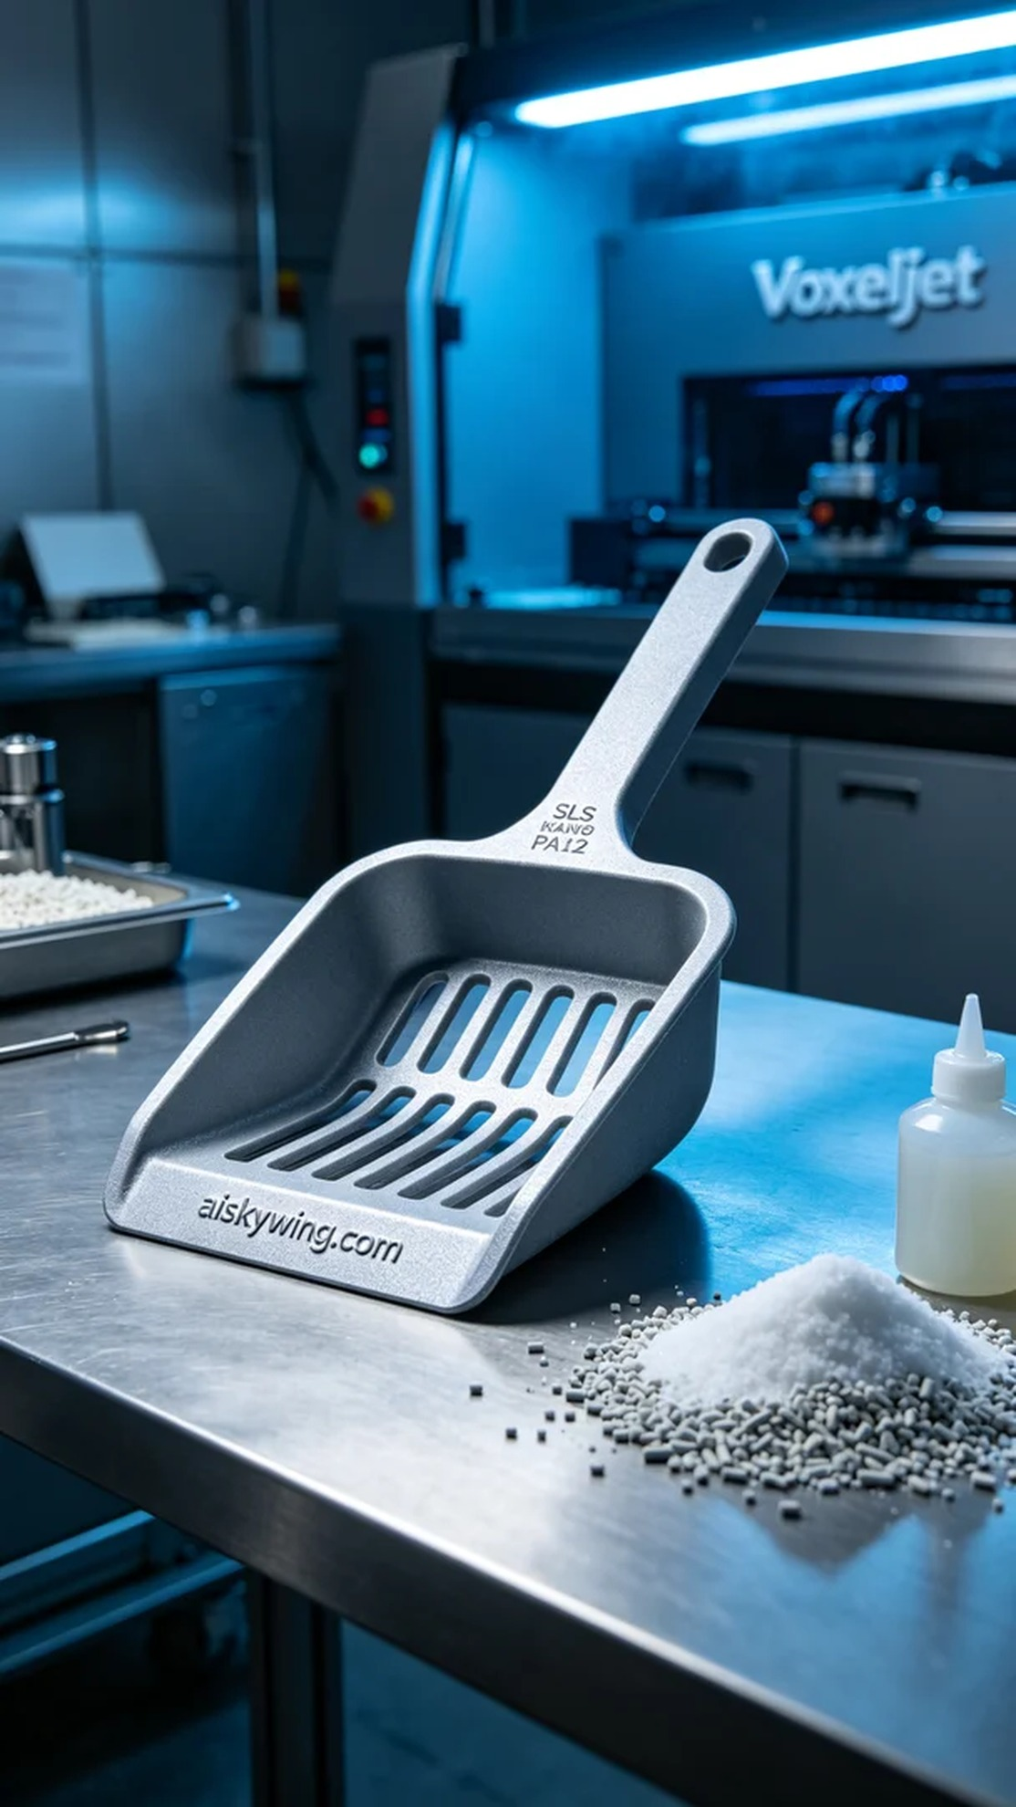
在今日的工作中，有人向我们求助，反映他们在使用市面上的猫砂盆铲时遇到了一些问题，尤其是在铲子的材质和强度方面。于是我们决定为他们打印一款宠物猫砂盆铲，力求解决他们的困扰。
我们在制作前，选择了SLS尼龙PA12作为原材料。这种材料具有优良的强度和韧性，同时表面磨砂质感能够有效抵挡磨损。准备过程中，我们使用的是Voxeljet品牌的3D打印机，设置了适宜的打印参数：层厚0.1毫米，温度保持在180摄氏度，激光功率为40瓦，打印速度设定为300毫米每秒，预计打印时间为4小时。
打印过程相对顺利，Voxeljet打印机的性能稳定，很好地将设计图纸转化为实物。整个过程我们时刻监控设备运行状态，确保没有出现任何异常情况。经过数小时的工作，铲子终于成型，外观也符合我们的预期，"aiskywing.com"的雕刻字样十分清晰，展现了极致的工艺。
接下来，我们进行了后处理工序。首先将成品用清水清洗，去除表面的粉尘和残留物。清洗完成后，使用砂纸对铲子的边缘进行了打磨，以确保手感光滑。然后，我们在固化炉中进行了固化处理，确保材料强度达到最佳状态。最后，对铲子进行了严格的检验，确保没有瑕疵。
所有工序完成后，宠物猫砂盆铲成功地交付给了需要的人。通过这次制作，不仅解决了他们的问题，也让我们体验到了3D打印技术的魅力。
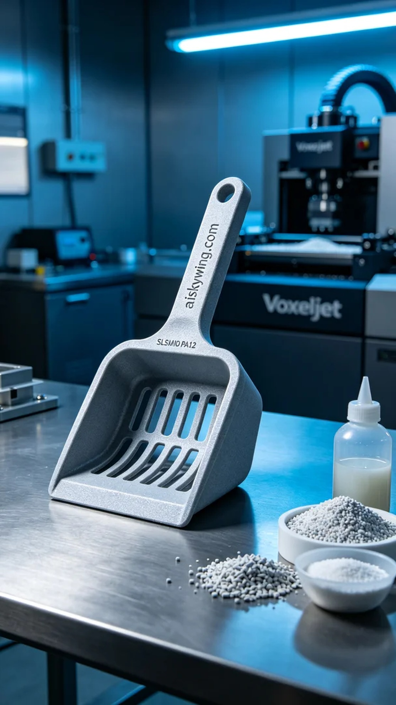
Aiskywing Industrial 3D Printing
Pet cat litter scoop


