0954-宠物玩具球的3D打印生产记录
Pet toy ball
🖨️ SLS尼龙烧结
🖥️ 打印机: EOS
📦 材料: SLS尼龙
生活就像3D打印，每一步都至关重要。有人在Facebook上找我们，想定做一款宠物玩具球，问题是希望它既耐用又轻巧。
Life is like 3D printing; every step is crucial. Someone found us on Facebook and wants to customize a pet toy ball, but the challenge is that they want it to be both durable and lightweight.
________________________________________________________________________________
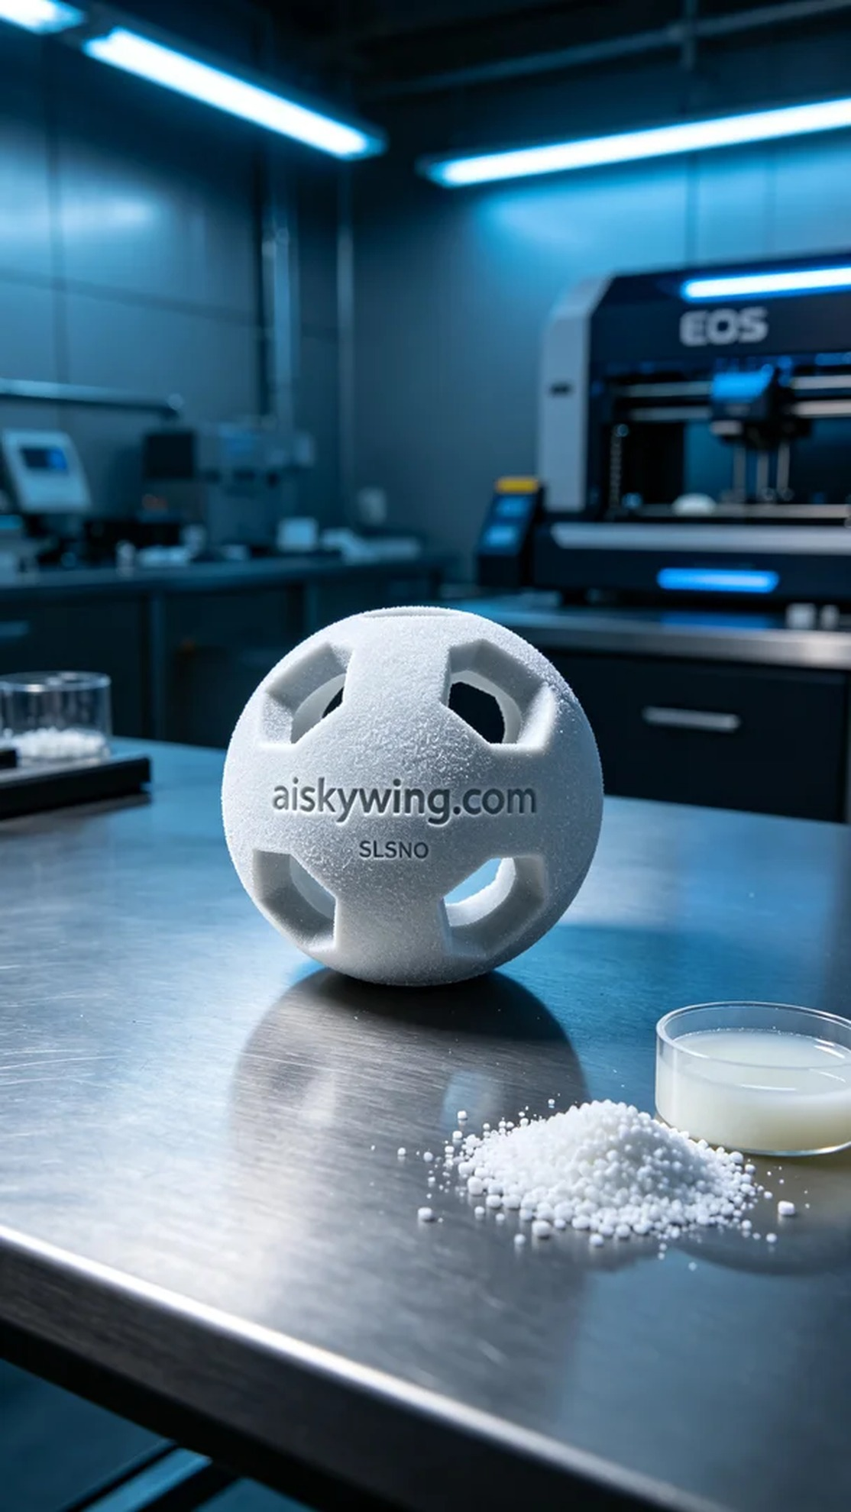
Life is like 3D printing, every step matters. Someone contacted us through Facebook, wanting a custom pet toy ball, with the issue of wanting it to be durable yet lightweight.
We chose SLS nylon as the material for its excellent strength and toughness, perfect for making wear-resistant toys. In our preparations, we ensured the EOS 3D printer was in good condition, setting the printing parameters to a layer thickness of 0.1mm, maintaining a temperature of 180°C, and setting the power to 90%. For speed, to ensure detail, we selected a print speed of 5 mm/s, with the entire printing process expected to take about 4 hours.
During the printing process, the EOS printer operated smoothly, sintering the powder layer by layer to form the toy ball shape. We monitored the print quality at all times, ensuring each layer fused perfectly without gaps or defects. Once printing was complete, the lightweight toy ball awaited further processing in the printing room.
Post-processing was crucial; we first soaked the toy ball in a cleaning solution to remove any unsintered powder from the surface, then gently sanded it down to ensure smoothness and safety. Finally, we cured the toy ball to guarantee its strength and durability, and conducted strict inspections to ensure each toy ball met quality standards.
In the end, this pet toy ball was successfully created—lightweight and durable, satisfying the user's needs. Each printing experience reminds us that pursuing perfection makes our products even better.
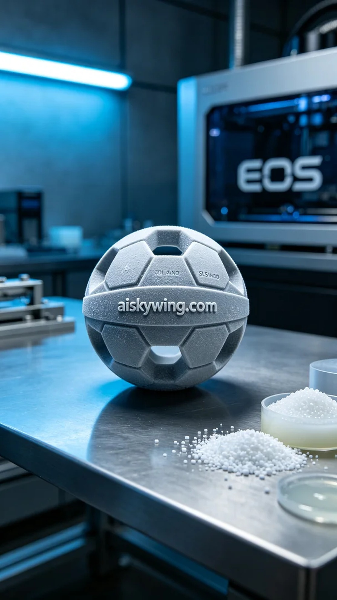
我们接到的这个订单是来自Facebook，要求制作一款宠物玩具球。有人希望这款玩具球不仅好玩，而且耐用，适合各种宠物的使用，最关键的是要轻便，方便宠物携带和玩耍。
我们选择了SLS尼龙作为原材料，这种材料的强度和韧性都很好，适合制作耐磨损的玩具。准备工作中，我们需要确保EOS 3D打印机的状态良好，设定打印参数为层厚0.1mm，温度保持在180°C，功率设置为90%。速度方面，为了确保细节，选择了5 mm/s的打印速度，整个打印过程预计耗时大约4小时。
打印过程中，EOS打印机平稳运行，粉末逐层烧结，形成玩具球的形状。我们时刻监控着打印质量，确保每一层都能完美融合，避免出现空隙或瑕疵。打印完成后，轻巧的玩具球在打印室中静静地等待后续处理。
后处理工序是不可忽视的，我们先用清洗液对玩具球进行浸泡，去除表面的未烧结粉末，然后用磨砂工具轻轻打磨表面，以确保它的光滑和安全。最后，我们对玩具球进行固化处理，保证材料的强度和耐用性，经过严格检验，确保每个玩具球都符合质量标准。
最终，这款宠物玩具球成功问世，既轻巧又耐用，满足了使用者的需求。每一次的打印都在告诉我们，坚持完美，才能让产品更加出色。
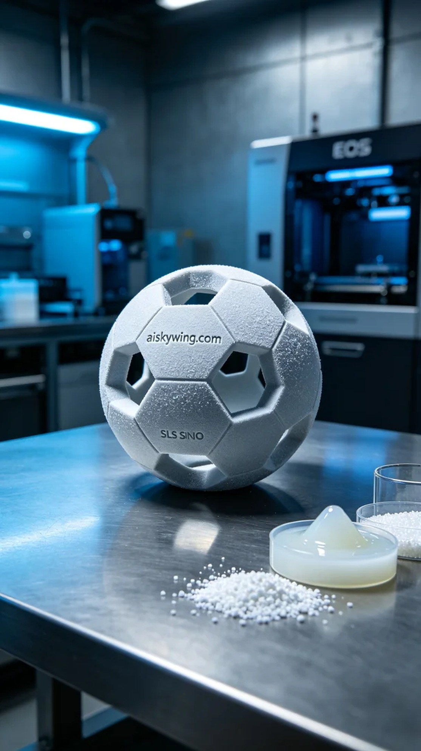
Aiskywing Industrial 3D Printing
Pet toy ball


