0955-宠物电推剪外壳3D打印生产记录
Pet grooming clipper shell
🖨️ SLS尼龙烧结
🖥️ 打印机: Stratasys
📦 材料: SLS尼龙
生活再难，也别停下脚步。就像接下这个宠物电推剪外壳的单子，有人因为想要提升产品的质量和外观找到我们，希望能通过3D打印实现他们的梦想。
No matter how difficult life gets, don't stop moving forward. Just like taking on this order for a pet electric clipper shell, someone approached us because they wanted to enhance the quality and appearance of their product, hoping to realize their dream through 3D printing.
________________________________________________________________________________
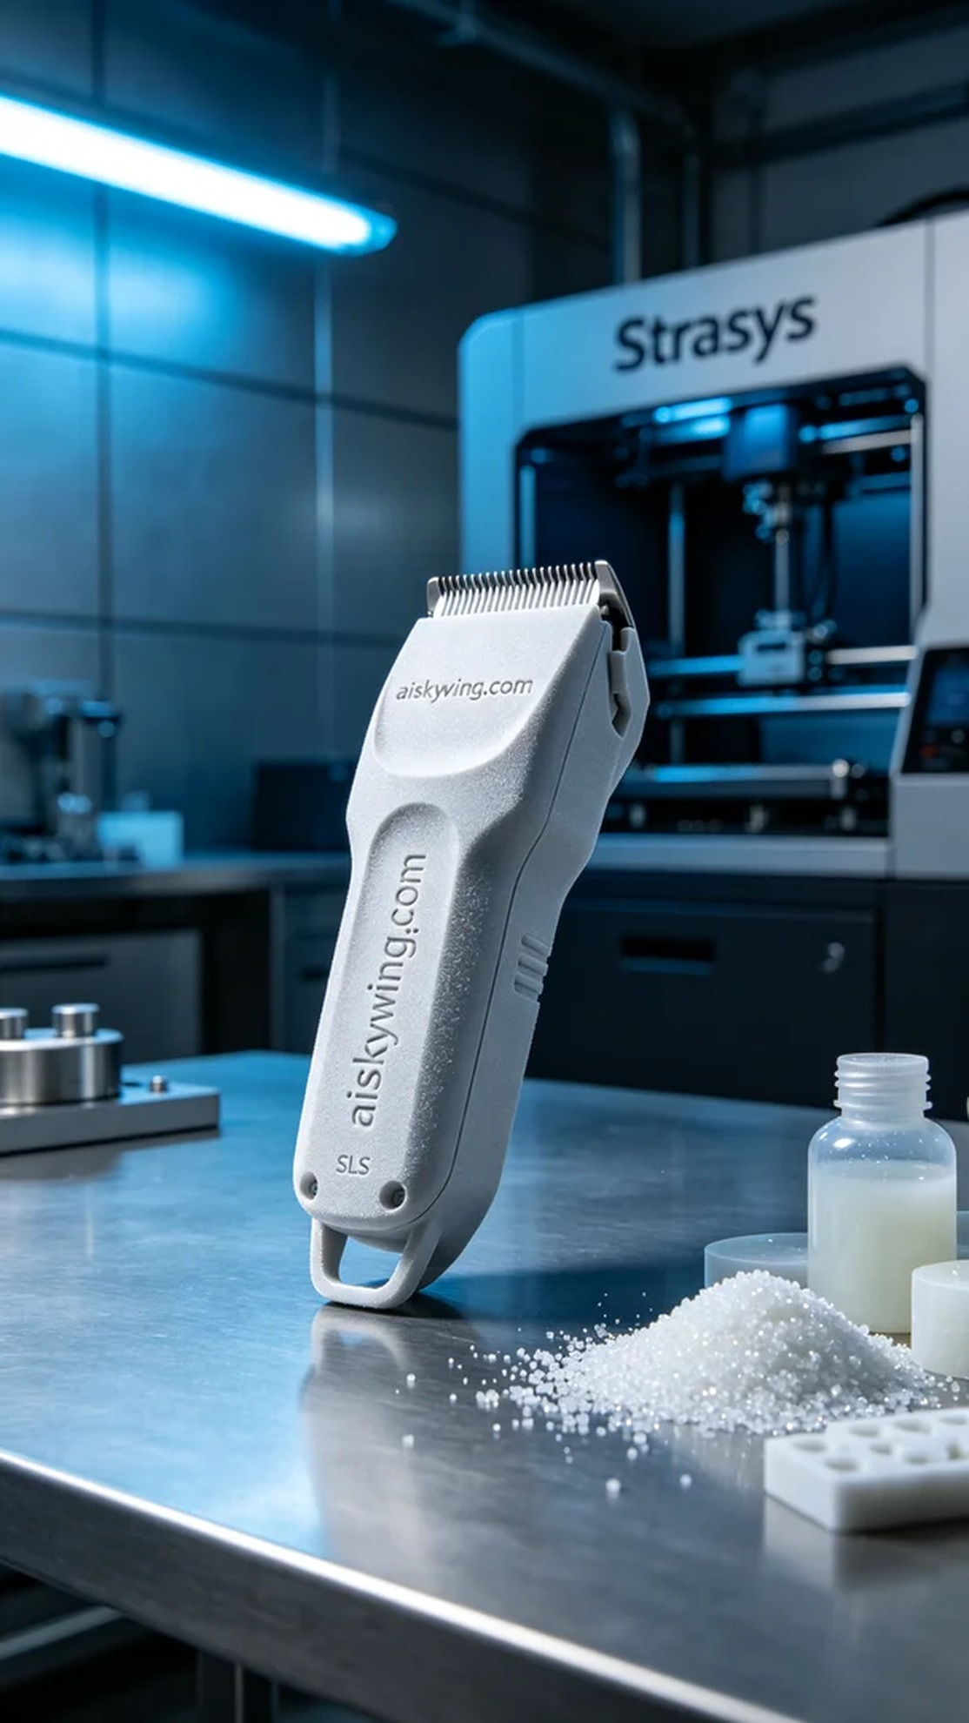
Life can be tough, but we must keep pushing forward. Just like when we took on the task of creating this pet clipper shell; someone reached out to us looking to enhance the quality and look of their product through 3D printing.
For this project, we chose SLS nylon as the raw material due to its excellent wear resistance and lightweight characteristics. To ensure print quality, we utilized a Stratasys 3D printer, setting the layer thickness to 0.1 mm, a temperature of 180℃, a power of 80 watts, and a print speed of 20 mm per second, with an estimated printing time of 10 hours. With these parameters, we aimed for optimal strength and precision in the printed part.
Once the printing began, the machine operated smoothly, and the process was quite stable. We closely monitored the print quality to ensure every layer was stacked correctly. As the printing progressed, the fine powder sintering texture gradually appeared, showcasing excellent surface smoothness and details, which left us excited about the final product.
Upon completion, we moved to the post-processing phase. First, we cleaned the printed shell to remove excess powder. Next, we sanded the surface with fine sandpaper to ensure a smooth finish. Following that, we applied photosensitive resin for curing to enhance its strength and durability, and finally conducted a quality inspection to ensure every detail met our standards.
After a series of meticulous steps, we concluded with a high-quality pet clipper shell. This not only resolved the user's issue but also deepened our understanding and experience with the application of 3D printing technology.
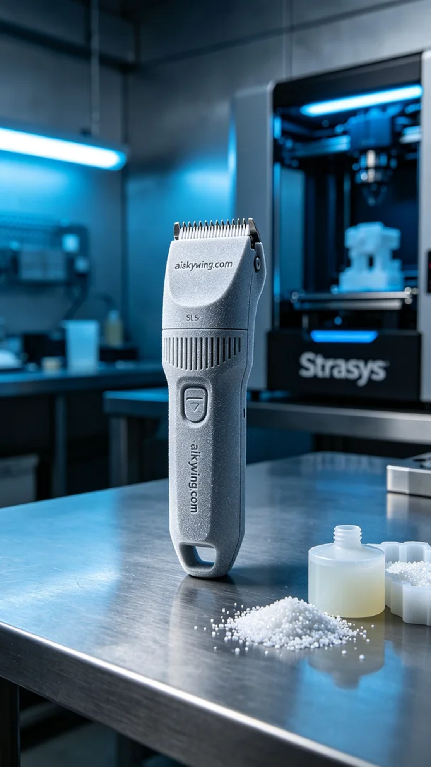
在YouTube上，有人因为市面上现有的宠物电推剪外壳不够耐用和舒适而寻求我们的帮助。他们希望能通过3D打印技术生产出一个更符合需求的电推剪外壳，以提升用户的使用体验。这就是我们开展这次项目的原因。
为了这个项目，我们选择了SLS尼龙作为原材料，因其优异的耐磨性和轻量化特性。为确保打印质量，我们使用了Stratasys品牌的3D打印机，设置了层厚0.1毫米，温度为180℃，功率为80瓦，打印速度为20毫米每秒，预计打印时间为10小时。材料在这样的参数下能更均匀地烧结，达成理想的强度与精度。
打印开始后，机器稳定运转，整个过程极为顺利。我们随时监控打印质量，确保每一层的堆叠都符合标准。在打印期间，不少细微的粉末烧结纹理逐渐显现，表面光滑度和细节非常优秀，令我们对最终产品充满期待。
打印完成后，我们进入了后处理环节。首先对打印出的外壳进行清洗，以去除多余的粉末。之后，我们使用细砂纸进行打磨，保证外壳表面的光滑感。接着，我们使用光敏树脂进行固化处理，以增强其强度与耐用性，最后进行了质量检验，确保每一个细节都达到标准。
经过一系列精细的步骤，最终我们得到了一个高质量的宠物电推剪外壳。这不仅解决了使用者的问题，也让我们对3D打印技术的应用有了更深的理解与体会。
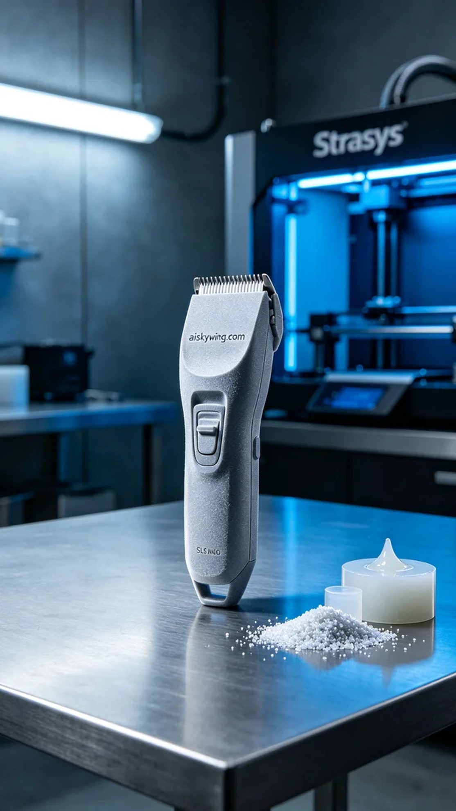
Aiskywing Industrial 3D Printing
Pet grooming clipper shell


