0956-宠物眼部清洁器手柄3D打印记录
Pet Eye Cleaner Handle
🖨️ SLS尼龙烧结
🖥️ 打印机: Xjet
📦 材料: SLS尼龙
生活就像这宠物眼部清洁器手柄的制作过程，要用心去打磨。最近，有人通过WhatsApp联系我，询问如何定制一款高效的眼部清洁器手柄。
Life is like the process of making the handle of this pet eye cleaner; it requires careful polishing. Recently, someone contacted me via WhatsApp, asking how to customize an efficient eye cleaner handle.
________________________________________________________________________________
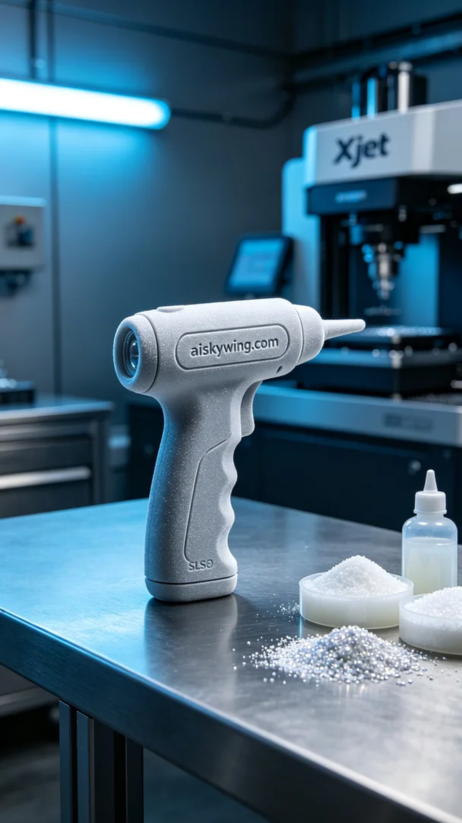
Life is like the process of creating this pet eye cleaner handle; it requires meticulous crafting. Recently, someone contacted me via WhatsApp, inquiring about how to customize an efficient eye cleaner handle.
For this project, we opted for SLS nylon as the primary material due to its high strength and lightweight advantages, making it ideal for producing this type of handle. To ensure successful printing, I prepared the Xjet 3D printer and set the printing parameters: a layer thickness of 0.1mm, printing temperature at 190°C, output power of 120W, speed of 20mm per hour, with an estimated print time of 6 hours.
During the printing process, the Xjet printer operated steadily, with the SLS nylon powder sintering layer by layer to form the desired handle shape. I monitored the print quality closely to ensure there were no bubbles or material defects. The process went smoothly, with equipment running steadily and the initial print results looking very promising.
After printing, we proceeded to the post-processing stage. First, we placed the handle in a cleaning tank to remove any unsintered powder from the surface. Next, we manually polished it to ensure a smooth finish. After that, we carried out a curing process to enhance the hardness and durability of the material, and finally, a comprehensive inspection of the finished product ensured that every detail met the requirements.
In the end, the pet eye cleaner handle was successfully completed, being both aesthetically pleasing and practical, fully satisfying the user's needs. Through this production, I have experienced the charm of 3D printing once again and look forward to more innovative designs being realized in the future.
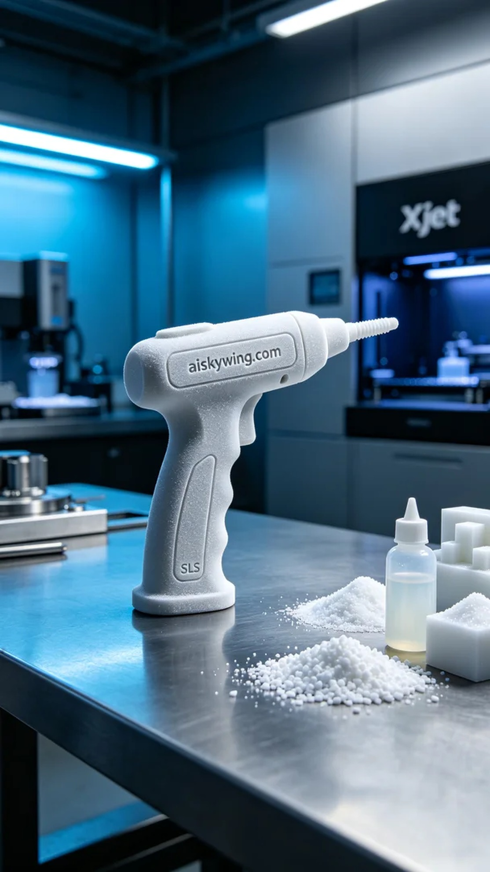
这次的项目是为了一位热爱宠物的人设计的宠物眼部清洁器手柄。因市场上现有的产品多不符合他们的需求，所以他们找到我，希望能使用更先进的3D打印技术定制一款更符合使用习惯的产品。
我们选择使用SLS尼龙作为主要原材料，这种材料具有高强度和轻量化的优势，非常适合这类手柄的生产。为确保打印的成功，我准备了Xjet品牌的3D打印机，设定了打印参数：层厚为0.1毫米，打印温度设定在190°C，功率为120瓦，速度为每小时20毫米，预计打印时间为6小时。
打印过程中，Xjet打印机稳定运作，SLS尼龙的粉末逐层烧结，形成理想的手柄形状。我时刻监控打印质量，确保没有出现气泡或材料缺陷。整个过程很顺利，设备运行平稳，打印结果初步看上去非常令人满意。
完成打印后，我们进入后处理阶段。首先，将手柄放入清洗槽中，去除表面的未烧结粉末。接着，对其进行手动打磨，确保表面光滑。随后进行固化处理，确保材料的硬度和耐用性提升，最后对成品进行全面检验，确保每个细节都达到要求。
最终，这款宠物眼部清洁器手柄顺利完成，既美观又实用，充分满足了使用者的需求。通过这次制作，我再次感受到3D打印的魅力，也期待着更多创新的设计能在未来实现。
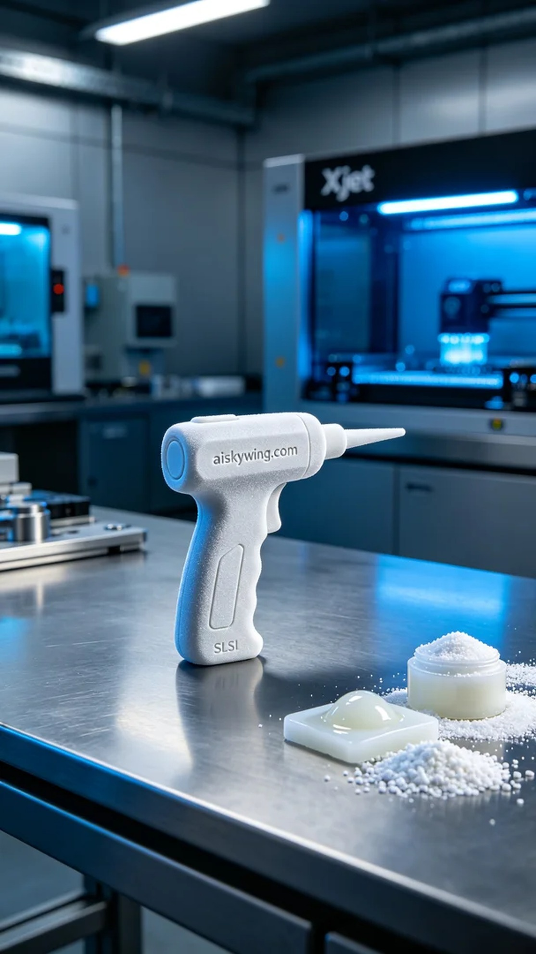
Aiskywing Industrial 3D Printing
Pet Eye Cleaner Handle


