0957-宠物窝边框的3D打印制作记录
Pet Bed Frame
🖨️ SLS尼龙烧结
🖥️ 打印机: HP
📦 材料: SLS尼龙
生活就像3D打印，有时需要耐心和细致。最近，有人通过Instagram找到我们，希望定制一款宠物窝边框，解决他们家的小宠物舒适问题。
Life is like 3D printing; sometimes it requires patience and attention to detail. Recently, someone contacted us through Instagram, hoping to customize a pet bed frame to solve their little pet's comfort issue.
________________________________________________________________________________
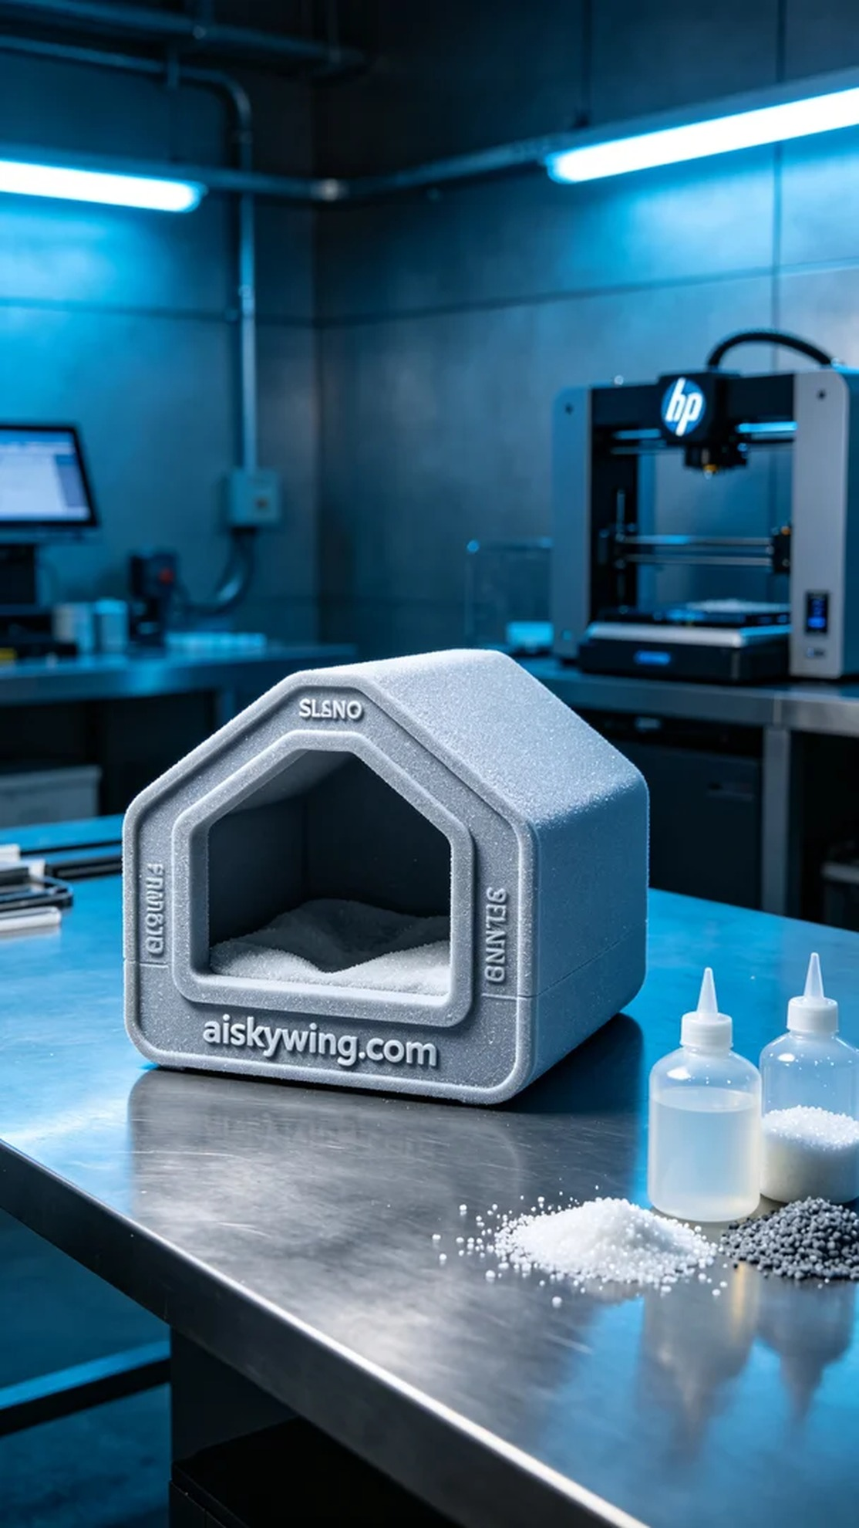
Life is like 3D printing; sometimes it requires patience and attention to detail. Recently, someone reached out to us via Instagram, hoping to customize a pet bed frame to solve their little pet's comfort issues.
We decided to use SLS nylon as the primary material for its lightweight yet sturdy properties, perfect for showcasing intricate surface textures. In preparation, we chose an HP 3D printer, setting the layer height to 0.1mm, printing temperature at 170℃, power adjusted to 80%, speed at 35mm/s, with an estimated print time of around 6 hours.
During the printing process, we closely monitored the machine's operation to ensure even sintering of the material at high temperatures. The roar of the printer and the subtle changes in the powder reminded us that every aspect of the process is crucial. After about 4 hours of continuous printing, we observed the frame's outline taking shape, filling us with anticipation.
After printing, we proceeded with post-processing. First, we rinsed the finished frame with water to remove any excess powder on the surface. Next, we carefully sanded the edges with sandpaper to ensure a smooth finish at every corner. Finally, we cured it under UV light to ensure stability and durability. After rigorous inspection, we confirmed that each product met our quality standards.
After careful crafting, the pet bed frame was finally completed. It not only boasts high practicality but also combines a sense of technology and aesthetic appeal.
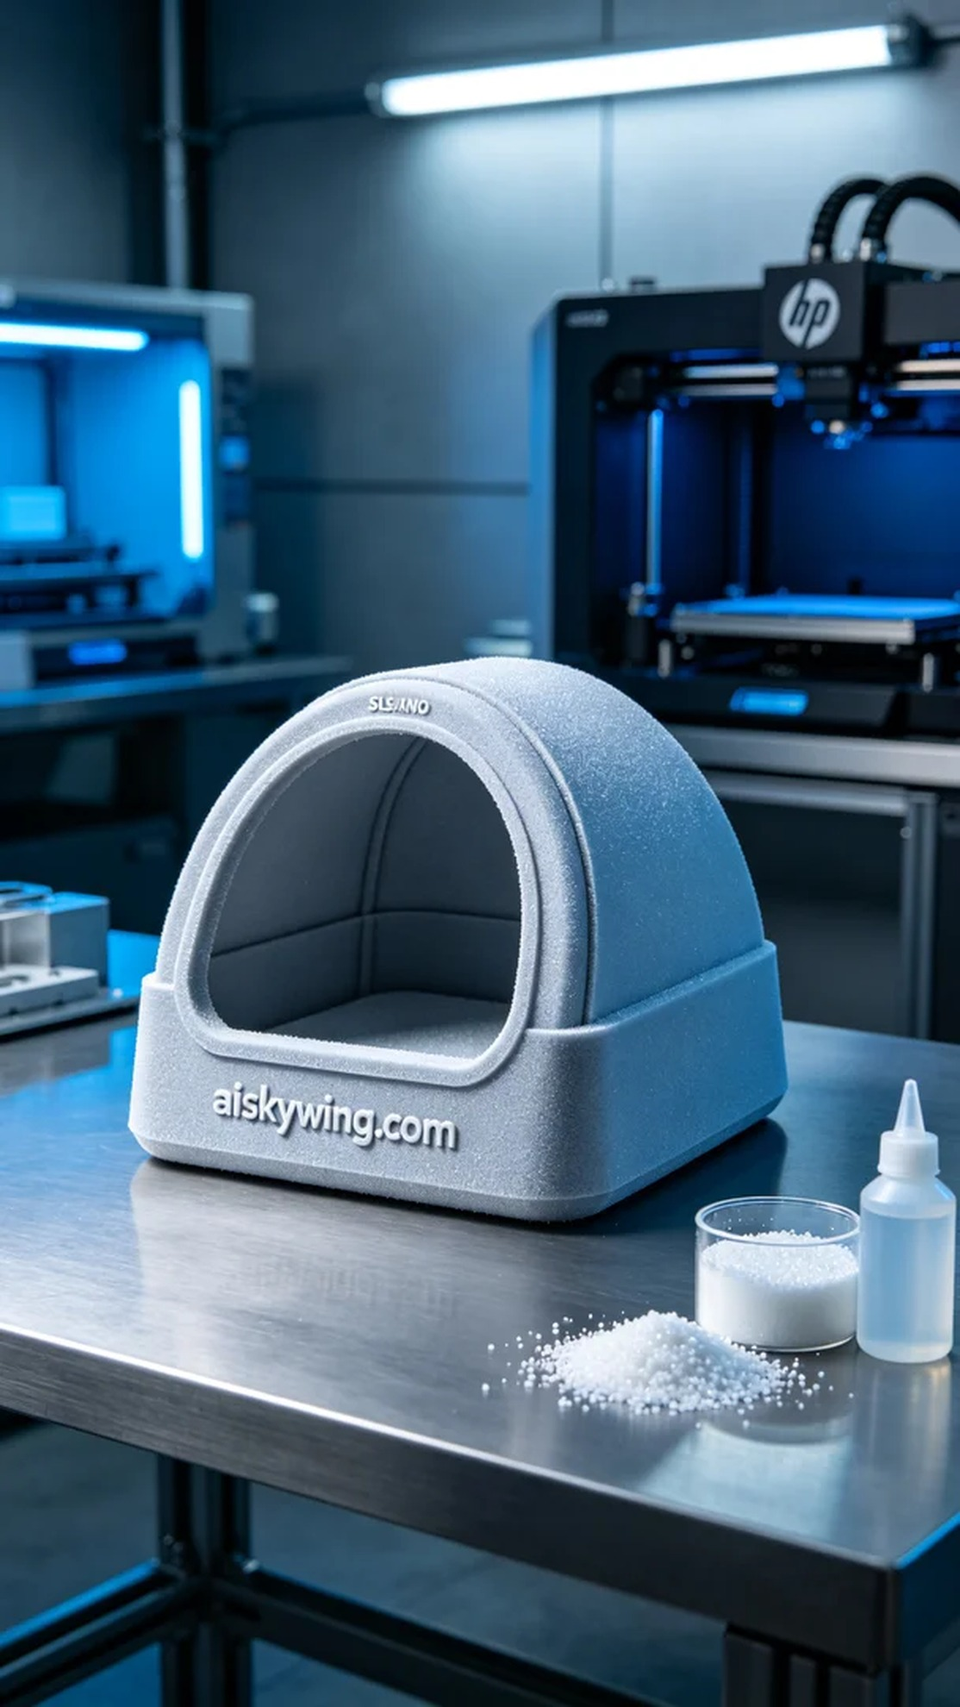
在Instagram上，有人因为小宠物的舒适问题找到了我们，希望制作一个专属的宠物窝边框。他们想要一个既轻便又结实的设计，以便能在家中摆放，并且希望表面能有清晰的品牌铭文。
我们决定使用SLS尼龙作为主要材料，这种材料不仅轻量坚固，还能很好地展现出细腻的表面纹理。在准备工作中，我们选择了HP的3D打印机，设置层厚为0.1mm，打印温度设定在170℃，功率调整到80%，速度为35mm/s，预计打印时间大约需要6小时。
打印过程中，我们密切关注设备的运行状态，确保材料在高温下的均匀烧结。打印机发出的轰鸣声和粉末的细微变化都在提醒我们，工艺的每个环节都至关重要。经过4小时的持续打印，我们看到边框的轮廓逐渐成型，心中充满期待。
完成打印后，我们进行了后处理。首先，用清水对成型的边框进行冲洗，去除表面多余的粉末。随后，我们使用砂纸细心打磨边框的边缘，确保每个角落都光滑无瑕。最后，在UV灯下固化，确保结构的稳定性和使用寿命。经过严格的检验，我们确认每个产品都能满足质量标准。
经过一番精心制作，宠物窝边框终于完成。它不仅具有极高的实用性，还给人一种科技感与美感融合的独特体验。
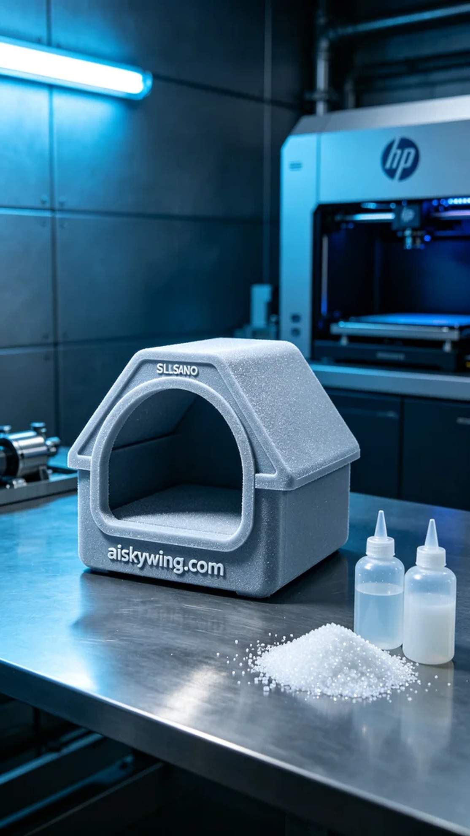
Aiskywing Industrial 3D Printing
Pet Bed Frame


