0958-宠物粘毛滚筒支架制作实录
Pet hair lint roller holder
🖨️ SLS尼龙烧结
🖥️ 打印机: Rize
📦 材料: SLS尼龙PA12
在Instagram上，有人因为家里宠物掉毛的烦恼，找到我们，希望制作一个宠物粘毛滚筒支架。挑战虽大，心中却满是期待。
On Instagram, someone reached out to us with the frustration of pet hair shedding at home, hoping to create a pet hair roller holder. Although the challenge is significant, we are filled with anticipation.
________________________________________________________________________________
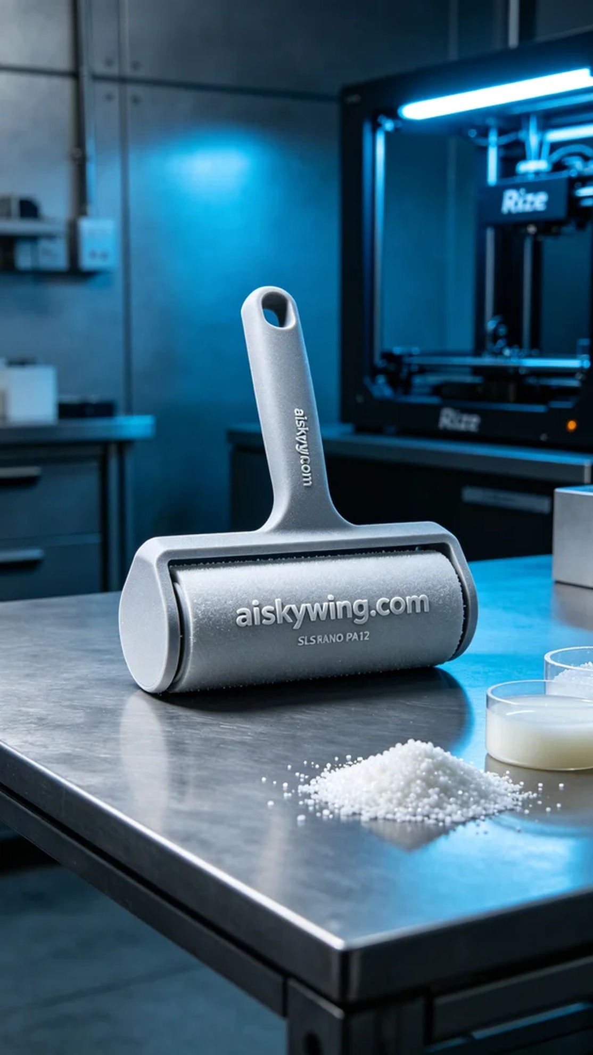
Today, we embarked on the project to create a pet fur roller stand, which someone mentioned on Instagram as a solution for their pet shedding issues. This stand needs to be both aesthetically pleasing and practical, with durability and ease of cleaning.
We used SLS nylon PA12 as the material, a high-strength engineering plastic known for its excellent wear resistance and impact resistance, making it suitable for 3D printing. In terms of equipment preparation, we chose the Rize 3D printer, setting a layer thickness of 0.1mm, a printing temperature of 190°C, a power setting of 90%, a printing speed of 30mm/s, and an estimated print time of 4 hours.
Once the printing process began, we monitored the machine's operations closely to ensure each layer was deposited evenly. The hum of the printer resonated through the workshop, and our meticulous quality monitoring gave us peace of mind, ensuring every detail met our expectations.
After the print was completed, we started with the post-processing steps. First, we cleaned the stand to remove excess powder, then we sanded it to ensure a smooth surface. After that, we cured it to enhance its sturdiness, and finally conducted a thorough inspection to ensure every part was free of defects.
After a series of intricate processes, the pet fur roller stand was finally completed. Seeing it serve its purpose in daily life brings a sense of fulfillment, truly realizing our intention of helping others.
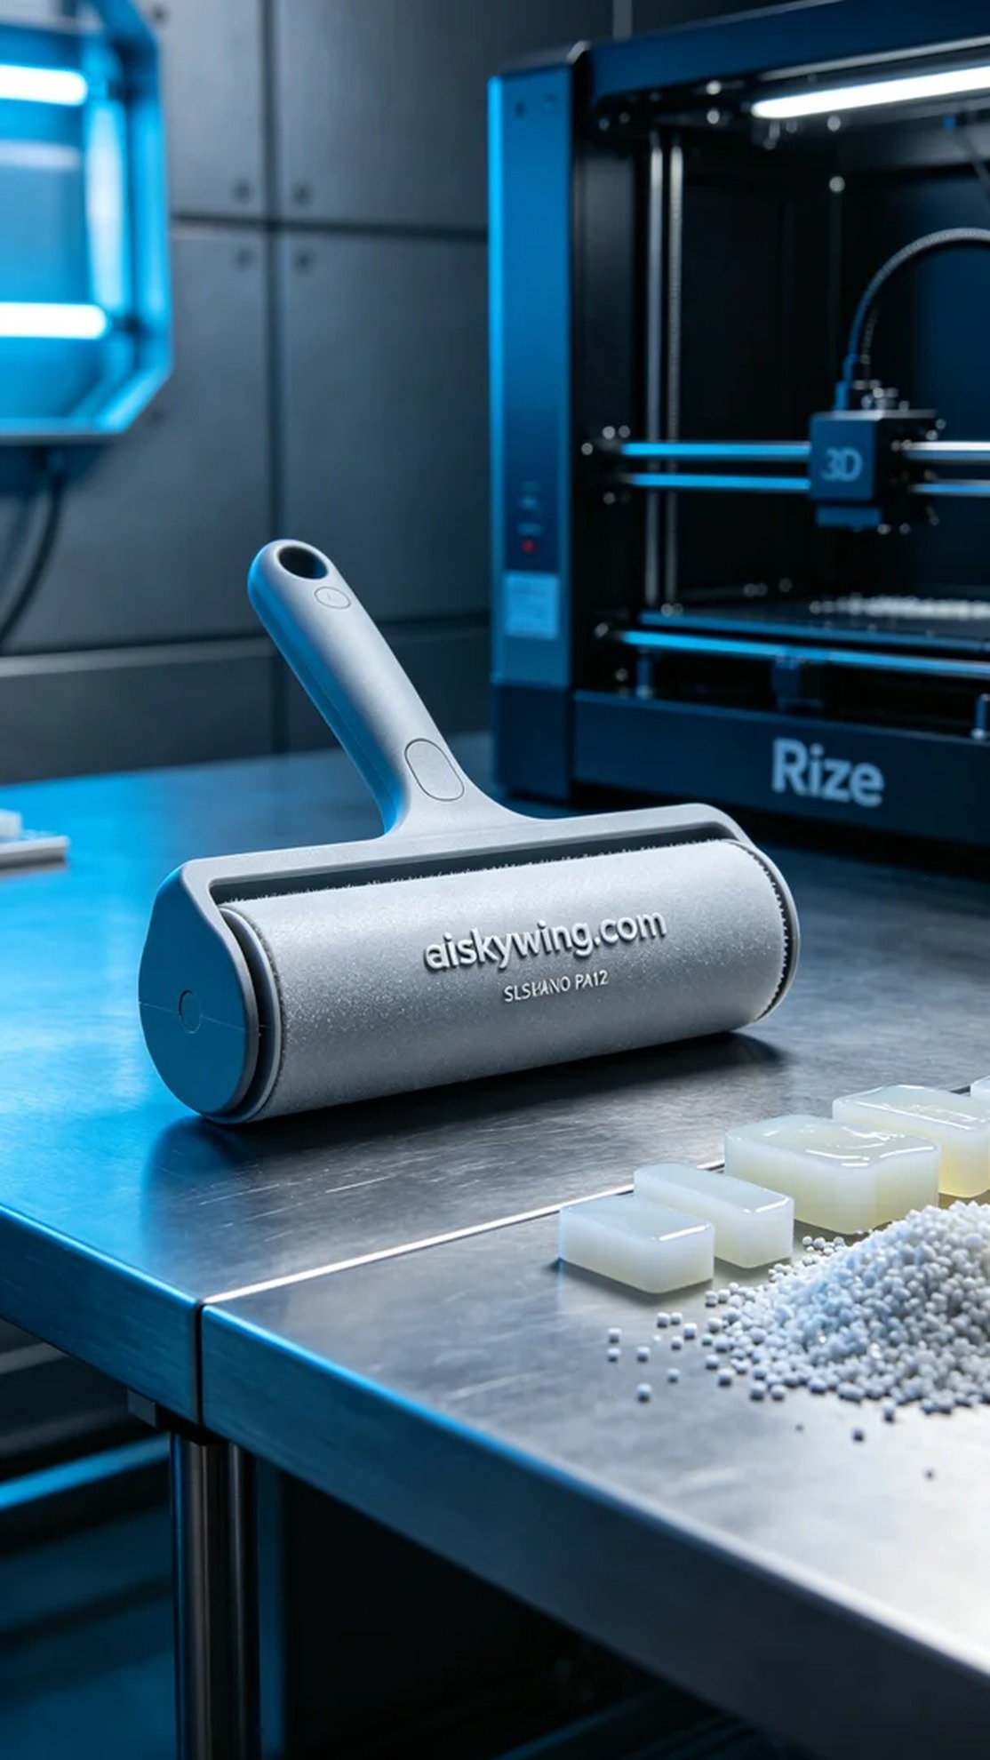
今天我们开始制作一个宠物粘毛滚筒支架，这个项目是在Instagram上有人提到的，他们希望能解决宠物掉毛的问题。该支架既要美观又要实用，希望能够耐用且容易清洗。
我们使用了SLS尼龙PA12作为原材料，这是一种高强度的工程塑料，具有优秀的耐磨性和抗冲击性，非常适合3D打印的需求。设备准备方面，我们选用了Rize的3D打印机，设置了层厚0.1mm、打印温度为190°C，功率设定为90%，打印速度为30mm/s，预计打印时间为4小时。
在打印过程开始后，我们全程监控设备的运行情况，确保每一层都能均匀沉积。打印机的运作声在车间中回响，细致入微的质量监控让我们心中踏实，确保每一个细节都能达到预期的标准。
打印完成后，我们开始进行后处理工序。首先对支架进行清洗，去除多余的粉末，然后进行打磨，确保表面光滑。接着进行固化处理，使其更加坚固，最后进行仔细的检验，确保每一个部分都没有瑕疵。
经过一系列繁复的过程，这个宠物粘毛滚筒支架终于完成了。看到它在日常生活中发挥用场，心中总是感到一阵满足，真正实现了帮助他人的初衷。
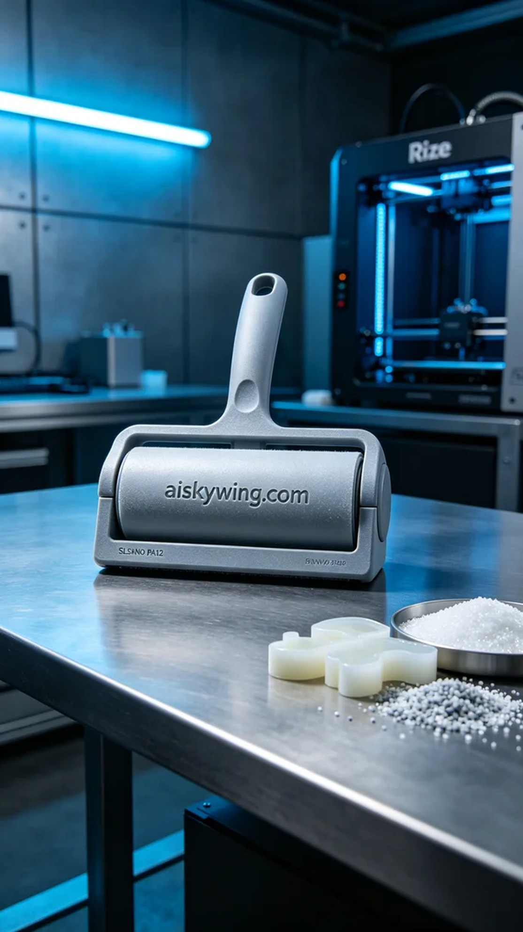
Aiskywing Industrial 3D Printing
Pet hair lint roller holder


