0959-宠物耳部清洁器手柄的3D打印过程
Pet Ear Cleaner Handle
🖨️ SLS尼龙烧结
🖥️ 打印机: Stratasys
📦 材料: SLS尼龙PA12
生活中的每一个小细节都值得我们去关注，就像有人在Instagram上看到我们的宠物耳部清洁器手柄，想解决他们宠物耳朵清洁的问题。
Every little detail in life deserves our attention, just like when someone sees our pet ear cleaner handle on Instagram and wants to solve their pet's ear cleaning issues.
________________________________________________________________________________
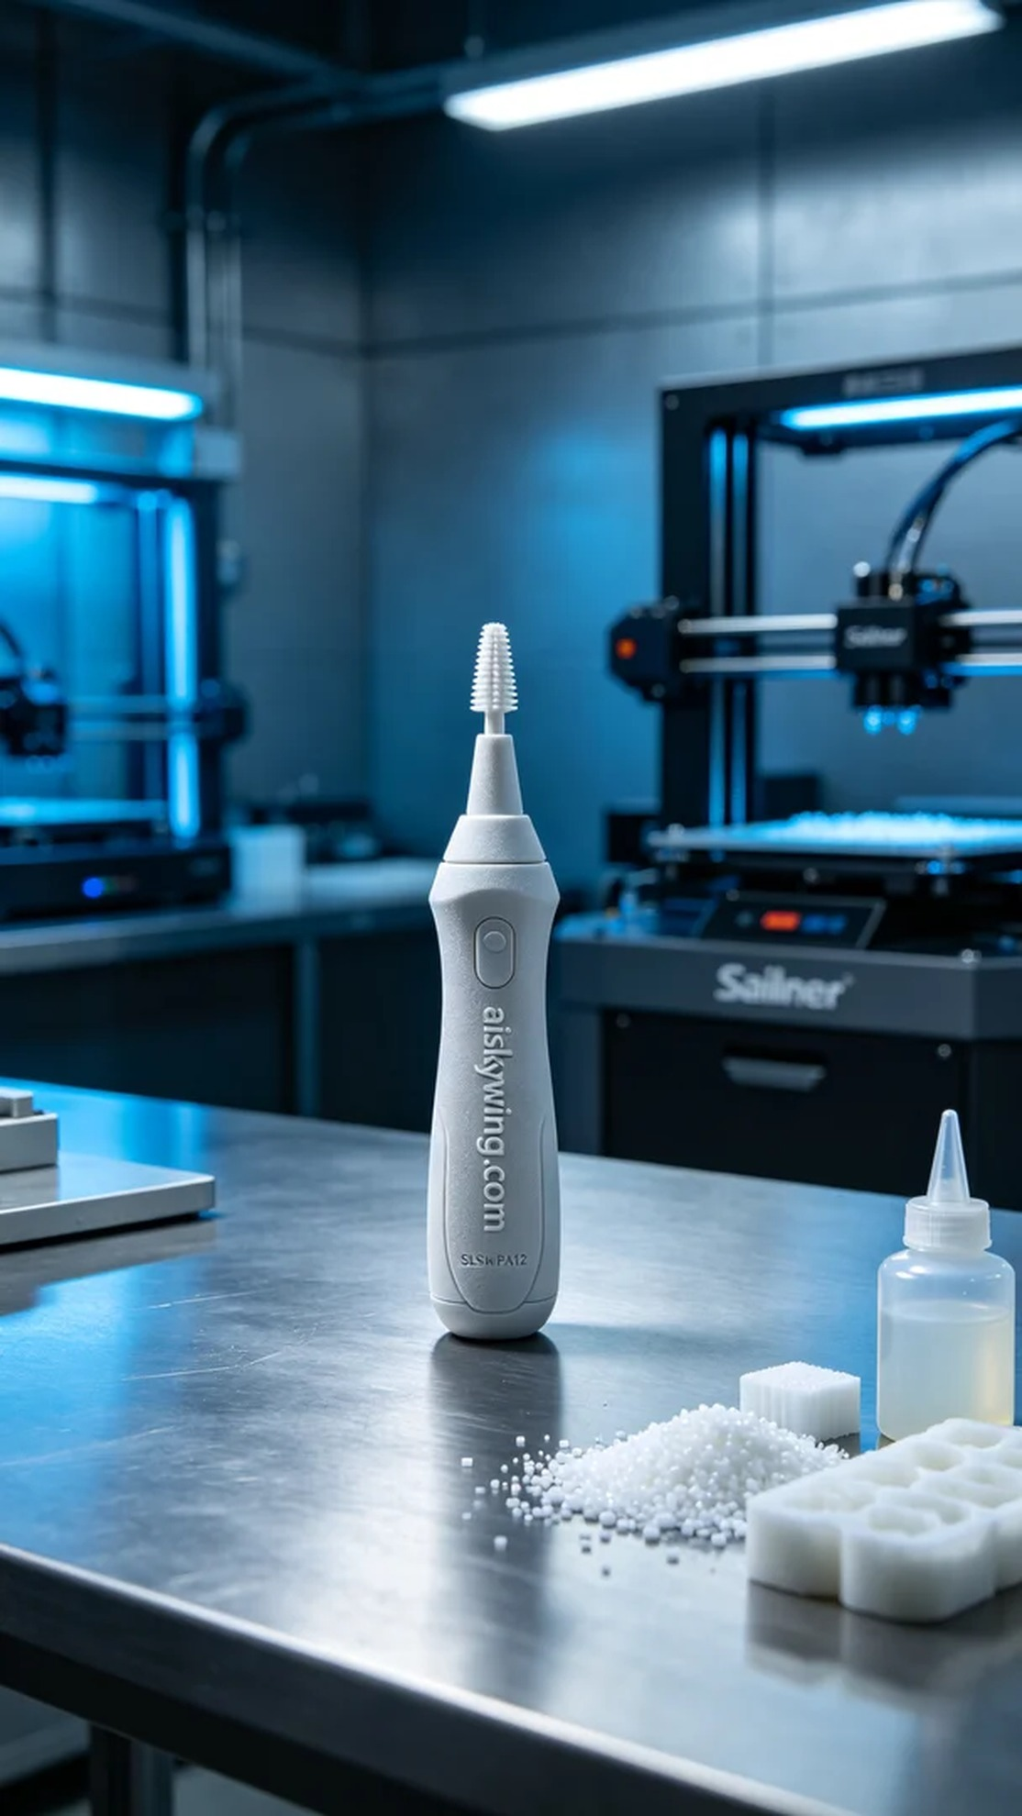
Every small detail in life deserves our attention, just like someone who found our pet ear cleaner handle on Instagram, looking to solve their pet's ear cleaning issues.
For this project, we chose SLS nylon PA12 as our raw material due to its high strength and heat resistance, making it perfect for 3D printing. We prepared the Stratasys printer and set the parameters: layer thickness of 0.1 mm, printing temperature at 180 degrees Celsius, power set to 50W, and a printing speed of 30 mm/s. This ensures the handle will be durable and reliable.
The printing process went smoothly, with the Stratasys printer heating the nylon powder to a molten state and layering it. We maintained optimal environmental temperature and humidity to ensure quality monitoring throughout the process. Real-time monitoring of the equipment's operation allowed us to confirm that each layer fused perfectly, resulting in the initial shape of the handle.
After printing, the post-processing steps are crucial. We first cleaned the handle with a cleaning solution to remove excess powder from the surface. Then, we sanded it to ensure a smooth and pleasant touch. Finally, we placed the handle in a curing device to ensure its strength reached optimum levels. After a final inspection, the handle met all quality standards, flawless and ready for use.
With all these meticulous operations, we achieved the ideal pet ear cleaner handle. I believe this product will help many pet owners take better care of their furry companions.
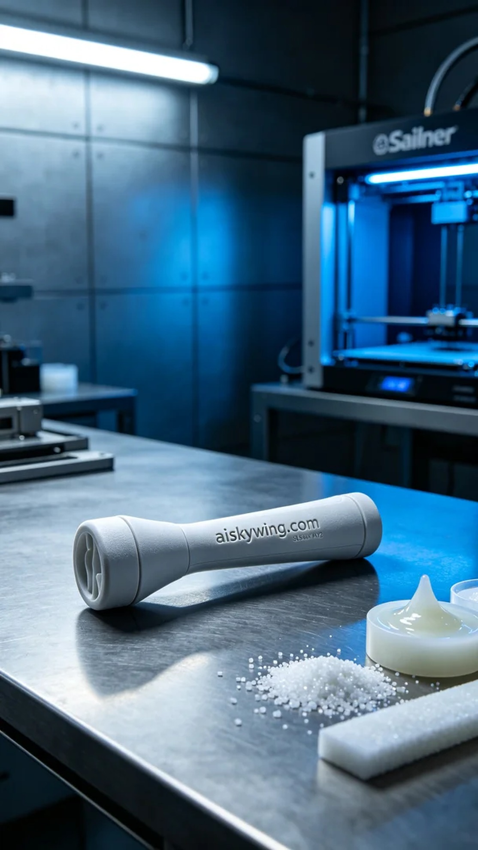
在今天的工作中，有人通过Instagram找到了我们，他们希望能解决宠物耳朵清洁的难题。于是，我们决定为他们制作一款宠物耳部清洁器手柄，以便更好地照顾他们的宠物。
我们选用了SLS尼龙PA12作为原材料，这种材料的强度高、耐热性好，非常适合3D打印。准备工作包括确定打印机为Stratasys品牌，设置打印参数：层厚0.1 mm，打印温度为180摄氏度，功率设定为50W，打印速度为30 mm/s。这样可以确保打印出的手柄结实耐用。
打印过程非常顺利，Stratasys打印机启动后，SLS技术将尼龙粉末加热至熔融状态，并逐层堆叠。整个过程保持在良好的环境温度和湿度下，以确保质量监控。我们通过实时监控设备运行情况，确保每一层都能完美融合，最终形成手柄的初步形状。
完成打印后，后处理的工序也至关重要。我们首先用清洗剂对手柄进行清洗，以去除表面多余的粉末。接着进行打磨，确保手柄表面光滑触感良好。最后，将手柄放入固化设备，确保其强度达到最佳状态。经过最终检验，手柄的各项指标均符合标准，完美无瑕。
经过这一系列精细的操作，最终得到了理想的宠物耳部清洁器手柄。我相信，这款产品将帮助很多宠物主人更好地照顾他们的小伙伴。
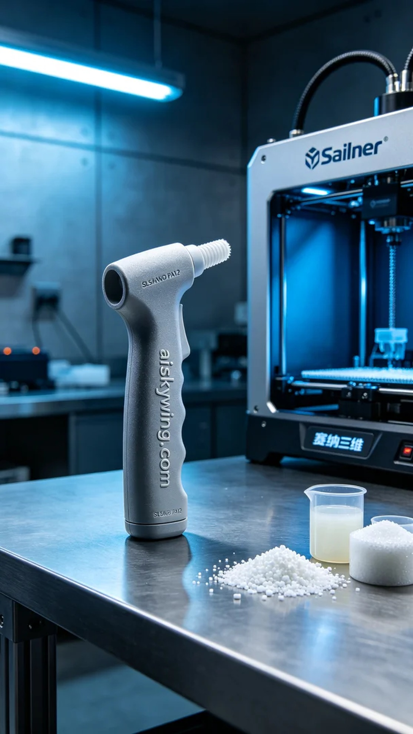
Aiskywing Industrial 3D Printing
Pet Ear Cleaner Handle


