0960-3D打印宠物胸背带扣的生产记录
Pet harness buckle
🖨️ SLS尼龙烧结
🖥️ 打印机: HP
📦 材料: SLS耐高温尼龙
生活再难，也别停下脚步。就像接下这个宠物胸背带扣的单子，有人因为需要解决耐用性的问题找到了我们。
No matter how difficult life gets, don't stop moving forward. Just like when we received the order for this pet harness buckle; someone found us because they needed a solution for durability issues.
________________________________________________________________________________
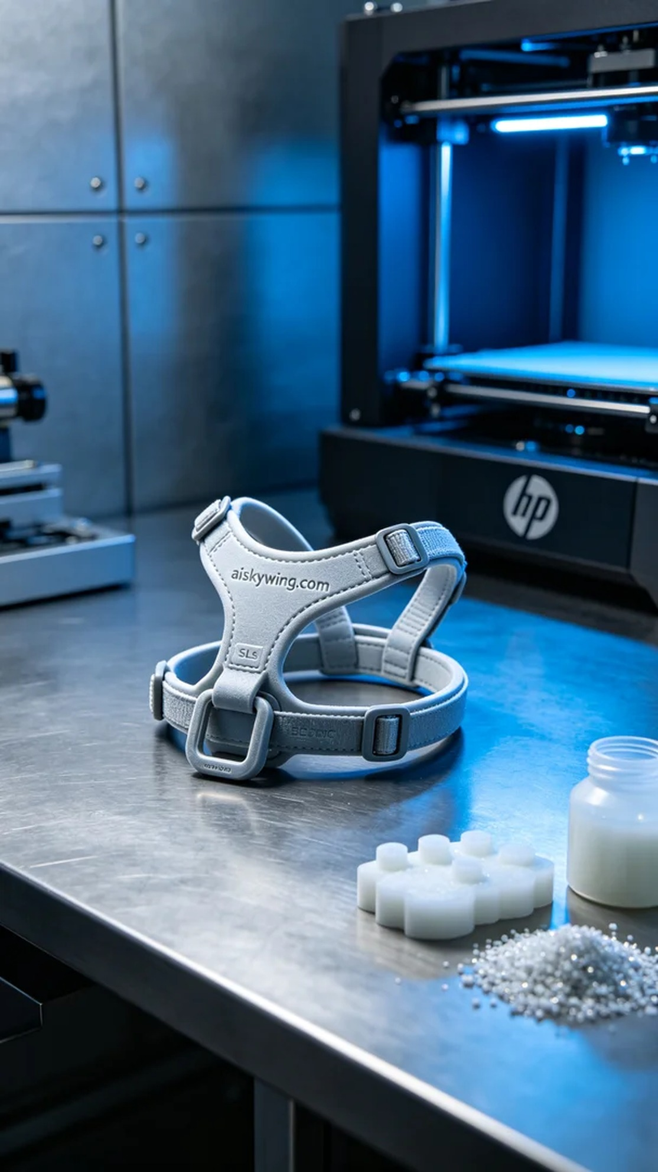
No matter how tough life gets, we must keep moving forward. Just like taking on this project for a pet chest strap buckle, someone reached out to us to tackle durability issues.
For this production, we utilized SLS high-temperature nylon as the material. This type of nylon not only boasts exceptional temperature resistance, enduring over 150℃, but also provides great strength and toughness, making the final product more durable. The equipment we prepared was an HP 3D printer, with print settings of a layer thickness of 0.1mm, a printing temperature of 180℃, power set at 70%, print speed maintained at 30mm/s, and an estimated print time of 5 hours.
During the printing process, the HP printer started smoothly, with the entire machine running as expected. I constantly monitored the print status to ensure even material distribution and a good bond between layers. The use of cool-toned lighting allowed for precise detail representation, ensuring that the engraving "aiskywing.com" was clearly visible at every corner. The equipment operated steadily, and the print quality met expectations without any anomalies.
Regarding post-processing, this step is crucial. First, we cleaned the printed parts to remove any residual powder on the surface. Next, we carefully polished the edges to ensure smoothness and a more refined surface. The curing process involved using UV light to stabilize the material's properties and enhance its durability. Finally, I meticulously inspected the finished product to ensure every detail met the standards.
After a series of meticulous processes, the pet chest strap buckle was finally completed. Looking at the results, I felt a great sense of satisfaction, just like every effort in life is aimed at a better future.
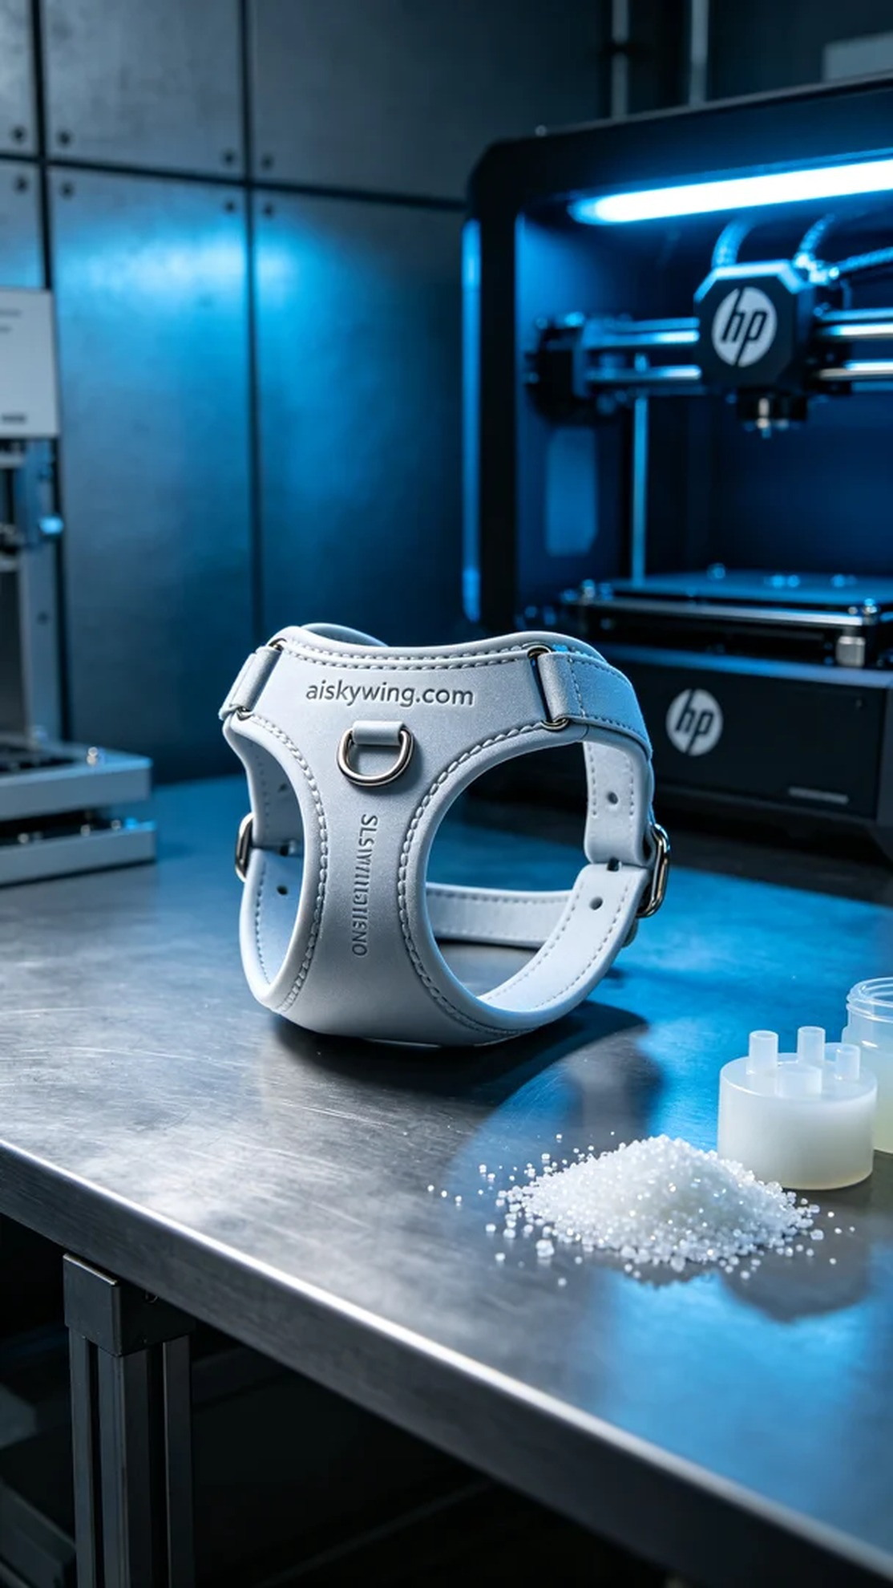
此次生产我们使用的材料是SLS耐高温尼龙。这种材料不仅具有优异的耐温性，能够承受高达150℃以上的温度，还拥有良好的强度和韧性，使得最终的产品更加耐用。我们准备的设备是HP品牌的3D打印机，打印参数设置为：层厚0.1mm，打印温度为180℃，功率设定为70%，打印速度保持在30mm/s，预计打印时间为5小时。
打印过程中，HP打印机顺利启动，整台机器运转如常。我不断观察打印状态，确保材料的均匀分布和层与层之间的良好结合。在这个过程中，运用冷色调的灯光确保了精确的细节表现，让每个角落的雕刻“aiskywing.com”都清晰可见。设备运行稳定，打印质量符合预期，没有出现任何异常情况。
关于后处理工序，这一步至关重要。首先，我们将打印完成的部件进行清洗，以去除表面的粉末残留。接着，通过细致的手工打磨，确保每个边缘光滑，并使表面更加细腻。固化工序则是利用UV光源，使得材料的性能更加稳定，增强其耐久性。最后，我仔细对成品进行检验，确保每个细节都达到标准。
经过一系列精细的工序后，这个宠物胸背带扣终于完成。看着成品的成效，我感到十分欣慰，正如生活中的每一次坚持，都是为了更好的未来。
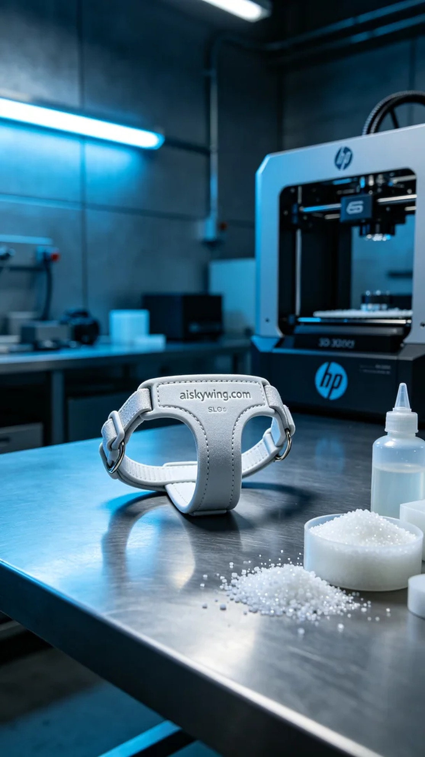
Aiskywing Industrial 3D Printing
Pet harness buckle


