0969-AGV保护罩3D打印生产记录
AGV Protective Cover
🖨️ SLS尼龙烧结
🖥️ 打印机: Systems
📦 材料: SLS阻燃尼龙
在LinkedIn上看到许多人对AGV保护罩的关注，这让我想起了我们在3D打印工作中坚持的意义。如果我们不断努力，就能创造出更好的产品。
I noticed many people on LinkedIn showing interest in AGV protective covers, which reminded me of the significance of our commitment to 3D printing work. If we keep striving, we can create better products.
________________________________________________________________________________
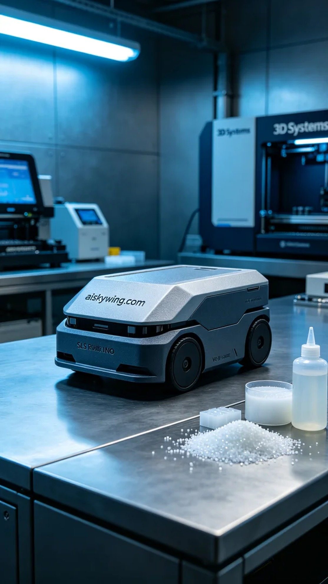
Recently, someone reached out to us looking for a high-performance AGV protective cover. They needed this cover to have excellent flame-retardant properties and durability, ensuring the equipment's safety in harsh environments. Given these special requirements, we decided to use SLS flame-retardant nylon for printing.
In the preparation stage, we selected SLS flame-retardant nylon as the printing material. This material not only features V0-level flame retardancy but also offers excellent mechanical strength and heat resistance. We utilized a 3D printer from Systems, setting the layer thickness to 0.1mm, maintaining a printing temperature of 180 degrees, a power setting of 200W, and controlling the printing speed at 50mm/s, with an expected printing time of 12 hours.
As the printing commenced, the equipment smoothly entered operation, layering powder bit by bit. We closely monitored the printing quality, regularly checking the nozzle's operation and the material supply to ensure each layer settled evenly. Throughout the printing process, observing the device's operation allowed us to timely identify and adjust any potential issues, making the entire process more efficient.
After printing was completed, the post-processing stage was particularly crucial. We first cleaned the formed parts to remove any unfused powder from the surface, followed by sanding to ensure a smooth finish. Next, we placed the protective cover into a curing device to further enhance its properties. Finally, we conducted a comprehensive inspection of the formed part, ensuring it met all design specifications.
Ultimately, we successfully completed the production of the AGV protective cover, with quality meeting expectations, and the stakeholder expressed satisfaction. Each effort and perseverance lays the foundation for a better tomorrow.
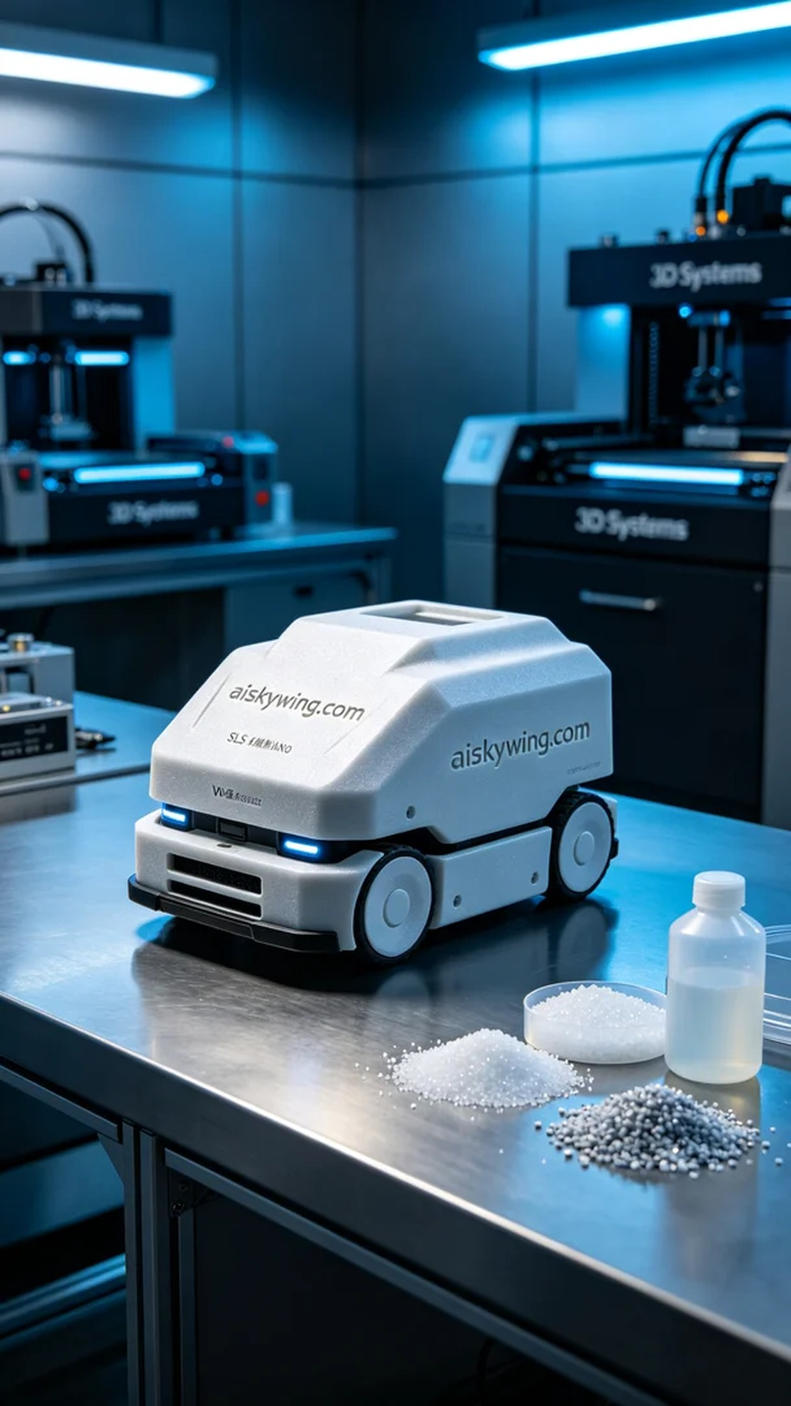
最近，有人因为需要一款高性能的AGV保护罩找到了我们。他们希望这个保护罩具备良好的阻燃性能和耐用性，以确保设备在恶劣环境下的安全运行。由于其特殊要求，我们决定使用SLS阻燃尼龙材料进行打印。
在准备阶段，我们选择了SLS阻燃尼龙作为打印材料。这种材料不仅具备V0级阻燃特性，还具有极好的机械强度和耐高温性。我们使用的是3D Systems品牌的打印机，设置了层厚为0.1mm，打印温度保持在180度，功率设定为200W，打印速度控制在50mm/s，预计打印时间为12小时。
打印开始后，设备顺利进入工作状态，粉末逐层堆积。我们全程监控打印质量，定期检查喷头的工作状态和材料的供给情况，确保每一层都能够均匀沉淀。在打印过程中，透过观察设备的运行，我们能够及时发现并调整任何潜在的问题，让整个过程更加顺畅。
打印完成后，后处理阶段尤为重要。我们首先对成型件进行了清洗，去除表面的未融合粉末，随后进行打磨，以确保表面光滑。接着，将保护罩放入固化设备中进行固化，使其性能得到进一步提升。最后，我们对成型件进行了全面检验，确保其符合所有设计规范。
最终，我们如愿以偿地完成了AGV保护罩的生产，质量达到预期标准，客户对此表示满意。每一次的努力和坚持，都是在为更美好的明天打下基础。
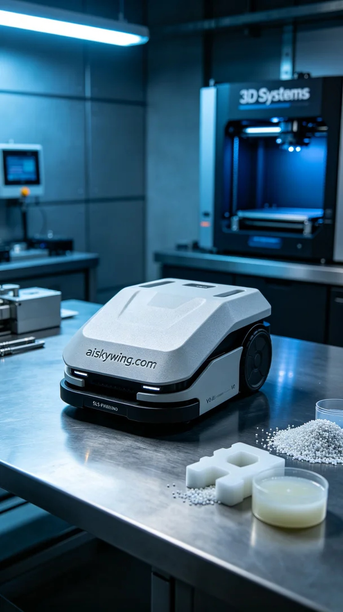
Aiskywing Industrial 3D Printing
AGV Protective Cover


