0970-宠物臀部清洁器手柄的制作过程
Pet Butt Cleaner Handle
🖨️ SLS尼龙烧结
🖥️ 打印机: Carbon
📦 材料: SLS尼龙PA12
生活就像3D打印，细致入微，往往需要耐心与坚持。最近有人在YouTube上寻求帮助，希望制作一个宠物臀部清洁器手柄。
Life is like 3D printing, intricate and often requiring patience and perseverance. Recently, someone sought help on YouTube, hoping to create a handle for a pet butt cleaner.
________________________________________________________________________________
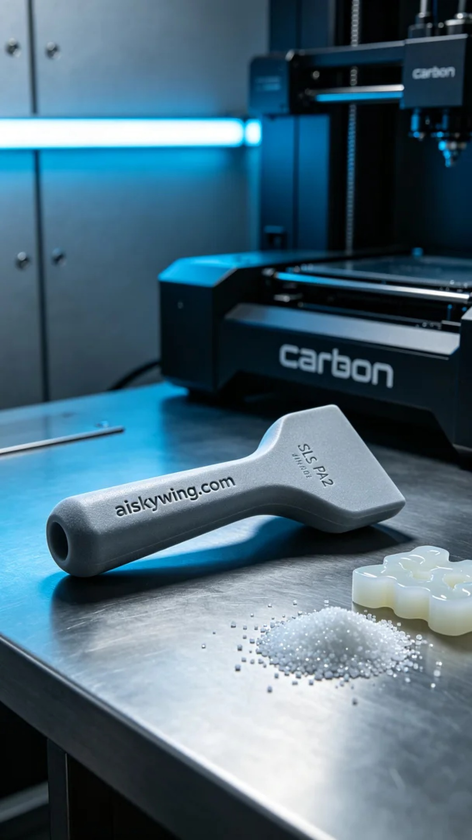
Life is like 3D printing, detailed and nuanced, requiring patience and persistence. Recently, someone reached out on YouTube for help in creating a handle for a pet cleaning device.
We selected SLS Nylon PA12 as our raw material. This material boasts excellent strength and durability, making it ideal for high-strength engineering plastic products. For the equipment setup, we used a Carbon brand 3D printer. To ensure quality, the print settings included a layer thickness of 0.1mm, a temperature of around 180°C, a power setting of 80%, a speed of 100mm/s, and an estimated print time of six hours.
During the printing process, the Carbon printer ran smoothly, while I monitored the quality closely. Each layer was clearly defined, ensuring no bubbles or defects. The low rumble of the machine was reassuring as the product took shape, filling me with anticipation for the final result.
The post-processing steps were crucial. We first cleaned the finished product, removing any residual powder, then proceeded to sand it down to ensure a smooth touch. Next, we placed it in a UV curing chamber to enhance the material's strength and durability. Lastly, we conducted a thorough inspection, ensuring every detail met our standards.
After a series of production and processing steps, the pet cleaning device handle was finally born. Looking at the finished product, I knew once again we had successfully combined technology with everyday needs.
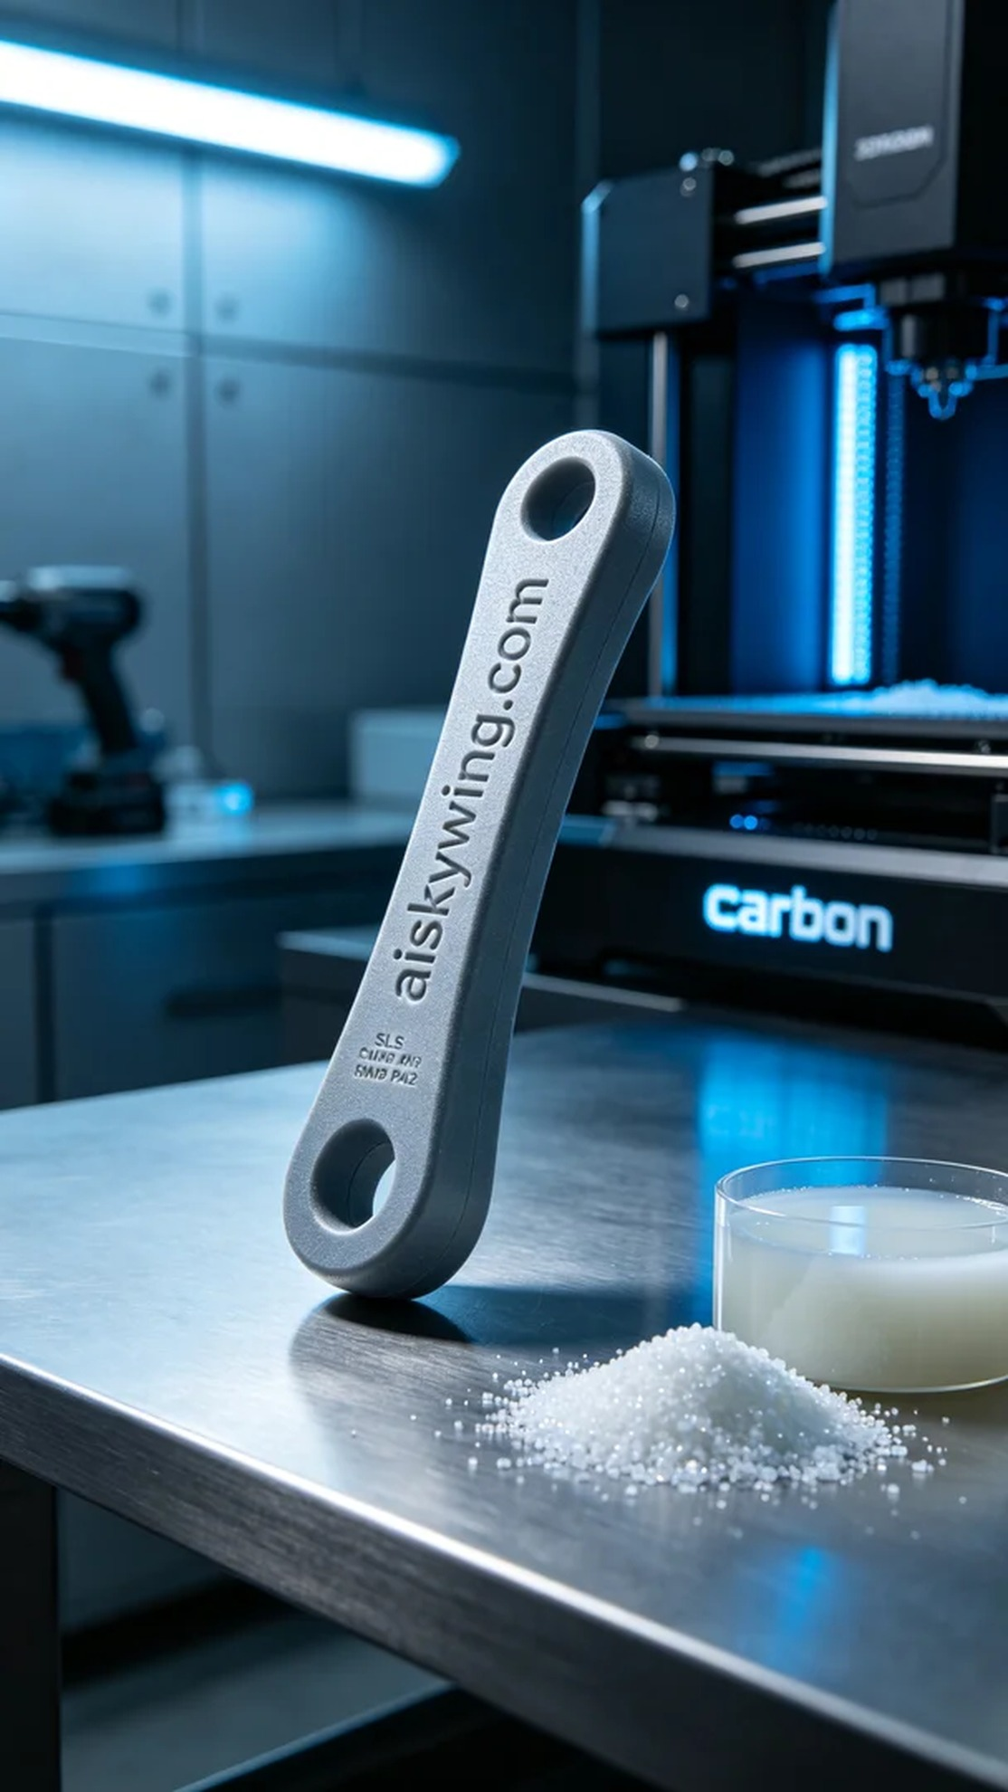
在YouTube上，有人因为宠物卫生问题找到了我们，想要制作一个宠物臀部清洁器的手柄。这款产品不仅能有效解决宠物清洁难题，还结合了现代科技的力量，让日常护理变得简单而高效。
我们选择了SLS尼龙PA12作为原材料。这种材料具有优异的强度和耐用性，非常适合制作高强度的工程塑料产品。在设备准备方面，我们使用了Carbon品牌的3D打印机。为了确保打印质量，设定的打印参数为层厚0.1mm，温度约为180°C，功率设定在80%，速度为100mm/s，预计打印时间为6小时。
打印过程中，Carbon打印机平稳运行，整个过程我一直在进行质量监控。每一层的打印都清晰可见，确保没有气泡或瑕疵。机器发出的低音轰鸣声让人感到安心，打印产品逐渐成形，使我对最终效果充满期待。
完成后处理工序十分重要。我们首先将成品清洗，去除表面残留的粉末，然后进行打磨，确保手柄的触感光滑。接下来，将其放入UV固化箱进行固化，以增强材料的强度和耐用性。最后，我们进行了全面检验，确保每个细节都符合标准。
经过一系列的制作与处理，这个宠物臀部清洁器手柄终于诞生了。看着成品，我知道又一次成功地将科技与生活需求结合在了一起。
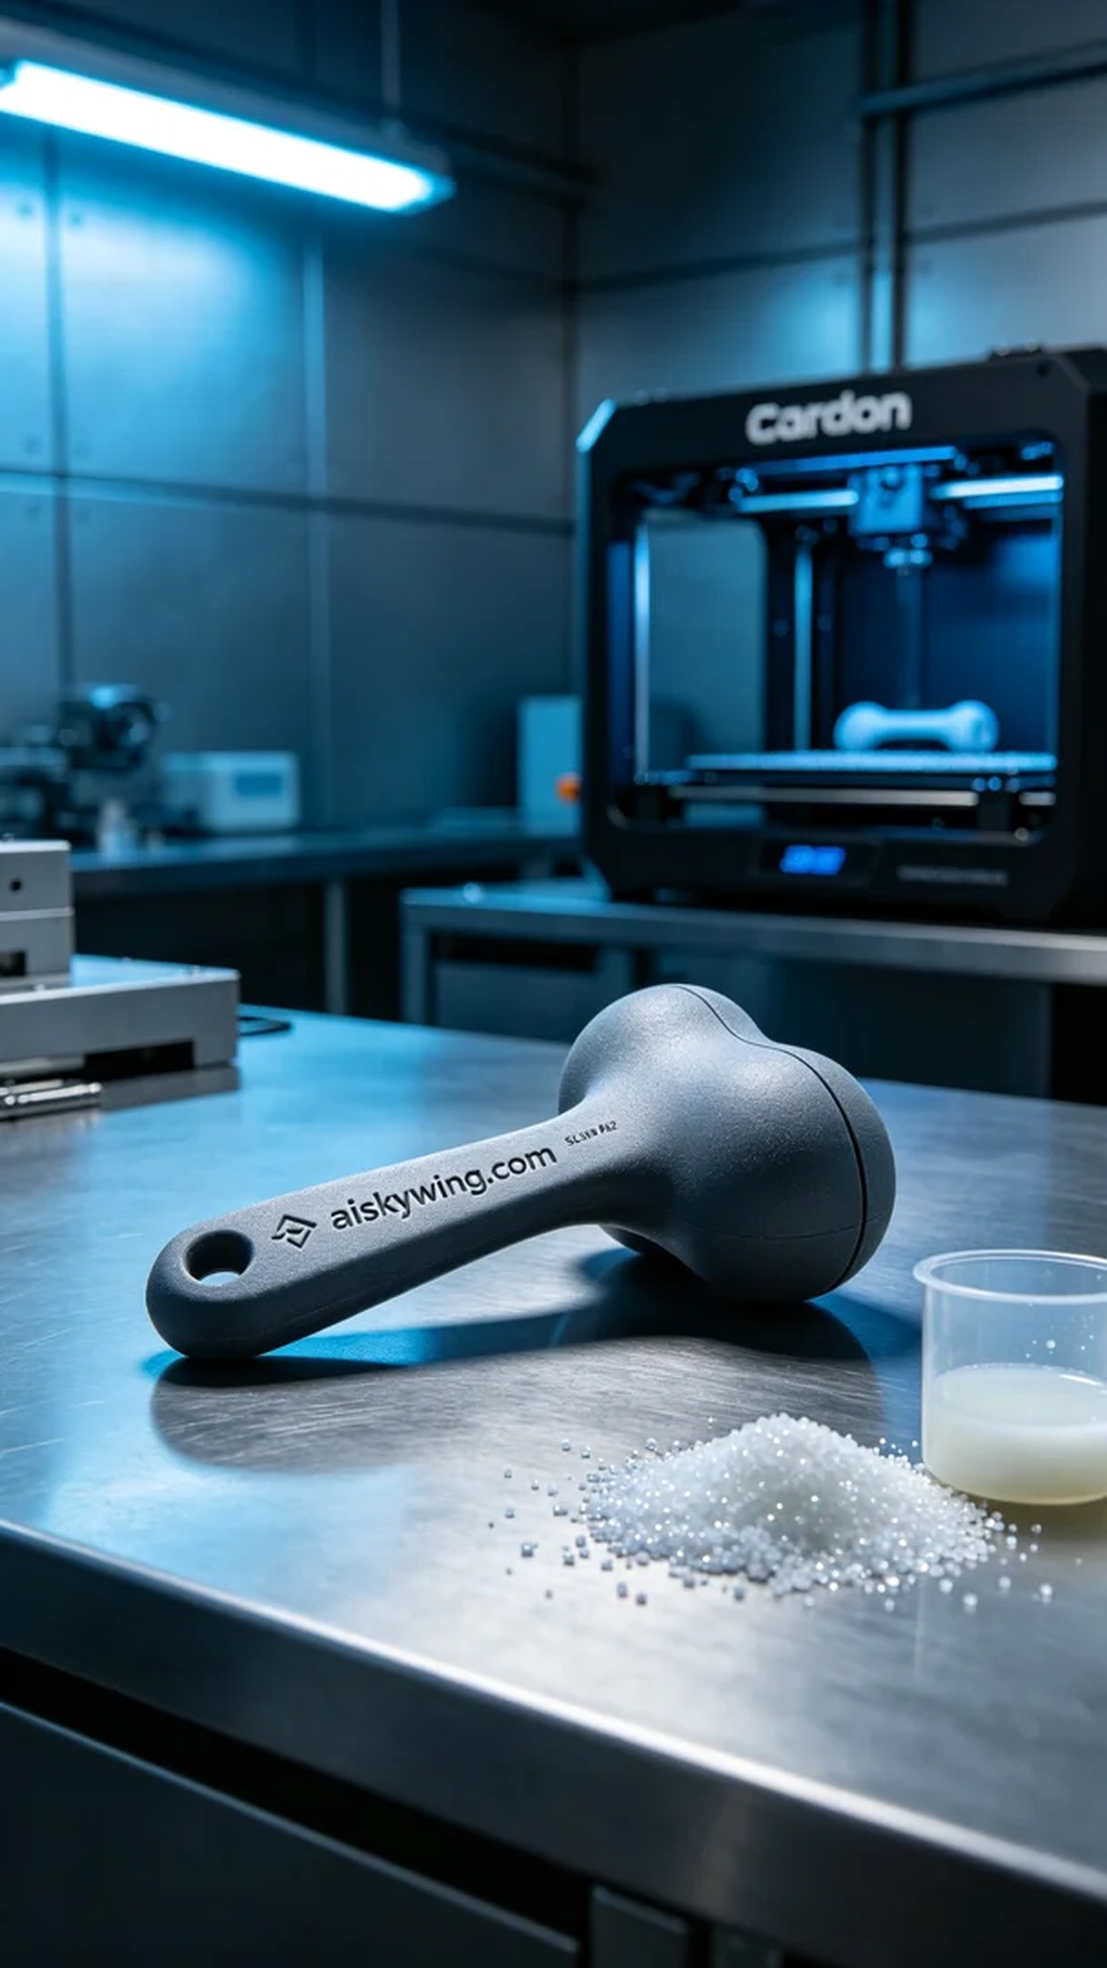
Aiskywing Industrial 3D Printing
Pet Butt Cleaner Handle


