0972-宠物自动逗猫棒生产记录
Pet Automatic Cat Teaser Stick Base
🖨️ SLS尼龙烧结
🖥️ 打印机: Stratasys
📦 材料: SLS耐高温尼龙
生活再难，也别停下脚步。就像接下这个宠物自动逗猫棒的单子，有人希望给他们的爱宠带来更多乐趣。
No matter how difficult life gets, don't stop moving forward. Just like taking on this order for an automatic cat teaser, some people hope to bring more joy to their beloved pets.
________________________________________________________________________________
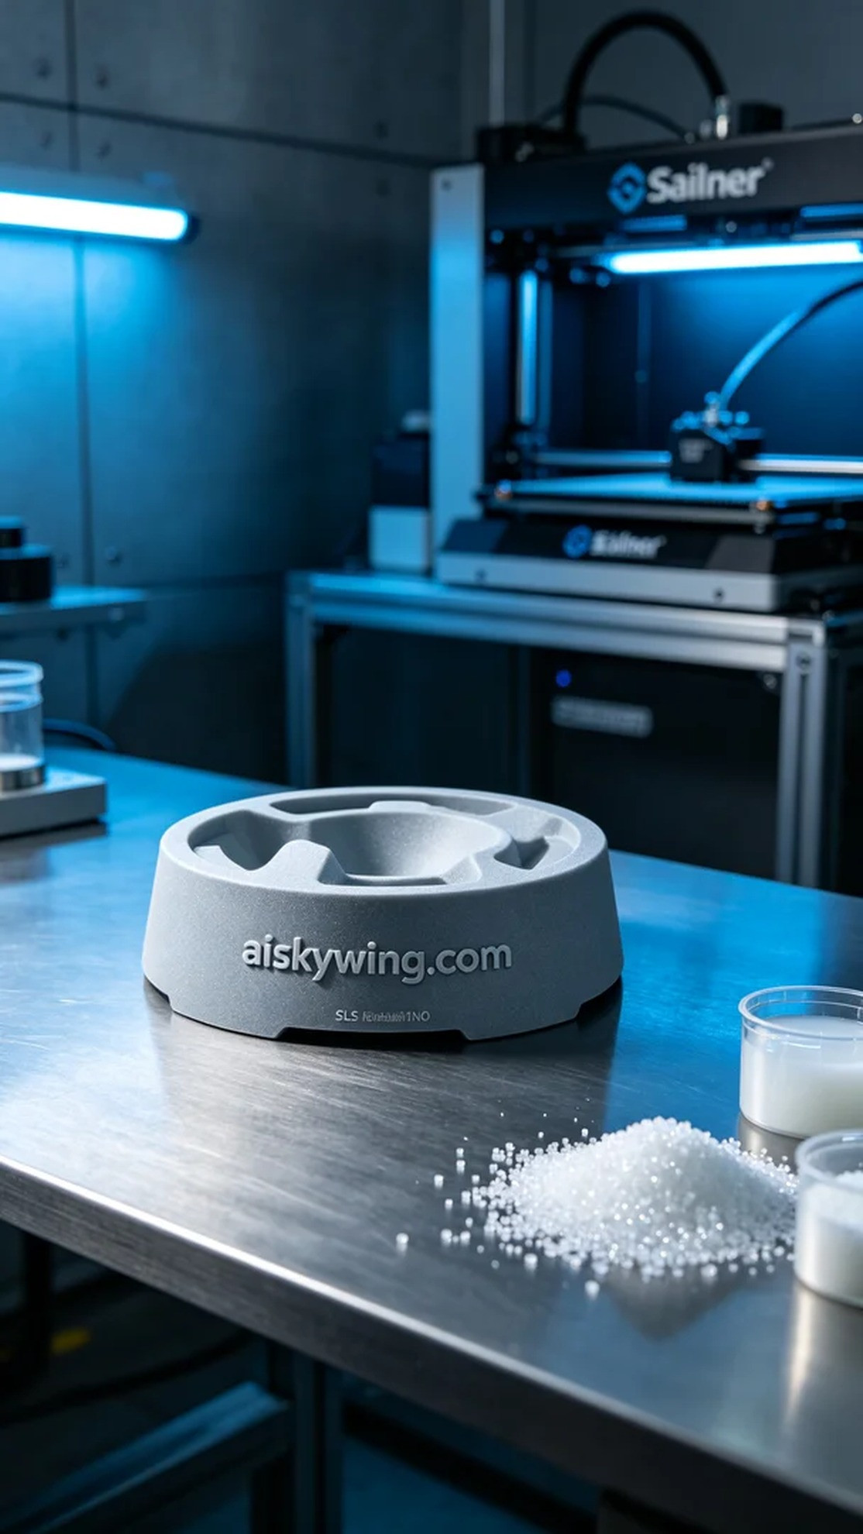
Life can be tough, but we should never stop moving forward. Just like taking on the project for this pet automatic cat teaser base, someone wanted to bring more joy to their beloved pets.
Today, someone reached out through Instagram looking to create a pet automatic cat teaser base. They wanted the product to be both durable and aesthetically pleasing, suitable for various environments. After our discussion, we decided to use SLS high-temperature nylon for this project.
In the preparation phase, I first checked the raw materials, ensuring that we were using high-quality SLS high-temperature nylon. This material can withstand temperatures above 150°C, making it suitable for indoor use, while its matte texture enhances the overall appearance. For the equipment, I chose a Stratasys printer and set the printing parameters: a layer thickness of 0.1mm, a printing temperature of 190°C, a power setting of 80%, a printing speed of 20mm per second, and an estimated printing time of about 8 hours.
During the printing process, the Stratasys device ran steadily, with the print head carefully moving layer by layer to ensure even material deposition. Throughout the process, I maintained quality monitoring, regularly checking the print to ensure there were no defects. As time went by, the base gradually took shape, displaying the clear engraving of "aiskywing.com," and its texture became increasingly noticeable.
Once the printing was completed, I began the post-processing steps. First, I placed the printed base into the cleaning tank, using ultrasonic cleaning to remove excess resin from the surface. After cleaning, I gently sanded the surface with fine sandpaper to ensure every corner was smooth and flawless. Finally, the base was placed under a UV curing lamp to ensure its strength and durability. After meticulous inspection, the final product was confirmed to meet our standards.
After multiple processes, the pet automatic cat teaser base was finally completed, and it was truly a rewarding moment. Each detail showcased our commitment to quality, and this will become a new companion for pets to enjoy.
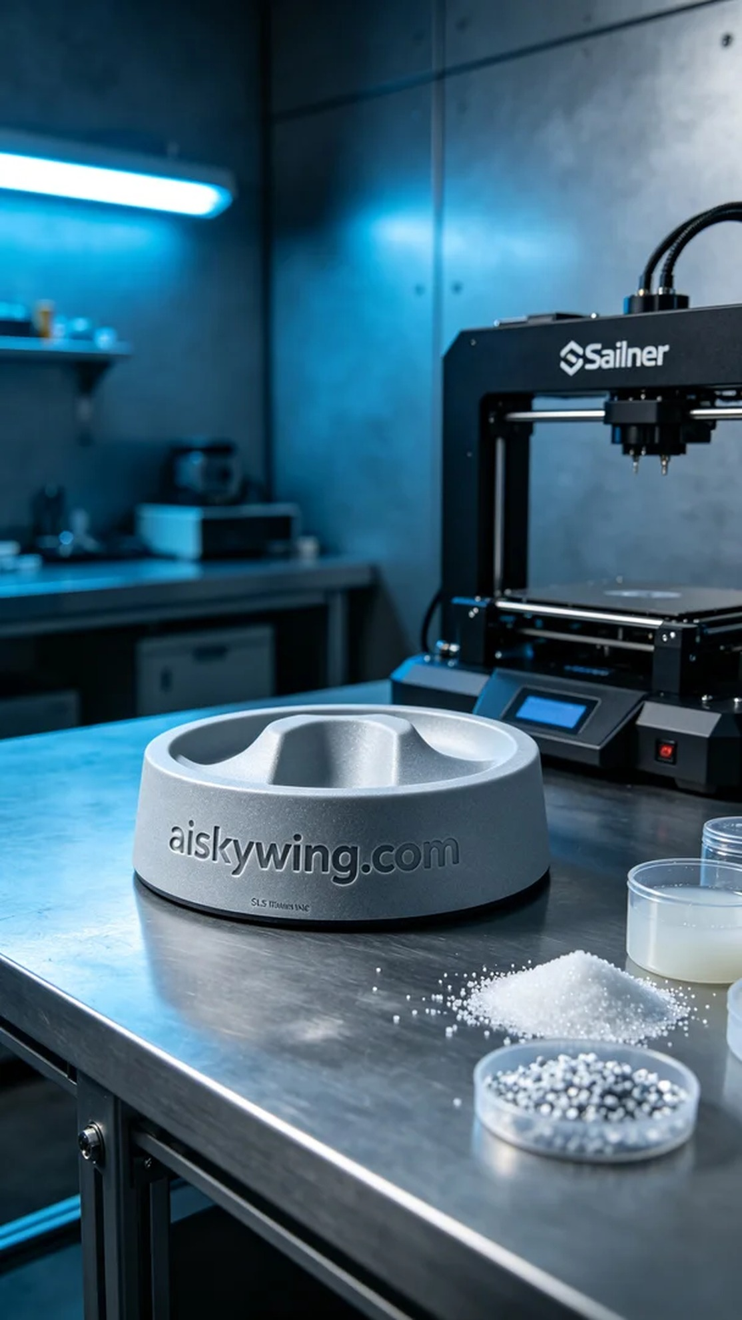
今天，有人通过Instagram联系我，想要制作一个宠物自动逗猫棒的底座。他们希望这个产品能够既耐用又美观，适合在各种环境下使用。经过沟通，我们决定使用SLS耐高温尼龙材料来完成这个项目。
在准备阶段，我首先检查了原材料，确保使用的是优质的SLS耐高温尼龙。由于这种材料的耐温可达150℃以上，适合各种室内环境，同时它的磨砂质感也能提升整体的外观效果。设备方面，我选择了Stratasys打印机，并设置了打印参数：层厚0.1毫米，打印温度为190℃，功率设置在80%，打印速度为20毫米每秒，预计打印时间约为8小时。
打印过程中，Stratasys设备运行稳定，打印头在每层上仔细移动，确保材料均匀沉积。整个过程中，我保持对打印质量的监控，定期检查打印情况，确保没有出现任何瑕疵。随着时间的推移，底座逐渐成型，显示出清晰的“aiskywing.com”雕刻字样，质感也越来越明显。
打印完成后，我开始着手后处理工序。首先将打印出的底座放入清洗槽中，用超声波清洗去除表面多余的树脂。清洗完成后，用细砂纸轻轻打磨表面，确保每一个角落都光滑无瑕。最后，将底座放在UV固化灯下固化，确保其强度和耐用性。整个过程仔细检验，最终检验确认产品达标。
经过多道工序，宠物自动逗猫棒的底座终于完成，真是令人欣慰的一刻。每一个细节都展现了我们对品质的追求，这将成为宠物们玩乐的新助手。
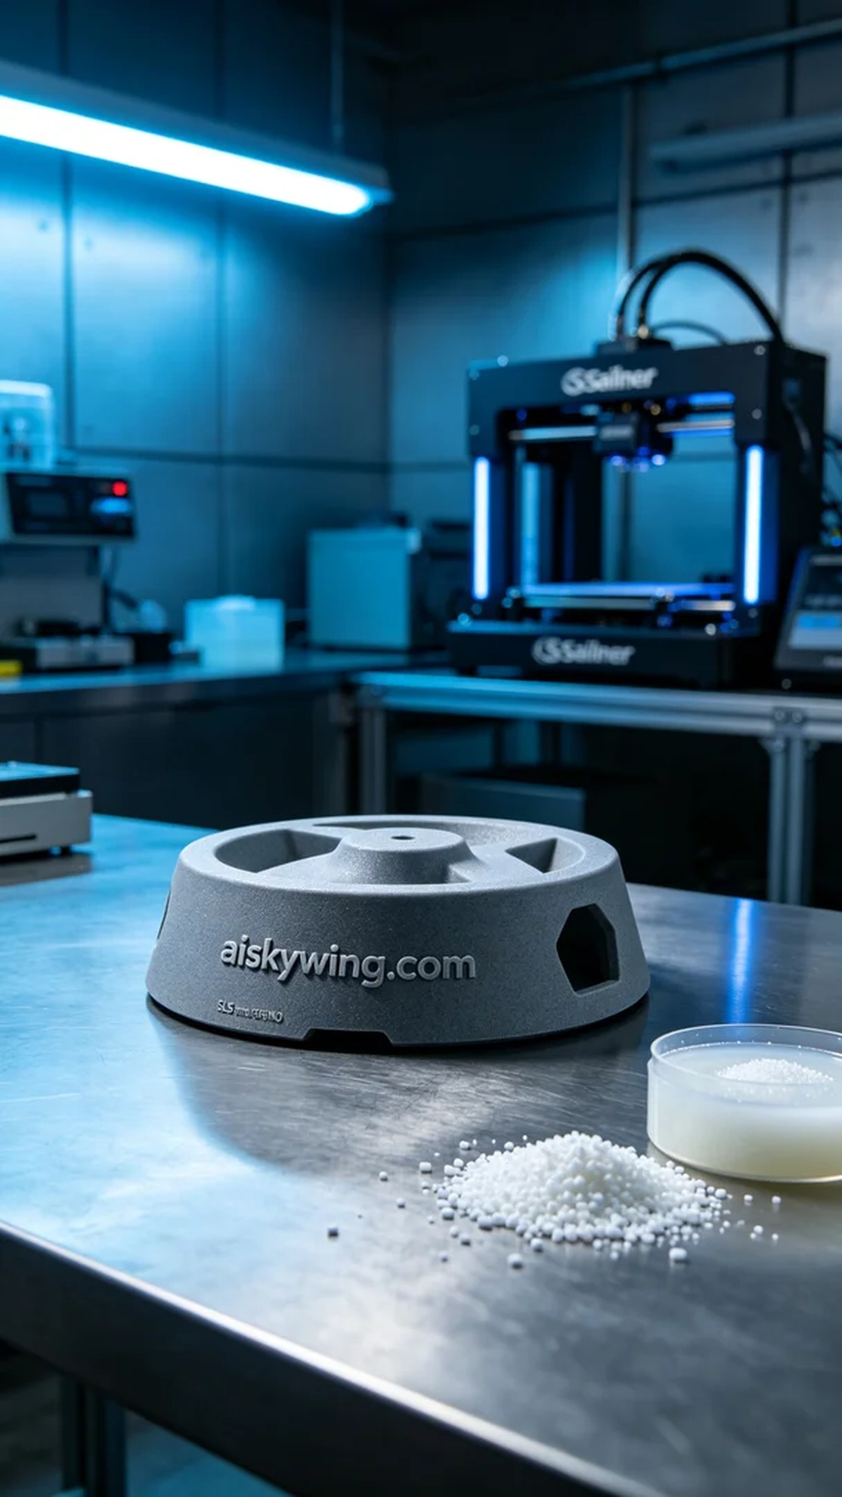
Aiskywing Industrial 3D Printing
Pet Automatic Cat Teaser Stick Base


