0973-宠物航空箱通风件生产记录
Pet Airline Carrier Ventilation Component
🖨️ SLS尼龙烧结
🖥️ 打印机: EOS
📦 材料: SLS尼龙PA12
在这个快速变化的时代，我们总要迎接新的挑战。就像有人找到我们，请我们制作这个宠物航空箱通风件一样，为了给它的爱宠提供最好的出行体验。
In this rapidly changing era, we always have to embrace new challenges. Just like when someone approached us to create a ventilation piece for this pet airline crate, in order to provide the best travel experience for their beloved pet.
________________________________________________________________________________
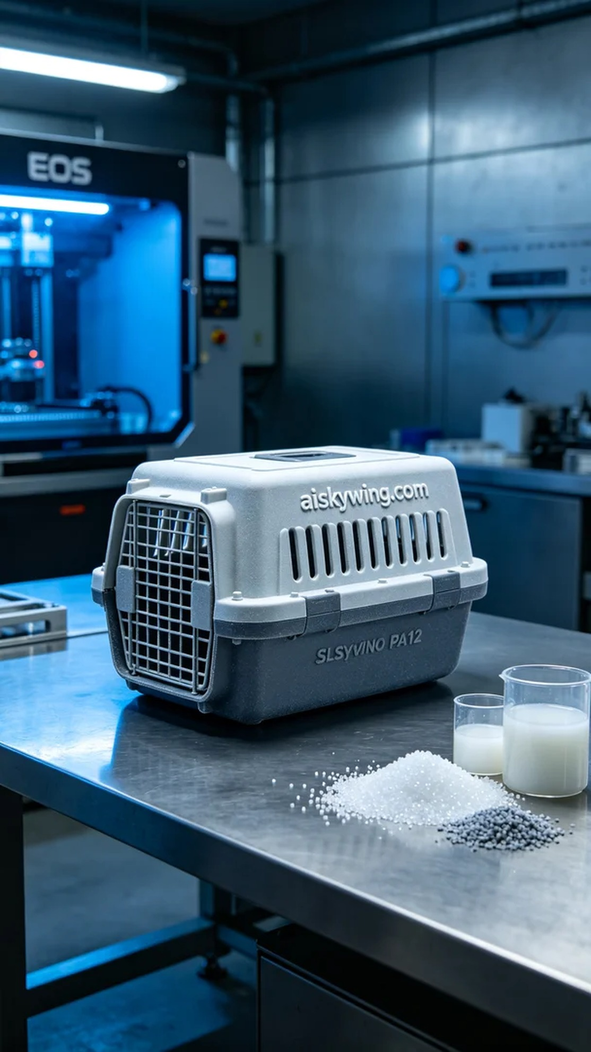
In this fast-paced world, we must embrace new challenges. Just like someone reached out to us, asking for the production of a pet air cargo box ventilation component to ensure a better traveling experience for their beloved pet.
We selected SLS Nylon PA12 as the raw material, known for its high strength and durability, making it ideal for parts that need to withstand pressure. The EOS brand 3D printer was used for the printing process, with a layer thickness of 0.1 mm, printing temperature set at 180°C, power at 240W, and a speed of 20 mm per second, with an estimated print time of 6 hours to ensure detail and strength.
During the printing process, the EOS printer operated quietly and steadily, maintaining optimal internal and nozzle temperatures. We monitored the print quality in real-time through our monitoring system, ensuring that each layer cured properly, with no warping or defects, resulting in a successful print of the ventilation piece.
After printing, we moved on to post-processing steps. The printed parts were placed in a cleaning tank for ultrasonic cleaning to remove any uncured powder, followed by sanding with fine sandpaper to ensure a smooth surface. Next, we used UV curing equipment to cure the parts, a critical step for enhancing material strength and durability. Lastly, we conducted rigorous inspections to ensure that every detail met our standards.
Through this production, we not only resolved the ventilation component issue but also enhanced our skills and experience. Each challenge presents an opportunity for growth, inspiring us to continue creating better products for pets and their owners.
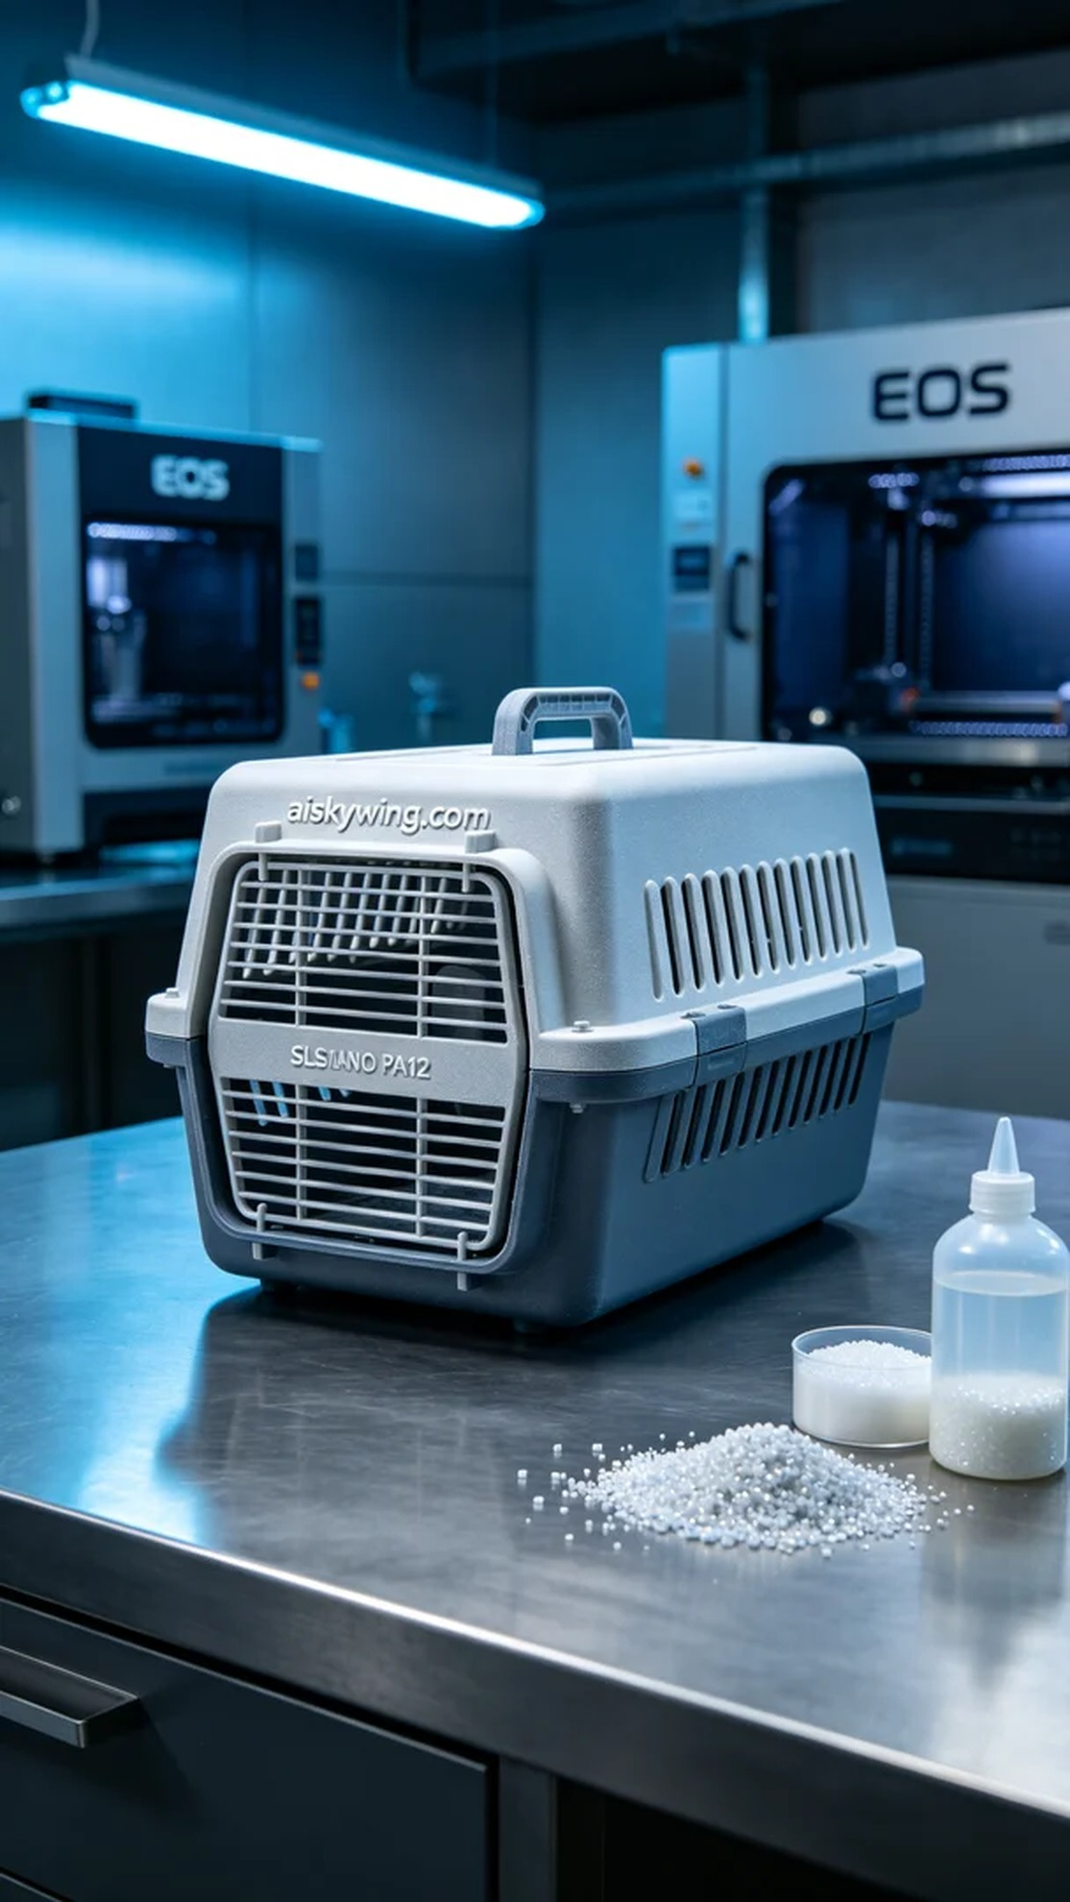
有人在Facebook上发帖，提到他们的宠物在航空箱中感到不适，苦恼于通风不良的问题，于是他们找到我们，希望能定制一款宠物航空箱通风件，改善通风效果。这让我们意识到，这不仅是个项目，更关乎到每个小生命的舒适与安全。
我们选择了SLS尼龙PA12作为原材料，这种材料具有高强度和耐用性的特点，十分适合需承受一定压力的产品。同时，我们使用EOS品牌的3D打印机进行打印，设置了层厚0.1毫米，打印温度为180℃，功率240W，打印速度为20毫米每秒，预计打印时间为6小时，这样可以确保部件的细节和强度。
在打印过程中，EOS打印机安静而稳定地运行，机器内部的温度和喷嘴温度都维持在最佳状态。我们通过监控系统实时观察打印质量，确保每一层的固化效果良好，没有出现翘曲或缺陷，最终成功打印出了通风件。
完成打印后，我们进行了后处理工序。首先将打印好的部件放入清洗槽，用超声波清洗去除未固化的粉末，然后使用细砂纸进行打磨，确保表面光滑。接下来，采用UV固化设备对部件进行固化，这一步骤是确保材料强度和耐用性的重要环节。最后，我们对成品进行了严格检验，确保每个细节都符合标准。
通过这次生产，我们不仅成功解决了本次通风件的问题，也进一步提升了我们的技术和经验。每一次的挑战都是成长的机会，让我们继续为宠物和它们的主人创造更好的产品。
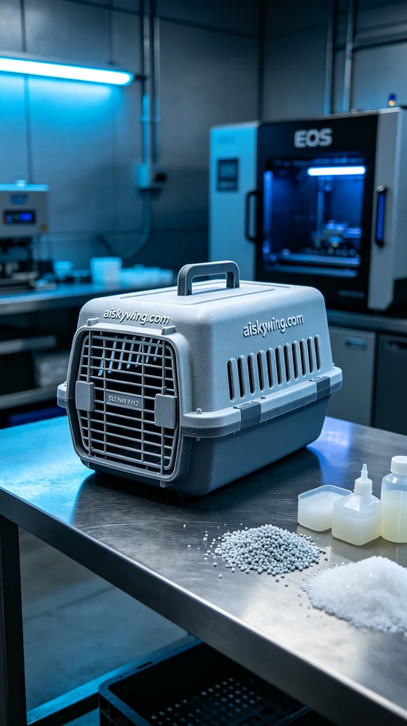
Aiskywing Industrial 3D Printing
Pet Airline Carrier Ventilation Component


