0974-宠物足部清洁器手柄的生产记录
Pet Foot Cleaner Handle
🖨️ SLS尼龙烧结
🖥️ 打印机: Stratasys
📦 材料: SLS阻燃尼龙
在Facebook上，有人因为宠物足部清洁的问题找到我们，求助于这个宠物足部清洁器手柄，希望能打造出既实用又耐用的产品。
On Facebook, someone reached out to us regarding the issue of cleaning pet paws, seeking help with this pet paw cleaner handle, hoping to create a product that is both practical and durable.
________________________________________________________________________________
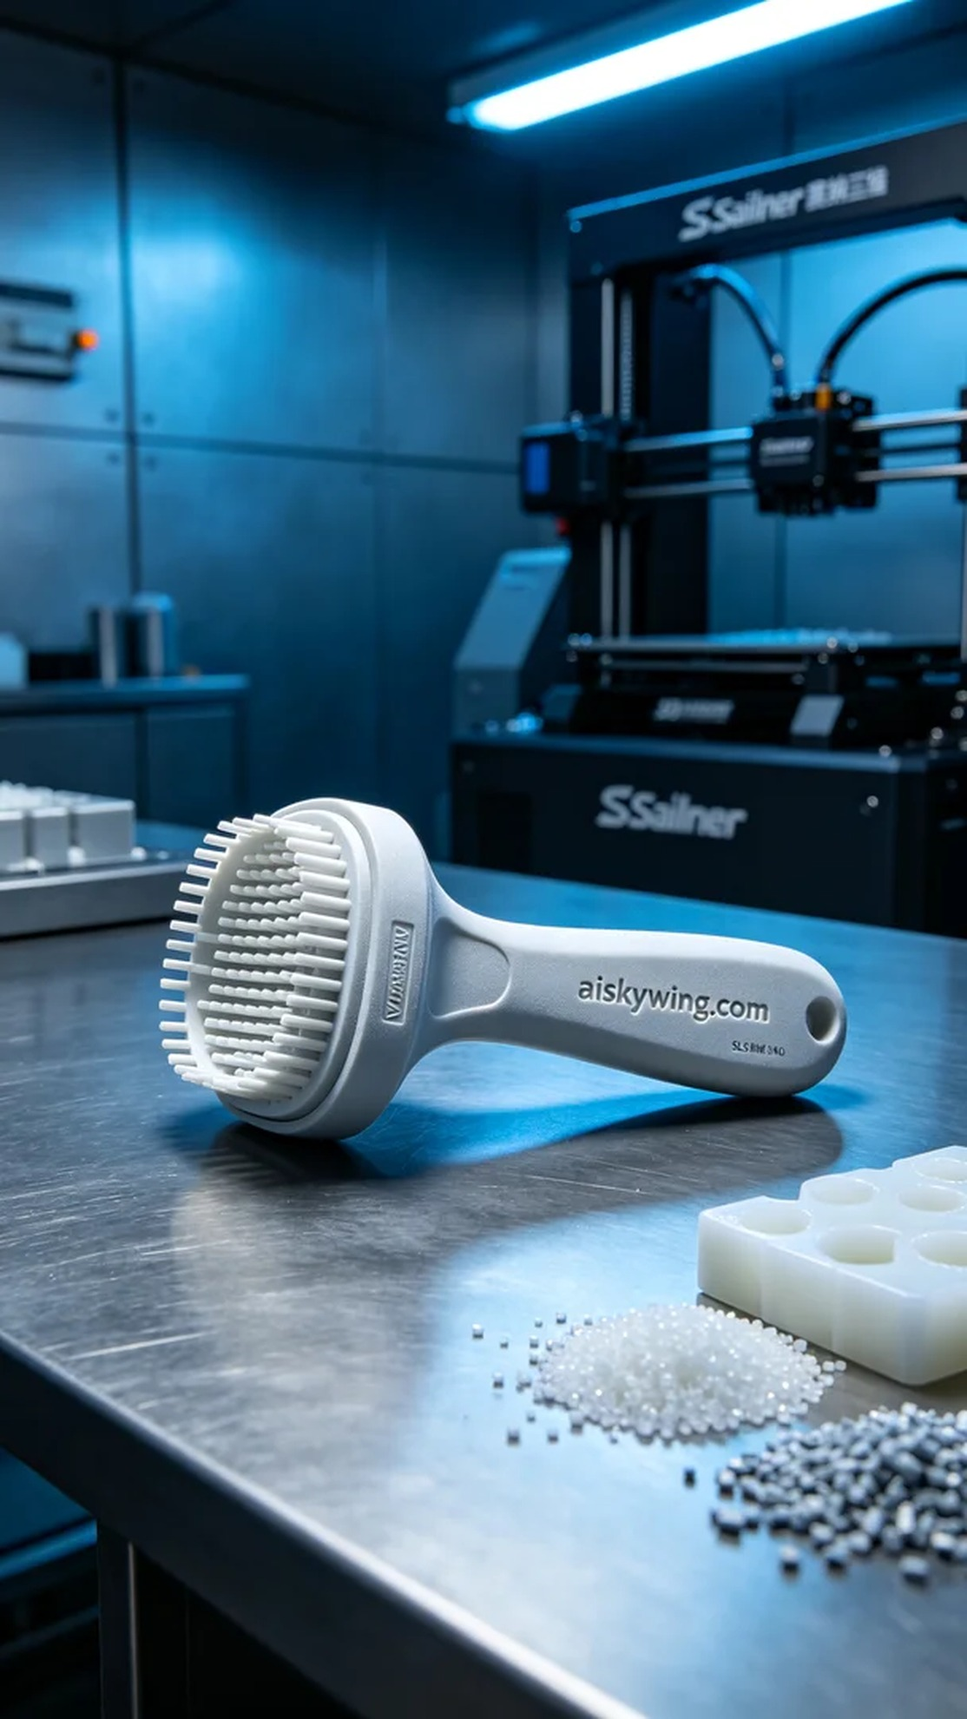
On Facebook, someone reached out to us for help with cleaning their pet's paws, seeking a solution in the form of a pet foot cleaner handle that is both functional and durable.
For this project, we selected SLS flame-retardant nylon as the primary material. This SLS nylon is known for its excellent strength, wear resistance, and V0 level flame retardancy, ensuring that the product remains safe during use. Additionally, the material features a matte finish that effectively reduces glare and enhances user comfort. In preparation, we utilized a Stratasys 3D printer and set optimized parameters: a layer thickness of 0.1mm, a printing temperature of 180°C, a power level of 85%, and a printing speed of 40mm/s, with an estimated printing time of 8 hours.
As the printing commenced, the Stratasys printer operated smoothly. We closely monitored the quality control system to ensure each layer fused together accurately. The monitoring software provided real-time feedback on the printing status, allowing us to make necessary adjustments to the parameters if any issues arose. Ultimately, the print process was completed successfully, with the final product meeting our expected precision and detail standards.
Post-printing, the finishing processes were equally crucial. First, we submerged the printed handle in a cleaning bath, using a specialized cleaning agent to remove any uncured resin. Following that, we meticulously sanded the handle's surface to ensure it was smooth, eliminating any rough edges. Finally, we carried out a curing process to ensure that the product's strength and durability met the required standards. After rigorous inspection, we confirmed that every detail adhered to the design specifications.
With all these processes completed, the final pet foot cleaner handle showcased a stunning technological aesthetic that stands out in the market as an essential practical item. We are very pleased with the production process, as both the material choice and the application of 3D printing technology reflect our commitment to quality.
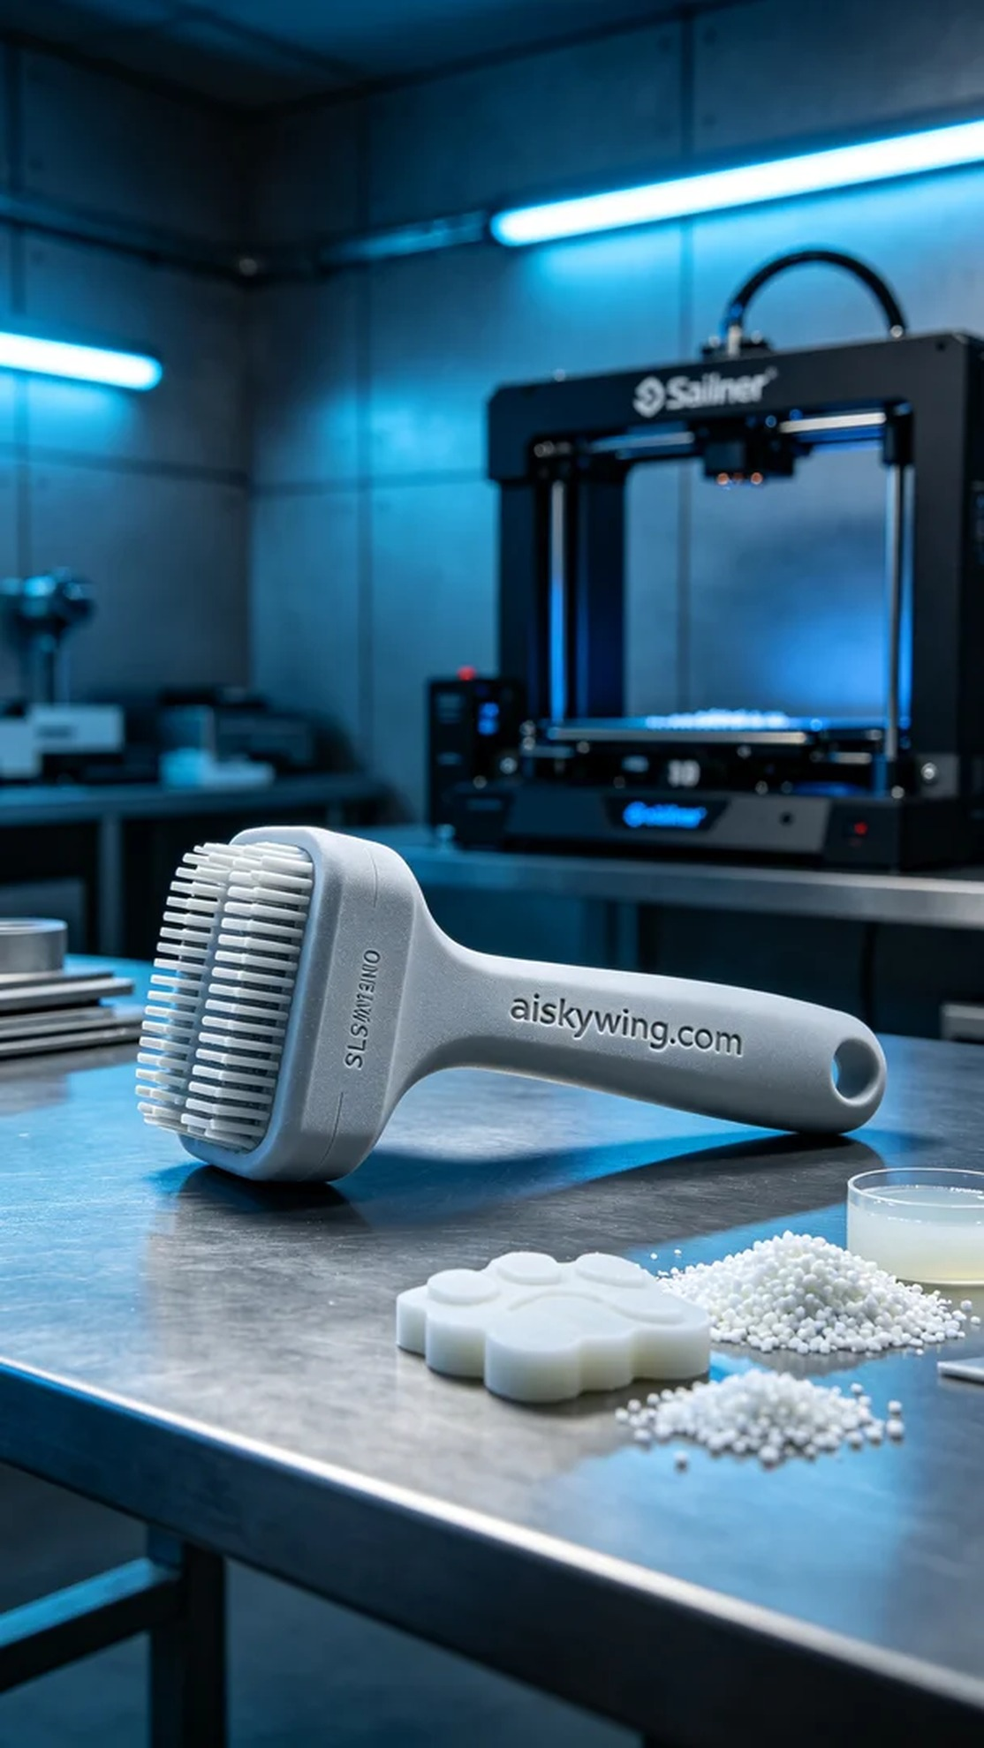
我们采用了SLS阻燃尼龙材料来打印这个宠物足部清洁器手柄。SLS尼龙具有优异的强度和耐磨性，同时具备V0级阻燃性，确保产品在使用过程中安全可靠。此外，材料的表面经过磨砂处理，能够有效减小反光，增加用户的使用舒适感。在准备过程中，我们使用Stratasys的3D打印机进行打印，设置了适合的参数：层厚为0.1mm，打印温度在180°C，功率达到85%，打印速度为40mm/s，预计打印时间为8小时。
打印过程开始后，Stratasys打印机平稳运行。我们密切关注设备的质量监控系统，确保每一层都能精准融化成型。打印过程中，监控软件实时反馈打印状态，帮助我们及时调整打印参数，以应对可能出现的问题。最终，整个打印过程顺利完成，成品的表面精度和细节都达到了预期的标准。
完成打印后的后处理工序同样重要。首先，我们将打印好的手柄放入清洗槽，使用液态光敏树脂专用的清洗剂去除未固化的树脂。之后，手柄经过细致的打磨，确保表面光滑，去掉任何粗糙的边缘。最后，我们进行了固化处理，确保产品的强度和耐久性符合要求。经过严格的检验，确保每一个细节都符合设计标准。
在这一系列流程结束后，最终的宠物足部清洁器手柄展现出极具科技感的工业美学，成为了市场中一款不可或缺的实用品。我们对这次的生产过程感到非常满意，无论是材料的选择还是3D打印技术的运用，都体现了我们对品质的追求。
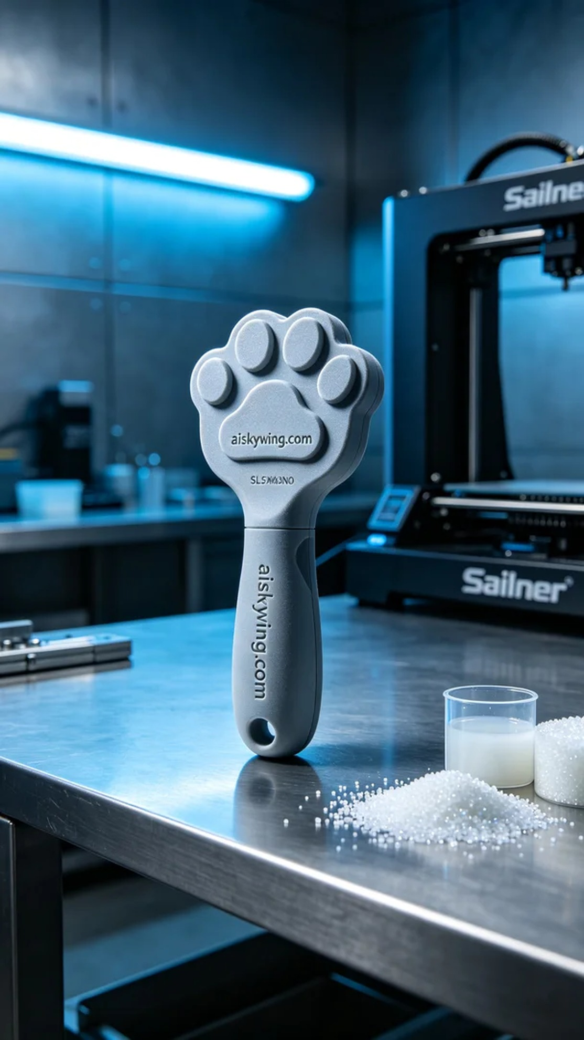
Aiskywing Industrial 3D Printing
Pet Foot Cleaner Handle


