0975-宠物追踪器外壳3D打印生产记录
Pet Tracker Shell
🖨️ SLS尼龙烧结
🖥️ 打印机: Voxeljet
📦 材料: SLS阻燃尼龙
生活再难，也别停下脚步。就像接下这个宠物追踪器外壳的单子，有人因为市场需求的变化，急需一个既美观又实用的外壳。
No matter how difficult life gets, don't stop moving forward. Just like taking on this order for a pet tracker shell, someone urgently needs a shell that is both aesthetically pleasing and practical due to changes in market demand.
________________________________________________________________________________
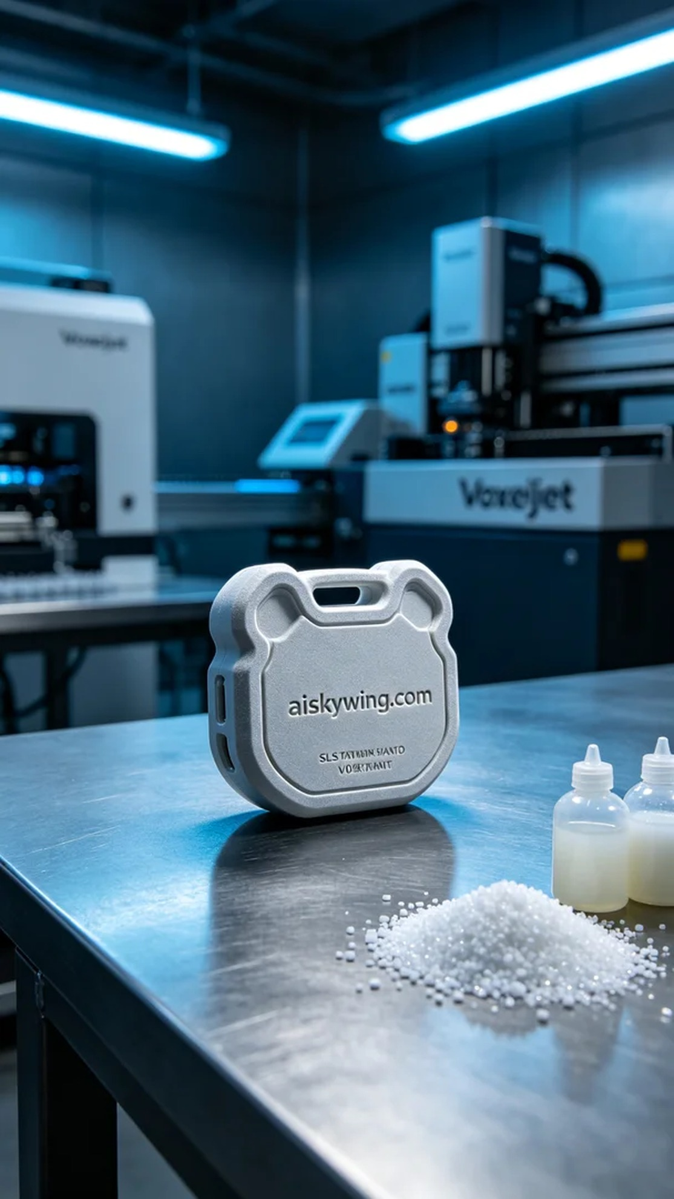
Life can be tough, but we must keep moving forward. Just like taking on this pet tracker shell project, someone needed a shell that is both aesthetically pleasing and practical due to changing market demands.
We received an interesting project regarding the production of a pet tracker shell. Someone saw our previous works on TikTok and wanted a shell that not only protects the device but also showcases a sense of technology. After in-depth communication, we decided to use SLS flame-retardant nylon as the material to ensure durability and safety.
To ensure a smooth production, we first prepared the SLS flame-retardant nylon raw materials. This material has excellent flame-retardant properties, meeting the V0 level standards. Its matte surface texture and toughness are also very suitable for our design requirements. We used a Voxeljet 3D printer, setting the parameters to a layer thickness of 0.1mm, a printing temperature of 180°C, a power of 50%, and a printing speed of 10mm/s. This ensures that each layer can be accurately stacked.
As the printing process began, the Voxeljet equipment operated steadily, with each spray from the nozzle hitting the precise position. We continuously monitored the print quality to ensure there were no defects. Observing the equipment's feedback, the printed shell rose while forming the clearly visible "aiskywing.com" lettering. Over time, the entire printing process took approximately 6 hours.
After printing, we proceeded with the post-processing steps. First, we removed the formed shell from the printer and cleaned it to remove any uncurred powder. Next, we used fine sandpaper to polish the shell for a smoother surface. Once polishing was completed, we cured the shell to enhance its durability, followed by a careful inspection to ensure every detail met the standard.
Through this production, we successfully obtained a pet tracker shell that meets the requirements. This experience has further strengthened my belief in the limitless possibilities of 3D printing.
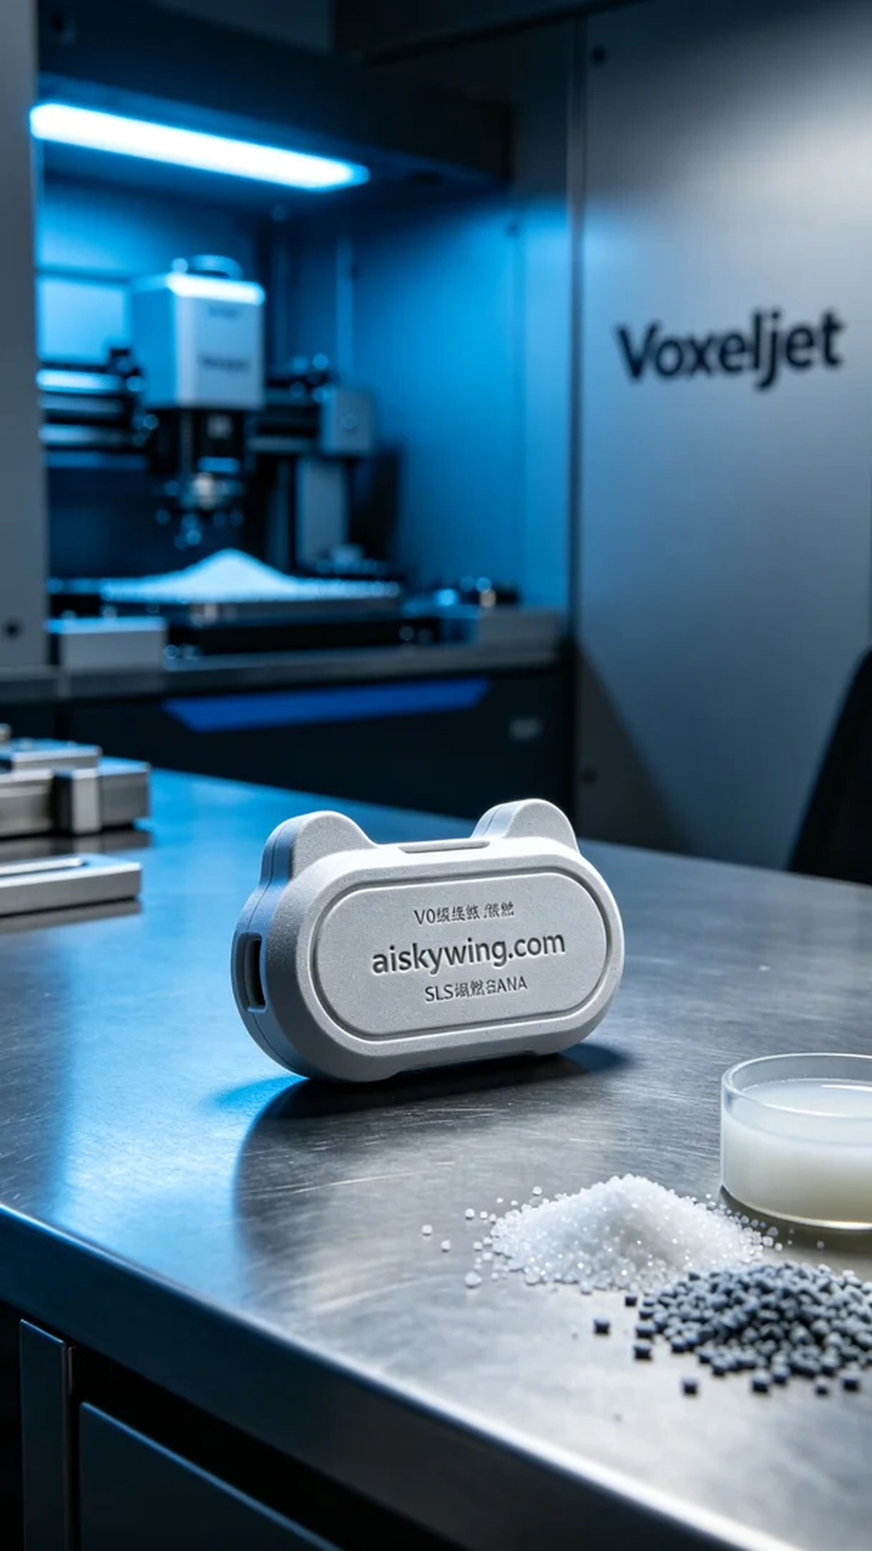
这次我们接到了一个很有趣的项目，涉及到一个宠物追踪器外壳的制作。有人在TikTok上看到我们之前的作品，想要一个既能保护设备，又能展现科技感的外壳。通过深入交流，我们确定了使用SLS阻燃尼龙作为材料，以确保外壳的耐用和安全。
为确保生产的顺利进行，我们首先准备了SLS阻燃尼龙的原材料。这种材料具有很好的阻燃性，符合V0级的标准。同时，它的表面磨砂质感和强韧性也非常适合我们的设计需求。我们使用的是Voxeljet的3D打印机，设置参数为层厚0.1mm、打印温度180°C、功率50%、打印速度为10mm/s。确保每一层都能精准叠加。
打印过程开始后，Voxeljet的设备运行稳定，喷头的每一次喷射都在精准的位置。我们时刻监控打印质量，确保没有任何瑕疵。观察到设备的反馈，打印的外壳在不断上升的过程中，形成了清晰可见的“aiskywing.com”字样。随着时间的推移，整个打印过程预计耗时约6小时。
打印完成后，我们进行了后处理工序。首先将成型的外壳从打印机中取出，并进行清洗，以去除未固化的粉末。接着，利用细砂纸对外壳进行打磨，使表面更加光滑。完成打磨后，我们对外壳进行固化处理，以提升耐用度，最后再进行仔细的检验，确保每一个细节都符合标准。
通过这次的生产，我们成功得到了一个符合要求的宠物追踪器外壳。这样的经历让我更加坚定，3D打印的未来无限可能。
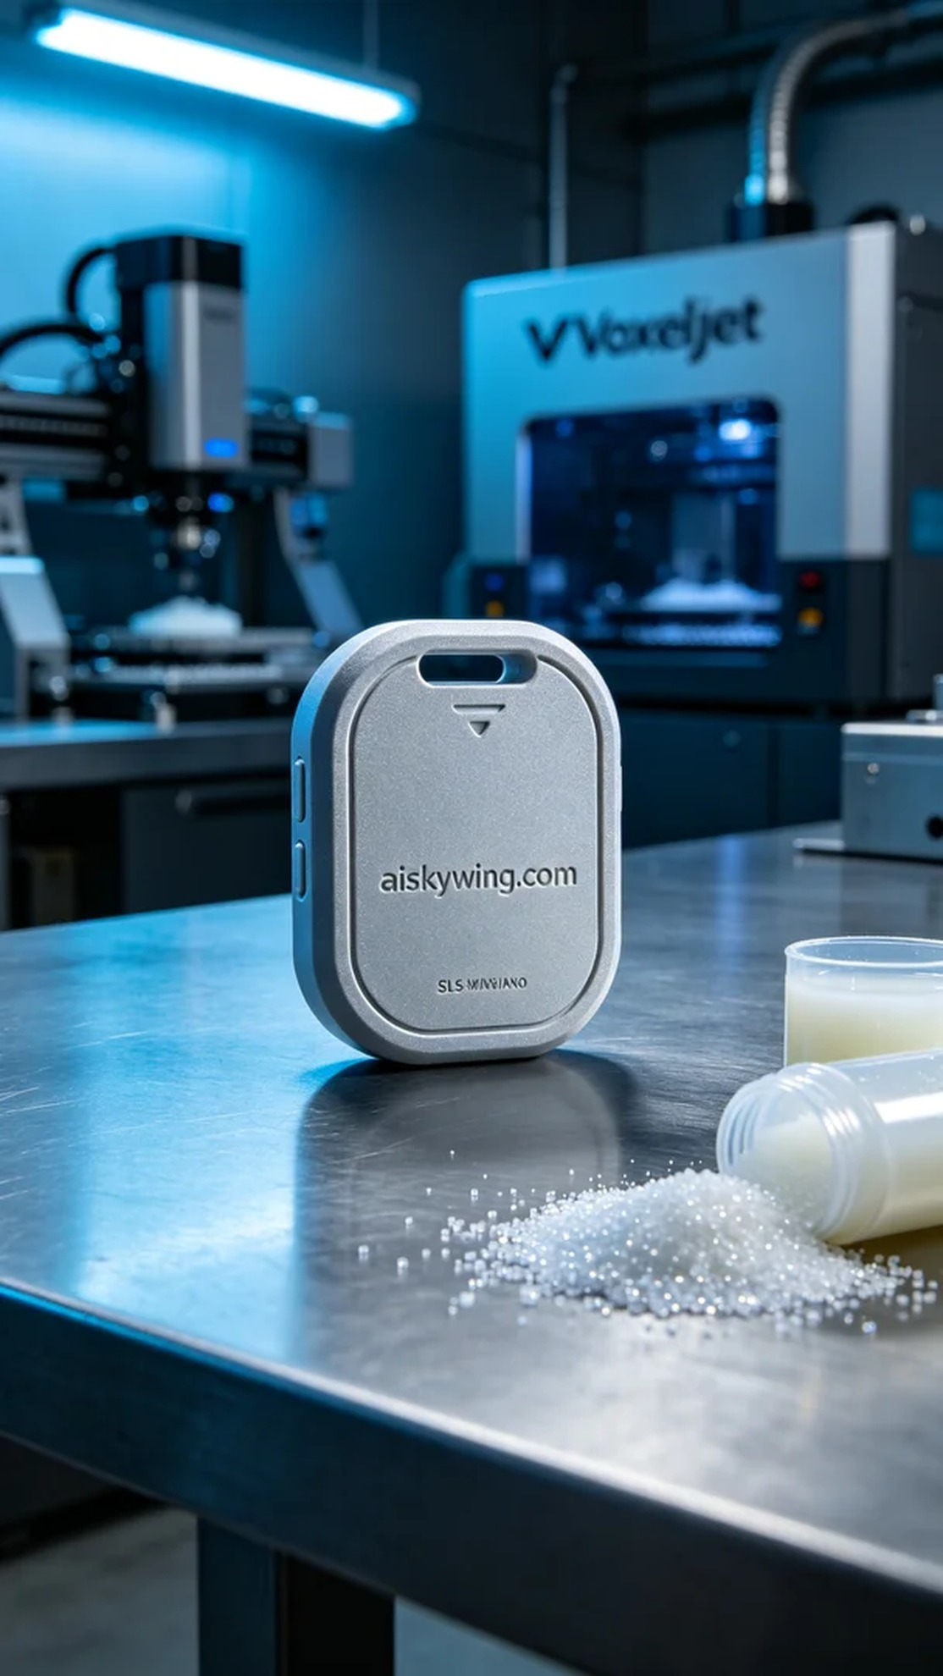
Aiskywing Industrial 3D Printing
Pet Tracker Shell


