0976-3D打印宠物除臭喷雾瓶盖记录
Pet deodorizing spray bottle cap
🖨️ SLS尼龙烧结
🖥️ 打印机: Stratasys
📦 材料: SLS尼龙
生活再难，也别停下脚步。就像接下这个宠物除臭喷雾瓶盖的单子，能为那些有爱心的人解决一个小烦恼。
No matter how difficult life gets, don't stop moving forward. Just like taking on the job of making a cap for this pet deodorizing spray bottle, it can help solve a small problem for those who care.
________________________________________________________________________________
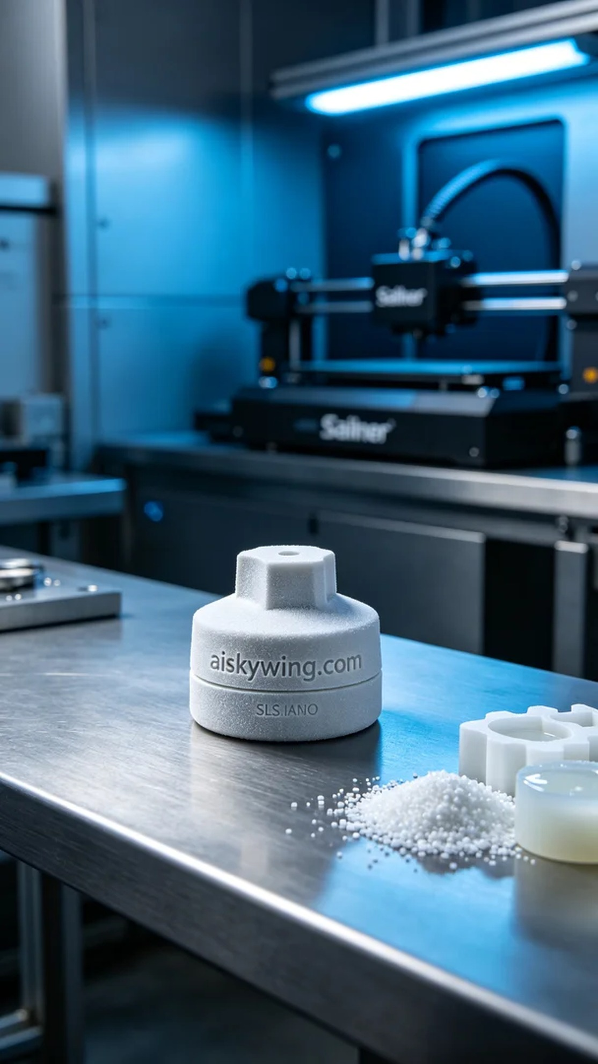
Recently, someone reached out to us via LinkedIn, hoping to create a pet deodorizing spray bottle cap. This product needs to not only function well but also showcase the brand's personality, especially with a clear engraving of "aiskywing.com" on its surface.
We chose SLS nylon as the raw material, which has excellent strength and toughness, making it suitable for lightweight structures. Before printing, I prepared the Stratasys printer, setting the layer thickness to 0.1 mm, temperature at 180℃, power at 80%, speed at 20 mm per hour, and estimated the printing time to be about 4 hours.
The printing process went smoothly, with the machine running steadily. I continuously monitored the print quality to ensure each layer bonded tightly, and the surface texture remained delicate. After printing, I carefully inspected every detail to ensure there were no defects and that the engraving of "aiskywing.com" was clear.
The post-processing stage is crucial. First, I washed the finished product to remove any excess powder. Next, I sanded it down to achieve a smoother surface, followed by curing to ensure the structural stability of the material. Finally, I conducted a thorough inspection to confirm it met our high standards.
Through this production, we successfully created a pet deodorizing spray bottle cap that is both aesthetically pleasing and functional, resulting in high satisfaction, and I look forward to our next collaboration.
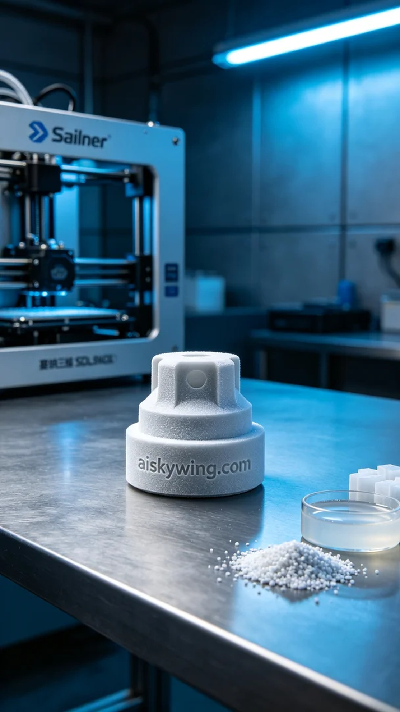
最近，有人通过LinkedIn找到我们，希望能制作一款宠物除臭喷雾瓶盖。这款产品不仅要具备良好的功能性，还要求在外观上能体现出品牌的个性，尤其是表面能够清晰呈现“aiskywing.com”的雕刻。
我们选用了SLS尼龙作为原材料，这种材料在强度和韧性上都有很好的表现，适合制作轻量化的结构。在打印前，使用Stratasys打印机进行准备，层厚设置为0.1毫米，温度控制在180℃，打印功率为80%，速度设定为每小时20毫米，预计打印时间为4小时。
打印过程顺利进行，设备运转稳定，我持续监控打印质量，确保每一层都紧密结合，表面纹理细腻。打印完成后，仔细检查了每一个细节，确保没有瑕疵，并保证了“aiskywing.com”字样的清晰。
后处理环节是至关重要的。首先，我将成品进行清洗，去除表面多余的粉末。接着，进行打磨，使得表面更加光滑，然后进行固化，确保材料的结构稳定。最后，对成品进行了检验，确保它符合我们的高标准。
经过这次生产，成功制作出符合需求的宠物除臭喷雾瓶盖，既美观又实用，客户满意度极高，期待下一次的合作。
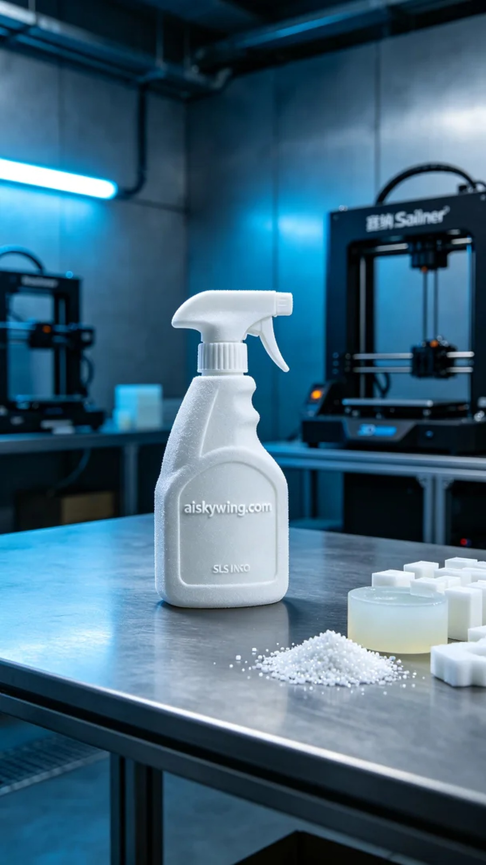
Aiskywing Industrial 3D Printing
Pet deodorizing spray bottle cap


