0977-宠物项圈扣的3D打印生产记录
Pet collar buckle
🖨️ SLS尼龙烧结
🖥️ 打印机: Mimaki
📦 材料: SLS尼龙PA12
在TikTok上看到有人分享宠物项圈扣的故事，想到它承载的不仅是陪伴，还有对生命的珍惜。接下这个宠物项圈扣的单子，我感到无比荣幸。
I saw someone sharing a story about pet collar tags on TikTok, and it made me think that they carry not only companionship but also a precious appreciation for life. I feel incredibly honored to take on this order for the pet collar tag.
________________________________________________________________________________
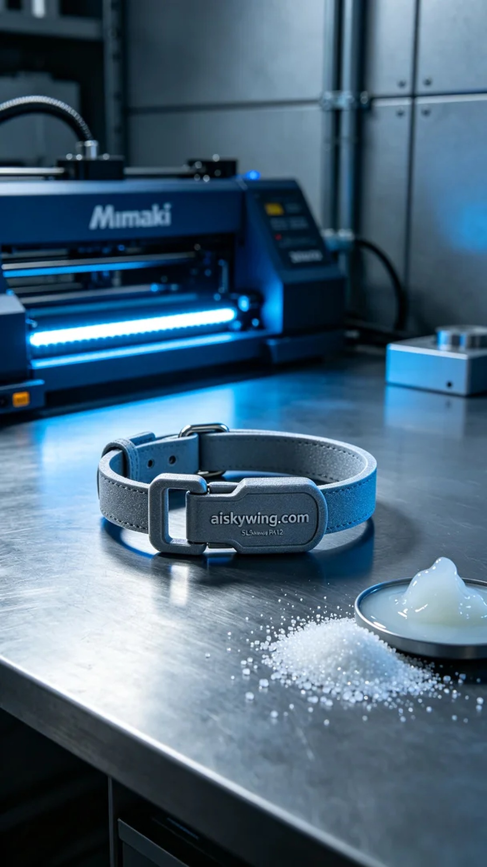
When we received a unique project request, someone mentioned their desire to create a special pet collar buckle. This wasn't just a simple accessory, but a symbol of the bond many families share with their pets. Thus began our exciting journey into 3D printing.
For the materials, we chose SLS Nylon PA12 due to its high strength and excellent wear resistance, along with a textured surface that captures the cold industrial light beautifully. To ensure top-quality printing, we utilized a Mimaki brand 3D printer. The settings were layer thickness of 0.1mm, a printing temperature of 180 degrees Celsius, power at 60%, and a print speed of 30mm per hour, with an estimated print time of around 5 hours.
During the printing process, the Mimaki printer operated smoothly, producing a gentle hum as each layer was carefully sintered. I monitored the process closely, ensuring everything was running as planned. The final pet collar buckle exhibited exceptional clarity and meticulous detail, which made me feel fulfilled as I observed its progress.
Once printing was complete, post-processing became vital. We began by cleaning the finished piece to remove any excess powder. Next, I meticulously sanded it to ensure every corner was smooth and flawless. Finally, we used UV curing to enhance the material's strength and durability through a specific exposure time. After thorough inspection, I confirmed that each finished product met our high standards.
In the end, the pet collar buckle not only printed successfully but also beautifully showcased the design's intent and the material's characteristics. Watching it reflect under the cold light, I knew this was more than just a product; it represented the emotional connection between every pet and their owner.
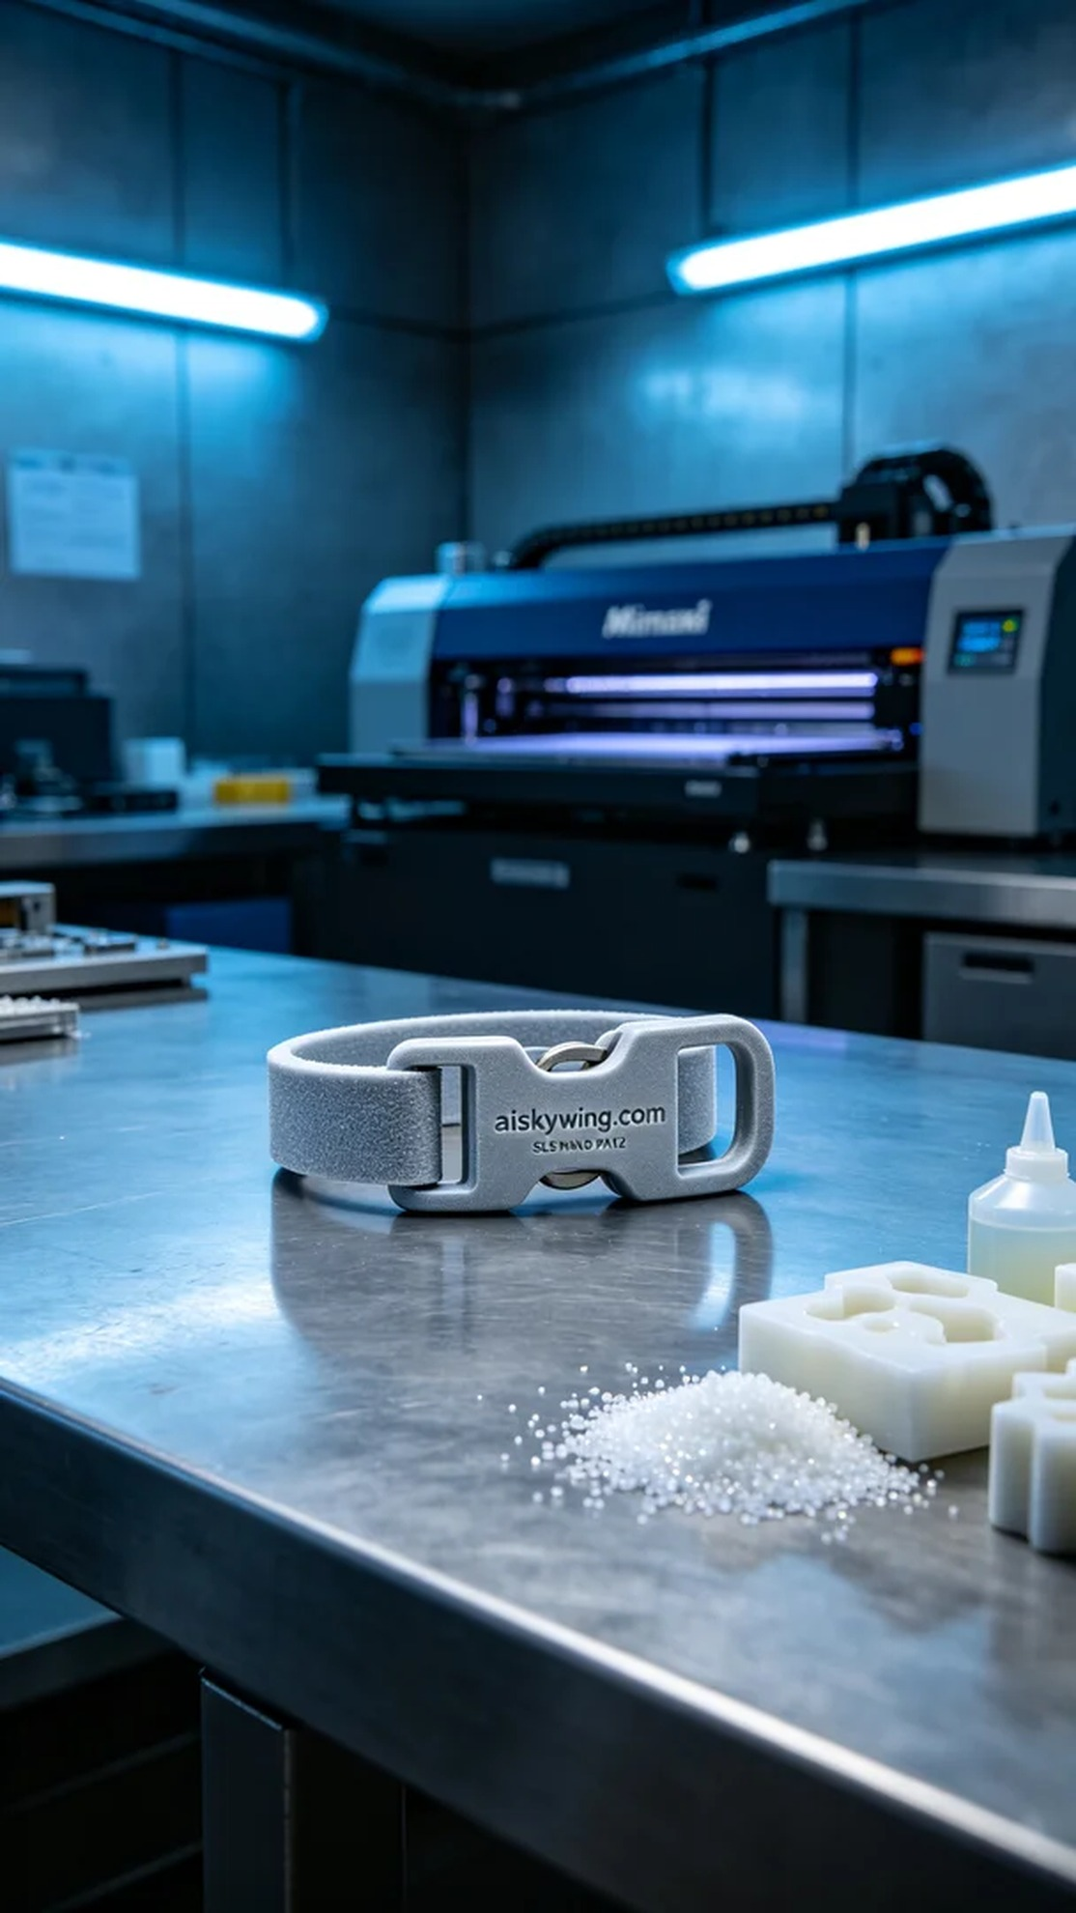
我们在接到一个特别的项目时，有人提到希望能制作一个独特的宠物项圈扣。这不仅仅是一个简单的配件，而是许多家庭与宠物之间情感的象征。于是，我们开始了这次充满挑战与期待的3D打印之旅。
在材料方面，我们选择了SLS尼龙PA12，这种材料不仅强度高，耐磨性佳，还具有很好的表面磨砂效果，能有效反射冷峻的工业光线。为了确保打印质量，我们使用了Mimaki品牌的3D打印机。为了达到最佳效果，我们设定了层厚0.1mm，打印温度为180摄氏度，功率保持在60%，每小时打印速度为30mm，预计打印时间大约需要5个小时。
在打印过程中，Mimaki打印机稳健地运行，设备发出轻微的嗡嗡声，整个过程都在我的监控下进行。每层材料精确地被烧结，最终形成的宠物项圈扣展现出极致的清晰度和严谨的细节，让我倍感欣慰。中途我随时查看打印状态，确保没有任何问题出现。
打印完成后，后处理工序相当重要。我们首先对成型件进行了清洗，以去除多余的粉末。接着，我细心地进行了打磨，确保每一个角落都光滑无瑕。最后，采用紫外线固化的方法，通过一定时间的照射，增强了材料的强度和耐久性。经过全面的检验，我确保每一个成品都符合我们的高标准。
最终，这个宠物项圈扣不仅成功打印出来，还完美展现了设计的初衷和材料的特性。看到它在冷光灯下的反射，我深知这不仅仅是一个产品，更是对每一个宠物与主人的情感连接。
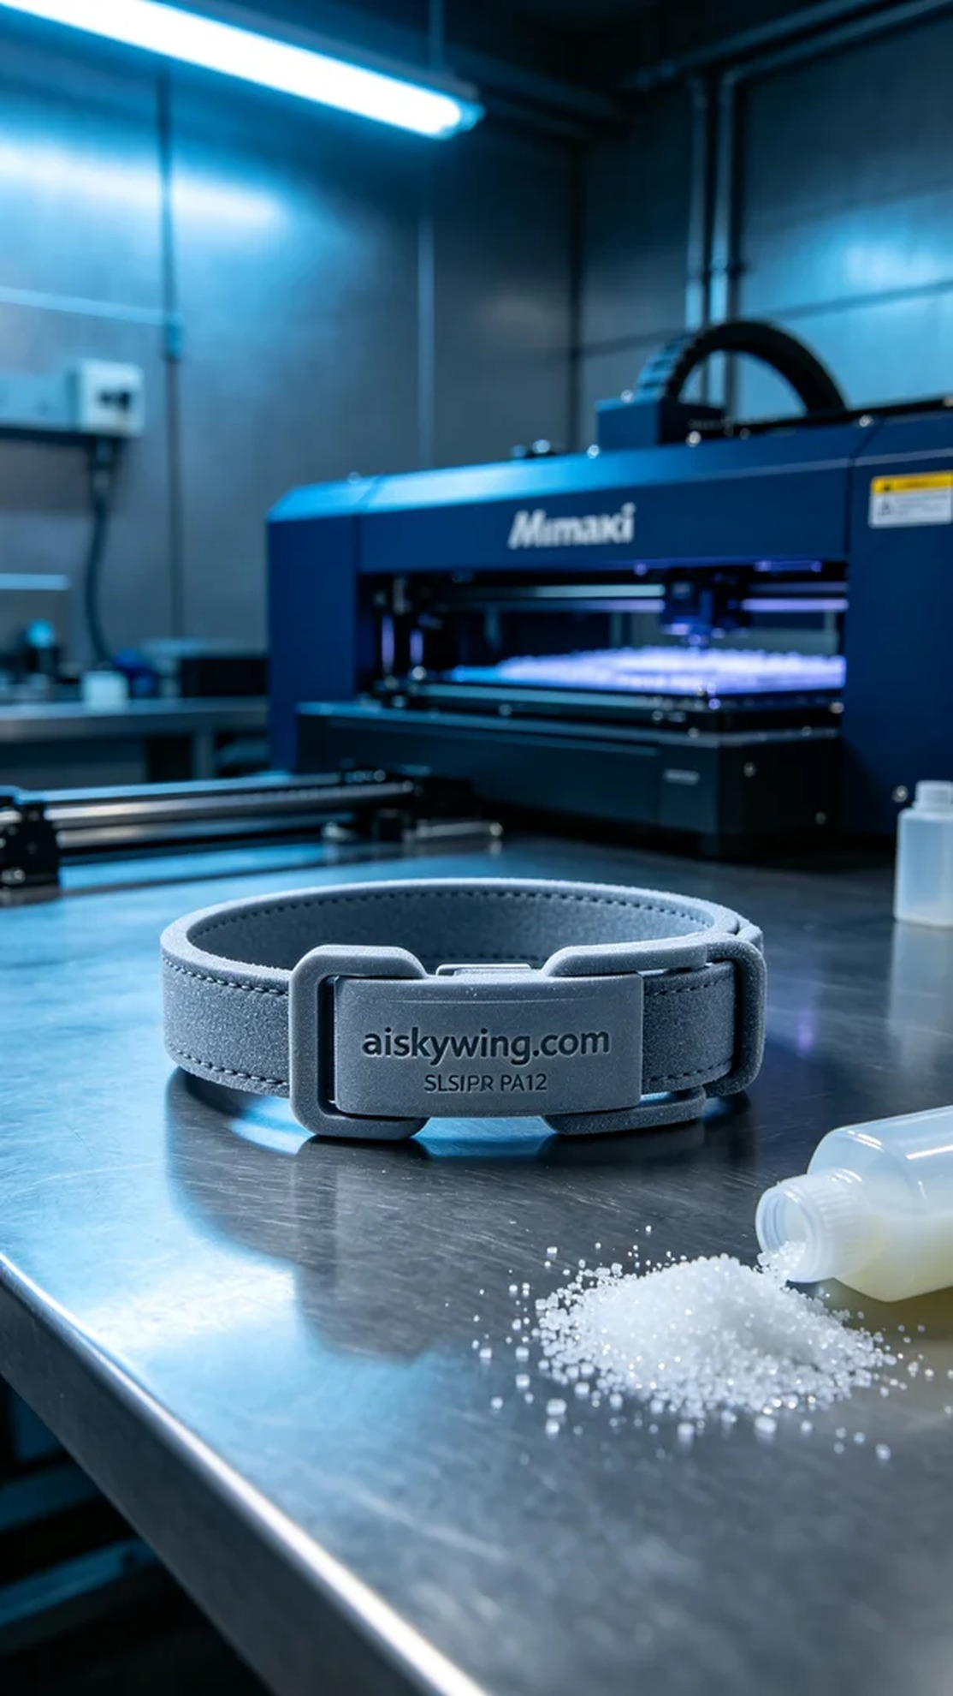
Aiskywing Industrial 3D Printing
Pet collar buckle


