0978-宠物食盆支架的3D打印记录
Pet food bowl stand
🖨️ SLS尼龙烧结
🖥️ 打印机: Xjet
📦 材料: SLS耐高温尼龙
生活就像3D打印，点滴积累才能呈现完美。有人在YouTube上看到我们的宠物食盆支架，想解决宠物进食时的不便。
Life is like 3D printing; only through gradual accumulation can perfection be achieved. Someone saw our pet food bowl stand on YouTube and wanted to solve the inconvenience of pets while eating.
________________________________________________________________________________
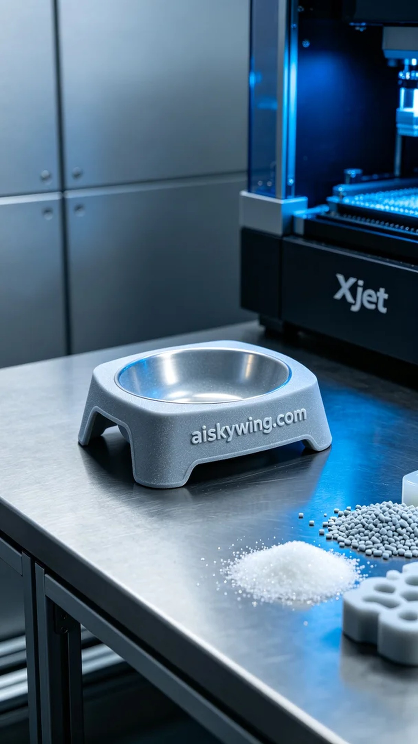
Life is like 3D printing; every small detail adds up to create perfection. Someone saw our pet food bowl stand on YouTube and wanted a solution for their pet's eating trouble.
We chose SLS high-temperature nylon as our primary material. This material can withstand temperatures above 150℃ and has good wear resistance and strength, making it suitable for long-term use. Additionally, the Xjet printer was ready, with settings of a layer thickness of 0.1mm, a printing temperature of 200℃, a power setting of 85%, and a printing speed of 20mm/s. These parameters ensure that we achieve high-quality products.
The printing process went smoothly, with the Xjet printer operating stably. As each layer of material gradually stacked, the contours of the stand began to emerge. Throughout the process, I continuously monitored the equipment's operation to ensure no anomalies occurred. After several hours, the pet food bowl stand was finally completed.
After that, we entered the post-processing phase. First, we cleaned the stand to remove excess powder and impurities. Next, we gently sanded the surface with sandpaper to ensure a smooth feel and eliminate any potential burrs. The curing process was also essential; we placed the stand in a specialized curing device to stabilize the material's properties. Finally, through strict inspection, we confirmed that every detail met the standard.
After several days of effort, the pet food bowl stand was finally completed, ready to assist this family’s pets, which fills me with satisfaction. Such work may be tedious, but it brings a profound sense of accomplishment.
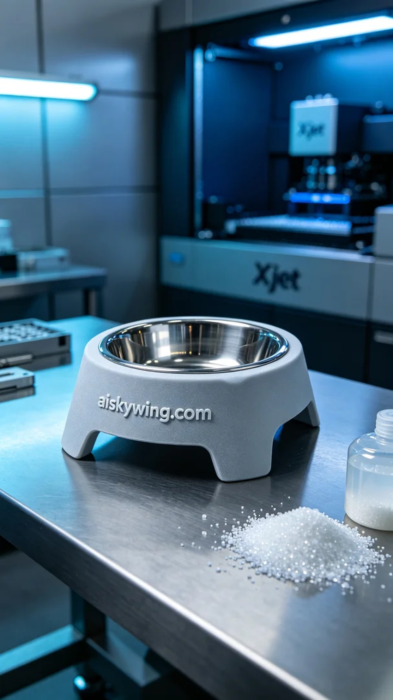
在一次偶然的机会，有人通过YouTube发现了我们的宠物食盆支架，并向我们询问能否制作一个解决他们宠物进食不便的问题。这个想法让我感觉到，生活中的每一个细节都值得用心去对待。
我们选择了SLS耐高温尼龙作为主要材料。它不仅耐温高达150℃以上，还具备良好的耐磨性和强度，适合长时间使用。此外，Xjet打印机也已准备就绪，参数设定为层厚0.1mm，打印温度保持在200℃，功率设定在85%，打印速度为20mm/s。这些设置确保了我们能获得高质量的产品。
打印过程非常顺利，Xjet打印机稳定地运转，随着每一层材料的逐步堆积，支架的轮廓也逐渐显现。在整个过程中，我不断监控设备的运行状态，确保没有任何异常情况发生。最终，经过几个小时的打印，食盆支架终于完成。
完成后，我们进入了后处理环节。首先，我们对支架进行了清洗，去除多余的粉末和杂质。接下来，用砂纸轻轻打磨表面，以确保手感光滑，并去掉任何可能的毛刺。固化工序也不可或缺，我们将支架放入专用固化设备中，确保材料的性质得以稳定。最后，通过严格的检验，确认每一个细节都达到标准。
经过这几天的努力，宠物食盆支架终于完成了，能帮助到这个家庭的宠物们，让我深感欣慰。这样的工作，虽是繁琐，却充满了成就感。
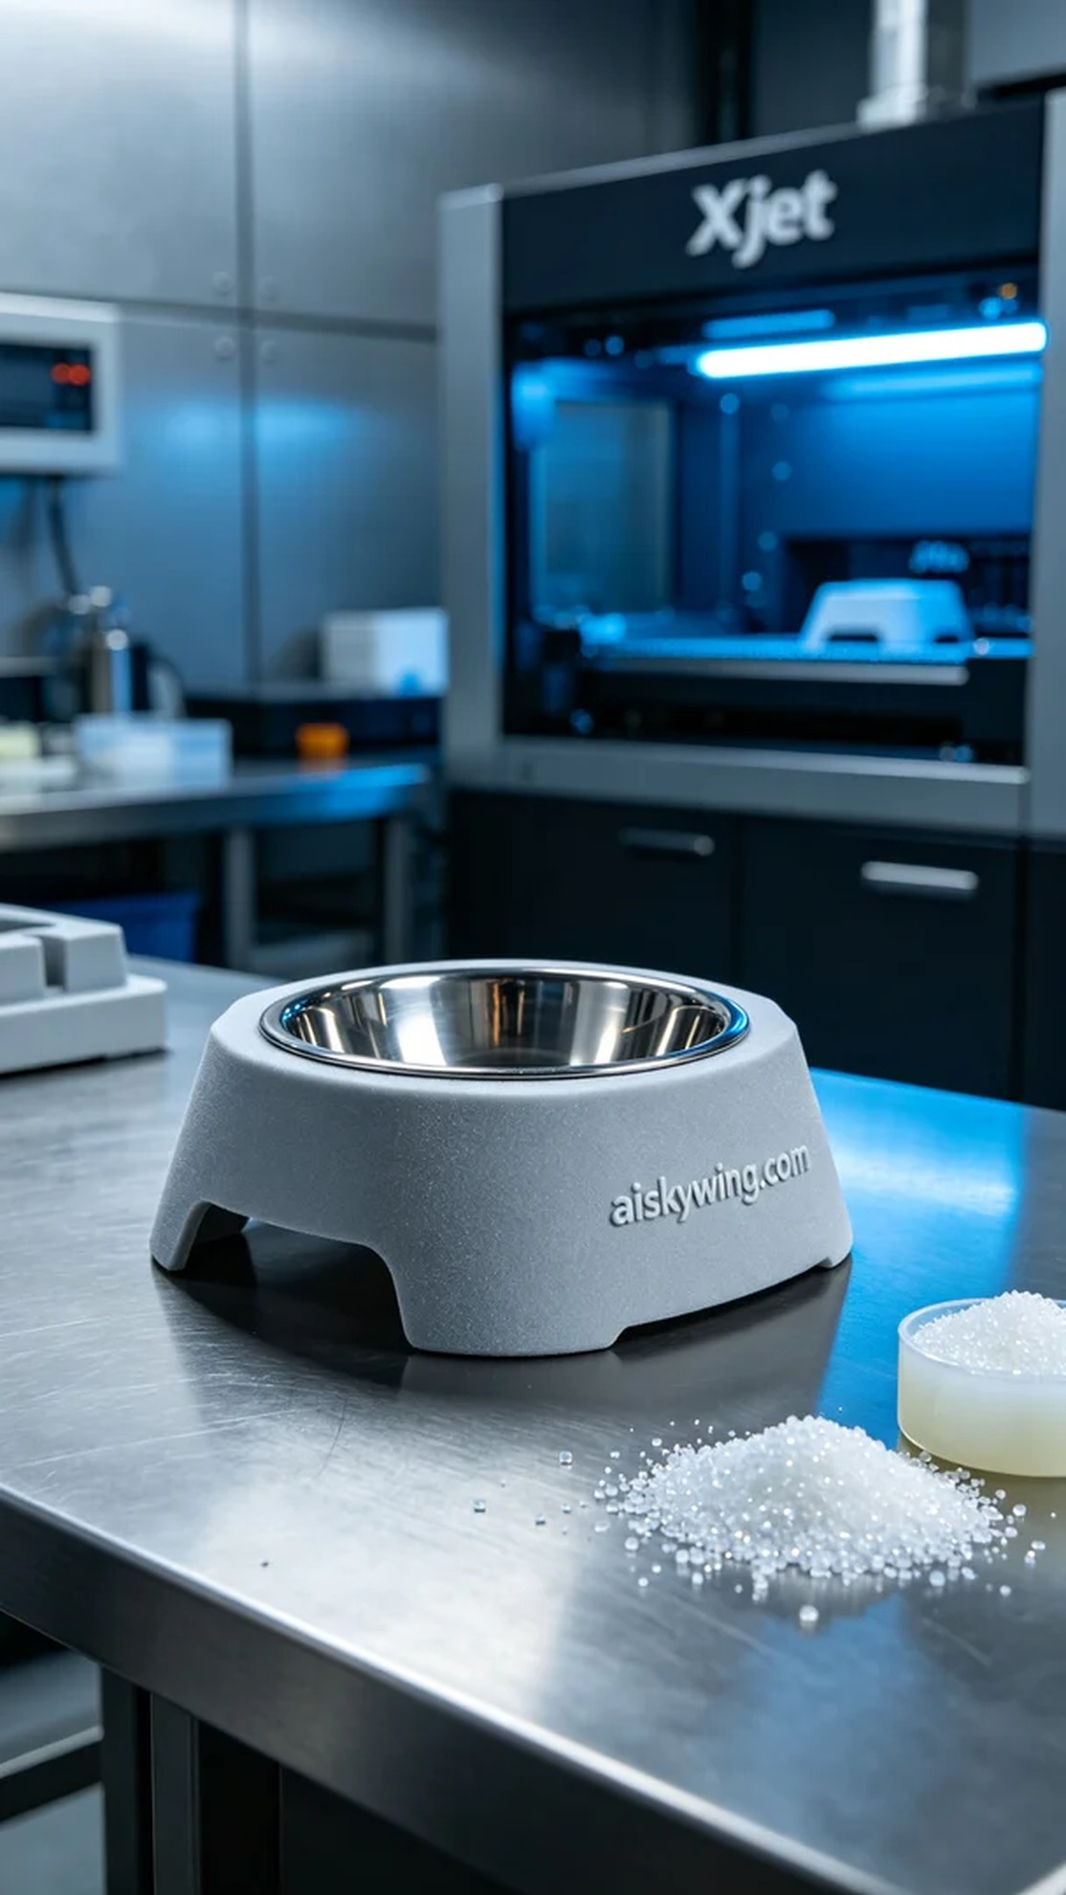
Aiskywing Industrial 3D Printing
Pet food bowl stand


