0979-宠物饮水机外壳生产记录
Pet water dispenser shell
🖨️ SLS尼龙烧结
🖥️ 打印机: Systems
📦 材料: SLS尼龙PA12
生活总会有难关需要我们去克服，就像最近有人找我们制作这个宠物饮水机外壳，想为爱宠提供更好的生活。
Life will always present challenges that we need to overcome. Recently, someone approached us to create a shell for a pet water dispenser, aiming to provide a better life for their beloved pet.
________________________________________________________________________________
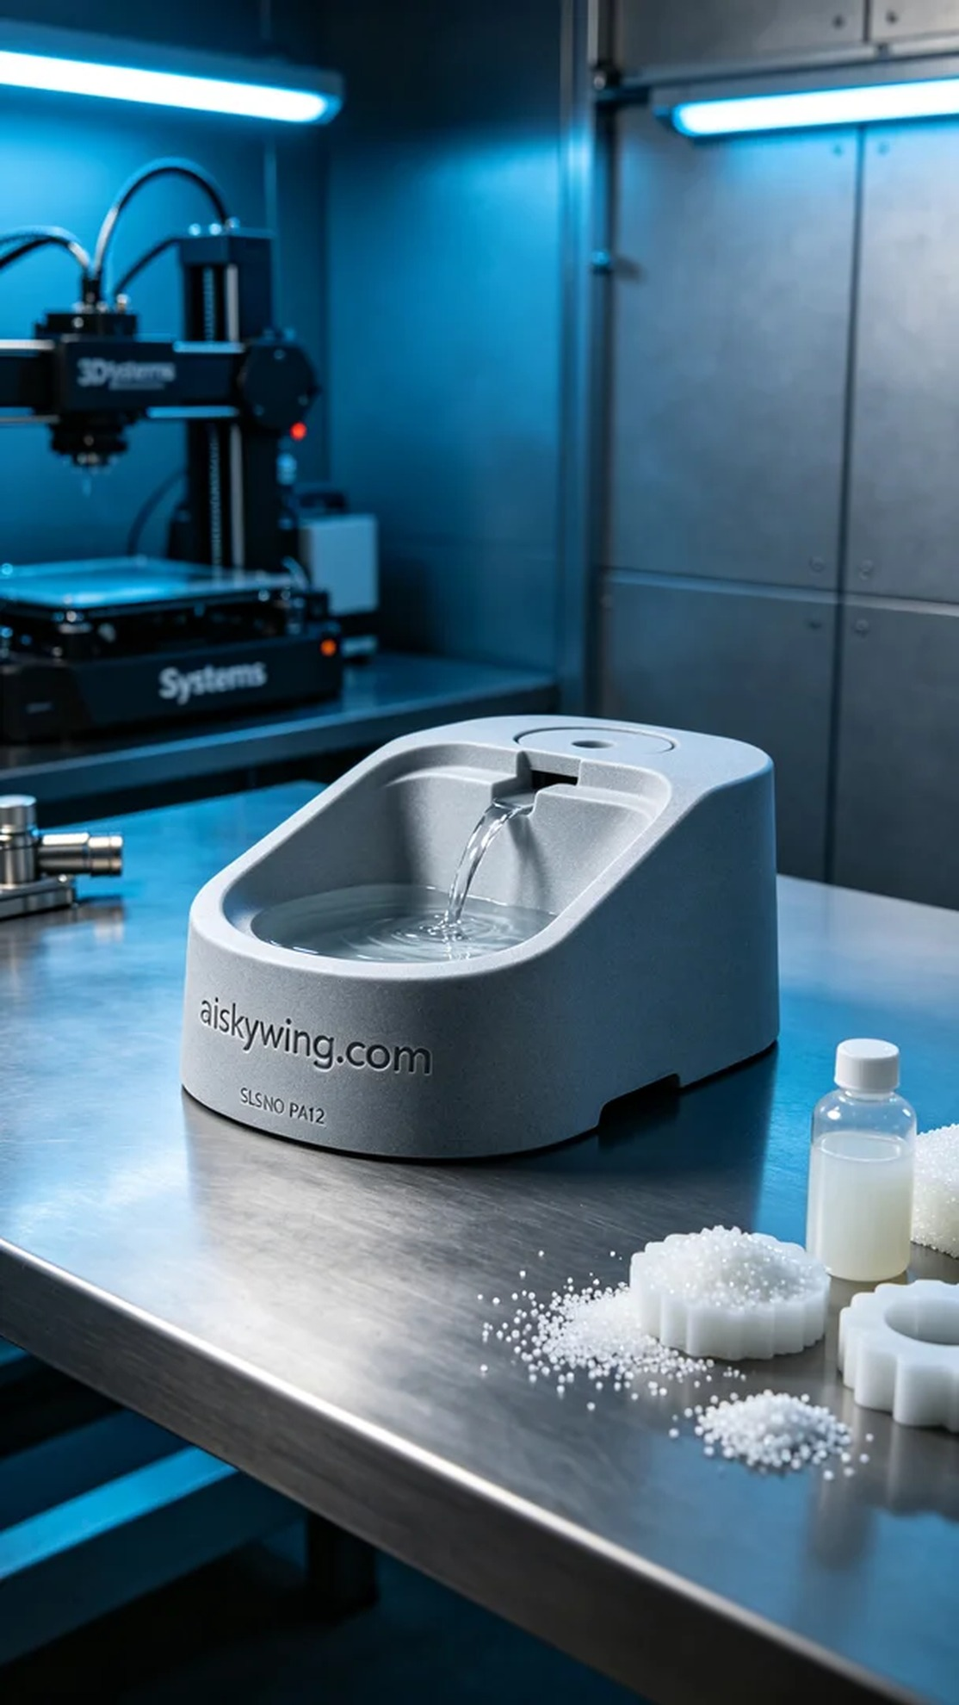
Life always throws challenges our way, just like recently when someone reached out to us on Facebook for a custom pet water dispenser shell. They wanted something both aesthetic and durable for their furry friend.
For this project, we chose SLS nylon PA12 as our material. This high-strength, wear-resistant material is perfect for industrial applications. We utilized the Systems 3D printer for the printing process. The set parameters included a layer thickness of 0.1 mm, a printing temperature of 185 degrees, a power of 200 watts, and a printing speed maintained at 40 mm/s, with an estimated total printing time of about 12 hours.
During the printing process, the machine operated smoothly, and the application of SLS technology ensured precision and strength in the shell. We monitored the print quality in real-time to make sure each layer was fully sintered, avoiding any bubbles or defects. After several hours of operation, the printer successfully completed the project.
For post-processing, we first cleaned the printed shell to remove excess powder, ensuring a smooth surface. Then, we proceeded with sanding to enhance the overall aesthetic. After that, we placed it in a curing machine for the final hardening step, followed by rigorous inspection to ensure it met our high standards.
In the end, the pet water dispenser shell was completed as scheduled, showcasing exceptional clarity and strength, greatly enhancing the drinking experience for pets. This successful output brings joy and motivates us to continue our journey in the world of 3D printing.
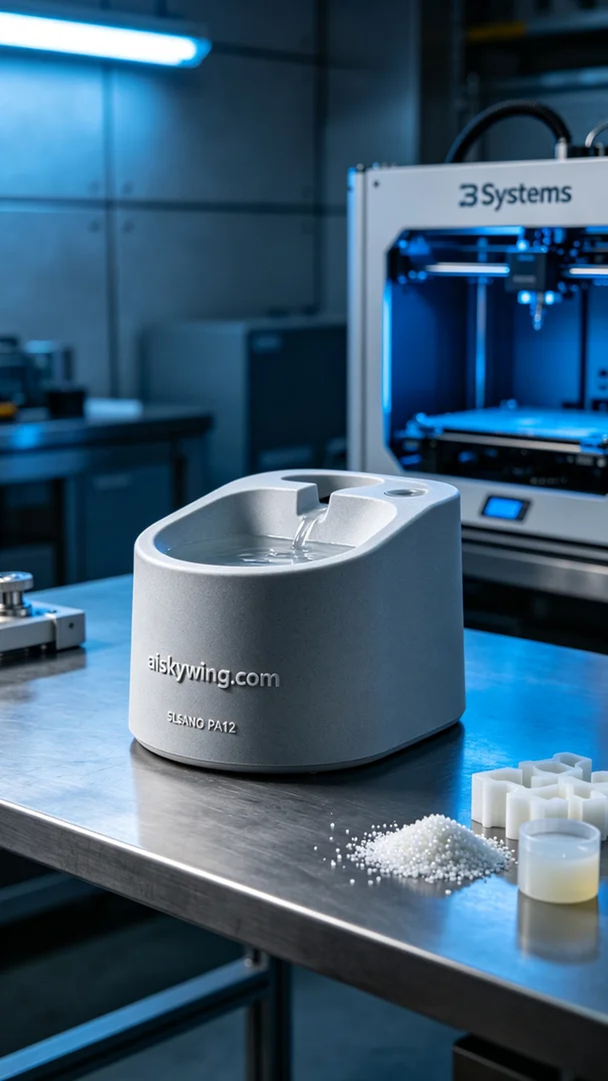
在我们的社交平台Facebook上，有人因为想提供更好的宠物饮水体验找上我们，提出了定制宠物饮水机外壳的需求。他们希望这个外壳既能美观又能耐用，适合长时间使用。于是，我们立刻准备开始这个项目。
原材料方面，我们选择了SLS尼龙PA12，这种材料的强度高、耐磨损，特别适合用于工业产品。我们用Systems品牌的3D打印机进行打印。打印参数方面，我们设置了层厚为0.1毫米，打印温度为185度，功率为200瓦，打印速度控制在40毫米每秒，整个打印过程中预计用时约为12小时。
在打印过程中，设备运行稳定，SLS技术的应用确保了外壳的精确度和强度。我们实时监控打印质量，确保每一层的材料都充分烧结，避免出现气泡和瑕疵。经过数小时的运转，打印机顺利完成了这件作品。
后处理方面，我们首先对打印好的外壳进行了清洗，去除多余的粉末，确保表面光滑。接着，进行了打磨，以提高外观的细腻度。然后将其放入固化设备中进行固化处理，最后进行了严格的检验，确保其符合我们的高标准。
最终，宠物饮水机外壳如期完成，呈现出极致清晰的细节和高强度的特性，为爱宠的饮水体验带来了质的飞跃。这样的成品让人欣慰，也激励我们继续在3D打印的道路上不断前行。
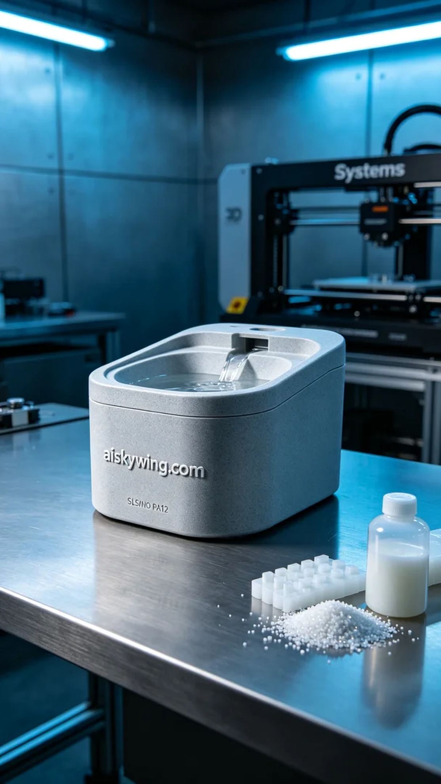
Aiskywing Industrial 3D Printing
Pet water dispenser shell


