0980-宠物香波瓶盖3D打印生产记录
Pet shampoo bottle cap
🖨️ SLS尼龙烧结
🖥️ 打印机: Stratasys
📦 材料: SLS耐高温尼龙
在这个快节奏的时代，人生如同一场雕刻，耐心与坚持总能创造出精美的作品。就像我们为这个宠物香波瓶盖付出的努力一样。
In this fast-paced era, life is like a sculpture; patience and perseverance can always create exquisite works. Just like the effort we put into this pet shampoo bottle cap.
________________________________________________________________________________
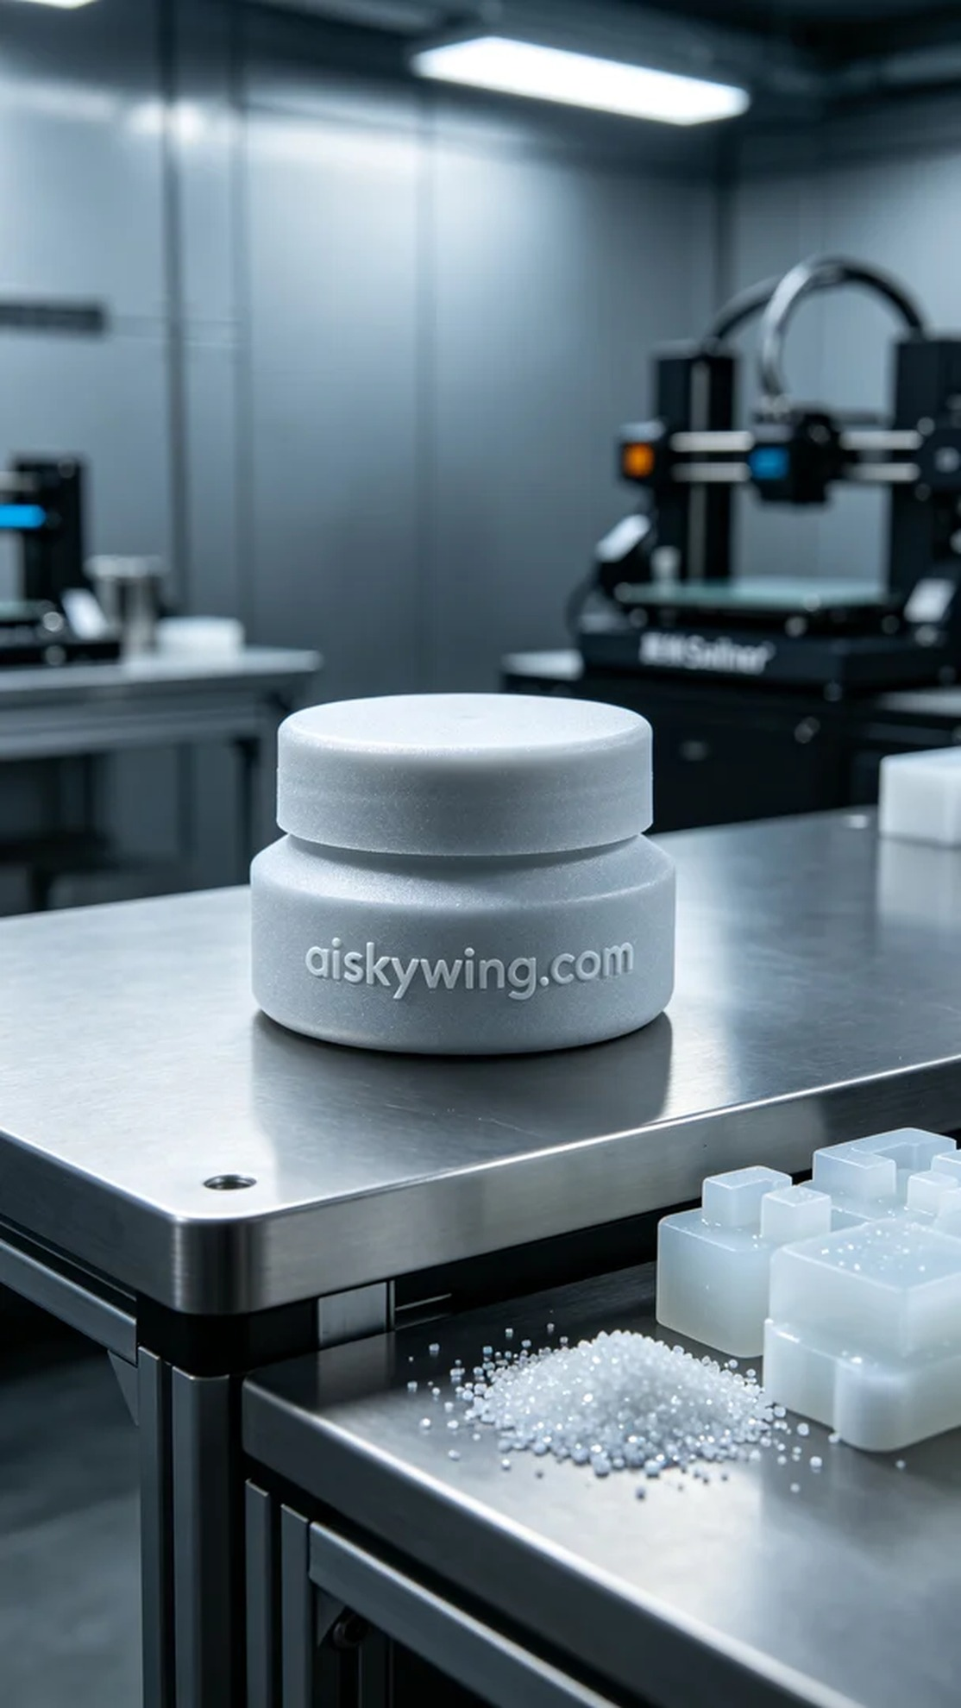
Recently, someone reached out to us via Twitter, asking if we could create a high-temperature resistant pet shampoo bottle cap. This project required not only special materials but also the ability to perform well under heat.
To meet these needs, we decided to use SLS high-temperature nylon. This material can withstand temperatures over 150℃, making it suitable for prolonged contact with warm grooming products. We chose the Stratasys 3D printer, setting the layer thickness to 0.1mm, maintaining the printing temperature at 165℃, adjusting the power to 80%, and setting the printing speed to 30mm/s. The entire printing process was expected to take about 4 hours.
The printing process went smoothly, with the printer running consistently throughout. We continuously monitored the device to ensure each layer adhered properly to the previous one for an optimal formation. Observing good melting of the material, the surface remained smooth, and the textures were clear, even in fine details.
After printing, we moved on to the post-processing phase. First, we washed the product to remove excess powder, then sanded it down to ensure a smooth surface. Following that, we applied a curing treatment to the bottle cap, finally conducting a thorough inspection to ensure that every detail met our expected standards.
Through this series of efforts, we successfully produced a high-quality pet shampoo bottle cap, both aesthetically pleasing and practical. Every bit of persistence and dedication adds a touch of brilliance to our work.
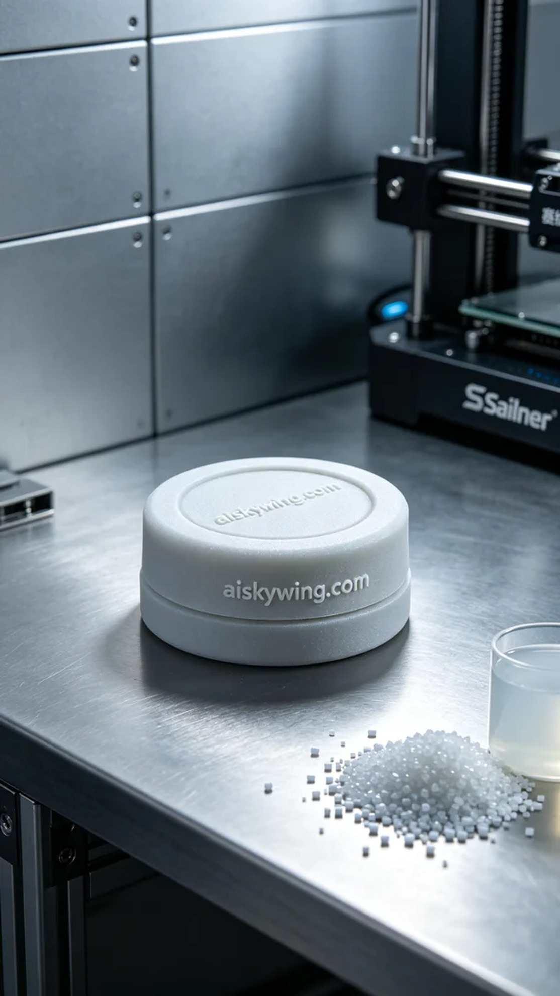
最近，有人通过Twitter找到了我们，询问能否帮助制作一个耐高温的宠物香波瓶盖。这个项目不仅需求特殊的材料，还需要在高温下维持良好的性能。
为此，我们决定使用SLS耐高温尼龙材料，这种材料耐温可达150℃以上，适合长时间接触温暖的洗护产品。我们选择了Stratasys的3D打印机，层厚设定为0.1mm，打印温度保持在165℃，功率调节至80%，打印速度设定在30mm/s，预计整个打印过程需要4小时完成。
打印过程非常顺利，设备在整个过程中运行稳定。我们不断监控设备的状态，确保每一层都能顺利附着在前一层上，以达到最佳的成型效果。观察到材料熔化良好，表面光滑，纹理清晰，即使在细节处亦不马虎。
完成打印后，我们进入了后处理环节。首先对产品进行清洗，去除多余的粉末，然后进行打磨，以确保表面光滑。之后，我们对瓶盖进行了固化处理，最后对成品进行仔细检验，确保每一个细节都符合预期的标准。
经过这一系列的努力，最终我们成功地制作出了这个高品质的宠物香波瓶盖，既美观又实用。每一次的坚持和努力，都是为我们的作品增添了一份光辉。
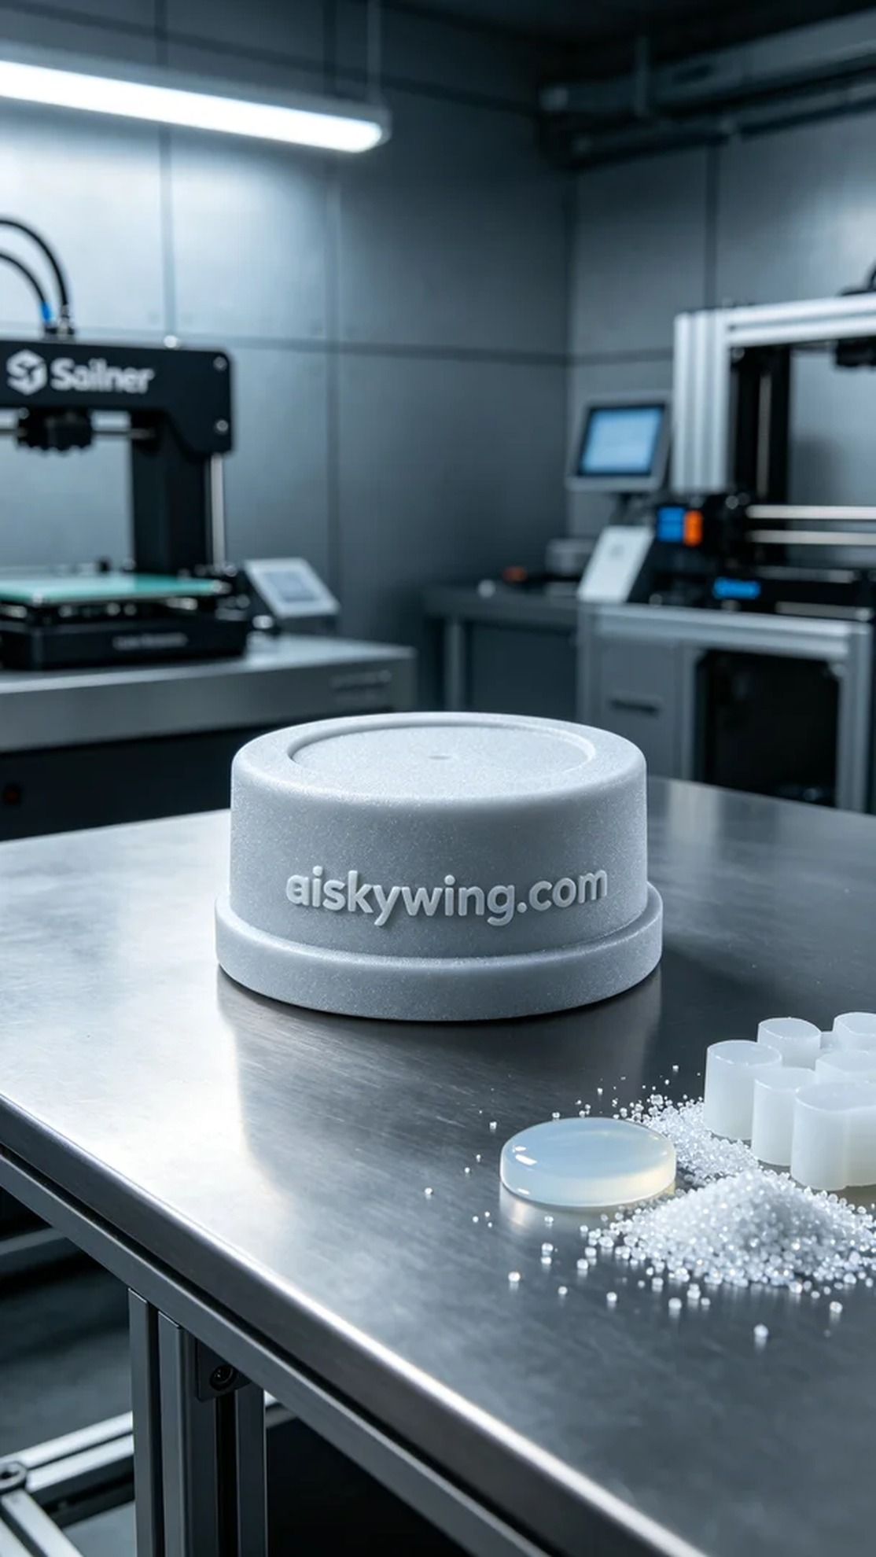
Aiskywing Industrial 3D Printing
Pet shampoo bottle cap


