0981-工业保护罩生产日志
Industrial protective cover
🖨️ SLS尼龙烧结
🖥️ 打印机: Xjet
📦 材料: SLS尼龙
在Facebook上，有人因工业保护罩的需求找到了我们。就像面对生活的挑战，我们也要迎难而上，做好每一个细节。
On Facebook, someone reached out to us due to a demand for industrial protective covers. Just like facing the challenges of life, we must also rise to the occasion and pay attention to every detail.
________________________________________________________________________________
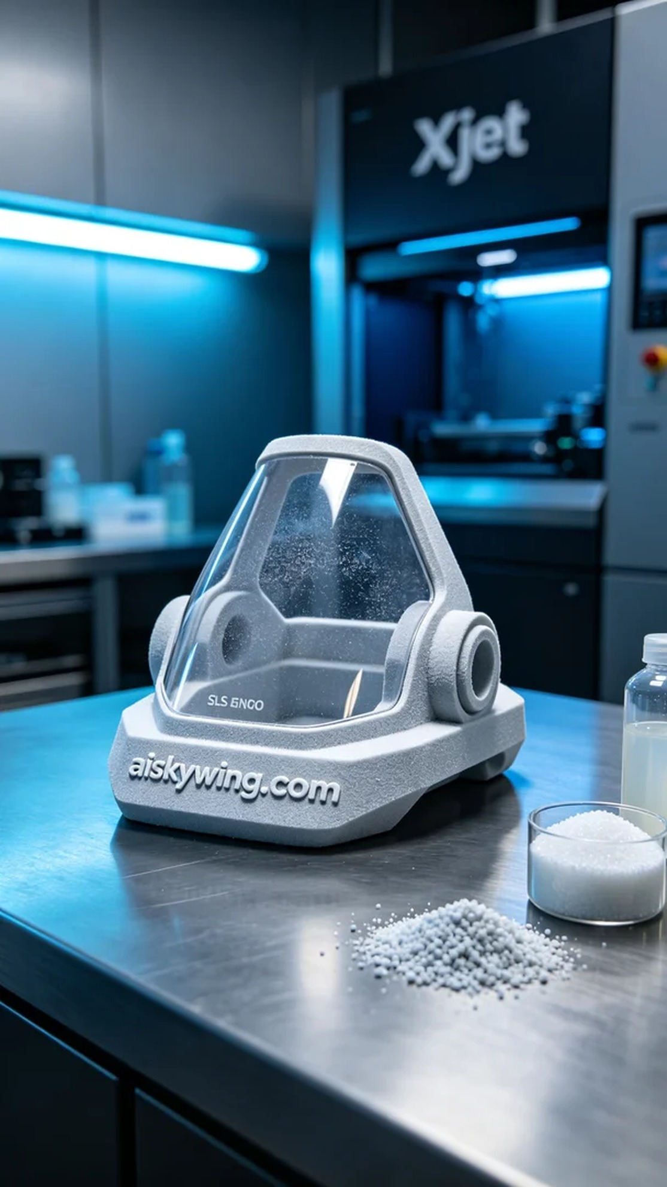
Today, we received an order for an industrial protective cover, as someone needed a product that is both lightweight and durable to withstand harsh industrial environments. After discussions, we decided to use SLS nylon material and produce it using the Xjet printer to ensure the quality and precision of the product.
SLS nylon is a material known for its high strength and toughness, making it perfect for the application of industrial protective covers. We prepared all the raw materials in advance to ensure the printer was in good condition. For the printing parameters, we set the layer thickness to 0.1mm, temperature to 190 degrees, printing power to 80%, and printing speed to 20mm/s. This configuration ensures that the finished product has sufficient strength and a fine surface finish.
As the printing process began, the Xjet printer ran smoothly, and after preheating, it entered the formal printing stage. We closely monitored the print quality, observing the formation of each layer to ensure there were no issues like warping or misalignment. After several hours of layer-by-layer addition, the industrial protective cover was finally completed.
In the post-processing phase, we first cleaned the printed product to remove any residual powder on the surface. Then, we polished it to ensure a smooth surface and eliminate any unnecessary burrs. Finally, we performed a curing treatment to enhance the material's properties, followed by a quality inspection to ensure it met all standards.
After a series of rigorous processes, we successfully completed the production of this industrial protective cover. Each step was challenging, but seeing the product take shape made all the hard work worthwhile.
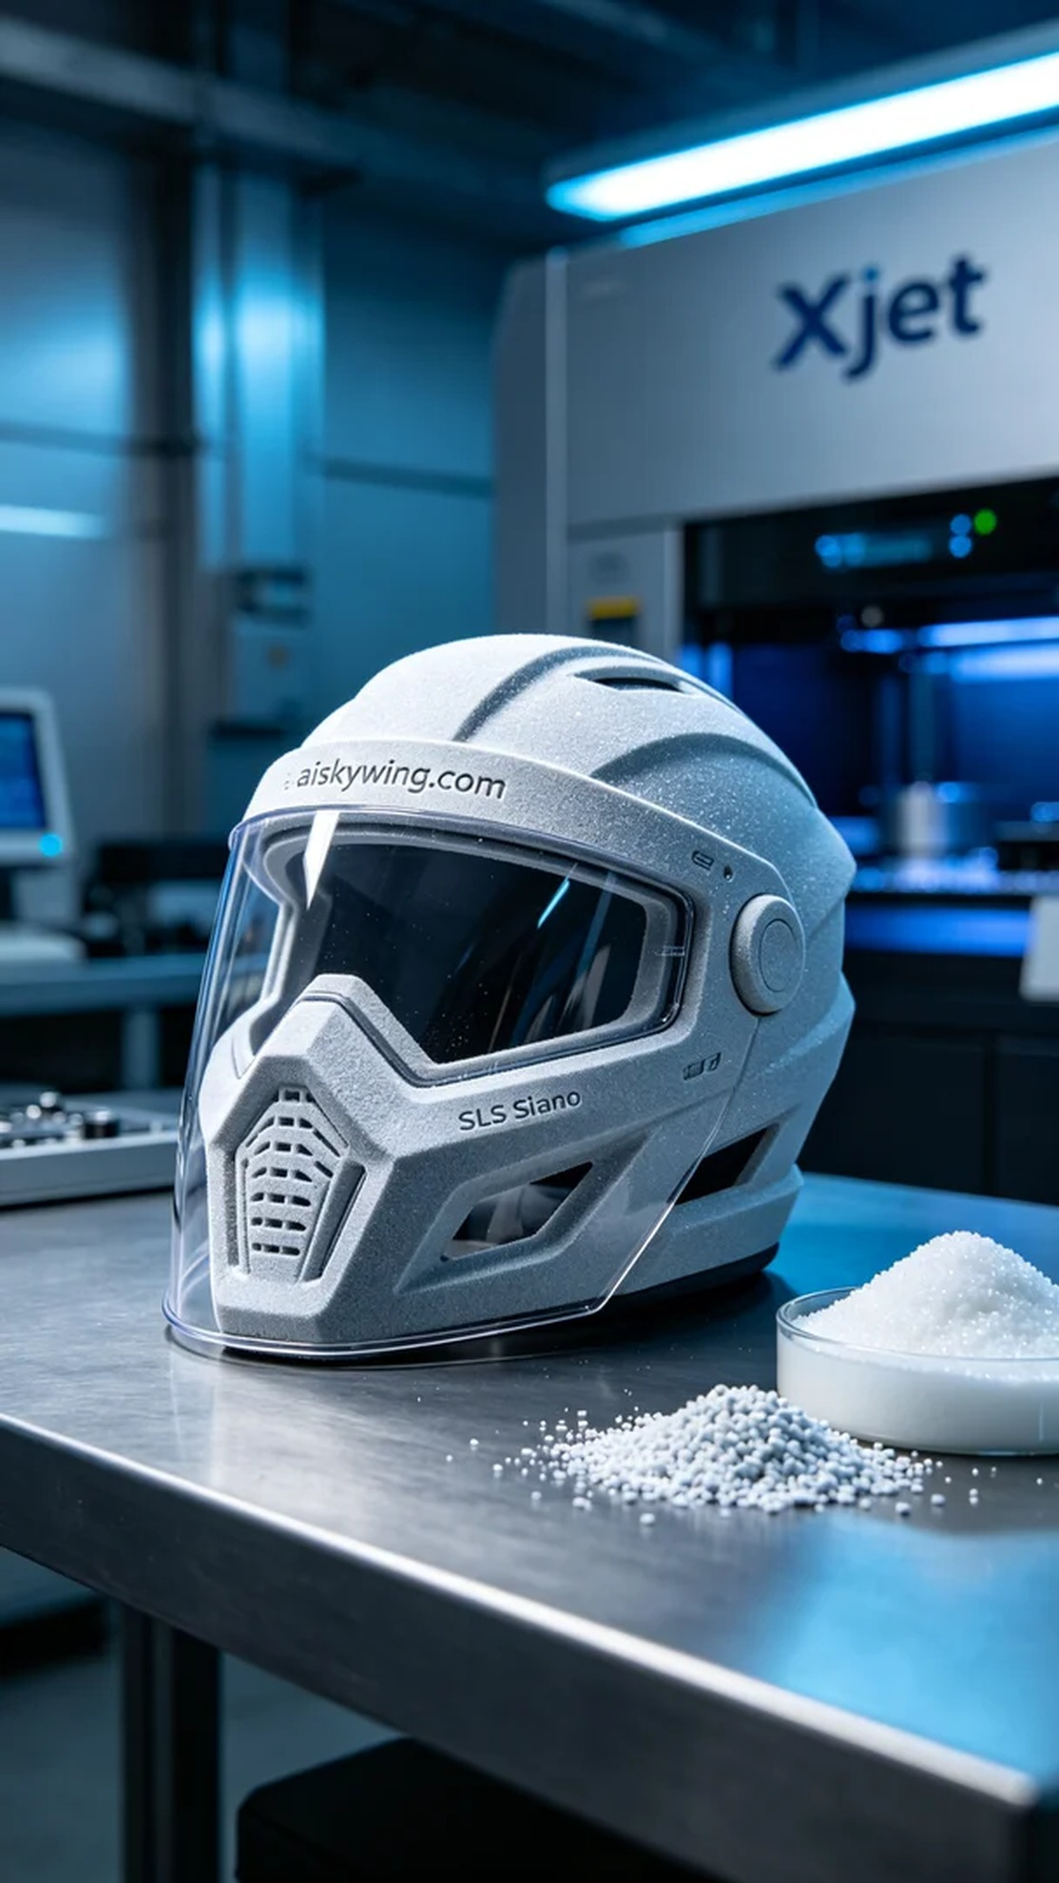
今天，我们接到一个关于工业保护罩的订单，客户需要一种既轻量又耐用的产品，能够适应严苛的工业环境。经过讨论，我们决定使用SLS尼龙材料，通过Xjet打印机进行生产，以确保产品的质量和精确度。
SLS尼龙是一种强度高、韧性好的材料，非常适合工业保护罩的应用。我们提前准备好所有原材料，确保打印机的状态良好。打印参数设置方面，我们选择了0.1mm的层厚，温度设定在190度，打印功率调整为80%，打印速度为20mm/s。这个配置能够确保成型后的产品有足够的强度和细致的表面效果。
打印过程开始后，Xjet打印机的运行十分平稳，预热后进入正式打印阶段。我们严格监控打印质量，观察每一层的成型情况，确保没有出现翘边或错位等问题。经过几个小时的逐层叠加，工业保护罩终于完成了打印。
在后处理环节，我们首先对打印好的产品进行清洗，去除表面的粉末残留。接着，我们对其进行打磨，以确保表面光滑，并去除任何不必要的毛刺。最后，进行固化处理，以增强材料的性能，最后一步是质量检验，确保其符合所有标准。
经过一系列严格的工序，最终我们成功完成了这款工业保护罩的生产。每一步都不容易，但看到产品成型的那一刻，所有的辛苦都值得了。
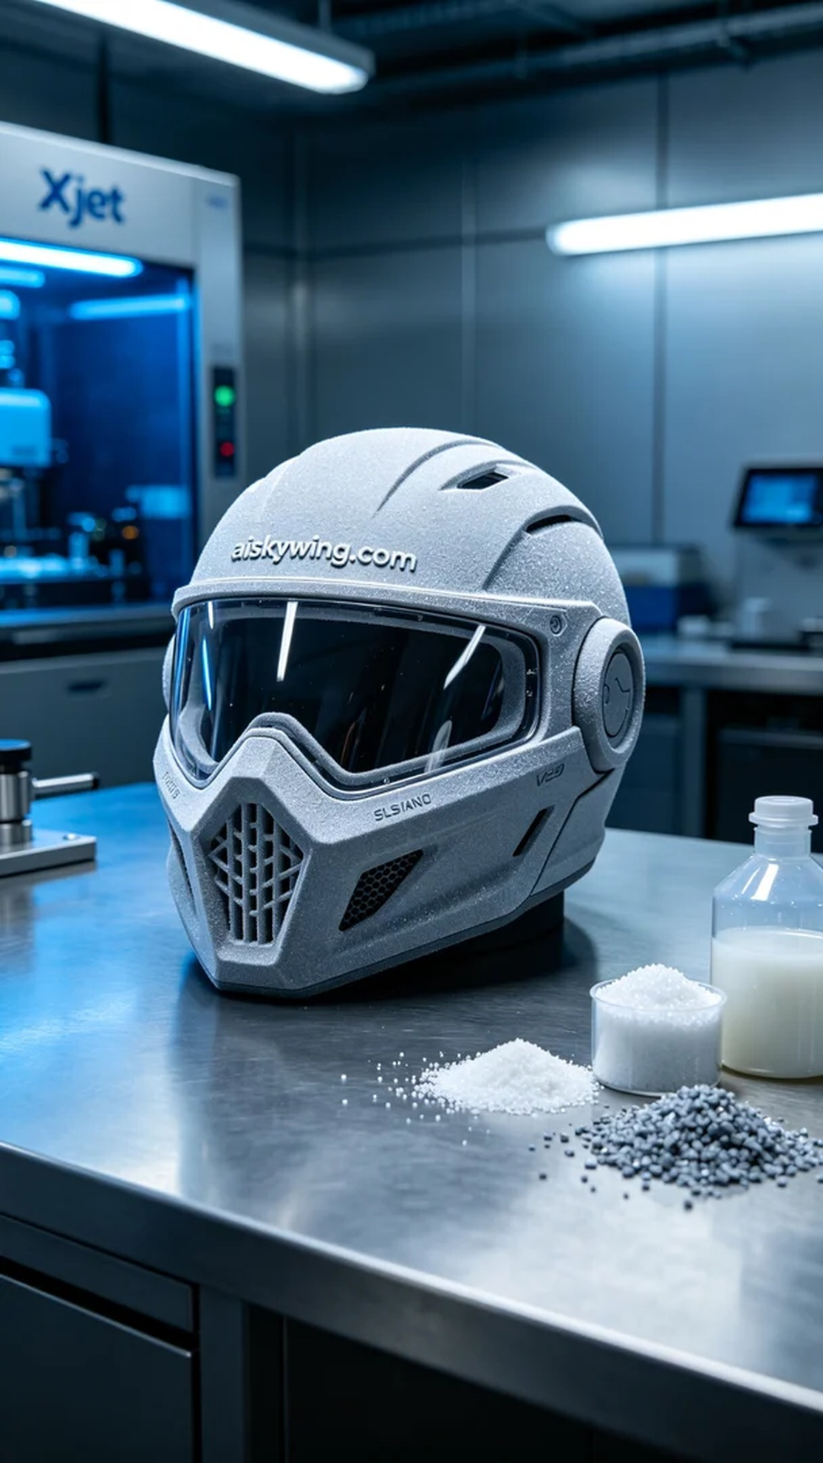
Aiskywing Industrial 3D Printing
Industrial protective cover


