0982-AGV外壳的3D打印生产记录
AGV shell
🖨️ SLS尼龙烧结
🖥️ 打印机: Rize
📦 材料: SLS尼龙PA12
生活从不缺少挑战，正如有人在YouTube上寻求帮助，希望解决AGV外壳的生产问题。面对工作，咬牙坚持，才能实现更好的自己。
Life is never short of challenges, just as someone on YouTube seeks help to solve the production issues of AGV shells. In the face of work, we must grit our teeth and persevere in order to become a better version of ourselves.
________________________________________________________________________________
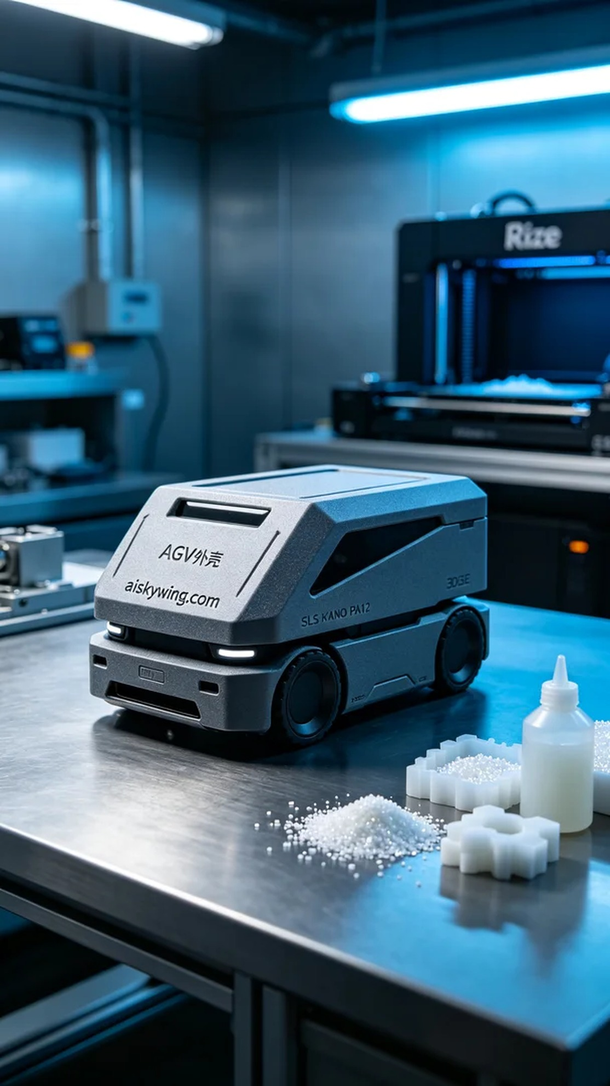
Someone on YouTube reached out to us regarding the production of an AGV shell. The design requirements for this shell are quite precise, needing to achieve both high strength and an attractive appearance. To meet these needs, we decided to use SLS nylon PA12 material, which perfectly suits this project due to its excellent properties and durability.
During the preparation work, we utilized a Rize printer, ensuring a clean printing environment and stable temperature. We set the printing parameters to a layer thickness of 0.1mm, with the temperature control at 180 degrees, a power setting of 50W, and a printing speed maintained at 30mm per hour. This configuration not only ensures clear details in the print but also enhances overall printing efficiency.
As the printing process commenced, the sound of the machine accompanied the layer-by-layer accumulation of the material, which was quite exhilarating. We monitored the print quality at all times to ensure there were no abnormalities. After about 12 hours of operation, the initial shape of the AGV shell began to take form, with the engraved "aiskywing.com" clearly visible, and the entire shell displaying a robust appearance and a frosted effect that reflected the austere industrial light.
Once printing was completed, we immediately moved to the post-processing stage. First, we submerged the printed part in a cleaning solution to remove excess powder; next, we meticulously sanded the surface with fine grinding tools to achieve a smoother finish; finally, we performed a curing process to ensure that the material strength reached its optimum state. Throughout the inspection, we adhered strictly to standards, checking each detail to ensure no defects were present.
After a series of processing steps, the AGV shell was finally completed, exhibiting both high strength and a flawless appearance that met all the pre-designed requirements. This production process not only challenged our technical skills but also tested our team's cohesion, and the result was truly satisfying.
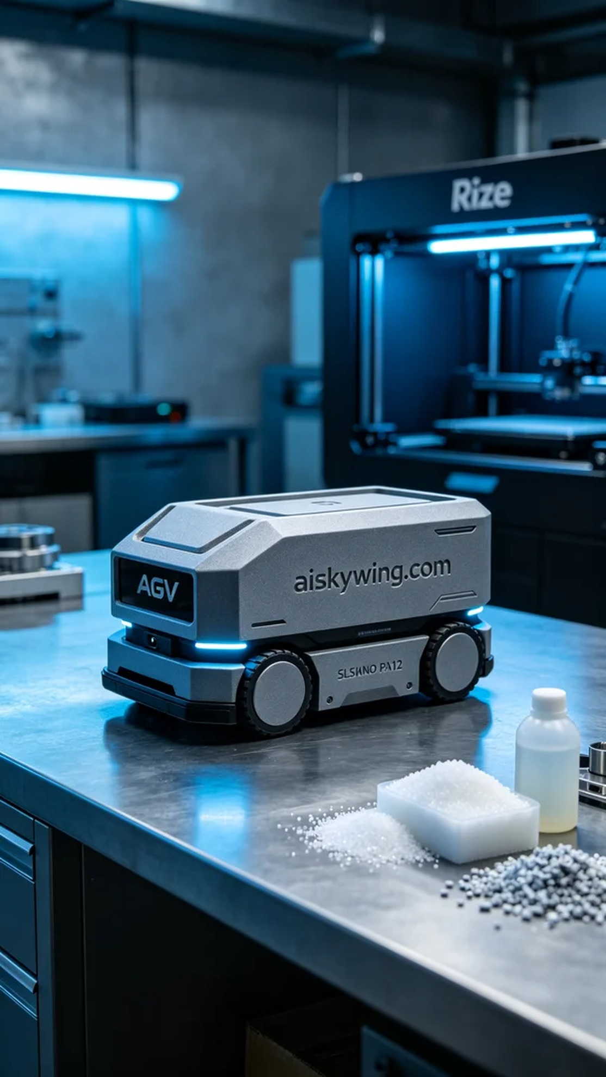
有人在YouTube上看到我们的技术，咨询关于AGV外壳的打印问题。这款外壳的设计要求非常严谨，需要具备高强度与良好的外观。为了满足需求，我们决定使用SLS尼龙PA12材质，它的优异性能和耐用性完美适合这个项目。
在准备工作中，我们使用了Rize打印机，确保打印环境的洁净与温度的稳定。为此，我们将打印参数设置为层厚0.1mm，打印温度控制在180度，功率设定为50W，打印速度则保持在每小时30毫米。这个设置不仅能确保打印的细节清晰，同时也能提高整体的打印效率。
打印过程开始后，机器的运转声伴随着材料的逐层堆积，令人振奋。我们时刻监控打印质量，确保没有异常情况发生。经过约12小时的运行，AGV外壳的初步形状已经显现，表面雕刻的“aiskywing.com”字样清晰可见，整个外壳呈现出坚固的外观和磨砂效果，反射出冷峻的工业光线。
打印完成后，我们立即进行后处理工序。首先，将打印件浸入清洗液中，去除多余的粉末；接着使用精细打磨工具对表面进行细致打磨，使其更加光滑；最后，进行固化处理，确保材料的强度达到最佳状态。在检验过程中，我们严格按照标准，逐一检查每个细节，确保无任何缺陷。
经过一系列的处理，AGV外壳终于完成，展现出高强度与完美的外观，满足了前期设计的所有要求。这一次的生产过程，不仅是对技术的挑战，也是对团队凝聚力的考验，结果令人满意。
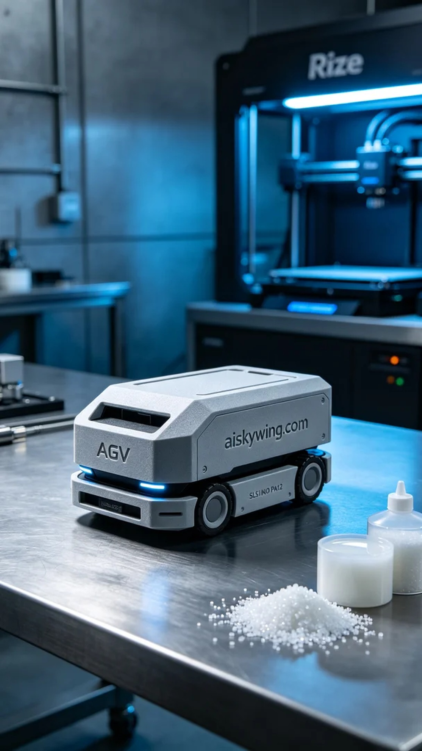
Aiskywing Industrial 3D Printing
AGV shell


